

May 30, 2020

To

The Corporate Relations Department The Corporate Relations Department

The National Stock Exchange of India Ltd. Department of Corporate Services

Exchange Plaza, 5th Floor, BSE Limited

Plot No. C/1, G-Block, 25th Floor, Phiroze Jeejeebhoy Towers,

Bandra-Kurla Complex, Dalal Street, Mumbai – 400001 Bandra (E), Mumbai - 400051

##### Re: Scrip Code 542602 and Scrip Symbol “EMBASSY”

**Sub: Submission of Valuation Report of Embassy Office Parks REIT for the year ended March 31, 2020 under Regulation 21 of the Securities and Exchange Board of India (Real Estate Investment Trusts) Regulations, 2014**

Dear Sir/Madam,

Pursuant to Regulation 21 of the Securities and Exchange Board of India (Real Estate Investment Trusts) Regulations, 2014, we have enclosed herewith the Valuation Report dated May 19, 2020 issued by Mr. Manish Gupta, Partner, iVAS Partners, Valuer, along with value assessment services undertaken by CBRE South Asia Private Limited, Value Assessment Service Provider, with respect to Embassy Office Parks REIT as at March 31, 2020.

Kindly take the above on record. Yours sincerely,

##### For and on behalf of Embassy Office Parks REIT acting through its Manager, Embassy Office Parks Management Services Private Limited

Ramesh

Digitally signed by Ramesh Periasamy

Periasamy Date: 2020.05.30

11:11:52 +05'30'

##### Ramesh Periasamy

**Company Secretary & Compliance Officer**

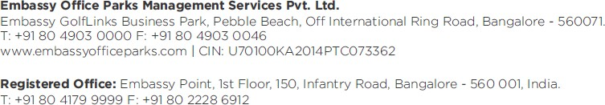

**SUMMARY VALUATION REPORT**

**Embassy Office Parks Management Services Private Limited in its capacity as manager of The Embassy Office Parks REIT**

**EMBASSY MANYATA, BENGALURU EXPRESS TOWERS, MUMBAI EMBASSY 247, MUMBAI**

**FIRST INTERNATIONAL FINANCE CENTRE (FIFC), MUMBAI EMBASSY TECHZONE, PUNE**

**EMBASSY QUADRON, PUNE EMBASSY QUBIX, PUNE EMBASSY OXYGEN, NOIDA EMBASSY GALAXY, NOIDA**

**EMBASSY GOLFLINKS, BENGALURU EMBASSY ONE, BENGALURU**

**HILTON AT EMBASSY GOLFLNKS, BENGALURU EMBASSY ENERGY, BELLARY DISTRICT, KARNATAKA**

**DATE OF VALUATION: MARCH 31, 2020**

**DATE OF REPORT: MAY 14, 2020**

Value Assessment Service

EMBASSY OFFICE PARKS MANAGEMENT SERVICES PRIVATE LIMITED | EMBASSY OFFICE PARKS REIT

Summary Valuation Report | Page 1



Valuer under SEBI (REIT)

Regulations, 2014

1. Instruction

Mr. Manish Gupta (Founder and Partner, iVAS Partners) has been instructed by **Embassy Office Parks Management Services Private Limited** (the ‘**Client**’, the **‘Instructing Party’)** in its capacity as **manager of The Embassy Office Parks REIT (Embassy REIT)** to advice upon the Market Value (MV) of properties comprising of commercial office real estate assets located across Bengaluru, Pune, Mumbai and Noida as well as affiliated facilities including a solar park, retail spaces and hotels (together herein referred as subject properties across the report).

CBRE has been instructed by the Client to be the ‘Value Assessment Service Provider’ for providing market intelligence to the ‘Valuer’ (Mr. Manish Gupta, Founder and Partner, iVAS Partners) and forecasting cash flows from the respective assets. The Valuer has utilized the market intelligence provided by CBRE and independently reviewed the cash flows to arrive at the Market Value of the respective assets as per the SEBI (REIT) regulations 2014. Mr. Manish Gupta (Founder and Partner, iVAS Partners) and CBRE are collectively referred to as the Consultants for the purpose of this report.

The details of the subject properties under the purview of this valuation exercise are tabulated below:

**Development Name Location**

Embassy Manyata Bengaluru

Express Towers Mumbai

Embassy 247 Mumbai

First International Finance Centre Mumbai

Embassy TechZone Pune

Embassy Quadron Pune

Embassy Qubix Pune

Embassy Oxygen Noida

Embassy Galaxy Noida

Embassy GolfLinks Bengaluru

Embassy One Bengaluru

Hilton at Embassy GolfLinks Bengaluru Embassy Energy Bellary District, Karnataka

* 1. Purpose

The Valuer understands that the valuation is required by the Client for financial and investor reporting purposes to comply with the requirements of Regulation 21 of the SEBI (REIT) Regulations, 2014.

* 1. Reliant Party

Reliant parties to this report shall mean Embassy Office Parks Management Services Private Limited (EOPMSPL), the Embassy Office Parks REIT (“Embassy REIT”) and their Unit Holders and Axis Trustee Services Limited (the Trustee for the Embassy REIT) for the purpose (of the valuation) as highlighted in this report. The auditors would be extended reliance by the ‘Consultants’ but would extend no liability to the auditors.

The valuation will be prepared strictly and only for the use of the Reliant Party and for the Purpose specifically stated. The instructing party would make all reliant parties aware of the terms and conditions of this agreement under which this exercise is being undertaken and take due acknowledgements to the same effect.

* 1. Limitation of Liability
     + The ‘Consultants’ provide the Services exercising due care and skill, but the ‘Consultants’ do not accept any legal liability arising from negligence or otherwise to any person in relation to possible

environmental site contamination or any failure to comply with environmental legislation which may affect the value of the properties. Further, the ‘Consultants’ shall not accept liability for any errors, misstatements, omissions in the Report caused due to false, misleading or incomplete information or documentation provided to the ‘Consultants’ by the Instructing Party.

* + - The Consultants’ maximum aggregate liability for claims arising out of or in connection with the Valuation Report, under this contract shall not exceed Indian Rupees 30 mn.
    - In the event that any of the Sponsor, Manager, Trustee, Embassy REIT in connection with the report be subject to any claim (“Claim Parties”) in connection with, arising out of or attributable to the Valuation Report, the Claim Parties will be entitled to require the ‘Consultants’ to be a necessary party/ respondent to such claim and the ‘Consultants’ shall not object to their inclusion as a necessary party/ respondent. If the ‘Consultants’ do not co-operate to be named as a necessary party/ respondent to such claims or co-operate in providing adequate/ successful defense in defending such claims, the Claim Parties jointly or severally will be entitled to initiate a separate claim against the ‘Consultants’ in this regard and the Consultants’ liability shall extend to the value of the claims, losses, penalties, costs and liabilities incurred by the Claim Parties.
    - The Consultants will neither be responsible for any legal due diligence, title search, zoning check, development permissions and physical measurements nor undertake any verification/ validation of the zoning regulations/ development controls etc.
  1. Capability of Valuer and Value Assessment Service Provider

**Valuer under SEBI (REIT) Regulations, 2014: Mr. Manish Gupta, Partner, iVAS Partners**

Manish Gupta, Partner at iVAS Partners, is a Registered Architect with Council of Architecture (COA) and a member of the Royal Institute of Charted Surveyors (MRICS) and Institution of Valuers (IOV), with over 12 years of experience in the real estate industry. Manish is a seasoned professional with experience in providing real estate valuation services to a wide spectrum of clients including financial institutions, private equity funds, developers, NBFCs, corporate houses, banks, resolution professionals, land owners, etc.

He has worked on variety of valuation, consulting and technical due-diligence assignments for various purposes including investment related due diligence, mortgage/collateral appraisals, financial reporting, listing purposes, IBC led requirements, etc. across a range of asset classes such as residential projects, integrated township developments, hospitality assets, commercial (office and retail) projects, industrial developments, warehousing parks, educational projects, healthcare developments, etc. for both national as well as international clients.

**Value Assessment Service Provider: CBRE South Asia Pvt. Ltd.**

CBRE Advisory Services India is an integral part of CBRE Global Valuation & Advisory Services team. The Global VAS team comprises of over 1,500 professionals across approximately 280 offices globally and India Advisory Services team comprises of more than 280 professionals.

CBRE Advisory Services India have completed over 80,000 valuation and advisory assignments across varied asset classes spread across 20 states and 300+ cities. CBRE provides quality valuation, risk advisory and consulting services across a range of property types including residential, hospitality, retail, commercial, institutional, Special Economic Zone (SEZ), industrial, etc. CBRE derives global best practices while maintaining the complexities of Indian real estate markets and are ideally positioned to help solve any valuation related real estate challenge, ranging from single asset valuations to valuation of multi-market and multi-property portfolios.

Our dedicated and experienced professionals provide quality services from 9 offices across India (Delhi, Mumbai, Bengaluru, Chennai, Kolkata, Gurgaon, Hyderabad, Pune and Ahmedabad). Our professionals have a varied qualification base such as Royal Institute of Chartered Surveyors (RICS) or IOV, IIV certified valuation professional, master planner, architect, MBA, CA, CFA, etc. and this entire multi-faceted experience helps us in achieving our commitment to provide the highest level of professional expertise to our clients.

CBRE Advisory Services India team has substantial experience with several institutional clients including financial institutions, real estate funds, private equity funds, developers, corporates, banks, NBFCs, etc.

* 1. Disclosures

The Consultants hereby certify that:

* + - iVAS Partners (Valuer Registration Number: IBBI/RV-E/02/2020/112), represented by Mr. Manish Gupta (hereinafter referred to as the Valuer), is eligible to be appointed as a valuer in terms of Regulation 2(1)(zz) of the Securities and Exchange Board of India (Real Estate Investment Trusts) Regulations, 2014
    - Neither CBRE nor iVAS Partners (represented by Mr. Manish Gupta - Partner, iVAS Partners) are an associate of the instructing party
    - Mr. Manish Gupta, Partner, iVAS Partners (the Valuer) has a minimum of five years of experience in the valuation of real estate
    - The Valuer has not been involved with the acquisition or disposal within the last twelve months of any of the properties valued under this summary valuation report in the last twelve months
    - The Valuer has adequate and robust internal controls to ensure the integrity of the valuation reports
    - The Valuer has sufficient key personnel with adequate experience and qualification to perform services related to property valuation at all times
    - The Valuer has sufficient financial resources to enable them to conduct their business effectively and meet their liabilities
    - The Valuer has acquainted itself with all laws or regulations relevant to such valuation
    - The valuation of assets undertaken is impartial, true and fair and in accordance with the Securities and Exchange Board of India (Real Estate Investment Trusts) Regulations, 2014
    - The Valuer and any of its employees/ consultants involved in valuation of the REIT assets are not invested in units of the REIT or in the assets being valued till the time such person is designated as valuer of such REIT and not less than 6 months after ceasing to be valuer of the REIT
    - The Valuer has conducted the valuation of the REIT assets with transparency and fairness and shall render, at all times, high standards of service, exercise due diligence, ensure proper care and exercise professional judgement
    - The Valuer has acted with independence, objectivity and impartiality in performing the valuation
    - The Valuer has discharged its duties towards the Embassy REIT in an efficient and competent manner, utilizing its knowledge, skills and experience in best possible way to complete the said assignment
    - The Valuer shall not accept remuneration, in any form, for performing a valuation of the REIT assets from any person other than the Embassy REIT or its authorised representatives.
    - The Valuer shall before accepting any assignment from any related party to the Embassy REIT, shall disclose to the Embassy REIT, any direct or indirect consideration which the valuer may have in respect of such assignment
    - The Valuer shall disclose to the trustee of the Embassy REIT, any pending business transactions, contracts under negotiation and other arrangements with the Instructing Party or any other party whom the Embassy REIT is contracting with and any other factors which may interfere with the Valuer’s ability to give an independent and professional valuation of the property
    - The Valuer shall not make false, misleading or exaggerated claims in order to secure assignments
    - The Valuer shall not provide misleading valuation, either by providing incorrect information or by withholding relevant information
    - The Valuer shall not accept an assignment that includes reporting of the outcome based on predetermined opinions and conclusions required by the Embassy REIT
    - The valuation undertaken by the Valuer abides by international valuation standards and valuation

standards as may be specified by the Institute of Chartered Accountants of India for valuation of real estate assets. Provided that in case of any conflict, standard specified by the Institute of Chartered Accountants of India shall prevail

* + - The Valuer notes that there are encumbrances, however, no options or pre-emptions rights in relation to the assets based on the title report prepared by King & Partridge, Shardul Amarchand Mangaldas & Co, Cyril Amarchand Mangaldas, Little & Company, Jayashree Sridhar and Law Shield (hereinafter collectively referred to as ‘Legal Counsels’)
  1. Assumptions, Disclaimers, Limitations & Qualifications to Valuation

Valuation Subject

to Change:

* The subject valuation exercise is based on prevailing market dynamics as on the date of valuation and does not take into account any unforeseeable developments which could impact the same in the future

Our

Investigations:

* The Consultants are not engaged to carry out all possible investigations in relation to the subject properties.

Where in our report the Consultants identify certain limitations to our investigations, this is to enable the reliant party to instruct further investigations where considered appropriate or where the Consultants recommend as necessary prior to reliance. The Consultants are not liable for any loss occasioned by a decision not to conduct further investigations

Assumptions: • Assumptions are a necessary part of undertaking valuations. The Valuer adopts assumptions for the purpose of providing valuation advice because some matters are not capable of accurate calculation or fall outside the scope of our expertise, or our instructions. The reliant parties accept that the valuation contains certain specific assumptions and acknowledges and accepts the risk that if any of the assumptions adopted in the valuation are incorrect, then this may have an effect on the valuation

Information

Supplied by Others:

* The valuations are based on the information provided by the Instructing Party (Embassy Office Parks

Management Services Private Limited). The same has been assumed to be correct and has been used for valuation exercise. Where it is stated in the report that another party has supplied information to the ‘Consultants’, this information is believed to be reliable but the ‘Consultants’ can accept no responsibility if this should prove not to be so

Future Matters: • To the extent that the valuation includes any statement as to a future matter, that statement is provided as an estimate and/or opinion based on the information known to the ‘Consultants’ at the date of this document. The ‘Consultants’ do not warrant that such statements are accurate or correct

Map and Plans: • Any sketch, plan or map in this report is included to assist reader while visualizing the properties and assume

no responsibility in connection with such matters

Site Details:

* Based on title due-diligence information provided by the Client, the Valuer understands that the subject properties are free from any encroachments and are available as on the date of the valuation

Property Title: • For the purpose of this valuation exercise, the Valuer has relied on the Title Reports prepared by the Legal

Counsels for each of the properties and has made no further enquiries with the relevant local authorities in this regard. The Valuer understands that the subject properties may have encumbrances, disputes and claims. The Valuer does not have the expertise or the preview to verify the veracity or quantify these encumbrances, disputes or claims. For the purpose of this valuation, the Valuer has assumed that the respective assets have title deeds that are clear and marketable.

Environmental • The Valuer has assumed that the subject properties are not contaminated and are not adversely affected by any Conditions: existing or proposed environmental law and any processes which are carried out on the properties are regulated

by environmental legislation and are properly licensed by the appropriate authorities

Town Planning: • The current zoning of the subject properties has been adopted on the basis of review of various documents (title

deeds) provided by the Instructing Party and the current land use maps for the subject region. The same has been considered for the purpose of this valuation exercise. Further, it has been assumed that the development on the subject properties adheres/ would adhere to the development regulations as prescribed by the relevant authorities. The Valuer has not made any enquiries with the relevant development authorities to validate the legality of the same.

Area:

* The total leasable area considered for the purpose of this valuation exercise is based on the rent rolls/ Architect certificate provided by the Instructing Party. It must be noted that the above information has been provided by the Client and has been verified based on the approvals/ layout plans/building plans provided by the Client. However, the Valuer has not undertaken additional verification and physical measurement for the purpose of this valuation exercise

Condition &

Repair:

* In the absence of any information to the contrary, the Valuer has assumed that there are no abnormal ground

conditions, nor archaeological remains present which might adversely affect the current or future occupation, development or value of the property; the property is free from rot, infestation, structural or latent defect; no currently known deleterious or hazardous materials or suspect techniques will be used in the construction of or subsequent alterations or additions to the property and comments made in the property details do not purport to express an opinion about, or advice upon, the condition of uninspected parts and should not be taken as making an implied representation or statement about such parts

Not a Structural • The Valuer states that this is a valuation report and not a structural survey Survey:

Legal: • Unless specifically disclosed in the report, the Valuer has not made any allowances with respect to any existing

or proposed local legislation relating to taxation on realization of the sale value of the subject property.

Others:

* Considering the unorganized nature of real estate markets in India, all comparable evidence (if any) provided in the valuation report has been limited to the basic details such as the area of asset, rate at which transacted, broad location, etc. other specific details would be provided only if the information is available in public domain

Other

Assumptions:

* Please note that all the factual information such as tenants’ leasable area, lease details such as lease rent, lease

commencement and lease end date, lock – in period, escalation terms, etc. pertaining to the subject properties is based on the appropriate relevant documents provided by the Client and the same has been adopted for the purpose of this valuation exercise. While we have reviewed a few lease deeds on a sample basis, the Consultants do not take any responsibility towards authenticity of the rent rolls provided by the Client. Any change in the above information will have an impact on the assessed value and in that case the Valuer will have to relook at the assessed value. The relevant information sources are represented in section 2.5

* All measurements, areas and ages quoted in our report are approximate
* We are not advisors with respect to legal tax and regulatory matters for the transaction. No investigation of the respective Special Purpose Vehicles (SPVs) holding the assets’ claim to title of assets has been made for the purpose of this Report and the SPVs’ claim to such rights have been assumed to be valid. No consideration has been given to liens or encumbrances against the assets. Therefore, no responsibility is assumed for matters of a legal nature
* Kindly note that we have undertaken a quarterly assessment of cash flows for the purpose of the valuations
* Please note that the pending cost to complete highlighted in the individual asset pages (section 5) of this summary valuation report is indicative of pending cost towards base build works only and does not include the cost for refurbishments/ infrastructure upgrade works. The details pertaining to balance cost towards refurbishments/ infrastructure upgrade works have been presented in the detailed valuation report

Material • The outbreak of the Novel Coronavirus (COVID-19), declared by the World Health Organisation as a “Global Valuation Pandemic” on the 11th March 2020, is causing heightened uncertainty in both local and global market Uncertainty conditions. Global financial markets have seen steep declines since late February largely on the back of the from Novel pandemic over concerns of trade disruptions and falling demand. Many countries globally have implemented Coronavirus: strict travel restrictions and a range of quarantine and “social distancing” measures.

Market activity is being impacted in most sectors. In this environment, we have considered / relooked at various performance parameters and have adopted heuristic/ careful interventions to our projected cashflows based on our view as of this date. As at the valuation date, we consider that we can attach less weight to previous market evidence for comparison purposes, to inform opinions of value. Indeed, the current response to COVID-19 means that we are faced with an unprecedented set of circumstances on which to base a judgement.

Our valuation(s) is / are therefore reported on the basis of ‘material valuation uncertainty’. Consequently, less certainty – and a higher degree of caution – should be attached to our valuation than would normally be the case. Values may change more rapidly and significantly than during standard market conditions. Given the unknown future impact that COVID-19 might have on the real estate market, we recommend that you keep the valuation of these properties under frequent review.

For the avoidance of doubt, the inclusion of the ‘material valuation uncertainty’ declaration above does not mean that the valuation cannot be relied upon. Rather, the declaration has been included to ensure transparency of the fact that – in the current extraordinary circumstances – less certainty can be attached to the valuation than would otherwise be the case. The material uncertainty clause is to serve as a precaution and does not invalidate the valuation.

1. Valuation Approach & Methodology
   1. Scope of Valuation

The valuation exercise is aimed at the assessment of the Market Value (MV) of the subject property. In considering the value of the property, the Valuer has considered the guidelines laid out in the Appraisal and Valuation Manual published by the Royal Institution of Chartered Surveyors (RICS).

* 1. Basis of Valuation

The valuations have been conducted in accordance with the RICS Valuation – Global Standards 2017 (Red Book Incorporating the IVSC International Valuation Standards issued in June 2017, effective from 1 July 2017) and is in compliance with the International Valuation Standards (IVS) and valuation standards as may be specified by the Institute of Chartered Accountants of India for valuation of real estate assets. The valuation exercise has been undertaken by appropriately qualified Valuer and would be aimed at assessing the Market Value of subject properties.

As per the Valuation and Guidance Notes issued by the Royal Institution of Chartered Surveyors (RICS) the market value is defined as:

***‘The estimated amount for which an asset or liability should exchange on the valuation date between a willing buyer and a willing seller in an arm’s length transaction, after proper marketing and where the parties had each acted knowledgeably, prudently and without compulsion’.***

* 1. Approach and Methodology

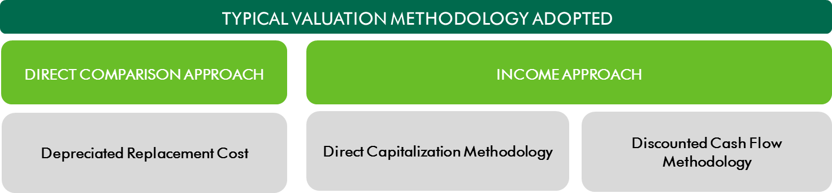The purpose of this valuation exercise is to estimate the Market Value (MV) of the subject properties. Market Value is derived through the following Methodologies:

* + 1. Direct Comparison Approach

In **‘Direct Comparison Approach’**, the subject property is compared to similar properties that have actually been sold in an arms-length transaction or are offered for sale (after deducting for value of built-up structure located thereon). The comparable evidence gathered during research is adjusted for premiums and discounts based on property specific attributes to reflect the underlying value of the property.

* + 1. Income Approach

The income approach is based on the premise that value of an income - producing asset is a function of future benefits and income derived from that asset. There are two commonly used methods of the income approach in real estate valuation namely, direct capitalization and discounted cash flow (DCF).

* + - 1. **Direct Capitalization Method**

Direct capitalization involves capitalizing a ‘normalized’ single - year net income estimated by an appropriate yield. This approach is best utilized with stable revenue producing assets, whereby there is little volatility in the net annual income.

* + - 1. **Discounted Cash Flow Method**

Using this valuation method, future cash flows from the property are forecasted using precisely stated assumptions. This method allows for the explicit modelling of income associated with the property. These future financial benefits are then discounted to a present-day value (valuation date) at an appropriate discount rate. A variation of the Discounted Cash Flow Method is illustrated below:

* + - * 1. **Discounted Cash Flow Method using Rental Reversion**

The market practice in most commercial/ IT developments involves contracting tenants in the form of pre- commitments at sub-market rentals to increase attractiveness of the property to prospective tenants – typically extended to anchor tenants. Additionally, there are instances of tenants paying above-market rentals for certain properties as well (primarily owing to market conditions at the time of contracting the lease). In order to arrive at a unit value for these tenancies, the Valuer has considered the impact of such sub/ above market leases on the valuation of the subject property.

* 1. Approach and Methodology Adopted

A large number of leases at the subject properties were executed at rentals prevalent at the time of signing of such leases or at a discount to prevailing market rental (for a few anchor tenants). Since the real estate industry is dynamic and is influenced by various factors (such as existing supply, tenants looking at spaces, quality of spaces available in the market, overall health of the economy, existing rentals, future growth plans, etc.) at a particular point in time, negotiated rentals may tend to move away from the prevalent market rents over a period of time. It has also been witnessed that the market rents for some properties or sub markets increase or decrease at a rate significantly different from those agreed to in initial leases. These factors reinforce the need to review each of these leases in isolation to assess the intrinsic value of the property under review.

Considering the objective of this exercise and the nature of asset involved, the value of the office component in the subject properties has been assessed through the Discounted Cash Flow Method using Rental Reversion and the value of the Solar Park and hotel component at the respective properties have been valued using Discounted Cash Flow Method. Further, the following steps have been adopted as part of the valuation for the respective subject properties (assets).

**Asset-specific Review:**

1. As the first step to the valuation of the asset, the rent rolls (and the corresponding lease deeds on a sample basis) were reviewed to identify tenancy characteristics for the asset. As part of the rent roll review, top 10 tenants have been reviewed from their lease terms perspective. For anchor tenants, discounts on marginal rent or additional lease-up timeframe have been adopted upon lease reversion.
2. Title documents and architect certificates were reviewed for validation of area details, ownership of the asset

**Micro-market Review:**

1. A detailed assessment of the site and surroundings has been undertaken with respect to the prevalent activities, change in dynamics impacting the values and the optimal use of the respective properties vis-à-vis their surrounding sub-market, etc. Further, a primary and secondary research exercise has been carried out in the catchment areas for the respective assets to ascertain the transaction activity of commercial, retail and hospitality developments. This has been achieved through interactions with various market players such as developers, real estate brokers, key office tenants, hospitality occupiers, etc. Peers to the assets were identified in terms of potential competition (both completed and under-construction/planned assets), comparable recent lease transactions witnessed in the micro-market were analysed along with the historical leasing and re- leasing history within the asset over the last 2 – 3 years. This was undertaken to assess the applicable market rent (applicable rental for the micro-market where the asset is located) and

applicable marginal rental (the Consultants’ view on rental for the asset – used for leasing vacant spaces as well as upon releasing).

1. The Consultants also analysed the historical leasing within the asset for anchor tenants to identify the discount that is extended to such tenants at the time of fresh leasing or lease renewals. Every lease deed of large anchor tenants were analysed and applicable discount to marginal rental was estimated for individual leases. For other tenants occupying relatively large space within the properties, the Valuer assumed the leases to revert to marginal rentals (duly escalated from the date of valuation) post expiry of the lease, factoring appropriate re-leasing time.

**Cash Flow Projections:**

1. The cash flows for the operational and under-construction/proposed area were projected separately to arrive at their respective value conclusion.
2. The Valuer has utilized the EBIDTA to arrive at the value of the subject properties. The following steps were undertaken to arrive at the value for operational and under-construction/proposed area respectively.

The Valuer has projected future cash flows from the property based on existing lease terms for the operational area till the expiry of the leases or re-negotiation (using the variance analysis), whichever is earlier. Post which, the lease terms have been aligned with marginal rentals. For vacant area and under-construction/proposed area, the Valuer has projected the marginal rent led cash flows factoring appropriate lease-up time frame for vacant/under-construction/proposed area. These cash flows have been projected for 10-year duration from the date of valuation and for 11th year (for assessment of terminal value). These future financial benefits are then discounted to a present-day value (valuation date) at an appropriate discount rate.

For each lease, the following steps have been undertaken to assess the rental over a 10-year time horizon:

* 1. **Step 1:** Project the rentals for identified tenancies up to the period of lease expiry, lock- in expiry, first escalation, second escalation, etc. whichever is applicable. In the event of unleased spaces, market-led rentals to be adopted with suitable lease-up time
  2. **Step 2:** Generating a marginal rental stream for identified tenancies for the time period similar to the cash flows drawn in the aforementioned step
  3. **Step 3:** In the event the escalated contracted rental is above the marginal rent (viz. by 10% for Bengaluru/ Mumbai assets & 15% for Pune/ Noida assets), the contracted terms are discarded, and the terms are reverted to market. In the event the escalated contracted rent is below the marginal rent by the threshold highlighted above, the contracted terms are adopted going forward until the next lease review/ renewal. Intent of this step is to project the rental for respective leases until lease expiry as well as post expiry
  4. **Step 4:** Computing the monthly income based on rentals projected as part of Step 3 and translating the same to a quarterly income (for the next 10 years and 11th year – considered for calculation of terminal value)

1. Adjustments for other revenues and recurring operational expenses, fit-out income (if any – projected till first term expiry and discounted to present day – the same has been considered below the NOI and does not get capitalized) and vacancy provision have been adopted in-line with prevalent market dynamics. In addition, appropriate rent-free periods have been adopted during lease roll-overs to factor potential rent free terms as well as outflows towards brokerage. For all

assets, the Valuer has looked at the operational revenues and expenses of the respective assets to understand the recurring, non-recurring, recoverable and non-recoverable expenses and accordingly modelled the common area maintenance income and operational expenses for the asset. For Embassy Manyata, Embassy GolfLinks and Embassy TechZone, common area maintenance is managed by an external agency and accordingly, no CAM margin has been considered during the course of operations. However, for assessing the exit cash flows, the Valuer has assumed that on a notional exit, market-led CAM charges and hence CAM margin would be accruable to a potential buyer and the same has been adopted during capitalization.

1. The net income on quarterly basis have been projected over the next 10 years and the 1 year forward NOI (for 11th year) as of end of year 10 has been capitalized to assess the terminal value of the development. The quarterly net income over the next 10 years along with the terminal value during the end of year 10 have been discounted at a suitable discount rate to arrive at the net present value of the asset through this approach.
2. For the hospitality component, future cash flows from the property, were projected based on our assessment of ARRs and Occupancy. Adjustments for other revenues and recurring operational expenses, have been adopted in-line with prevalent market dynamics. The net income on quarterly basis have been projected over the next 10 years and the 1 year forward EBITDA (for 11th year) as of end of year 10 has been capitalized to assess the terminal value of the development. The quarterly net income over the next 10 years along with the terminal value during the end of year 10 have been discounted at a suitable discount rate to arrive at the net present value of the asset.
   1. Information Sources for Valuation

Property related information referred to for the valuation exercise has been provided by the Client unless otherwise mentioned. The Valuer has assumed the documents to be a true copy of the original. The rent rolls have been cross-checked with the lease deeds on a sample basis to verify the authenticity. Additionally, wherever possible, the Valuer has independently revalidated the information by reviewing the originals as provided by the Client.

* 1. Scope of Services for Value Assessment Service Provider

CBRE has been engaged by the Instructing Party to provide value assessment services and accordingly, would be responsible for the below scope as part of this exercise.

* Provide market intelligence to the Valuer on the following aspects:
  + Economic and Investment Overview
  + India Real Estate Overview
    - IT/ ITES Industry Dynamics
    - Key Office Markets
    - Outlook
  + For cities housing Embassy REIT Assets
    - Key Office Markets
    - General market practices
    - Demand Supply for Key Office Markets & Rental Trends
    - Outlook
* Review rent roll and forecast cash flows from the respective assets for the Valuer to independently review and work towards assessing the valuation of each Asset

**Official Signatory for Value Assessment Service Provider:**

**Name:** Vamshi KK Nakirekanti | MRICS | FIE | FIV | CEng (India)

**Designation:** Executive Director, Head – Valuation and Advisory Services, India & South East Asia

**Firm:** CBRE South Asia Pvt Ltd

1. Nature of the Interest of the Embassy REIT

The table below highlights the nature of interest of the Embassy REIT:

|  |  |  |  |
| --- | --- | --- | --- |
| **Property** | **Interest Valued In** | **terest Embassy REIT holds** | **Remainder of term in case of Leasehold (approx.)** |
| **Embassy Manyata, Bengaluru** | Freehold* | 100.0% | NA |
| **Express Towers, Mumbai** | Freehold | 100.0% | NA |
| **Embassy 247, Mumbai** | Freehold | 100.0% | NA |
| **First International Financial Center,**  **Mumbai** | Leasehold | 100.0% | 68 Years |
| **Embassy TechZone, Pune** | Leasehold | 100.0% | 80 Years |
| **Embassy Quadron, Pune** | Leasehold | 100.0% | 80 Years |
| **Embassy Qubix, Pune** | Freehold | 100.0% | NA |
| **Embassy Oxygen, Noida** | Leasehold | 100.0% | 77 Years |
| **Embassy Galaxy, Noida** | Leasehold | 100.0% | 76 Years |
| **Embassy GolfLinks, Bengaluru** | Freehold | 50.0% | NA |
| **Embassy One, Bengaluru** | Freehold | 100.0% | NA |
| **Hilton at GolfLinks, Bengaluru** | Freehold | 100.0% | NA |
| **Embassy Energy, Bellary District,** Freehold | | 100.0% | NA |

**Karnataka**

*\*Excluding the M3 block which is being developed on a leasehold land parcel (6.64 Acres)*

1. Value Summary

The following table highlights the summary of the market value of each property which is a part of the said Embassy REIT portfolio as on March 31, 2020:

|  |  |  |  |  |  |
| --- | --- | --- | --- | --- | --- |
| **Property** | **Asset Type** | **Leasable Area** | **Market Value (INR mn)** | | |
| **Completed** | **Under construction**  **(UC) / Proposed** | **Total** |

Mixed-use Completed office – 11.8 msf

**Embassy Manyata,**

|  |  |  |  |  |
| --- | --- | --- | --- | --- |
| **Bengaluru** SEZ^), Hotel, Retail,  Convention Centre) | UC Hotel (5 star) - 266 keys  UC Hotel (3 star) - 353 keys |  | | |
| **Express Towers,** Office (Non-SEZ) | Completed office - 0.5 msf | 17,866 | - | **17,866** |
| **Embassy 247, Mumbai** Office (Non-SEZ) | Completed office - 1.2 msf | 16,624 | - | **16,624** |
| **First International**  **Financial Centre,** Office (Non-SEZ)  **Mumbai** | Completed office - 0.4 msf | 13,911 | - | **13,911** |
| **Embassy TechZone,** Office Completed office - 2.2 msf  **Pune** (IT/ ITeS SEZ) Proposed/ UC office - 3.3 msf | | 14,929 | 6,103 | **21,032** |

(Office (IT/ ITeS SEZ/ Non- Proposed/ UC* office - 3.1 msf

129,952 23,954 **153,906**

**Mumbai**

**Pune** (IT/ ITeS SEZ)

|  |  |  |  |
| --- | --- | --- | --- |
|  |  |  |  |
| **Embassy Quadron,** Office Completed office - 1.9 msf | 13,838 | - | **13,838** |
| **Embassy Qubix, Pune** Office Completed office - 1.5 msf | 10,085 | - | **10,085** |

**Embassy Oxygen, Noida**

(IT/ ITeS SEZ)

Office (IT/ ITeS SEZ)

Completed office - 2.5 msf Proposed/ UC office - 0.7 msf

19,492 1,924 **21,416**

**Embassy Galaxy, Noida**

Office (Non-SEZ) Completed office - 1.4 msf 8,696 - **8,696**

**Embassy One, Bengaluru**

Mixed-use

(Office (Non-SEZ), Hotel, Retail)

Office & Retail - 0.3 msf 12,570 - **12,570**

Hotel (5 star) - 230 Keys

**Hilton at Embassy GolfLinks, Bengaluru Embassy Energy,**

Hotel Hotel (5 star) - 247 Keys 4,436 - **4,436**

Installed capacity of 130 MW DC (100

|  |  |  |  |  |  |
| --- | --- | --- | --- | --- | --- |
| **Karnataka** |  | | | | |
| **Total – 100% owned assets** |  |  | **272,688** | **31,981** | **304,669** |
| **Embassy GolfLinks, Bengaluru** | Office (Non-SEZ) | Completed office - 2.7 msf | 27,014 | - | **27,0141** |
| **Total** |  |  | **299,702** | **31,981** | **331,683** |

**Bellary District,**

Solar park

MW AC) 10,289 - **10,289**

*1 Note: Indicative of Embassy REIT’s economic interest in the asset, viz. 50%*

*\*UC -under construction, ^SEZ – Special Economic Zone*

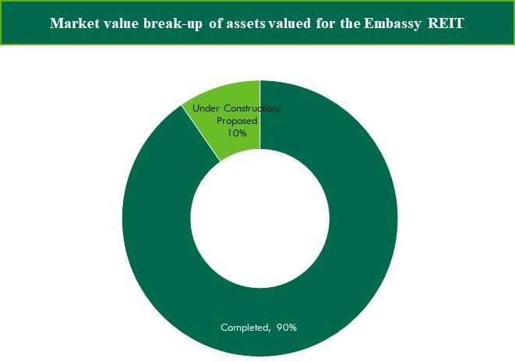

Assumptions, Disclaimers, Limitations & Qualifications

This summary valuation report is provided subject to assumptions, disclaimers, limitations and qualifications detailed throughout this report. Reliance on this report and extension of our liability is conditional upon the reader’s acknowledgement and understanding of these statements. This valuation is for the use of the parties as mentioned in Section 1.2 of this summary report.

Prepared by: Mr. Manish Gupta, Partner, iVAS Partners

Official Signatory:

**Name:** Mr. Manish Gupta

**Designation:** Partner, iVAS Partners

**Valuer Registration Number:** IBBI/RV-E/02/2020/112

1. Assets
   1. Embassy Manyata

Property Name: Embassy Manyata is a commercial office development located along Outer Ring Road, Nagavara, Bengaluru, Karnataka

Property Address: Nagavara Village, Kasaba Hobli, Bengaluru North Taluk, Bengaluru District and Rachenahalli and Thanisandra Villages, Krishnarajapuram Hobli, Bengaluru East Taluk, Bengaluru District, Karnataka

Land Area: Based on review of the title report (for Manyata Promoters Pvt Ltd and M3 Block respectively), the Valuer understands that the total land area of the subject property under the ownership of the Client is approximately

121.76 acres

Brief Description: The subject property is the second largest commercial office asset in India (in terms of scale), largest in Bengaluru and is a landmark in North Bengaluru. The property is accessible through the Nagavara Outer Ring Road emanating from Hebbal. Further, the subject development is strategically located in proximity to micro- markets of Thanisandra & Hennur Road which are amongst the fastest developing vectors in North Bengaluru.

The subject property is located in close proximity to the Nagavara Outer Ring Road, which connects the subject location to prominent locations such as Yeshwanthpur, KR Puram, Whitefield, Sarjapur Outer Ring Road, Old Madras Road, etc. Further, it is located at a distance of 1-2 km from Nagavara Junction, 3-4 km from Hebbal Junction, 7-8 km from Yelahanka Junction, 11-14 km from MG Road (CBD) and 29-31 km from Kempegowda International Airport

Statement of Assets (sf):

**Block**

**Total Area (sf)**

**Operational area (in sf)**

**Under Construction**

**Proposed Development**

Based on review of various documents (such as rent roll, lease deeds, Architect’s Certificate, etc.), the subject property is an operational office asset with approximately 11.7 msf of completed leasable area out of which occupancy is approximately 97.7% (including committed occupancy) as on the date of valuation. Table below highlights the leasable area for individual blocks that form part of the subject development:

|  |  |  |  |  |
| --- | --- | --- | --- | --- |
|  | | | **area (in sf)** | **area (in sf)** |
| SEZ Area | 10,650,357 | 8,347,511 | 1,594,846 | 708,000 |
| Non – SEZ Area | 4,111,213 | 3,403,663 | - | 707,550 |
| Retail | 58,083 | - | 58,083 |  |
| **Total – Office/Retail** | **14,819,653** | **11,751,174** | **1,652,929** | **1,415,550** |
|  |  |  | 619 keys |  |
| Hotel | 619 keys |  | (Hotel - |  |
| (including convention  centre) | (Hotel - 722,678  Convention – 58,000) | - | 722,678  Convention – |  |
|  |  |  | 58,000) |  |

Source: Architect certificates, rent roll, lease deeds; Note – office & retail refers to leasable area while hotel & convention refers to developable area

Location Map

Key Assumptions

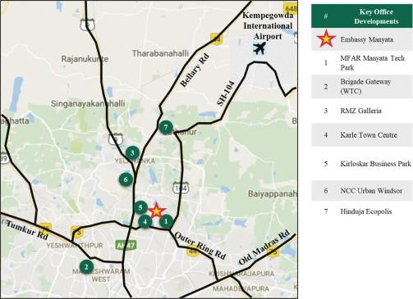

|  |  |  |
| --- | --- | --- |
| **Particulars Unit Details**  Construction assumptions | | |
| Pending cost to complete | INR mn | 17,089* |
| Proposed project completion timelines (all blocks) | Quarter, Year | Q3, FY 2025 |
| Revenue assumptions (as on March 31, 2020) | |  |
| Lease completion | Year | FY 2025 |
| In-place rent | INR psf/mth | 60 |
| Marginal rent – IT office component | INR psf/mth | 90 |
| Marginal rent – Non IT office component | INR psf/mth | 104 |
| Marginal rent – Retail component | INR psf/mth | 117 |
| Parking rent (Effective) | INR / bay/mth | 3,750 |
| ARR – 5 star hotel | INR / room / day | 8,000 |
| Stabilized Occupancy – 5 star hotel | % | 70% |
| ARR – 3 star hotel | INR / room / day | 5,500 |
| Stabilized Occupancy – 3 star hotel | % | 70% |
| Other fin | ancial assumptions |  |
| Cap rate – commercial components | % | 8.00% |
|  |  | 7.14% |
| Cap rate – hotel components | % | (viz. an EV-EBITDA  multiple of 14) |
| WACC rate (operational) | % | 12.03% |
| WACC rate (under-construction/proposed) | % | 13.00% |
| WACC rate (hotel) | % | 13.60% |

*\* Indicative of pending cost towards base build works and does not include the cost for refurbishments/ infrastructure upgrade works*

Market Value: **INR 153,906 Mn**

* 1. Express Towers

Property Name: ‘Express Towers’ is an operational office asset located along Barrister Rajni Patel Marg, Nariman Point, Mumbai

Property Address: Barrister Rajni Patel Marg, Nariman Point, Mumbai

Land Area: Based on review of the title report, the Valuer understands that the total land area of the subject property under the ownership of the Client is approximately 1.46 acres

Brief Description: The subject property ‘Express Towers’ is an office asset situated in Nariman Point. The subject property is located opposite to the Oberoi Trident hotel. The G+25 floor storey structure was constructed in the late 1960s and has been refurbished in the past few years. Nariman Point is located at the southernmost tip of the Mumbai City, at a distance of approximately 1 - 2 km from the Churchgate Railway Station; approximately 25 - 28 km from the Domestic / International City Airport.

Statement of Assets (sf):

Based on review of various documents (such as rent roll, Architect’s Certificate, etc.), the subject property is an operational office asset with approximately 472,377 sf of completed leasable area, which is approximately 93.5% occupied as on the date of valuation. Also, the top 2 floors viz the 24th and 25th floor are not owned by Indian Express Newspapers (Mumbai) Pvt. Ltd (IENPL). Table below highlights the leasable area details for the subject development under the ownership of IENPL.

|  |  |  |
| --- | --- | --- |
| **Particular** | **Leasable Area (sf)** | **Committed Occupancy (%)** |
| Completed Blocks | 472,377 | 93.5% |
| Under Construction Blocks | - | NA |
| Proposed Blocks | - | NA |
| **Total** | **472,377** |  |

Source: Architect certificate, Rent roll, lease deeds;

Location Map

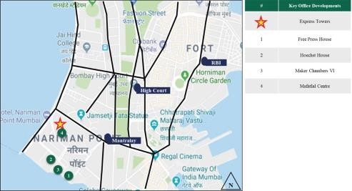

Key Assumptions

|  |  |  |
| --- | --- | --- |
| **Particulars Unit Details**  Revenue assumptions (as on March 31, 2020) | | |
| Lease completion | Year | FY 2021 |
| In-place rent | INR psf/mth | 256^ |

Marginal Rent – Commercial office component

INR psf/mth 270

Parking rent (Effective) INR / bay/mth -

|  |  |  |
| --- | --- | --- |
| Other | financial assumptions |  |
| Cap rate – commercial components | % | 7.50% |
| WACC rate (operational) | % | 12.03% |

^denotes the weighted average rentals for leased office/restaurant spaces

Market Value: **INR 17,866 Mn**

* 1. Embassy 247

Property Name: ‘Embassy 247’ is an operational office asset located along LBS Road, Gandhinagar, Vikhroli West, Mumbai Property Address: LBS Marg, Vikhroli (W), Mumbai, Maharashtra.

Land Area: Based on review of the title report, the Valuer understands that the total land area of the subject property under the ownership of the Client is approximately 7.27 acres

Brief Description: The subject property, “Embassy 247”, is an operational office asset located along LBS Road in Gandhinagar, Vikhroli West, Mumbai. The development is divided in three towers viz. A, B & C. The towers A & C are identical to each other and have an elevation of 2 Basement + Ground + 11 upper floors. Tower B situated in between Tower A & C has an elevation of 2 Basement + Ground + 14 upper floors. Based on the site visit, it is understood that all the three towers are internally connected from basement to the 3rd floor and floors 10 and 11. The entire development has a total completed leasable area of approximately 1,189,544 sf. The subject property is located in proximity to established residential and commercial locations within the city such as Bhandup, Kanjurmarg, Ghatkopar etc.

The subject property is located at a distance of approximately 28-30 km from the Central Business District of Mumbai (viz. Nariman Point), approximately 11-12 km from Domestic Airport, approximately 10-12 km from the Chhatrapati Shivaji International Airport Terminal, Mumbai etc.

Statement of Assets (sf): Based on information provided by the Client, the total completed leasable area considered for the purpose of this valuation is 1,189,544 sf. Table below highlights the leasable area details for the subject development:

**Particular**

**Leasable Area (sf)**

**Committed Occupancy (%)**

Completed Blocks 1,189,544 93.2%

Under Construction Blocks - NA

Proposed Blocks - NA

**Total 1,189,544**

Source: Architect certificate, Rent roll, lease deeds;

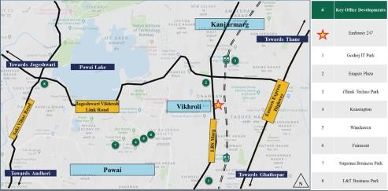Location Map

Key

|  |  |  |
| --- | --- | --- |
| Particulars Unit Details Revenue assumptions (as on March 31, 2020) | | |
| Lease completion | Year | FY 2021 |
| In-place rent | INR psf/mth | 99^ |

Assumptions

Marginal rent – Commercial office component

INR psf/mth 110*

Marginal rent – Retail component INR psf/mth 78

Parking rent (Effective) INR / bay/mth -

|  |  |  |
| --- | --- | --- |
| Other | financial assumptions |  |
| Cap rate – commercial components | % | 8.00% |
| WACC rate (operational) | % | 12.03% |

*^denotes the weighted average rentals for leased office/retail and food-court spaces; * Inclusive of car park rent*

Market Value: **INR 16,624 Mn**

* 1. First International Finance Centre (FIFC)

Property Name:

First International Finance Centre is a commercial office development located on Bandra Kurla Complex Road, Bandra Kurla Complex, Mumbai, Maharashtra

Property Address:

G-Block, Bandra Kurla Complex road, Bandra Kurla Complex, Mumbai, Maharashtra

Land Area: Based on review of the title report, the Valuer understands that the total land area of the subject property under the ownership of the Client is approximately 1.99 Acres

Brief The subject property, “First International Finance Centre”, is an operational office asset located along BKC Road in

Description: G Block, Bandra Kurla Complex, Mumbai. This office asset has a total leasable area of approximately 658,390 sf. The development is operated as a condominium and is co-owned by two entities i.e., a leading bank and the Client. Based on review of the title report for the subject property, the Client has an ownership of approximately 360,947 sf of the total area and the same has been considered for the purpose for this valuation exercise (this area will be considered as the subject property hereinafter). The subject property is located in proximity to locations such as Kurla, Bandra, Santacruz etc., which are considered as established residential and commercial locations within the city.

The subject property is located at a distance of approximately 20-22 km from the Central Business District of Mumbai (viz. Nariman Point), approximately 6-8 km from Domestic Airport, approximately 8-9 km from the Chhatrapati Shivaji International Airport Terminal, Mumbai etc.

Statement of Based on review of various documents (such as rent roll, Architect’s Certificate, lease deeds, etc.), the subject

Assets (sf):

property is an operational office asset with approximately 360,947 sf of completed leasable area out of which approximately 77.8% is leased as on the date of valuation. Table below highlights the leasable area details for the subject development:

|  |  |  |
| --- | --- | --- |
| **Particular** | **Leasable Area (sf)** | **Committed Occupancy (%)** |
| Completed Blocks | 360,947 | 77.8% |
| Under Construction Blocks | - | NA |
| Proposed Blocks | - | NA |
| **Total** | **360,947** |  |

Source: Architect certificate, Rent roll, lease deeds;

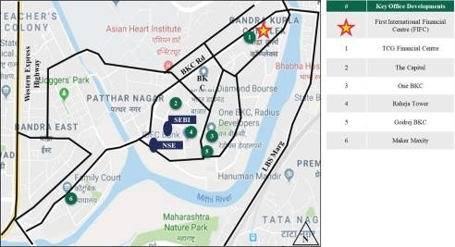Location Map

Key Assumptions

Cap rate – commercial components % 7.75%

|  |  |  |
| --- | --- | --- |
| **Particulars Unit Details**  Revenue assumptions (as on March 31, 2020) | | |
| Lease completion | Year | FY 2022 |
| In-place rent | INR psf/mth | 297^ |
| Marginal rent – Office Component | INR psf/mth | 285 |
| Marginal rent – Retail | INR psf/mth | 314 |
| Parking rent (Effective) | INR / bay/mth | - |
| Other financial assumptions | | |

WACC rate (operational) % 12.03%

*^denotes the weighted average rentals for leased office/retail spaces*

Market Value:

**INR 13,911 Mn**

* 1. Embassy TechZone

Property Name: ‘Embassy TechZone’ is an operational office asset located in Phase 2, Rajiv Gandhi Infotech Park, Hinjewadi, Pune, Maharashtra

Property Address: Plot No. 3/A and Plot No. 3/B, Rajiv Gandhi Infotech Park, Hinjewadi, Phase-II, Village Marunji, Taluka Mulshi, District Pune, Maharashtra

Land Area: Based on review of the title report, the Valuer understands that the total land area of the subject property under the ownership of the Client is approximately 67.45 acres

Brief Description: ‘Embassy TechZone’, has been conceptualized as an office asset spread across a total land area of approximately 67.45 acres. The property is an office asset leased to various tenants and is also well equipped with number of facilities and amenities like food court, amphitheater, intra park shuttles, gymnasium, multilevel car parking, sports ground, etc. The area details of the property are as follows:

|  |  |
| --- | --- |
| ***Particulars*** | ***Leasable area (in sf)*** |
| Completed Leasable Area | 2,160,055 |
| Under Construction/ Proposed Development Leasable Area | 3,312,891 |
| **Total** | **5,472,946** |

Statement of Assets (sf):

*Source: Client Inputs*

‘Embassy TechZone’ is strategically located in Hinjewadi which is a prominent technology hub of Pune city. ‘Embassy TechZone’ is located at a distance of approximately 5 – 6 km from National Highway 48 (Connecting Mumbai – Pune – Bengaluru), 20 – 21 km from Pune CBD (Peth areas), 20 – 21 km from Pune Railway Station and approximately 26 – 27 km from Pune International Airport.

Based on review of various documents (such as rent roll, lease deeds, Architect’s Certificate, etc.), the Valuer understands that ‘Embassy TechZone’ is an operational office asset with approximately 2.2 msf of completed leasable area out of which committed occupancy is approximately 93.9% as on the date of valuation. Further, approximately 0.88 msf is currently under construction and approx. 2.43 mn sft is under planning stage. Table below highlights the leasable area for individual blocks that form part of the subject development:

|  |  |  |  |
| --- | --- | --- | --- |
| **Completed**  **Component Leasable** | | **Under Construction** | **Proposed Development** |
|  | **area (in sf)** | **area (in sf)** | **area (in sf)** |
| SEZ Office | 2,151,630 | 880,615 | 2,392,587 |
| Other ~ Food court, training centre, etc. | 8,425 | - | 39,689 |
| **Total** | **2,160,055** | **880,615** | **2,432,276** |

Source: Rent roll, lease deeds, architect certificate provided by the Client;

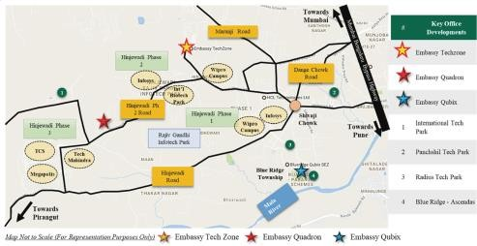Location Map

Key Assumptions

|  |  |  |
| --- | --- | --- |
| **Particulars Unit Details**  Construction assumptions | | |
| Pending cost to complete (overall) | INR mn | 13,692* |
| Proposed project completion timelines | Year | FY 2026 |
| Revenue assumptions (as | on March 31, 2020) |  |
| Lease completion | Year | FY 2027 |
| In-place rent | INR psf/mth | 50 |
| Marginal rent – IT SEZ office component | INR psf/mth | 48 |
| Parking rent (Effective) | INR / bay/mth | 1,500 |
| Other financial a | ssumptions |  |
| Cap rate – commercial components | % | 8.25% |
| WACC rate (operational) | % | 12.03% |
| WACC rate (under-construction/proposed) | % | 13.00% |

*\* Indicative of pending cost towards base build works and does not include the cost for refurbishments/ infrastructure upgrade works*

Market Value: **INR 21,032 Mn**

* 1. Embassy Quadron

Property Name: ‘Embassy Quadron’ is a Commercial Office Business Park located in Phase 2, Rajiv Gandhi Infotech Park, Hinjewadi, Pune, Maharashtra

Property Address: Plot No. 28, Hinjewadi Phase II, Rajiv Gandhi Infotech Park, Pune, Maharashtra, 411057

Land Area: Based on review of the title report, the Valuer understands that the total land area of the subject property under the ownership of the Client is approximately 25.52 acres

Brief Description: ‘Embassy Quadron’, has been conceptualized as an IT SEZ office development leased to various domestic and multi- national IT/ ITeS tenants. The property is well equipped with number of facilities and amenities like enhanced landscapes, Q café food court, grocery stores, ATMs, indoor sports zone, gymnasium, crèche, two-wheeler and four- wheeler car parking spaces, etc. The property has been constructed in phased manner between 2008 to 2011.

The development currently includes four operational buildings (Q1 to Q4).

Further, ‘Embassy Quadron’ is strategically located in Hinjewadi which is a prominent technology hub of Pune city. ‘Embassy Quadron’ is located at a distance of approximately 7 – 8 km from National Highway 48 (connecting Mumbai – Pune – Bengaluru), 22 – 23 km from Pune CBD (Peth areas), 22 – 23 km from Pune Railway Station and approximately 26 - 27 km from Pune International Airport.

Statement of Assets (sf): Based on review of various documents (such as rent roll, Architect’s Certificate, etc.), the Valuer understands that ‘Embassy Quadron’ is an operational SEZ office asset with approximately 1.9 msf of completed leasable area out of which committed occupancy is approximately 79.0% as on the date of valuation. Table below highlights the leasable area for individual blocks that form part of the subject development:

|  |  |  |
| --- | --- | --- |
|  | *Components* | *Completed leasable area (in sf)* |
| Office |  | 1,843,236 |
| Retail |  | 22,887 |
| Food Court |  | 28,551 |
| **Total** |  | **1,894,674** |

Source: Rent roll, lease deeds, architect certificate provided by the Client;

Location Map

Key Assumptions

|  |  |
| --- | --- |
| Particulars Unit Details  Revenue assumptions (as on March 31, 2020) | |
| Lease completion Year | FY 2022 |
| In-place rent INR psf/mth | 43 |
| Marginal rent – IT SEZ office component INR psf/mth | 48 |
| Parking rent (Effective) INR / bay/mth | 1,500 |
| Other financial assumptions |  |
| Cap rate – commercial components % | 8.25% |
| WACC rate (operational) % | 12.03% |

Market Value: **INR 13,838 Mn**

* 1. Embassy Qubix

Property Name: ‘Embassy Qubix’ is a Commercial Office Business Park located in Phase 1, Rajiv Gandhi Infotech Park, Hinjewadi, Pune, Maharashtra

Property Address: Plot No.2, Blue Ridge Township, Near Rajiv Gandhi Infotech Park – Phase I, Hinjewadi, Pune, Maharashtra 411057

Land Area: Based on review of the title report, the Valuer understands that the total land area of the subject property under the ownership of the Client is approximately 25.16 acres

Brief Description: “Embassy Qubix”, has been conceptualized as an IT SEZ office development leased to various domestic and multi- national technology tenants. The property is well equipped with number of facilities and amenities like enhanced landscapes, Q Court Courtyard, grocery stores, ATMs, two-wheeler and four-wheeler car parking spaces, etc. The property has been constructed in phased manner between 2010 to 2012.

The development currently includes six operational buildings (IT 1 to IT 6).

Further, Embassy Qubix is strategically located in Hinjewadi which is a prominent technology hub of Pune city. Embassy Qubix is located at a distance of approximately 3 – 4 km from National Highway 48 (connecting Mumbai

– Pune – Bengaluru), 18 – 19 km from Pune CBD (Peth areas), 19 – 20 km from Pune Railway Station and approximately 23 - 24 km from Pune International Airport.

Statement of Assets (sf):

Based on review of various documents (such as rent roll, Architect’s Certificate, etc.), the Valuer understands that “Embassy Qubix” is an operational SEZ office asset with approximately 1.5 msf of completed leasable area, which is 99.8% occupied as on the date of valuation. Table below highlights the leasable area for individual blocks that form part of the subject development:

**Particular**

**Leasable Area (sf)**

**Committed Occupancy (%)**

Completed Blocks 1,450,494 99.8%

Under Construction Blocks - NA

Proposed Development - NA

**Total 1,450,494**

Source: Rent roll, lease deeds, architect certificate;

Location Map

Key

Assumptions

|  |  |  |
| --- | --- | --- |
| Particulars Unit Details Revenue assumptions (as on March 31, 2020) | | |
| Lease completion | Year | FY 2021 |
| In-place rent | INR psf/mth | 39^ |
| Marginal rent – IT SEZ office component | INR psf/mth | 48 |
| Parking rent (Effective) | INR / bay/mth | 1,500 |
| Other financial ass | umptions |  |

|  |  |  |  |
| --- | --- | --- | --- |
|  | Cap rate – commercial components | % | 8.25% |
| WACC rate (operational) | % | 12.03% |
| Market Value: | *^denotes the weighted average rentals for leased office/retail spaces*  **INR 10,085 Mn** |  |  |

* 1. Embassy Oxygen

Property Name: ‘Embassy Oxygen’ is an operational IT/ ITeS SEZ office development located at Sector 144, Noida, Uttar Pradesh Property Address: Plot No. – 07, Sector 144, Noida, Uttar Pradesh, India

Land Area: Based on review of the title report, the Valuer understands that the total land area of the subject property under the ownership of the Client is approximately 24.83 Acres

Brief Description: The subject property “Embassy Oxygen” is a partly operational office asset, leased to technology occupiers. The subject property is located at Sector 144, Noida in proximity to Noida – Greater Noida Expressway, which is an emerging commercial

/ residential vector of Noida. The property is a two side open plot with accessibility via approximately 45 m and 24 m wide roads. The subject property lies in proximity to various office assets such as Candor TechSpace, Assotech Business Cresterra, Advant Navis Business Park, Stellar 135, Express Trade Towers 2, etc.

The subject property is located in close proximity to Noida – Greater Noida Expressway, which makes it easily accessible from other regions of NCR (National Capital Region) such as Delhi, Greater Noida, etc. Further, it is located at a distance of approximately 16 – 17 km from the established commercial hub of Noida viz. Sector-18, approximately 16 – 17 km from DND Flyway and approximately 38 – 39 km from Indira Gandhi International Airport, Delhi

Statement of Assets (sf):

Based on review of various documents (such as architect certificate, rent roll, lease deeds, etc.), the subject property is an operational SEZ office asset with approximately 2.5 msf of completed leasable area, out of which committed occupancy is approximately 84.0% as on the date of valuation. Table below highlights the leasable area for operational and under construction/ proposed blocks that form part of the subject development:

|  |  |  |
| --- | --- | --- |
| **Particular** | **Leasable Area (sf)** | **Committed Occupancy (%)** |
| Completed Blocks | 2,517,307 | 84.0% |
| Under Construction Blocks | NA | NA |
| Proposed Development | 737,000 | NA |
| **Total** | **3,254,307** |  |

Source: Architect Certificate, Rent roll, lease deeds provided by the Client

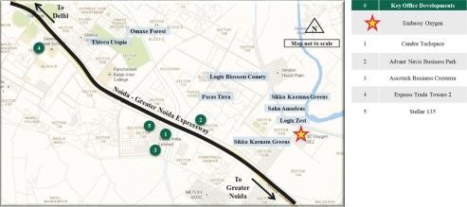Location Map:

Key

|  |  |  |
| --- | --- | --- |
| Particulars | Unit | Details |
|  | Construction assumptions |  |
| Pending cost to complete (overall) | INR mn | 3,273* |
| Proposed project completion timelines (overall) | Quarter, Year | Q2, FY 2023 |
| Revenue | assumptions (as on March 31, 2020) |  |
| Lease completion | Year | FY 2023 |
| In-place rent | INR psf/mth | 48 |
| Marginal rent – IT SEZ office component | INR psf/mth | 54 |
| Parking rent (Effective) | INR / bay/mth | - |
| Other financial assumptions | |  |
| Cap rate | % | 8.25% |
| WACC rate (operational) | % | 12.03% |

Assumptions:

WACC rate (under- construction/proposed)

% 13.00%

*\* Indicative of pending cost towards base build works and does not include the cost for refurbishments/ infrastructure upgrade works*

Market Value: **INR 21,416 Mn**

* 1. Embassy Galaxy

Property

Name: ‘Embassy Galaxy’ is an operational IT/ ITeS office development located at Sector 62, Noida, Uttar Pradesh

Property

Address: A-44 & 45, Sector 62, Noida, Uttar Pradesh, India – 201309

Land Area: Based on review of the title report, the Valuer understands that the total land area of the subject property under the ownership of the Client is approximately 9.88 Acres

Brief Description:

Statement of Assets (sf):

The subject property “Embassy Galaxy” is an operational office asset, leased to technology occupiers. The subject property is located at Sector 62, Noida, which is an established commercial vector of Noida. The property is accessible by an internal road of Sector 62 (approximately 45 m wide). The subject property lies in proximity to various office assets such as 3C Green Boulevard, Stellar IT Park, Logix Cyber Park, Candor Techspace, etc.

The subject property is located in close proximity to National Highway (NH) – 24, which makes it easily accessible from other regions of NCR (National Capital Region) such as Delhi, Ghaziabad, etc. Further, it is located at a distance of approximately 9 – 10 km from the established commercial hub of Noida viz. Sector-18, approximately 10 – 11 km from DND Flyway and approximately 31 – 32 km from Indira Gandhi International Airport, Delhi

Based on review of various documents (such as architect certificate, rent roll, lease deeds, etc.), the subject property is an operational office asset with approximately 1.4 msf of completed leasable area, which is approximately 98.9% leased as on the date of valuation. Table below highlights the leasable area details for the subject development:

|  |  |  |
| --- | --- | --- |
| Particular | Leasable Area (sf) | Committed Occupancy (%) |
| Completed Blocks | 1,357,029 | 98.9% |
| **Total** | **1,357,029** | **98.9%** |

Source: Architect certificate, Rent roll, lease deeds provided by the Client;

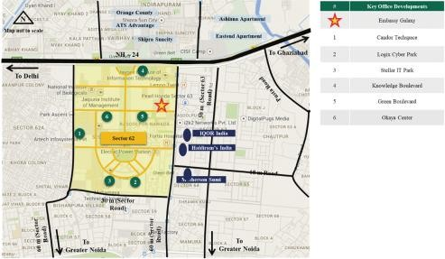Location Map:

Key Assumptions:

|  |  |  |
| --- | --- | --- |
| Particulars Unit Details Revenue assumptions (as on March 31, 2020) | | |
| Lease completion | Year | FY 2021 |
| In-place rent | INR psf/mth | 34 |
| Marginal rent – IT office component | INR psf/mth | 45 |

|  |  |  |
| --- | --- | --- |
| Parking rent (Effective) | INR / bay/mth | - |
|  | Other financial assumptions |  |
| Cap rate | % | 8.25% |
| WACC rate (operational) | % | 12.03% |
| Market Value: **INR 8,696 Mn** |  |  |

* 1. Embassy GolfLinks

Property

Name: Embassy GolfLinks is an office asset located along Intermediate Ring Road, Bengaluru, Karnataka

Property

Address: Challaghatta Village, Varthur Hobli, Mahadevapura, Bengaluru East Taluk, Bengaluru, Karnataka

Land Area: Based on review of the title report, the Valuer understands that the total land area of the subject property under the ownership of the Client is approximately 37.11 acres.

Brief Description:

The subject property, “Embassy GolfLinks”, is an operational office asset located along Intermediate Ring Road, Bengaluru. This office asset has a total leasable area of approximately 4.5 msf. The interest being valued corresponds to approximately 2.7 msf of office area which forms part of the economic interest of the Client. The larger development also includes an operational hotel (Hilton at Embassy GolfLinks). The immediate surroundings of the subject property comprises of large aggregates of land owned by the Defence Services of the Country Karnataka Golf Association’s operational golf course, Diamond District, DivyaSree Greens, Maruthi Infotech Park, etc. In addition, the subject property is located in proximity to locations such as Indiranagar, Koramangala etc., which are considered as established residential and commercial locations within the city.

The subject property is located at a distance of approximately <1 km from the Domlur flyover, 1 – 2 km from Indiranagar, 2-3 km from Koramangala, 7-8 km from MG Road and approximately 43 - 45 km from Bengaluru International Airport.

Statement of Assets (sf):

Based on review of various documents (such as rent roll, Architect’s Certificate, etc.), the subject property is an operational office asset with approximately 2.7 msf of completed leasable area and is 98.3% occupied as on the date of valuation. Table below highlights the leasable area for subject property that form part of the subject development:

**Block Leasable Area (sf)**

Office Area (Operational) 2,737,442 (Occupancy – 98.3%)

Source: Source: Rent roll, lease deeds, architect certificate provided by the Client

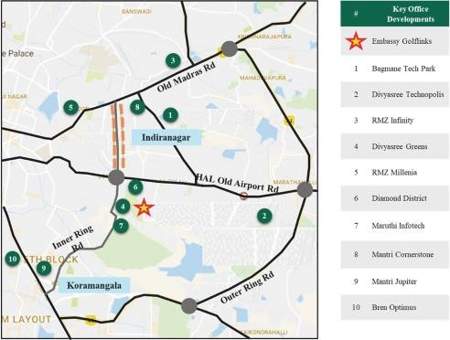Location Map

Key Assumptions

|  |  |  |
| --- | --- | --- |
| Particulars Unit Details  Revenue assumptions (as on March 31, 2020) | | |
| In-place rent | INR psf pm | 115 |
| Marginal rent – office component | INR psf pm | 148 |
| Parking rent (Effective) | INR / bay/mth | 4,500 |
|  | Other financial assumptions |  |
| Cap rate – commercial components | % | 8.00% |
| WACC rate | % | 12.03% |

Market Value: **INR 54,027 Mn**

*Note:*

1. *The valuation presented is for 100% interest in the asset. However, based on inputs provided by the Client, the REIT hold 50% of the interests in the asset (viz. INR 27,014 Mn)*
2. *The above valuation excludes valuation of Hilton at Embassy GolfLinks. The valuation of Hilton at Embassy GolfLinks is presented in section 4.12*
   1. Embassy One

Property Name: ‘Embassy One’ is a premium mixed-used development (High-end office, retail and hospitality components) located along, Bellary Road, Ganga Nagar, Bengaluru, Karnataka

Property Address: Bellary Road, Ganga Nagar, Bengaluru, Karnataka

Land Area: Based on review of the title report, the Valuer understand that the total land area of the subject property under the ownership of the Client is approximately 5.62 acres (which includes residential component). The interest being valued as part of this assessment is an undivided share of 3.19 acres (for the office, retail and hospitality components).

Brief Description: The subject property is a premium mixed-used development comprising of commercial, retail and hospitality components. Subject property is located in a premium location in close proximity to the CBD, approximately 6-7 km from MG Road. The stretch between the CBD and Mekhri Circle is recognized as a premium residential and hospitality hub of Bengaluru. Subject location lies in close proximity to premium residential colonies of Sheshadripuram, Sadashiva Nagar, Dollars colony, Fraser Town, Jayamahal, etc., which house affluent population of businessmen community, ministers, etc. Further, the location is considered an established hub for premium hotels, housing prominent 5 star hotels such as Windsor Manor, Lalit Ashok, & Taj Westend. As per information provided by the client, the Valuer understands that 5.5% of total area is leased as of date of valuation.

The subject property’s location along the initial stretch of Bellary Road further adds to the attractiveness of the development. Bellary Road connects the city centre to the airport and also provides connectivity to all major hubs within Bengaluru City. Further, the subject property’s proximity to the Hebbal Outer Ring Road, connects the subject location to prominent locations such as Yeshwanthpur, KR Puram, Whitefield, Sarjapur Outer ring road, Old Madras road, etc. Further, it is located at a distance of 1-2 km from Mekhri Circle, 3-4 km from Hebbal ORR Junction, 6-7 km from MG Road, 27-28 K from Bengaluru International Airport.

Statement of Assets (sf):

Table below highlights the leasable area for individual blocks that form part of the subject development:

**Block No of Keys/ Leasable Area (sf)**

Office 194,948

Retail 55,148

Hotel (Four Seasons at Embassy One) 230 keys

**Total 230 keys / 250,096**

Source: Architect certificate provided by the Client

Location Map

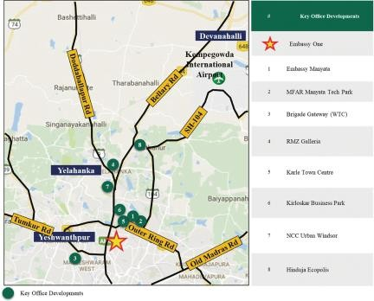

Key Assumptions

|  |  |  |
| --- | --- | --- |
| Particulars Unit Details Revenue assumptions (as on March 31, 2020) | | |
| Lease completion | Year | Q4, FY 2023 |
| In-place rent | INR psf/mth | 156 |
| Marginal rent – Non IT office component | INR psf/mth | 147* |
| Marginal rent – Retail component | INR psf/mth | 170 |
| Parking rent (Effective) | INR / bay/mth | - |
| ARR – Four Seasons at Embassy One | INR / room / day | 10,500 |
| Stabilized Occupancy – Four Seasons at Embassy One | % | 70% |
| Other financial ass | umptions |  |
| Cap rate – commercial components | % | 7.50% |
|  |  | 7.14% |
| Cap rate – hotel components | % | (viz. an EV-EBITDA  multiple of 14) |
| WACC rate (operational) | % | 12.03% |
| WACC rate (hotel) | % | 12.63% |

*\* Inclusive of car park rent*

Market Value: **INR 12,570 Mn**

* 1. Hilton at Embassy GolfLinks

Property Name: Hilton at Embassy GolfLinks is an operational hospitality development as part of a larger office asset ‘Embassy GolfLinks’ located along Intermediate Ring Road, Bengaluru, Karnataka

Property Address: Challaghatta Village, Varthur Hobli, Bengaluru East Taluk, Bengaluru, Karnataka

Land Area: Based on review of the title report, the Valuer understands that the total land area of the subject property under the ownership of the Client is approximately 3.58 acres

Brief Description: The subject property, Hilton at Embassy GolfLinks, is an operational hospitality development located along Intermediate Ring Road, Bengaluru. The interest being valued corresponds to a developed area of 448,156 sf of hotel with 247 keys (operational since March 2014 and operated by Hilton). The immediate surroundings of the subject property comprise of large aggregates of land owned by the Defence Services of the Country Karnataka Golf Association’s operational golf course, Diamond District, DivyaSree Greens, Maruthi Infotech Park, etc. In addition, the subject property is located in proximity to locations such as Indiranagar, Koramangala etc., which are considered as established residential and commercial locations within the city. In addition to the subject property, the micro-market also comprises of other hotels such as The Leela, Taj Vivanta, Hyatt, The Paul, Ramada Encore, etc.

The subject property is located at a distance of approximately <1 km from the Domlur flyover, 1 – 2 km from Indiranagar, 2-3 km from Koramangala, 7-8 km from MG Road and approximately 43 - 45 km from Bengaluru International Airport.

Statement of Assets (sf):

Based on the information provided by the client, the subject property is an operational hospitality development. Table below highlights the total operational area of the subject development:

**Property No of Keys**

Hotel (Hilton at Embassy GolfLinks) 247 keys

(developed area - 448,156 sf)

Location Map

Key Assumptions

Source: Architect certificate provided by the Client

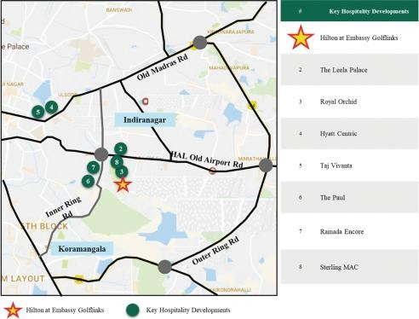

Revenue assumptions (as on March 31, 2020)

Details

Unit

Particulars

ARR – Hilton at Embassy GolfLinks INR / room / day 9,000

Stabilized Occupancy – Hilton at Embassy GolfLinks % 72

Other financial assumptions

7.14%

Cap rate – hotel components %

(viz. an EV-EBITDA multiple of 14)

WACC rate % 12.63%

Market Value: **INR 4,436 Mn**

* 1. Embassy Energy

Property Name: ‘Embassy Energy’ is a Solar PV electricity generation facility spread across Villages Ittigi, Mooregeri and Nellukudure, Bellary District, Karnataka

Property

Address:

Villages Ittigi and Mooregeri in Huvin Hadagali Taluka and Nellukudure in Hagri Bommanhalli Taluka, Bellary District, Karnataka

Land Area: The Valuer understands from the Client, title reports, site plans, letter highlighting Commercial Operations Date and site visit, that the park is spread over 465.77 Acres of which the land aggregation is in place by way of sale deed, Agreement to Sell (ATS) or General Power of Attorney (GPA), etc. The Valuer understands that currently only about 254.47 Acres is owned by the company by way of Sale Deed whereas the rest is under various stages of sale and conversion – below is a table which highlights the current status of the Land Aggregation. Further, the Valuer understands that physical possession of the land is with EEPL and/or its contractors and sub-contractors and that the solar park has been constructed on most of the land. It is assumed that the sale and conversion would be successful and any adverse impact has not been factored in the valuation

|  |  |
| --- | --- |
| **Particular** | **Area (acres)** |
| Total extent of identified Land | 465.77 |
| Registered ATS and POA completed | 465.77 |
| Applied for approval u/s 109 | 464.51 |
| Extent of land approved/recommended by DC u/s 109 | 442.54 |
| Final approval received u/s 109 | 442.54 |
| Sale Deed executed favouring EEPL | 254.47 |

Brief The subject property is an operational solar park under the ownership of **‘Embassy-Energy Private Limited (EEPL)’**. The

Description: subject site is spread across three villages namely Ittigi, Mooregeri and Nellukudure in Bellary District. The subject location is situated at a distance of more than 300 km from Bengaluru City and is currently a nascent vector in terms of real estate activity. Being a peripheral location, the region is predominantly characterized by the presence of agricultural land parcels (with black cotton soil). However, a few solar parks are currently operational/ proposed at the subject location by prominent players such as Adani, ReNew, etc. The accessibility of the subject region is via State Highway – 45 (SH – 45).

On account of being accessible through the State Highway – 45 (SH – 45), the subject property enjoys good connectivity to neighbouring towns and villages. Further, it is located at a distance of approximately 3 – 4 km from the 220 KV Sub-station (Ittigi), approximately 3 – 4 km from Ittigi Village Centre, approximately 65 – 70 km from Davangere and approximately 300 – 310 km from MG Road (Bengaluru).

Based on review of power purchase agreements between EEPL and the power purchasers, the Valuer understands that the solar plant would supply electricity to the existing office parks / hotels of Embassy in Bengaluru. In lieu of the same, it is understood that EEPL has already signed power purchase agreements (PPAs) for 25 years with various entities for commercial and industrial category.

Further, based on the review of various documents provided by the Client, it is understood that EEPL has entered into a project development agreement with IL&FS Solar Power Limited, as per which IL&FS Solar Power Limited would set up the entire solar plant facility including land acquisition, development, design, engineering, procurement, construction, erection, testing and commissioning of the solar park. For the same, IL&FS Solar Power Limited will receive deferred payments from EEPL in equated monthly instalments for 15 years (180 months) from Commercial Operation Date (COD). Additionally, it is also understood that IL&FS Solar Power Limited would undertake the O&M services for the solar park facility for a period of 15 years from COD. For the same, EEPL would pay a lump sum operations and maintenance service fee (during the term of this agreement) to IL&FS Solar Power Limited.

Statement of Assets:

Based on review of various documents (such as deferred payment agreement, project development agreement, commissioning certificates, Government Order, etc.), the solar park has an installed capacity of approximately 130 Mega Watts (MW) DC (output will be 100 MW AC), capable of generating at least 215 Million Units (MU) of electricity by the end of the first 12 months from the date on which it achieves COD and subject to plant stabilization. Table below highlights the details for the subject plant:

Particular Detail

Capacity (MW) (A) 130 MW DC (100 MW AC)

Plant Load Factor (%) (B) 18.88%

Number of hours in a day (C) 24

Days in a year (D) 365

Total units generated (kWH) (A * B * C * D) * 1000 215 Million Units (MU)* in kWH in Year 1 *Source: Various documents/ inputs provided by the Client; * Subject to plant stabilization, however, considering the past performance of the subject plant, the maximum generation has been capped at approx. 200 Million Units (MU) for any given year*

Key Assumptions:

As per the PPAs executed with various entities, the purchasers have agreed to purchase at least 85% of the contracted quantity

**(‘minimum guaranteed offtake’)** each tariff year, commencing from the commercial operation date until the end of the term.

Development Timelines

Details

Unit

Particulars

COD Date 28th February 2018*

Revenue assumptions (as on March 31, 2020)

BESCOM Tariff – Commercial INR per kWH 9.00

BESCOM Tariff – Industrial INR per kWH 7.40

**Blended Tariff INR per kWH 8.76\*\***

Other financial assumptions

Useful Life Years 25 years

Cost of Equity % 13.50%

*\* 40% commenced operations on 23rd January 2018 and balance 60% on 28th February 2018*

*\*\* In proportion of the distribution between commercial and industrial category consumers*

Market Value:

**INR 10,289 Mn (includes debt of INR 6,489 Mn)**

Annexures

Key Assumptions and Value Summary – March’20

|  |  |  |  |  |  |  |  |  |  |  |
| --- | --- | --- | --- | --- | --- | --- | --- | --- | --- | --- |
|  | **Leasable Area (msf)/ Keys/ MW** | | | **Discount Rate** | |  |  | **GAV as of Mar’20 (Rs mm)** | | |
| **Asset** | **Completed** | **Proposed/ U/C** | **Total** | **Completed** | **U/C** | **Cap Rate/ EBITDA**  **Multiple** | **Rent/ ADR/Tariff**  **Rate** | **Completed** | **Proposed/ U/C** | **Total** |
| **Commercial Assets** |  |  |  |  |  |  |  |  |  |  |
| Embassy Manyata | 11.8 | 3.1 | 14.8 | 12.03% | 13.00% | 8.00% | 90 | 129,952 | 20,154 | 150,106 |
| Embassy GolfLinks* | 2.7 | 0.0 | 2.7 | 12.03% | NA | 8.00% | 148 | 27,014 | - | 27,014 |
| Embassy One | 0.3 | 0.0 | 0.3 | 12.03% | NA | 7.50% | 147^ | 4,897 | - | 4,897 |
| Express Towers | 0.5 | 0.0 | 0.5 | 12.03% | NA | 7.50% | 270 | 17,866 | - | 17,866 |
| Embassy 247 | 1.2 | 0.0 | 1.2 | 12.03% | NA | 8.00% | 110^ | 16,624 | - | 16,624 |
| FIFC | 0.4 | 0.0 | 0.4 | 12.03% | NA | 7.75% | 285 | 13,911 | - | 13,911 |
| Embassy TechZone | 2.2 | 3.3 | 5.5 | 12.03% | 13.00% | 8.25% | 48 | 14,929 | 6,103 | 21,032 |
| Embassy Quadron | 1.9 | 0.0 | 1.9 | 12.03% | NA | 8.25% | 48 | 13,838 | - | 13,838 |
| Embassy Qubix | 1.5 | 0.0 | 1.5 | 12.03% | NA | 8.25% | 48 | 10,085 | - | 10,085 |
| Embassy Oxygen | 2.5 | 0.7 | 3.3 | 12.03% | 13.00% | 8.25% | 54 | 19,492 | 1,924 | 21,416 |
| Embassy Galaxy | 1.4 | 0.0 | 1.4 | 12.03% | NA | 8.25% | 45 | 8,696 | - | 8,696 |
| **Sub-Total (Commercial Offices)** | **26.2** | **7.1** | **33.3** |  |  |  |  | **277,304** | **28,181** | **305,485** |
| **Hospitality Asset** |  |  |  |  |  |  |  |  |  |  |
| Hilton at Embassy GolfLinks  Four Seasons at Embassy One | 247 Keys  230 Keys | -  - | 247 Keys  230 Keys | 12.63%  12.63% | NA  NA | 14x  14x | 9,000  10,500 | 4,436  7,673 | -  - | 4,436  7,673 |
| Hilton at Embassy Manyata (5 Star) | - | 266 Keys | 266 Keys | NA | 13.60% | 14x | 8,000 | - | 2,378 | 2,378 |
| Hilton at Embassy Manyata (3 Star) | - | 353 Keys | 353 Keys | NA | 13.60% | 14x | 5,500 | - | 1,422 | 1,422 |
| **Sub-Total (Hospitality)** | **477 Keys** | **619 Keys** | **1096 Keys** |  |  |  |  | **12,109** | **3,800** | **15,909** |
| **Others** |  |  |  |  |  |  |  |  |  |  |
| Embassy Energy | 100MW | - | 100MW | 13.50% | NA | NA | 8.76 | 10,289 | - | 10,289 |
| **Sub-Total (Others)** | **100MW** | **-** | **100MW** |  |  |  |  | **10,289** | **-** | **10,289** |
| **Total** | **26.2 msf/477**  **Keys/100MW** | **7.1 msf/619**  **Keys** | **33.3 msf/1096**  **Keys/100MW** |  |  |  |  | **299,702** | **31,981** | **331,683** |
| **% Split** |  |  |  |  |  |  |  | **90%** | **10%** | **100%** |

*\*Indicative of Embassy REIT’s economic interest in the asset, viz. 50%; ^ Inclusive of car park rent*

Key Assumptions and Value Summary – September’19

|  |  |  |  |  |  |  |  |  |  |  |
| --- | --- | --- | --- | --- | --- | --- | --- | --- | --- | --- |
|  | **Leasable Area (msf)/ Keys/ MW** | | | **Discount Rate** | |  |  | **GAV as of Sep’19 (Rs mm)** | | |
| **Asset** | **Completed** | **Proposed/ U/C** | **Total** | **Completed** | **U/C** | **Cap Rate/ EBITDA**  **Multiple** | **Rent/ ADR/Tariff**  **Rate** | **Completed** | **Proposed/ U/C** | **Total** |
| **Commercial Assets** |  |  |  |  |  |  |  |  |  |  |
| Embassy Manyata | 11.0 | 3.3 | 14.2 | 12.30% | 13.30% | 8.00% | 85 | 113,662 | 22,306 | 135,968 |
| Embassy GolfLinks* | 2.7 | 0.0 | 2.7 | 12.30% | NA | 8.00% | 146 | 26,432 | - | 26,432 |
| Embassy One | 0.3 | 0.0 | 0.3 | 12.30% | NA | 7.50% | 153 | 5,608 | - | 5,608 |
| Express Towers | 0.5 | 0.0 | 0.5 | 12.30% | NA | 7.50% | 275 | 18,590 | - | 18,590 |
| Embassy 247 | 1.2 | 0.0 | 1.2 | 12.30% | NA | 8.00% | 105 | 17,256 | - | 17,256 |
| FIFC | 0.4 | 0.0 | 0.4 | 12.30% | NA | 7.75% | 290 | 14,912 | - | 14,912 |
| Embassy TechZone | 2.2 | 3.3 | 5.5 | 12.30% | 13.30% | 8.25% | 48 | 15,395 | 5,930 | 21,325 |
| Embassy Quadron | 1.9 | 0.0 | 1.9 | 12.30% | NA | 8.25% | 50 | 14,609 | - | 14,609 |
| Embassy Qubix | 1.5 | 0.0 | 1.5 | 12.30% | NA | 8.25% | 48 | 9,962 | - | 9,962 |
| Embassy Oxygen | 1.9 | 1.3 | 3.3 | 12.30% | 13.30% | 8.25% | 54 | 15,107 | 5,550 | 20,657 |
| Embassy Galaxy | 1.4 | 0.0 | 1.4 | 12.30% | NA | 8.25% | 45 | 8,914 | - | 8,914 |
| **Sub-Total (Commercial Offices)** | **24.8** | **7.9** | **32.7** |  |  |  |  | **260,447** | **33,786** | **294,233** |
| **Hospitality Asset** |  |  |  |  |  |  |  |  |  |  |
| Hilton at Embassy GolfLinks  Four Seasons at Embassy One | 247 Keys  230 Keys | -  - | 247 Keys  230 Keys | 12.63%  12.63% | NA  NA | 14x  14x | 8,750  11,200 | 5,045  8,244 | -  - | 5,045  8,244 |
| Hilton at Embassy Manyata (5 Star) | - | 266 Keys | 266 Keys | NA | 13.63% | 14x | 7,500 | - | 2,064 | 2,064 |
| Hilton at Embassy Manyata (3 Star) | - | 353 Keys | 353 Keys | NA | 13.63% | 14x | 5,000 | - | 1,016 | 1,016 |
| **Sub-Total (Hospitality)** | **477 Keys** | **619 Keys** | **1096 Keys** |  |  |  |  | **13,289** | **3,079** | **16,368** |
| **Others** |  |  |  |  |  |  |  |  |  |  |
| Embassy Energy | 100MW | - | 100MW | 13.50% | NA | NA | 8.36 | 10,519 | - | 10,519 |
| **Sub-Total (Others)** | **100MW** | **-** | **100MW** |  |  |  |  | **10,519** | **-** | **10,519** |
| **Total** | **24.8 msf/477**  **Keys/100MW** | **7.9 msf/619**  **Keys** | **32.7 msf/1096**  **Keys/100MW** |  |  |  |  | **284,255** | **36,865** | **321,120** |
| **% Split** |  |  |  |  |  |  |  | **89%** | **11%** | **100%** |

*\*Indicative of Embassy REIT’s economic interest in the asset, viz. 50%*



*ANNEXURE:*

**DETAILED VALUATION REPORT**

# DETAILED VALUATION REPORT



*Issued to:*

# Embassy Office Parks Management Services Private Limited in its capacity as manager of The Embassy Office Parks REIT

### EMBASSY MANYATA, BENGALURU EXPRESS TOWERS, MUMBAI EMBASSY 247, MUMBAI

**FIRST INTERNATIONAL FINANCE CENTRE (FIFC), MUMBAI EMBASSY TECHZONE, PUNE**

**EMBASSY QUADRON, PUNE EMBASSY QUBIX, PUNE EMBASSY OXYGEN, NOIDA EMBASSY GALAXY, NOIDA**

**EMBASSY GOLFLINKS, BENGALURU EMBASSY ONE, BENGALURU**

**HILTON AT EMBASSY GOLFLNKS, BENGALURU EMBASSY ENERGY, BELLARY DISTRICT, KARNATAKA**

##### REF NO: SF-0001016426

**DATE OF VALUATION: MARCH 31, 2020**

**DATE OF REPORT: MAY 19, 2020**

Value Assessment Service Valuer under SEBI (REIT) Regulations, 2014

**Contents**

1. Instruction 14
   1. Purpose 14
   2. Reliant Party 14
   3. Limitation of Liability 15
   4. Scope of Services 15
   5. Valuation Capability 16
   6. Scope of Appraisal 17
   7. Valuer’s Interest 19
   8. Qualifications 19
   9. Disclosures 19
   10. Assumptions, Disclaimers, Limitations & Qualifications to Valuation 21
   11. Material Valuation Uncertainty from Novel Coronavirus 24
2. Valuation Approach & Methodology 26
   1. Scope of Valuation 26
   2. Basis of Valuation 26
   3. Approach and Methodology 26
      1. Direct Comparison Approach 26
      2. Income Approach 27
   4. Approach and Methodology Adopted 31
   5. Information Sources for Valuation 32
3. Embassy REIT Assets at a Glance 36
   1. Key Characteristics 36
   2. Nature of the Interest of the Embassy REIT 39
   3. Capitalization Rate Adopted 40
   4. Discount Rate Adopted 41
      1. Cost of Equity 41
      2. Cost of Debt 41
      3. Weighted Average Cost of Capital (WACC) 42
4. Valuation Certificate 44
   1. Embassy Manyata 44
   2. Express Towers 46
   3. Embassy 247 48
   4. First International Finance Centre (FIFC) 50
   5. Embassy TechZone 52
   6. Embassy Quadron 54
   7. Embassy Qubix 56
   8. Embassy Oxygen 58
   9. Embassy Galaxy 60
   10. Embassy GolfLinks 62
   11. Embassy One 64
   12. Hilton at Golflinks 66
   13. Embassy Energy 68
   14. Value Summary 71
5. Embassy Manyata 73
   1. Property Description 73
      1. Site Details 73
      2. Legal Details 77
      3. Town Planning 77
      4. Statutory Approvals, One time Sanctions & Periodic Clearances 78
      5. Area Details, Type and Age of Existing Structures 79
      6. Site Services and Finishes 81
      7. Condition & Repair 81
      8. Property Photographs 82
   2. Tenancy Analysis 83
      1. Historical Committed Occupancy Rates 83
      2. Lease Expiry Analysis 83
      3. Escalation Analysis 83
   3. Assumptions Rationale 84
      1. Demand and Supply Dynamics 84
      2. Lease Rent Analysis 86
   4. Value Assessment 88
      1. Adopted Methodology 88
      2. Area statement 88
      3. Construction Timelines 89
      4. Absorption/ Leasing Velocity and Occupancy Profile 89
      5. Revenue Assumptions (Office & Retail) 90
      6. Revenue Assumptions - Hotel 93
      7. Expense Assumptions 94
      8. Other Assumptions 97
      9. Capitalization Rates 97
      10. Discount Rate 97
   5. Value of the Subject Property 97
6. **Express Towers** 99
   1. Property Description 99
      1. Site Details 99
      2. Legal Details 102
      3. Town Planning 102
      4. Statutory Approvals, One time Sanctions & Periodic Clearances 103
      5. Area Details, Type and Age of Existing Structures 104
      6. Site Services and Finishes 104
      7. Condition & Repair 104
      8. Property Photographs 105
   2. Tenancy Analysis 106
      1. Historical Committed Occupancy Rates 106
      2. Lease Expiry Analysis 106
      3. Escalation Analysis 106
   3. Assumptions Rationale 106
      1. Demand-Supply Dynamics 107
      2. Lease Rent Analysis 109
   4. Value Assessment 111
      1. Adopted Methodology 111
      2. Area statement 111
      3. Construction Timelines 111
      4. Absorption/ Leasing Velocity and Occupancy Profile 112
      5. Revenue Assumptions (Office) 112
      6. Expense Assumptions 114
      7. Other Assumptions 114
      8. Capitalization Rates 115
      9. Discount Rate 115
   5. Value of the Subject Property 115
7. Embassy 247 116
   1. Property Description 116
      1. Site Details 116
      2. Legal Details 119
      3. Town Planning 119
      4. Statutory Approvals, One time Sanctions & Periodic Clearances 120
      5. Area Details, Type and Age of Existing Structures 121
      6. Construction, Services and Finishes 122
      7. Condition & Repair 122
      8. Property Photographs 123
   2. Tenancy Analysis 124
      1. Historical Committed Occupancy Rates 124
      2. Lease Expiry Analysis 124
      3. Escalation Analysis 124
   3. Assumptions Rationale 124
      1. Demand-Supply Dynamics 125
      2. Lease Rental Analysis 127
   4. Value Assessment 129
      1. Adopted Methodology 129
      2. Area statement 129
      3. Construction Timelines 129
      4. Absorption/ Leasing Velocity and Occupancy Profile 130
      5. Revenue Assumptions (Office) 130
      6. Expense Assumptions 132
      7. Other Assumptions 132
      8. Capitalization Rates 133
      9. Discount Rate 133
   5. Value of the Subject Property 133
8. First International Financial Centre (FIFC) 134
   1. Property Description 134
      1. Site Details 134
      2. Legal Details 137
      3. Town Planning 137
      4. Statutory Approvals, One time Sanctions & Periodic Clearances 138
      5. Area Details, Type and Age of Existing Structures 138
      6. Site Services and Finishes 138
      7. Condition & Repair 139
      8. Property Photographs 139
   2. Tenancy Analysis 140
      1. Historical Committed Occupancy Rates 140
      2. Lease Expiry Analysis 140
      3. Escalation Analysis 140
   3. Assumptions Rationale 140
      1. Demand and Supply Dynamics 141
      2. Lease Rent Analysis 143
   4. Value Assessment 144
      1. Adopted Methodology 144
      2. Area statement 144
      3. Construction/ Refurbishment Timelines 144
      4. Absorption/ Leasing Velocity and Occupancy Profile 145
      5. Revenue Assumptions 145
      6. Expense Assumptions 147
      7. Other Assumptions 147
      8. Capitalization Rates 147
      9. Discount Rate 148
   5. Value of the Subject Property 148
9. Embassy TechZone 149
   1. Property Description 149
      1. Site Details 149
      2. Legal Details 153
      3. Town Planning 153
      4. Statutory Approvals, One Time Sanctions & Periodic Clearances 154
      5. Area Details, Type and Age of Existing Structures 155
      6. Site Services and Finishes 156
      7. Condition & Repair 156
      8. Property Photographs 157
   2. Tenancy Analysis 158
      1. Historical Committed Occupancy Rates 158
      2. Lease Expiry Analysis 158
      3. Escalation Analysis 158
   3. Assumptions Rationale 158
      1. Demand and Supply Dynamics 159
      2. Lease Rent Analysis 161
   4. Value Assessment 163
      1. Adopted Methodology 163
      2. Area statement 163
      3. Construction Timelines 164
      4. Absorption/ Leasing Velocity and Occupancy Profile 164
      5. Revenue Assumptions 166
      6. Expense Assumptions 167
      7. Other Assumptions 169
      8. Capitalization Rates 169
      9. Discount Rate 169
   5. Value of the Subject Property 169
10. Embassy Quadron 170
    1. Property Description 170
       1. Site Details 170
       2. Legal Details 173
       3. Town Planning 173
       4. Statutory Approvals, One Time Sanctions & Periodic Clearances 174
       5. Area Details, Type and Age of Existing Structures 174
       6. Site Services and Finishes 175
       7. Condition & Repair 175
       8. Property Photographs 176
    2. Tenancy Analysis 177
       1. Historical Committed Occupancy Rates 177
       2. Lease Expiry Analysis 177
       3. Escalation Analysis 177
    3. Assumptions Rationale 178
       1. Demand and Supply Dynamics 178
       2. Lease Rental Analysis 180
    4. Value Assessment 182
       1. Adopted Methodology 182
       2. Area statement 182
       3. Construction Timelines 183
       4. Absorption/ Leasing Velocity and Occupancy Profile 183
       5. Revenue Assumptions 183
       6. Expense Assumptions 185
       7. Other Assumptions 185
       8. Capitalization Rates 185
       9. Discount Rate 186
    5. Value of the Subject Property 186
11. Embassy Qubix 187
    1. Property Description 187
       1. Site Details 187
       2. Legal Details 191
       3. Town Planning 191
       4. Statutory Approvals, One Time Sanctions & Periodic Clearances 192
       5. Area Details, Type and Age of Existing Structures 192
       6. Construction, Services and Finishes 193
       7. Condition & Repair 193
       8. Property Photographs 194
    2. Tenancy Analysis 195
       1. Historical Committed Occupancy Rates 195
       2. Lease Expiry Analysis 195
       3. Escalation Analysis 195
    3. Assumptions Rationale 195
       1. Demand and Supply Dynamics 196
       2. Lease Rental Analysis 198
    4. Value Assessment 200
       1. Adopted Methodology 200
       2. Area statement 200
       3. Construction Timelines 201
       4. Absorption/ Leasing Velocity and Occupancy Profile 201
       5. Revenue Assumptions 201
       6. Expense Assumptions 203
       7. Other Assumptions 203
       8. Capitalization Rates 203
       9. Discount Rate 204
    5. Value of the Subject Property 204
12. Embassy Oxygen 205
    1. Property Description 205
       1. Site Details 205
       2. Legal Details 209
       3. Town Planning 209
       4. Statutory Approvals, One Time Sanctions & Periodic Clearances 210
       5. Area Details, Type and Age of Existing Structures 211
       6. Site Services and Finishes 212
       7. Condition & Repair 212
       8. Property Photographs 214
    2. Tenancy Analysis 215
       1. Historical Committed Occupancy Rates 215
       2. Lease Expiry Analysis 215
       3. Escalation Analysis 215
    3. Assumptions Rationale 216
       1. Demand and Supply Dynamics 217
       2. Lease Rent Analysis 219
    4. Value Assessment 221
       1. Adopted Methodology 221
       2. Area statement 221
       3. Construction Timelines 222
       4. Absorption/ Leasing Velocity and Occupancy Profile 222
       5. Revenue Assumptions 222
       6. Expense Assumptions 224
       7. Other Assumptions 225
       8. Capitalization Rates 225
       9. Discount Rate 226
    5. Value of the Subject Property 226
13. Embassy Galaxy 227
    1. Property Description 227
       1. Site Details 227
       2. Legal Details 231
       3. Town Planning 231
       4. Statutory Approvals, One Time Sanctions & Periodic Clearances 232
       5. Area Details, Type and Age of Existing Structures 233
       6. Site Services and Finishes 233
       7. Condition & Repair 234
       8. Property Photographs 235
    2. Tenancy Analysis 236
       1. Historical Committed Occupancy Rates 236
       2. Lease Expiry Analysis 236
       3. Escalation Analysis 236
    3. Assumptions Rationale 236
       1. Demand and Supply Dynamics 237
       2. Lease Rent Analysis 239
    4. Value Assessment 241
       1. Adopted Methodology 241
       2. Area statement 241
       3. Construction Timelines 241
       4. Absorption/ Leasing Velocity and Occupancy Profile 242
       5. Revenue Assumptions 242
       6. Expense Assumptions 243
       7. Other Assumptions 244
       8. Capitalization Rates 244
       9. Discount Rate 244
    5. Value of the Subject Property 245
14. Embassy GolfLinks 246
    1. Property Description 246
       1. Site Details 246
       2. Legal Details 249
       3. Town Planning 249
       4. Statutory Approvals, One Time Sanctions & Periodic Clearances 250
       5. Area Details, Type and Age of Existing Structures 251
       6. Site Services and Finishes 252
       7. Condition & Repair 252
       8. Property Photographs 253
    2. Tenancy Analysis 254
       1. Historical Committed Occupancy Rates 254
       2. Lease Expiry Analysis 254
       3. Escalation Analysis 254
    3. Assumptions Rationale 254
       1. Demand and Supply Dynamics 255
       2. Lease Rent Analysis 257
    4. Value Assessment 259
       1. Adopted Methodology 259
       2. Area statement 259
       3. Construction Timelines 259
       4. Absorption/ Leasing Velocity and Occupancy Profile 260
       5. Revenue Assumptions 260
       6. Expense Assumptions 262
       7. Other Assumptions 263
       8. Capitalization Rates 264
       9. Discount Rate 264
    5. Value of the Subject Property 264
15. Embassy One 265
    1. Property Description 265
       1. Site Details 265
       2. Legal Details 268
       3. Town Planning 268
       4. Statutory Approvals, One Time Sanctions & Periodic Clearances 269
       5. Area Details, Type and Age of Existing Structures 270
       6. Site Services and Finishes 271
       7. Condition & Repair 271
       8. Property Photographs 272
    2. Assumptions Rationale 273
       1. Demand and Supply Dynamics 273
       2. Rent 276
    3. Value Assessment 279
       1. Adopted Methodology 279
       2. Area statement 279
       3. Construction Timelines 280
       4. Absorption/ Leasing Velocity and Occupancy Profile 280
       5. Revenue Assumptions – Office and Retail 280
       6. Revenue Assumptions - Hotel 281
       7. Expense Assumptions 282
       8. Other Assumptions 283
       9. Capitalization Rates 283
       10. Discount Rate 283
    4. Value of the Subject Property 283
16. Hilton at GolfLinks 284
    1. Property Description 284
       1. Site Details 284
       2. Legal Details 287
       3. Town Planning 287
       4. Statutory Approvals, One Time Sanctions & Periodic Clearances 288
       5. Area Details, Type and Age of Existing Structures 288
       6. Site Services and Finishes 288
       7. Condition & Repair 288
       8. Property Photographs 289
    2. Assumptions Rationale 290
       1. Bengaluru Hospitality Segment Overview 290
       2. Sub Market Analysis for Hospitality Segment 290
       3. Historical performance of the subject property 291
    3. Value Assessment 292
       1. Adopted Methodology 292
       2. Area statement 292
       3. Construction Timelines 292
       4. Revenue Assumptions (Hotel) 292
       5. Expense Assumptions 293
       6. Capitalization Rates 294
       7. Discount Rate 294
    4. Value of the Subject Property 294
17. Embassy Energy 295
    1. Asset Description 295
       1. Site Details 295
       2. Legal Details 297
       3. Town Planning 298
       4. Statutory Approvals, One Time Sanctions & Periodic Clearances 299
       5. Solar Power Plant Details 299
       6. Condition & Repair 299
       7. Property Photographs 300
    2. Renewable Energy Policy 301
       1. Indian Solar Industry Overview 301
       2. Karnataka Solar Policy: Highlights 302
    3. Project Details 303
       1. Deferred Payment Agreement between EEPL and IL&FS 303
       2. Operation & Maintenance Agreement between EEPL and IL&FS 304
       3. Executed Power Purchase Agreements (PPAs) 305
    4. Assumptions Rationale 307
       1. Capacity Utilization Factor (CUF) 307
       2. Commercial/Industrial tariff 308
       3. Escalation in tariff 308
       4. Operation & Maintenance (O&M) Expenditure 310
       5. Useful Life 310
       6. Working Capital 311
    5. Value Assessment 312
       1. Adopted Methodology 312
       2. Plant Details 312
       3. Development Timelines 312
       4. Electricity Consumption 313
       5. Revenue Assumptions 313
       6. Expense Assumptions 313
       7. Open Access Charges 314
       8. Other Charges 316
       9. Working Capital Assumptions 316
       10. Cash Flows for EEPL under the Deferred Payment Agreement and O&M Agreement with IL&FS 316
       11. Depreciation Assumptions 317
       12. Taxation Assumptions 317
       13. Useful Life 318
       14. Discount Rate 318
       15. Equity Value of EEPL 318
       16. Enterprise Value of EEPL 318
18. Exhibits and Addendums 320
    1. Other Mandatory Disclosures 320
       1. Details of Material Litigations 320
       2. Details of options or rights of pre-emption and other encumbrances, revenue pendencies and any matters which may affect the property or its value 325
    2. Site Plans 326
       1. Embassy Manyata 326
       2. Express Towers 327
       3. Embassy 247 328
       4. First International Finance Center (FIFC) 329
       5. Embassy TechZone 330
       6. Embassy Quadron 331
       7. Embassy Qubix 332
       8. Embassy Oxygen 333
       9. Embassy Galaxy 334
       10. Embassy GolfLinks 335
       11. Embassy One 336
       12. Hilton at GolfLinks 337
       13. Embassy Energy 338
    3. Statutory Approvals, One time Sanctions & Periodic Clearances 339
    4. Historical Value Summary 347

##### Instruction

Mr. Manish Gupta (Founder and Partner, iVAS Partners) has been instructed by Embassy Office Parks Management Services Private Limited (the ‘Client’, the ‘Instructing Party’) in its capacity as manager of The Embassy Office Parks REIT (Embassy REIT) to advice upon the Market Value (MV) of properties comprising of commercial office real estate assets located across Bengaluru, Pune, Mumbai and Noida as well as affiliated facilities including a solar park, retail spaces and hotels (together herein referred as subject properties across the report).

CBRE has been instructed by the Client to be the ‘Value Assessment Service Provider’ for providing market intelligence to the ‘Valuer’ (Mr. Manish Gupta, Founder and Partner, iVAS Partners) and forecasting cash flows from the respective assets. The Valuer has utilized the market intelligence provided by CBRE and independently reviewed the cash flows to arrive at the Market Value of the respective assets as per the SEBI (REIT) Regulations 2014. Mr. Manish Gupta (Founder and Partner, iVAS Partners) and CBRE are collectively referred to as the Consultants for the purpose of this report.

The details of the subject properties under the purview of this valuation exercise are tabulated below:

|  |  |  |  |
| --- | --- | --- | --- |
|  | | **Development Name** | **Location** |
| Embassy Manyata | Bengaluru |
| Express Towers | Mumbai |
| Embassy 247 | Mumbai |
| First International Finance Centre | Mumbai |
| Embassy TechZone | Pune |
| Embassy Quadron | Pune |
| Embassy Qubix | Pune |
| Embassy Oxygen | Noida |
| Embassy Galaxy | Noida |
| Embassy GolfLinks | Bengaluru |
| Embassy One | Bengaluru |
| Hilton at Embassy GolfLinks | Bengaluru |
| Embassy Energy | Bellary District, Karnataka |
| 1.1 | Purpose |  |  |

The Valuer understands that the valuation is required by the Client for financial and investor reporting purposes to comply with the requirements of Regulation 21 of the SEBI (REIT) Regulations, 2014.

* 1. Reliant Party

Reliant parties to this report shall mean Embassy Office Parks Management Services Private Limited (EOPMSPL), the Embassy Office Parks REIT (“Embassy REIT”) and their Unit Holders and Axis Trustee Services Limited (the Trustee for the Embassy REIT) for the purpose (of the valuation) as highlighted in this report. The auditors would be extended reliance by the ‘Consultants’ but would not extend any liability to them.

The valuation has been prepared strictly and only for the use of the Reliant Party and for the Purpose specifically stated. The instructing party would make all reliant parties aware of the terms and conditions of this agreement under which this exercise is being undertaken and take due acknowledgements to the same effect.

* 1. Limitation of Liability
     + The ‘Consultants’ provide the Services exercising due care and skill, but the ‘Consultants’ do not accept any legal liability arising from negligence or otherwise to any person in relation to possible environmental site contamination or any failure to comply with environmental legislation which may affect the value of the properties. Further, the ‘Consultants’ shall not accept liability for any errors, misstatements, omissions in the Report caused due to false, misleading or incomplete information or documentation provided to the ‘Consultants’ by the Instructing Party.
     + The Consultants’ maximum aggregate liability for claims arising out of or in connection with the Valuation Report, under this contract shall not exceed Indian Rupees 30 mn.
     + In the event that any of the Sponsor, Manager, Trustee, Embassy REIT in connection with the report be subject to any claim (“Claim Parties”) in connection with, arising out of or attributable to the Valuation Report, the Claim Parties will be entitled to require the ‘Consultants’ to be a necessary party/ respondent to such claim and the ‘Consultants’ shall not object to their inclusion as a necessary party/ respondent. If the ‘Consultants’ do not co-operate to be named as a necessary party/ respondent to such claims or co-operate in providing adequate/ successful defense in defending such claims, the Claim Parties jointly or severally will be entitled to initiate a separate claim against the ‘Consultants’ in this regard and the Consultants’ liability shall extend to the value of the claims, losses, penalties, costs and liabilities incurred by the Claim Parties.
     + The Consultants will neither be responsible for any legal due diligence, title search, zoning check, development permissions and physical measurements nor undertake any verification/ validation of the zoning regulations/ development controls etc.
  2. Scope of Services

Services will be provided solely for the benefit and use of the Reliant Party(ies) by the valuer. The report(s) and valuation(s) may not be used for any other purpose other than the expressly intended purpose as mentioned in the report(s). They are not to be used, circulated, quoted or otherwise referred to for any other purpose, nor are they to be filed with or referred to in whole or in part in any document without the prior written consent of the Consultants where such consent shall be given at the absolute, exclusive discretion of the Consultants. Where they are to be used with the Consultants’ written consent, they shall be used only in their entirety and no part shall be used without making reference to the whole report unless otherwise expressly agreed in writing by the Consultants.

Any reliance by any party other than the Reliant Party on the valuation report will be on their own accord. The Consultants do not purport to provide a site or structural survey in respect of the property(ies) to be valued. The Consultants do not purport to be suitably qualified to provide professional advice in respect of building or site contamination. The Reliant Party(ies) should seek independent advice on these issues. The Services are provided on the basis that the Instructing Party has disclosed to the Consultants all information which may affect the Services. All opinions expressed by the Consultants or its employees are subject to the statement of valuation policies and any conditions contained in written valuation report. The Letter of Engagement (LOE) along with amendments sets out the full scope of services that shall be covered by the valuation report.

* 1. Valuation Capability

Valuer under SEBI (REIT) Regulations, 2014: Mr. Manish Gupta, Partner, iVAS Partners

[iVAS Partners](https://www.ivaspartners.co.in/) (Valuer Registration Number: IBBI/RV-E/02/2020/112) delivers reliable and independent valuation (across categories viz. land & building and plant & machinery), advisory and technical due diligence services, that combine professional expertise with comprehensive databases, analytics and market intelligence across various asset classes and locations in India.

Manish Gupta, Partner at iVAS Partners, is a Registered Architect with Council of Architecture (COA) and a member of the Royal Institute of Charted Surveyors (MRICS) and Institution of Valuers (IOV), with over 12 years of experience in the real estate industry. Manish is a seasoned professional with experience in providing real estate valuation services to a wide spectrum of clients including financial institutions, private equity funds, developers, NBFCs, corporate houses, banks, resolution professionals, land owners, etc.

He has worked on variety of valuation, consulting and technical due-diligence assignments for various purposes including investment related due diligence, mortgage/collateral appraisals, financial reporting, listing purposes, IBC led requirements, etc. across a range of asset classes such as residential projects, integrated township developments, hospitality assets, commercial (office and retail) projects, industrial developments, warehousing parks, educational projects, healthcare developments, etc. for both national as well as international clients.

Value Assessment Service Provider: CBRE South Asia Pvt. Ltd.

CBRE Advisory Services India is an integral part of CBRE Global Valuation & Advisory Services team. The Global VAS team comprises of over 1,500 professionals across approximately 280 offices globally and India Advisory Services team comprises of more than 280 professionals.

CBRE Advisory Services India have completed over 80,000 valuation and advisory assignments across varied asset classes spread across 20 states and 300+ cities. CBRE provides quality valuation, risk advisory and consulting services across a range of property types including residential, hospitality, retail, commercial, institutional, Special Economic Zone (SEZ), industrial, etc. CBRE derives global best practices while maintaining the complexities of Indian real estate markets and are ideally positioned to help solve

any valuation related real estate challenge, ranging from single asset valuations to valuation of multi- market and multi-property portfolios.

Our dedicated and experienced professionals provide quality services from 9 offices across India (Delhi, Mumbai, Bengaluru, Chennai, Kolkata, Gurgaon, Hyderabad, Pune and Ahmedabad). Our professionals have a varied qualification base such as Royal Institute of Chartered Surveyors (RICS) or IOV certified valuation professionals, master planners, Architects, MBA, CA, CFA, etc. and this entire multi-faceted experience helps us in achieving our commitment to provide the highest level of professional expertise to our clients.

CBRE Advisory Services India team has substantial experience with several institutional clients including financial institutions, real estate funds, private equity funds, developers, corporates, banks, NBFCs, etc.

* 1. Scope of Appraisal

The appraisal has been undertaken to ascertain the market value of the subject property given the prevalent market conditions. In consideration of the same, a detailed assessment of the site and surroundings has been undertaken with respect to the prevalent activities, change in dynamics impacting the values and the optimal use of the subject property vis-à-vis the surrounding sub market, etc.

Portfolio comprises seven best-in-class office parks and four prime city-center office buildings, hospitality assets and common infrastructure located across different sub markets across Bengaluru, Pune, Mumbai and Noida. The portfolio also includes a Solar Park located in Bellary, Karnataka.

The location, sub market and catchment area for the individual Commercial Offices have been tabulated below:

**Development Name**

**Location**

**Sub Market**

**Catchment Area for the Valuation Exercise**

Embassy Manyata

North Bengaluru Hebbal, Bellary Road Domlur, Inner Ring Road,

Embassy GolfLinks Extended Business District Indira Nagar, CV Raman

Bengaluru

Nagar, Old Madras Road

Initial stretch of Bellary Road

|  |  |  |  |
| --- | --- | --- | --- |
| Embassy One |  | Extended Business District | and prime City Center Offices |
| Embassy TechZone |  | Hinjewadi | Hinjewadi |
| Embassy Qubix | Pune | Hinjewadi | Hinjewadi |
| Embassy Quadron |  | Hinjewadi | Hinjewadi |
| Express Towers |  | Central Business District | Nariman Point |
| First International Finance Centre | Mumbai | Alternate Business District | Bandra Kurla Complex |
| Embassy 247 |  | Peripheral Business District | Vikhroli, Powai, Kanjurmarg |
| Embassy Galaxy |  | Sector 62/ Peripheral Noida | Sector 62 |

Embassy Oxygen

Noida

Noida – Greater Noida Expressway

Noida – Greater Noida Expressway

A detailed assessment of the site and surroundings has been undertaken with respect to the prevalent activities, change in dynamics impacting the values and the optimal use of the respective properties vis-

à-vis their surrounding sub-market, etc. A primary and secondary research exercise has been carried out in the aforementioned catchment areas to ascertain the transaction activity of commercial developments. This has been achieved through interactions with various market players such as developers, real estate brokers, key office tenants, etc.

For the hospitality assets, i.e. Hilton at GolfLinks, Four Seasons at Embassy One and Proposed 5 Star and 3 Star hotels in Embassy Manyata, a primary and secondary research exercise has been carried out in the relevant sub markets to understand and benchmark the performance of competing developments. This has been achieved through interactions with various market players such as developers, key hospitality players, etc.

The Portfolio also includes a high-end retail offering as part of Embassy One. A primary and secondary research exercise has been carried out across other high-end retail developments / offerings across Bengaluru to ascertain the transaction activity of such developments. This has been achieved through interactions with various market players such as developers, real estate brokers, etc.

Scope of Services for Value Assessment Service Provider

CBRE has been engaged by the Instructing Party to provide value assessment services and accordingly, would be responsible for the below scope as part of this exercise.

* + - Provide market intelligence to the Valuer on the following aspects:
      * Economic and Investment Overview
      * India Real Estate Overview
        + IT/ ITES Industry Dynamics
        + Key Office Markets
        + Outlook
      * For cities housing Embassy REIT Assets
        + Key Office Markets
        + General market practices
        + Demand Supply for Key Office Markets & Rental Trends
        + Outlook
    - Review rent roll and forecast cash flows from the respective assets for the Valuer to independently review and work towards assessing the valuation of each Asset

Official Signatory for Value Assessment Service Provider:



Name: Vamshi KK Nakirekanti | MRICS | FIE | FIV | CEng (India)

Designation: Executive Director, Head – Valuation and Advisory Services, India & South East Asia Firm: CBRE South Asia Pvt Ltd

* 1. Valuer’s Interest

The Valuer certifies that; the Valuer does not have a pecuniary interest, financial or otherwise, that could conflict with the proper valuation of the properties (including the parties with whom our Client is dealing, including the lender or selling agent, if any); accepts instructions to value the property only from the instructing party.

* 1. Qualifications

This valuation is prepared in accordance with the Royal Institution of Chartered Surveyors (RICS) Valuation Standards and is in compliance with the International Valuation Standards (IVS).

* 1. Disclosures

The Consultants hereby certify that:

* + - iVAS Partners (Valuer Registration Number: IBBI/RV-E/02/2020/112), represented by Mr. Manish Gupta (hereinafter referred to as the Valuer), is eligible to be appointed as a valuer in terms of Regulation 2(1)(zz) of the Securities and Exchange Board of India (Real Estate Investment Trusts) Regulations, 2014
    - Neither CBRE nor iVAS Partners (represented by Mr. Manish Gupta - Partner, iVAS Partners) are an associate of the instructing party
    - Mr. Manish Gupta, Partner, iVAS Partners (the Valuer) has a minimum of five years of experience in the valuation of real estate
    - The Valuer has not been involved with the acquisition or disposal within the last twelve months of any of the properties valued under this valuation report in the last twelve months
    - The Valuer has adequate and robust internal controls to ensure the integrity of the valuation reports
    - The Valuer has sufficient key personnel with adequate experience and qualification to perform services related to property valuation at all times
    - The Valuer has sufficient financial resources to enable them to conduct their business effectively and meet their liabilities
    - The Valuer has acquainted itself with all laws or regulations relevant to such valuation
    - The valuation of assets undertaken is impartial, true and fair and in accordance with the Securities and Exchange Board of India (Real Estate Investment Trusts) Regulations, 2014
    - The Valuer and any of its employees/ consultants involved in valuation of the REIT assets are not invested in units of the REIT or in the assets being valued till the time such person is designated as valuer of such REIT and not less than 6 months after ceasing to be valuer of the REIT
    - The Valuer has conducted the valuation of the REIT assets with transparency and fairness and shall render, at all times, high standards of service, exercise due diligence, ensure proper care and exercise professional judgement
    - The Valuer has acted with independence, objectivity and impartiality in performing the valuation
    - The Valuer has discharged its duties towards the Embassy REIT in an efficient and competent manner, utilizing its knowledge, skills and experience in best possible way to complete the said assignment
    - The Valuer shall not accept remuneration, in any form, for performing a valuation of the REIT assets from any person other than the Embassy REIT or its authorised representatives.
    - The Valuer shall before accepting any assignment from any related party to the Embassy REIT, shall disclose to the Embassy REIT, any direct or indirect consideration which the valuer may have in respect of such assignment
    - The Valuer shall disclose to the trustee of the Embassy REIT, any pending business transactions, contracts under negotiation and other arrangements with the Instructing Party or any other party whom the Embassy REIT is contracting with and any other factors which may interfere with the Valuer’s ability to give an independent and professional valuation of the property
    - The Valuer shall not make false, misleading or exaggerated claims in order to secure assignments
    - The Valuer shall not provide misleading valuation, either by providing incorrect information or by withholding relevant information
    - The Valuer shall not accept an assignment that includes reporting of the outcome based on predetermined opinions and conclusions required by the Embassy REIT
    - The valuation undertaken by the Valuer abides by international valuation standards
    - The Valuer notes that there are encumbrances, however, no options or pre-emptions rights in relation to the assets based on the title report prepared by King & Partridge, Shardul Amarchand

Mangaldas & Co, Cyril Amarchand Mangaldas, Little & Company, Jayashree Sridhar and Law

Shield (hereinafter collectively referred to as ‘Legal Counsels’)

* 1. Assumptions, Disclaimers, Limitations & Qualifications to Valuation

Valuation Subject to

Change:

* The subject valuation exercise is based on prevailing market dynamics as on the date of valuation and does not take into account any unforeseeable developments which

could impact the same in the future

Our Investigations:

* + - The Consultants are not engaged to carry out all possible investigations in relation to the subject properties. Where in our report the Consultants identify certain limitations to our investigations, this is to enable the reliant party to instruct further investigations where considered appropriate or where the Consultants recommend as necessary prior to reliance. The Consultants are not liable for any loss occasioned by a decision not to conduct further investigations

Assumptions:

* Assumptions are a necessary part of undertaking valuations. The Valuer adopts assumptions for the purpose of providing valuation advice because some matters are not capable of accurate calculation or fall outside the scope of the Valuer’s expertise, or the instructions. The reliant parties accept that the valuation contains certain specific assumptions and acknowledges and accepts the risk that if any of the assumptions adopted in the valuation are incorrect, then this may have an effect on

the valuation

Information Supplied by Others:

* + - The valuations are based on the information provided by the Instructing Party (Embassy Office Parks Management Services Private Limited). The same has been assumed to be correct and has been used for valuation exercise. Where it is stated in the report that another party has supplied information to the ‘Consultants’, this information is believed to be reliable but the ‘Consultants’ can accept no responsibility if this should prove not to be so

Future Matters:

* To the extent that the valuation includes any statement as to a future matter, that statement is provided as an estimate and/or opinion based on the information known to the ‘Consultants’ at the date of this document. The ‘Consultants’ do not warrant

that such statements are accurate or correct

Map and Plans: ▪ Any sketch, plan or map in this report is included to assist reader while visualizing the properties and the Consultants assume no responsibility in connection with such matters

Site Details:

* Based on title due-diligence information provided by the Client, the Valuer

understands that the subject properties are free from any encroachments and are available as on the date of the valuation

Property Title: ▪ For the purpose of this valuation exercise, the Valuer has relied on the Title Reports prepared by the Legal Counsels for each of the properties and has made no further enquiries with the relevant local authorities in this regard. The Valuer understands that the subject properties may have encumbrances, disputes and claims. The Valuer does not have the expertise or the preview to verify the veracity or quantify these encumbrances, disputes or claims. For the purpose of this valuation, the Valuer has assumed that the respective assets have title deeds that are clear and marketable

Environmental Conditions:

* + - The Valuer has assumed that the subject properties are not contaminated and are not adversely affected by any existing or proposed environmental law and any processes which are carried out on the properties are regulated by environmental legislation and are properly licensed by the appropriate authorities

Town Planning: ▪ The current zoning of the subject properties has been adopted on the basis of review of various documents (title deeds) provided by the Instructing Party and the current land use maps for the subject region. The same has been considered for the purpose of this valuation exercise. Further, it has been assumed that the development on the subject properties adheres/ would adhere to the development regulations as prescribed by the relevant authorities. The Valuer has not made any enquiries with the relevant development authorities to validate the legality of the same

Area:

* The total leasable area considered for the purpose of this valuation exercise is based on the rent rolls/ Architect certificate provided by the Instructing Party. It must be noted that the above information has been provided by the Client and has been verified based on the approvals/ layout plans/building plans provided by the Client. However, the Valuer has not undertaken additional verification and physical

measurement for the purpose of this valuation exercise

Condition & Repair:

* + - In the absence of any information to the contrary, the Valuer has assumed that there are no abnormal ground conditions, nor archaeological remains present which might adversely affect the current or future occupation, development or value of the property; the property is free from rot, infestation, structural or latent defect; no currently known deleterious or hazardous materials or suspect techniques will be used in the construction of or subsequent alterations or additions to the property and comments made in the property details do not purport to express an opinion about,

or advice upon, the condition of uninspected parts and should not be taken as making an implied representation or statement about such parts

Not a Structural Survey:

* + The Valuer states that this is a valuation report and not a structural survey

Legal:

* Unless specifically disclosed in the report, the Valuer has not made any allowances

with respect to any existing or proposed local legislation relating to taxation on realization of the sale value of the subject property

Others: ▪ Considering the unorganized nature of real estate markets in India, all comparable evidence (if any) provided in the valuation report has been limited to the basic details such as the area of asset, rate at which transacted, broad location, etc. other specific details would be provided only if the information is available in public domain

Other Assumptions:

* + - Please note that all the factual information such as tenants’ leasable area, lease details such as lease rent, lease commencement and lease end date, lock – in period, escalation terms, etc. pertaining to the subject properties is based on the appropriate relevant documents provided by the Client and the same has been adopted for the purpose of this valuation exercise. While we have reviewed a few lease deeds on a sample basis, the Consultants do not take any responsibility towards authenticity of the rent rolls provided by the Client. Any change in the above information will have an impact on the assessed value and in that case the Valuer will have to relook at the assessed value. The relevant information sources are represented in section 2.5
    - All measurements, areas and ages quoted in our report are approximate
    - We are not advisors with respect to legal tax and regulatory matters for the transaction. No investigation of the respective Special Purpose Vehicles (SPVs) holding the assets’ claim to title of assets has been made for the purpose of this Report and the SPVs’ claim to such rights have been assumed to be valid. No consideration has been given to liens or encumbrances against the assets. Therefore, no responsibility is assumed for matters of a legal nature
    - Kindly note that we have undertaken a quarterly assessment of cash flows for the purpose of the valuations

Limited Inspection:

* + - Due to the outbreak of the Novel Coronavirus (COVID-19), declared by the World Health Organisation as a “Global Pandemic” on the 11th March 2020, it has not been possible to carry out a formal inspection of the properties for the current update. Therefore, as instructed, we have relied on information provided to us by the Client/

as obtained during the previous site visit, such as site photographs, site observations, construction status, etc.

In addition, we have made enquiries through online portals and property databases wherever possible. We have made the critical assumption that the property description within this report, including details such as location, site description, improvements, floor areas, etc., which is based on the information provided and available to us, is accurate, as at the date of valuation. Whilst all attempts to verify this information have been undertaken, the report should be referred back to the Valuer should any details be proven to be incorrect, as at date of valuation.

Additional:

* As per the Letter of Engagement (LOE) signed between the Consultants and the Client dated 14 August 2019, Mr. Manish Gupta of iVAS Partners (vide Valuer Registration Number: IBBI/RV/02/2019/11505) was appointed as the Valuer under REIT Regulations 2014. Subsequently, Mr. Manish Gupta has applied for and received registration of iVAS Partners (Valuer Registration Number: IBBI/RV-E/02/2020/112,

an entity co-founded by Mr. Manish Gupta), and rescinded his individual registration.

* 1. Material Valuation Uncertainty from Novel Coronavirus

The outbreak of the Novel Coronavirus (COVID-19), declared by the World Health Organisation as a “Global Pandemic” on the 11th March 2020, is causing heightened uncertainty in both local and global market conditions. Global financial markets have seen steep declines since late February largely on the back of the pandemic over concerns of trade disruptions and falling demand. Many countries globally have implemented strict travel restrictions and a range of quarantine and “social distancing” measures.

Market activity is being impacted in most sectors. In this environment, we have considered / relooked at various performance parameters and have adopted heuristic/ careful interventions to our projected cashflows based on our view as of this date. As at the valuation date, we consider that we can attach less weight to previous market evidence for comparison purposes, to inform opinions of value. Indeed, the current response to COVID-19 means that we are faced with an unprecedented set of circumstances on which to base a judgement.

Our valuation(s) is / are therefore reported on the basis of ‘material valuation uncertainty’. Consequently, less certainty – and a higher degree of caution – should be attached to our valuation than would normally be the case. Values may change more rapidly and significantly than during standard market conditions. Given the unknown future impact that COVID-19 might have on the real estate market, we recommend that you keep the valuation of these properties under frequent review.

For the avoidance of doubt, the inclusion of the ‘material valuation uncertainty’ declaration above does not mean that the valuation cannot be relied upon. Rather, the declaration has been included to ensure transparency of the fact that – in the current extraordinary circumstances – less certainty can be attached

to the valuation than would otherwise be the case. The material uncertainty clause is to serve as a precaution and does not invalidate the valuation.

##### Valuation Approach & Methodology

* 1. Scope of Valuation

The valuation exercise is aimed at the assessment of the Market Value (MV) of the subject property. In considering the value of the property, we have considered the guidelines laid out in the Appraisal and Valuation Manual published by the Royal Institution of Chartered Surveyors (RICS).

* 1. Basis of Valuation

The valuations have been conducted in accordance with the RICS Valuation – Global Standards 2020 (Red Book Global Incorporating the IVSC International Valuation Standards issued in November 2019, effective from 31 January 2020) and is in compliance with the International Valuation Standards (IVS). The valuation exercise has been undertaken by appropriately qualified Valuer and would be aimed at assessing the Market Value of subject properties.

As per the Valuation and Guidance Notes issued by the Royal Institution of Chartered Surveyors (RICS) the market value is defined as:

*‘The estimated amount for which an asset or liability should exchange on the valuation date between a willing buyer and a willing seller in an arm’s length transaction, after proper marketing and where the parties had each acted knowledgeably, prudently and without compulsion’.*

* 1. Approach and Methodology

The purpose of this valuation exercise is to estimate the Market Value (MV) of the subject properties. Market Value is derived through the following Methodologies:

* + 1. Direct Comparison Approach

In ‘Direct Comparison Approach’, the subject property is compared to similar properties that have actually been sold in an arms-length transaction or are offered for sale (after deducting for value of built- up structure located thereon). The comparable evidence gathered during research is adjusted for premiums and discounts based on property specific attributes to reflect the underlying value of the property.

* + 1. Income Approach

The income approach is based on the premise that value of an income - producing asset is a function of future benefits and income derived from that asset. There are two commonly used methods of the income approach in real estate valuation namely, direct capitalization and discounted cash flow (DCF).

* + - 1. Direct Capitalization Method

Direct capitalization involves capitalizing a ‘normalized’ single - year net income estimated by an appropriate yield. This approach is best utilized with stable revenue producing assets, whereby there is little volatility in the net annual income.

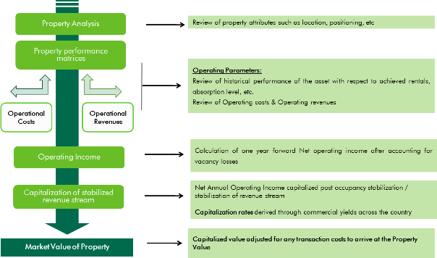

* + - 1. Discounted Cash Flow Method

Using this valuation method, future cash flows from the property are forecasted using precisely stated assumptions. This method allows for the explicit modelling of income associated with the property. These future financial benefits are then discounted to a present day value at an appropriate discount rate. The valuation process and the assumptions for valuation adopted while undertaking the valuation under this approach are detailed overleaf:

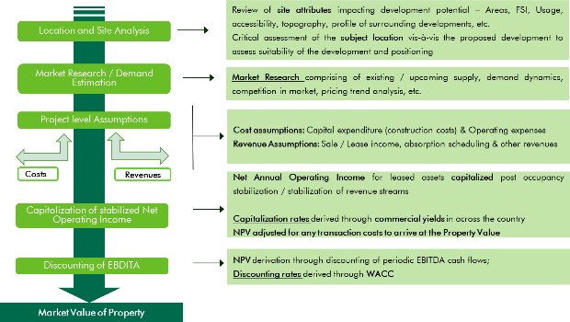

* + - * 1. Discounted Cash Flow Method using Rent Reversion

The market practice in most commercial/ IT developments involves contracting tenants in the form of pre-commitments at sub-market rent to increase attractiveness of the property to prospective tenants – typically extended to anchor tenants. Additionally, there are instances of tenants paying above-market rent for certain properties as well (primarily owing to market conditions at the time of contracting the lease). In order to arrive at a unit value for these tenancies, we have considered the impact of such sub/ above market leases on the valuation of the subject property.

For the purpose of this valuation exercise, we have analysed the tenancy details provided by the Client to identify variances vis-à-vis prevailing marginal rent. In the event the rent is within the threshold (10.0% for Bengaluru/ Mumbai assets & 15.0% for Pune/ Noida assets), we have assumed that the tenant will continue on the current agreed terms. In the event the rent is higher than the marginal rent threshold, we have assumed that the lease would be renegotiated to marginal rent terms (at the time of the lock-in expiry, next escalation, etc.).

For each lease, the following steps have been undertaken to assess the rent over a 10 year time horizon:

Step 1: Project the rent for identified tenancies up to the period of lease expiry, lock-in expiry, first escalation, second escalation, etc. whichever is applicable. In the event of unleased spaces, marginal rent to be adopted with suitable lease-up time

Step 2: Generating a comparable marginal rent based stream for identified tenancies for the time period similar to the cash flows drawn in the aforementioned step

Step 3: In the event the escalated contracted rent is above the marginal rent by threshold highlighted above, the contracted terms are discarded and the terms are reverted to marginal rent. In the event the escalated contracted rent is within the threshold band of the marginal rent, the contracted terms are adopted going forward until the next lease review/ renewal. Intent of this step is to project the rent for respective leases until lease expiry as well as post expiry. Further, in the under-construction developments, the pre-committed rent is compared with the marginal rent to assess the treatment w.r.t. threshold limits

Step 4: Computing the monthly income based on rent projected as part of Step 3 and translating the same to quarterly income (for the next 10 years and 11th year – considered for calculation of terminal value)

Adjustments for other revenues and recurring operational expenses:

Further, to arrive at the total value of the leased spaces (from base rentals), appropriate revenues and operational expenses (as highlighted below) have been projected on quarterly basis.

Parking Income – adopted based on income inputs provided by Client for the leased spaces and market assumption taken for vacant spaces

Security Deposit – adopted based on inputs received from the Client for the leased spaces and market assumption taken for vacant spaces

Miscellaneous Income – adopted based on income inputs provided by Client for the property

Annual Recurring Expense:

Insurance – adopted based on insurance outflow (if any) provided by Client

Annual Lease Rental / Property Taxes – adopted based on annual lease rental / property tax assessed for the property as provided by Client

Repair & Maintenance Reserve – adopted as a recurring expense as a percentage of the lease rental income as a provision for future repairs & maintenance based on market assumptions (only for Embassy Manyata, Embassy GolfLinks and Embassy TechZone)

Asset Management fee - adopted as a recurring expense as a percentage of the rental income

Margin on CAM – For all assets, we have looked at the operational revenues and expenses of the respective assets to understand the recurring, non-recurring, recoverable and non- recoverable expenses and accordingly modelled the common area maintenance income and operational expenses for the asset. For Embassy Manyata, Embassy GolfLinks and Embassy

TechZone, common area maintenance is managed by an external agency and accordingly, no CAM margin has been considered during the course of operations. However, for assessing the exit cash flows, we have assumed that on a notional exit, market-led CAM charges and hence CAM margin would be accruable to a potential buyer and the same has been adopted during capitalization.

Vacancy provision ~ based on the prevailing market benchmarks, vacancy provision is considered for the value assessment of subject property upon exit (the rent frees, CAM under recoveries, brokerage expenses during the 10 year projection period captures the implied rent loss during operations)

Revenue escalation ~ a market-led annual escalation on the market rent has been adopted

Rent – free period ~ based on the trend prevalent in the subject sub market, we consider appropriate rent free periods for the value assessment of the subject property from lease commencement date (for future / new leases)

Brokerage ~ based on prevalent market dynamics, we consider brokerage for future / new leases

The other revenues and recurring operational expenses highlighted above have been capitalized at market-led capitalization rates.

Additional Adjustments:

Fit-out Income ~ adopted based on fit-out rent (if any) provided by Client till lease expiry of applicable leases (same is not capitalized)

Transaction Cost on Exit ~ adopted as a percentage of the terminal value after aforesaid adjustments

The valuation process and the assumptions for valuation adopted while undertaking the valuation under this approach are detailed overleaf:

Location and Site Analysis

Market Research / Demand Estimation

Project level Assumptions

**Costs**

**Revenues**

Comparison of pre-committed rentals with market rentals

Adjustment for rental variance

Adjustment for other income and

expenditure

Capitalization of stabilized Net Operating Income

Discounting of EBDITA

**Net Annual Operating Income** for leased assets **capitalized** post **occupancy stabilization** / stabilization of revenue stream

**Capitalization rates** derived through **commercial yields** in the micro-market

**Adjustments for other income** like parking, CAM margin, property tax, insurance

etc,

Rentals are further **adjusted for variance**, in order to best reflect the earning

potential of the property for the purpose of capitalization

**A comparative analysis** performed to analyze the difference between the pre- committed rentals and market rental

**Market Value of Property**

**NPV** derivation through discounting of periodic EBITDA cash flows;

**Discounting rates** derived through **WACC/ yield plus the growth rate**

**Cost assumptions:** Capital expenditure (construction costs) & Operating expenses

**Revenue Assumptions**: Sale / Lease income, absorption scheduling & other

revenues

**Market Research** comprising of existing / upcoming supply, demand dynamics, competition in market, pricing trend analysis, etc.

Review of **site attributes** impacting development potential

* 1. Approach and Methodology Adopted

Based on a detailed review of the leases for the respective subject properties, we noted that a large number of leases at these properties were executed at rent prevalent at the time of signing of such leases or at a discount to prevailing market rental (for a few anchor tenants). Since the real estate industry is dynamic and is influenced by various factors (such as existing supply, tenants looking at spaces, quality of spaces available in the market, overall health of the economy, existing rent, future growth plans, etc.) at a particular point in time, negotiated rent may tend to move away from the prevalent market rent over a period of time. It has also been witnessed that the market rent for some properties or sub markets increase or decrease at a rate significantly different from those agreed to in initial leases. These factors reinforce the need to review each of these leases in isolation to assess the intrinsic value of the property under review.

Considering the objective of this exercise and the nature of asset involved, the value of the office component in the subject properties has been assessed through the Discounted Cash Flow Method (using rent reversion approach).

Further, the hotel components at the respective properties and the solar park have been valued using Discounted Cash Flow Method.

* 1. Information Sources for Valuation

Table below highlights various data points referred throughout the course of this valuation report and the data sources for the same. Property related documents referred to in the table below have been provided to the Consultants by the Client unless otherwise mentioned. The Consultants have assumed the documents to be a true copy of the original. The rent rolls have been cross-checked with the lease deeds on a sample basis to verify the authenticity.

|  |  |  |  |
| --- | --- | --- | --- |
| Particulars | Details | Units | Source |
|  | Land Area | Acres | Title report prepared by Legal Counsels |
|  | Permissible FSI | Ratio / No. | Architect Certificate |
|  | Achieved FSI | No. | Architect Certificate |
|  | FSI Area | Sf | Architect Certificate |
|  | Built-Up Area | Sf | Architect Certificate |
|  | Leasable Area – Tower Wise | Sf | Architect Certificate |
| **Area Details** | Leasable Area – Future Development | Sf | Architect Certificate |
|  | No. of Floors | No. | Occupancy Certificate |
|  | Stacking Plan | NA | Client/ Lease deeds |
|  | No. of Basements | No. | Architect Certificate/ Sanctioned Plan/ Occupancy Certificate |
|  | Car Parking Area | Sf | Architect Certificate |
|  | Number of car parks | No. | Architect Certificate |
|  | Land Use / Zoning | NA | Title Report/Zoning Plan |
|  | Title Deeds | NA | Title Report |
|  | Approved Sanction Plan | NA | Copy as applicable |
|  | Building Plan / Site Plan | NA | Copy as applicable |
| **Documents/ Approvals** | Floor Plans | NA | Copy as applicable |
|  | Height Clearance Approvals (AAI) | NA | Copy as applicable |
|  | Fire NOC | NA | Copy as applicable |
|  | Environment Clearance | NA | Copy as applicable |
|  | Commencement Certificate | NA | Copy as applicable |

|  |  |  |  |
| --- | --- | --- | --- |
| Particulars | Details | Units | Source |
| **Services Offered**  **Cost Assumptions**  **Exit Assumptions** | Occupancy Certificate  Building Certification Lease Agreements with Tenants  Sample CAM Agreements | NA  NA NA NA | Block-wise occupancy certificate  Client (as applicable) Lease deeds  Client |
| HVAC (Tonnage) Power Back-up  No. of Lifts with capacity  No. of staircase | TR KVA  No.  No. | Client Client Client  Client |
| Pending Construction Cost (if any) Total Budgeted Cost – Land Stage Block  Total Budgeted Cost – Under Construction Block Cost Already Incurred – Under Construction Block Cost towards fit-outs  Cost provisioned towards refurbishment / renovation  Maintenance Charges  Insurance Cost  Property Tax Margin on Maintenance  Asset Management Fee  Brokerage on lease Repair & Maintenance Reserve | INR Mn INR Mn INR Mn INR Mn  INR psf pm / INR Mn INR Mn  INR psf  INR Mn  INR Mn  % of CAM Charges  % of revenues  No. of Months  % of lease revenues | Client Client Client Client Client Client  CAM contract between SPVs holding subject properties & entity undertaking common area maintenance  Insurance premium receipt  Property Tax Demand Notice  Consultants’ Assessment  Agreement between Client and SPVs holding subject properties  Consultants’ Assessment Consultants’ Assessment |
| Capitalization Rate % Valuer Assessment  Quarter of Capitalization Quarter, Year Valuer Assessment | | |

|  |  |  |
| --- | --- | --- |
| Particulars | Details | Units Source |
| **Operational Assumptions** | Discount Rate % Valuer Assessment  Transaction cost on Exit % Valuer Assessment | |
| Leased Area Sf Rent rolls/ Lease agreements  Vacant Area Sf Rent rolls/ Lease agreements  Pre- Committed Area Sf Rent rolls/ Lease agreements  Lease Dates (Start, End, Lock in, Escalation etc.) for MM/DD/YYYY Rent rolls/ Lease existing leases agreements  Rent Achieved INR psf pm Rent rolls/ Lease agreements  Pre-Committed Rent INR psf pm Rent rolls/ Lease agreements  Security Deposit No. of months/ INR Mn Rent rolls/ Lease agreements  Rent rolls / Consultants’  Parking Rent INR per car park per month Assessment/ Lease agreements  Fit-out Rent INR psf pm Rent rolls/ Lease agreements  Miscellaneous Income INR Mn Rent rolls/ Financial Statements  Interest on Security Deposit NA Consultants’ Assessment Market Rent INR psf pm Consultants’ Assessment Reversion Threshold % Consultants’ Assessment  Escalation in Rent / CAM % Consultants’ Assessment  Lease Dates (Start, End, Lock in, Escalation etc.) for MM/DD/YYYY Consultants’ Assessment  vacant area  Lease escalation on Renewal for New/Future Leases % Consultants’ Assessment Security Deposit for New/Future Leases No. of months Consultants’ Assessment CAM Under-recoveries INR psf pm Consultants’ Assessment  Rent Free Period No. of Months Consultants’ Assessment  Brokerage No. of months Consultants’ Assessment | |

|  |  |  |
| --- | --- | --- |
| Particulars | Details | Units Source |
| **Construction Timelines**  **Absorption Timelines (for vacant space)**  **Market assessment and key portfolio characteristics** | Vacancy Provision % Consultants’ Assessment | |
| Construction Commencement Quarter, Year Client / Consultants’  Assessment  Construction Completion Quarter, Year Client / Consultants’  Assessment | |
| Respective spaces in each development Quarter, Year Consultants’ Assessment | |
| Opinions expressed on the scale of portfolio, relative  performance of submarkets, asset quality and Not applicable Consultants’ Assessment  characteristics of assets, etc. | |

##### Embassy REIT Assets at a Glance

* 1. Key Characteristics

*Seven best-in-class office parks and four prime city-center office buildings*

*Affiliated facilities include completed (2)/ proposed hotels (2) and a solar park (100 MW AC)*

*‘High quality assets built to international specifications and standards with best-in-class asset*

Noida

Embassy Galaxy Embassy Oxygen

## *management*

Express Towers FIFC

Embassy 247

(Total Leasable Area – 4.61 Mn sft)

PRESENCE

(Total Leasable Area – 2.02 Mn sft)

|  |  |
| --- | --- |
| **Embassy REIT Assets** | **Number** |
| **Total Leasable Area (msf)** | 33.26 |
| Completed Area (msf) | 26.14 |
| Occupancy (%) | 92.8% |
| Committed Occupancy (%) | 93.5% |
| Number of Hotel Keys |  |
| (including under- | 1,096 |
| construction) |  |

Pune

Mumbai



Embassy TechZone Embassy Qubix Embassy Quadron

(Total Leasable Area – 8.82 Mn sft)

Bengaluru

Embassy Manyata Embassy GolfLinks Hilton at GolfLinks Embassy One

(Total Leasable Area – 17.81 Mn sft) Embassy Energy (Solar park)

|  |  |
| --- | --- |
| **Top 10 Tenants by Gross Rental** | **Share of Gross Rental (%)** |
| IBM | 12.0% |
| Cognizant | 8.9% |
| NTT Data | 4.3% |
| ANSR | 3.4% |
| Cerner | 2.5% |
| PwC | 2.4% |
| Google India | 2.4% |
| NOKIA | 2.2% |
| JP Morgan | 2.0% |
| L&T Infotech | 1.9% |
| **Top 10 tenants share** | 42.0% |

*Source: Rent rolls provided by the Client*

Consultants’ opinion on asset portfolio characteristics:

* In our opinion, considering the portfolio’s scale (upwards of 25 msf), geographical diversity (more than 3 cities) and best-in-class asset quality, Embassy REIT would be amongst the top 3 office developers in India and over 200,000 employees work out of their assets
* In general, the Embassy REIT assets are located in in-fill locations within the best performing submarkets of India’s top office markets of Bengaluru, Pune, Mumbai and Noida. These cities on an average have exhibited strong demographics, house skilled talent pools and have well- developed infrastructure
* Most of the submarkets where Embassy REIT assets are located have exhibited strong market dynamics, robust absorption leading to lower vacancy, high rent growth, etc.
* Based on our understanding, few prominent multinational tenants in the Embassy REIT portfolio have one of their largest operations in India. These occupiers typically prefer to be operating out of parks developed by Grade-A developers across the country including that of Embassy REIT assets
* The assets are developed and managed according to international standards (for Grade-A spaces) – makes them a preferred option in their respective submarkets for both domestic and multinational occupiers
* Average in-place rent across the portfolio is significantly below the marginal rent across most submarkets owing to a combination of long-term nature of existing leases as well as strong growth witnessed in the market rents. This is expected to result in a significantly favourable mark to market upside upon reversion of leases.
* Few of the Embassy REIT assets are amongst the largest in their respective submarkets offering scalability to its occupiers. Replicating the development and success of such large scale office parks are limited by challenges in land acquisition in India along with longer development and marketing timeframe involved in the evolution of such parks
  1. Nature of the Interest of the Embassy REIT

The table below highlights the nature of interest of the Embassy REIT:

|  |  |  |  |
| --- | --- | --- | --- |
| **Development Name** | **Interest Valued** | **Interest Embassy REIT holds** | **Remainder of term in case of Leasehold (approx.)** |
| Embassy Manyata, Bengaluru | Freehold* | 100.0% | NA |
| Express Towers, Mumbai | Freehold | 100.0% | NA |
| Embassy 247, Mumbai | Freehold | 100.0% | NA |
| First International Financial Center (FIFC), Mumbai | Leasehold | 100.0% | 68 Years |
| Embassy TechZone, Pune | Leasehold | 100.0% | 80 Years |
| Embassy Quadron, Pune | Leasehold | 100.0% | 80 Years |
| Embassy Qubix, Pune | Freehold | 100.0% | NA |
| Embassy Oxygen, Noida | Leasehold | 100.0% | 77 Years |
| Embassy Galaxy, Noida | Leasehold | 100.0% | 76 Years |
| Embassy GolfLinks, Bengaluru | Freehold | 50.0% | NA |
| Embassy One, Bengaluru | Freehold | 100.0% | NA |
| Hilton at GolfLinks, Bengaluru | Freehold | 100.0% | NA |
| Embassy Energy, Bellary District, Karnataka | Freehold | 100.0% | NA |

*\*Excluding the M3 block which is being developed on a leasehold land parcel (6.64 Acres)*

* 1. Capitalization Rate Adopted

The capitalization rate adopted for valuing various assets has been based on factors such as:

* historical entry yields (going in cap rates) for yield/ core office asset transactions across various key markets in India which have steadily shown a downward trend over last 7 - 8 years from 10.5- 11.5% to about 7.5% - 8.5% in 2019-2020
* Hotel assets have been observed to transact between an EV/ EBITDA multiple of approximately 11 – 13 historically and over the past few years has improved to an approximately 12 – 14 multiple
* The increased appetite for income producing assets and availability of various modes of finance (real estate credit flows) backing such acquisitions
* The demand supply situation in the respective city and expected dynamics of demand leading supply - given the barriers to entry such as land availability, higher initial cost outlays etc. developers are expected to focus on fully built to suit or semi-speculative projects (with key tenants tied in prior to launch of construction)
* Inflation – inflation (and interest rates) expected to be maintained in check with interventions from regulators in case of severe swings
* Liquidity associated with REIT listed/ public listings (multiplicity of buyers and relatively lower budgets per buyer)

Based on the above highlighted attributes, the following cap rates have been adopted for the purpose of our valuation.

|  |  |
| --- | --- |
| Asset/ Property Name | Particular |
| Embassy Manyata | Office - 8%  Hotel - 7.14% (viz. an EV-EBITDA multiple of 14) |
| Express Towers | 7.5% |
| Embassy 247 | 8% |
| First International Financial Center (FIFC) | 7.75% |
| Embassy TechZone | 8.25% |
| Embassy Quadron | 8.25% |
| Embassy Qubix | 8.25% |
| Embassy Oxygen | 8.25% |
| Embassy Galaxy | 8.25% |
| Embassy GolfLinks | 8% |
| Embassy One | Office and retail – 7.5%  Hotel - 7.14% (viz. an EV-EBITDA multiple of 14) |
| Hilton at GolfLinks | Hotel - 7.14% (viz. an EV-EBITDA multiple of 14) |
| Embassy Energy | Not applicable |

* 1. Discount Rate Adopted

For discounting the cash flows, an appropriate discount rate has been calculated on the basis of

estimated ‘Weighted Average Cost of Capital’ (WACC).

* + 1. Cost of Equity

The Valuer has computed the cost of equity as per the Capital Asset Pricing Model (CAPM), which is derived as follows:

Cost of equity = Risk Free Rate (Rf) + Beta (**β)** * (Market Return (Rm) – Risk Free Rate (Rf))

As mentioned above, the cost of equity computed using CAPM constitutes of the following components:

* Risk free rate (Rf) i.e. long term (10-year) treasury bond rate in India
* Market return (Rm) based on the returns of Broad Based BSE 500 stock index for the past 10 to 15 years
* Computation of ‘Beta (β)’ of key listed realty stocks in India with respect to the Broad Based BSE 500 stock index

The cost of equity adopted for specific projects has been adjusted for market/ project specific risk pertaining to a real estate project such as execution risk (construction status), approval risk, marketing risk, etc. and adjusted for taxation. While the assumptions regarding the quantum of these risks have no quantitative basis, we have adopted them based on our understanding of the market and our opinion on the project performance.

* + 1. Cost of Debt

Completed Blocks

The cost of debt for competed office blocks has been considered based on prevalent Lease Rental Discounting (LRD) rates for Grade A office parks across the Embassy REIT sub-markets.

Under Construction/ Proposed Blocks

For under construction/ proposed blocks, the cost of debt has been considered based on prevalent Construction Finance (CF) rates for Grade A office parks across the Embassy REIT sub-markets.

* + 1. Weighted Average Cost of Capital (WACC)

Completed Blocks

As highlighted earlier, the cost of debt has been assumed based on the prevalent LRD rates while the cost of equity assumed has been adjusted for asset and market specific attributes to reflect the market expectations from an operational Grade A office development. Further, the proportion of debt and equity has been derived considering the prevalent LRD tenures and its contribution in the overall asset value.

Based on above, the following WACC rate has been assumed for completed office blocks at various Embassy REIT assets forming part of the said REIT portfolio:

|  |  |  |
| --- | --- | --- |
| **Particular** | **Proportion** | **Cost WACC** |
| Debt | 45.00% | 9.00% |
| Equity | 55.00% | 12.03%  14.50% |

Under construction/ Proposed Blocks

As highlighted earlier, the cost of debt has been assumed based on the prevalent CF rates. Further, on the base cost of equity assessed for completed blocks, additional risk premium towards construction and marketing has been adopted to arrive at the cost of equity for under construction/ proposed blocks. Additionally, the proportion of debt and equity has been derived considering the leverage extended for construction of Grade A office developments based on industry benchmarks and feedback received from financial institutions.

Based on above, the following WACC rate has been assumed for under construction/ proposed office blocks at various Embassy REIT assets forming part of the said REIT portfolio:

|  |  |  |
| --- | --- | --- |
| **Particular** | **Proportion** | **Cost WACC** |
| Debt | 60.00% | 11.00% |
| Equity | 40.00% | 13.00%  16.00% |

Hotel

For the hotel component at various properties located across Bengaluru, the cost of debt has been considered based on the prevalent lending rates for hospitality assets. Further, the cost of equity has been assessed keeping in purview the historical returns of listed hospitality stocks, duly factoring in the risk premium for the status of development and impact of seasonality in sustaining a stable ARR and occupancy. Additionally, the proportion of debt and equity has been derived considering the leverage extended for hospitality developments based on industry benchmarks and feedback received from financial institutions.

Based on above, the following WACC rate has been assumed for hotel component at various Embassy REIT assets forming part of the said REIT portfolio:

|  |  |  |  |  |
| --- | --- | --- | --- | --- |
| **Asset/ Property Name** | **Particular** | **Proportion** | **Cost** | **WACC** |
| Embassy Manyata, Bengaluru | Debt  Equity | 50.00%  50.00% | 10.50%  14.75% | 13.60%* |
| Hilton at Embassy GolfLinks, Bengaluru | Debt  Equity | 50.00%  50.00% | 10.50%  14.75% | 12.63% |
| Embassy One, Bengaluru | Debt  Equity | 50.00%  50.00% | 10.50%  14.75% | 12.63% |

*\* Additional risk premium adopted towards construction and operations commencement*

The cash flows are assumed to realize evenly during the course of every quarter, hence a mid-quarter discounting convention has been adopted for the purpose of this valuation. Additionally, we have also not factored any cash flows attributable to working capital requirement/expenses for valuation as the same is immaterial.

##### Valuation Certificate

* 1. Embassy Manyata

Property Name: Embassy Manyata is an Office Park located along Outer Ring Road, Nagavara, Bengaluru, Karnataka Property Address: Nagavara Village, Kasaba Hobli, Bangalore North Taluk, Bengaluru District and Rachenahalli and

Thanisandra Villages, Krishnarajapuram Hobli, Bengaluru East Taluk, Bengaluru District, Karnataka

Land Area: Based on review of the title report (for Manyata Promoters Pvt Ltd and M3 Block respectively), we understand that the total land area of the subject property under the ownership of the Client is approximately 121.76 Acres

Brief Description: The subject property is the second largest commercial office asset in India (in terms of scale), largest in Bengaluru and is a landmark in North Bengaluru. The property is accessible through the Nagavara Outer Ring Road emanating from Hebbal. Further, the subject development is strategically located in proximity to micro-markets of Thanisandra & Hennur Road which are amongst the fastest developing vectors in North Bengaluru.

The Nagavara Outer Ring Road, connects the subject location to prominent locations such as Yeshwanthpur, KR Puram, Whitefield, Sarjapur Outer Ring Road, Old Madras road, etc. Further, it is located at a distance of 1-2 km from Nagavara Junction, 3-4 km from Hebbal Junction, 7-8 km from Yelahanka Junction, 11-14 km from MG Road (CBD) and 29-31 km from Kempegowda International Airport

Statement of Assets (sf): Based on physical verification of various documents, we understand that the subject property is an operational Office Park with approximately 11.75 mn sf of completed leasable area with committed occupancy of 97.7% as on the date of valuation. Projects with such large scale of development are typically observed to have longer development lifecycle. Table below highlights the leasable area for individual blocks that form part of the subject development:

**Block**

**Total Area (sf)**

**Operational area (in sf)**

**Under Proposed Construction area (in**

|  |  |  |  |  |
| --- | --- | --- | --- | --- |
|  | | | **area (in sf)** | **sf)** |
| SEZ Area | 10,650,357 | 8,347,511 | 1,594,846 | 708,000 |
| Non – SEZ Area | 4,111,213 | 3,403,663 | - | 707,550 |
| Retail | 58,083 | - | 58,083 |  |
| Total – Office/ Retail | 14,819,653 | 11,751,174 | 1,652,929 | 1,415,550 |

Hotel (including convention

centre)

619 keys

(Hotel - 722,678 -

Convention – 58,000)

619 keys

(Hotel - 722,678

Convention –

58,000)

Source: Architect certificates, rent roll, lease deeds; Note – office & retail refers to leasable area while hotel & convention refers to developable area

Valuation Approaches:

|  |  |  |
| --- | --- | --- |
| **Valuation Approach** | **Completed Blocks** | **Under Construction/ Land Stage Blocks** |
| **Office/Retail Component**  **Other Components –**  **Hotel, Convention, etc.** | Discounted Cash Flow Method (using rent reversion approach) | Discounted Cash Flow Method (using rent reversion approach) |
| NA | Discounted Cash Flow Method |

Date of Valuation: March 31, 2020

Date of Inspection: Not Applicable. Due to the outbreak of Novel Coronavirus (COVID-19), declared by the World health Organisation as a “Global Pandemic” on 11th March 2020, it has not been possible to carry out a formal inspection of the property for the current update. The site observation, details and pictures are as per the previous site visit undertaken/ as provided by the Client

Purchase Price for the property:

The said acquisition was undertaken as part of the ‘Formation Transaction’ as described in the Final

Offer Document dated 27th March 2019

Ready Reckoner Rate (as per documents published by State Government):

Value Conclusion as of March 31, 2020:

Assumptions, Disclaimers, Limitations & Qualifications

Land Rate: INR 86,000 per sqm Built-up Rate: INR 74,000 per sqm

|  |  |
| --- | --- |
| **Component** | **Market Value (INR Mn)** |
| Completed Area | 129,952 |
| Under Construction/Proposed Blocks | 20,154 |
| Hotel (proposed) | 3,800 |
| Total Value of the property | 153,906 |

This valuation report is provided subject to assumptions, disclaimers, limitations and qualifications detailed throughout this report which are made in conjunction with those included within the Assumptions, Disclaimers, Limitations & Qualifications section located within this report. Reliance on this report and extension of our liability is conditional upon the reader’s acknowledgement and understanding of these statements. This valuation is for the use of the party to whom it is addressed and for no other purpose. No responsibility is accepted to any third party who may use or rely on the whole or any part of the content of this valuation. The valuer has no pecuniary interest that would conflict with the proper valuation of the property.

* 1. Express Towers

Property Name: ‘Express Towers’ is an operational city centre office located along Barrister Rajni Patel Marg, Nariman Point, Mumbai

Property Address: Plot No. 236, Block-III of Backbay Reclamation Estate, Barrister Rajni Patel Marg, Nariman Point, Mumbai

Land Area: Based on review of the title report, we understand that the total land area of the subject property under the ownership of the Client is approximately 1.46 acres

Brief Description: The subject property ‘Express Towers’ is a city centre office situated in Nariman Point. The B+G+25 storey structure which was completed in the early 1970s has been refurbished in the past few years. Nariman Point is located at the southern tip of the Mumbai City, at approximately 1 - 2 km from the Churchgate Railway Station and approximately 25 – 28 km from the Domestic / International City Airport terminal.

Statement of Assets (sf):

Valuation Approaches:

Based on review of various documents (such as rent roll, Architect’s Certificate etc.), the subject property is an operational city centre office with approximately 472,377 sf of completed leasable area out of which approximately 441,851 sf is leased as on the date of valuation. Also, the top 2 floors viz the 24th and 25th floor are not owned by the Client. Table below highlights the leasable area details for the subject development under the ownership of the Client.

|  |  |  |
| --- | --- | --- |
| **Particular** | **Leasable Area (sf)** | **Committed Occupancy (%)** |
| Completed Blocks | 472,377 | 93.5% |
| Under Construction Blocks | - | NA |
| Proposed Blocks | - | NA |
| Total | 472,377 |  |

*Source: Architect certificate, Rent-roll, lease deeds*

|  |  |
| --- | --- |
| **Valuation Approach Completed Blocks** | |
| **Office Component** | Discounted Cash Flow Method (using rent reversion approach) |

Date of Valuation: March 31, 2020

Date of Inspection: Not Applicable. Due to the outbreak of Novel Coronavirus (COVID-19), declared by the World health Organisation as a “Global Pandemic” on 11th March 2020, it has not been possible to carry out a formal inspection of the property for the current update. The site observation, details and pictures are as per the previous site visit undertaken/ as provided by the Client

Purchase Price for the property:

The said acquisition was undertaken as part of the ‘Formation Transaction’ as described in the Final Offer

Document dated 27th March 2019

Ready Reckoner Rate (as per documents published by State Government):

Land Rate: INR 192,200 per sqm; Built-up Rate: INR 518,000 per sqm

Value Conclusion as of March 31, 2020:

Express Towers 17,866

**Component Market Value (INR Mn)**

Total Value of the property 17,866

Assumptions, Disclaimers, Limitations & Qualifications

This valuation report is provided subject to assumptions, disclaimers, limitations and qualifications detailed throughout this report which are made in conjunction with those included within the Assumptions, Disclaimers, Limitations & Qualifications section located within this report. Reliance on this report and extension of our liability is conditional upon the reader’s acknowledgement and understanding of these statements. This valuation is for the use of the party to whom it is addressed and for no other purpose. No responsibility is accepted to any third party who may use or rely on the whole or any part of the content of this valuation. The valuer has no pecuniary interest that would conflict with the proper valuation of the property.

* 1. Embassy 247

Property Name: ‘Embassy 247’ is an operational office located along LBS Road, Vikhroli West, Mumbai Property Address: LBS Road, Vikhroli (W), Mumbai, Maharashtra.

Land Area: Based on review of the title report, we understand that the total land area of the subject property under the ownership of the Client is approximately 7.27 acres

Brief Description: The subject property ‘Embassy 247’ is an operational office located along LBS Road in Vikhroli west, Mumbai. The development is divided in three towers viz. A, B & C. The towers A & C are identical to each other and have an elevation of 2 Basement + Ground + 11 upper floors. Tower B situated in between Tower A & C has an elevation of 2 Basement + Ground + 14 upper floors. Based on the site visit, it is understood that all the three towers are internally connected from basement to the 3rd floor and floors 10 and 11. The entire development has a total completed leasable area of approximately 1,189,544 sf. The subject property is in proximity to established residential and commercial locations within the city such as Powai, Vikhroli and Kanjurmarg etc.

The subject property is located at approximately 28-30 km from the Central Business District of Mumbai (viz. Nariman Point), approximately 11-12 km from Domestic Airport terminal, approximately 10-12 km from the Chhatrapati Shivaji International Terminal.

Statement of Assets (sf):

Based on information provided by the Client, the total completed leasable area considered for the purpose of this valuation is 1,189,544 sf. Table below highlights the leasable area details for the subject development:

**Particular Leasable Area (sf) Committed Occupancy (%)**

Valuation Approaches:

Completed Blocks 1,189,544 93.2%

Under Construction Blocks - NA

Proposed Blocks - NA Total 1,189,544

*Source: Architect certificate, Rent roll, lease deeds*

|  |  |
| --- | --- |
| **Valuation Approach Completed Blocks** | |
| **Office Component** | Discounted Cash Flow Method (using rent reversion approach) |

Date of Valuation: March 31, 2020

Date of Inspection: Not Applicable. Due to the outbreak of Novel Coronavirus (COVID-19), declared by the World health Organisation as a “Global Pandemic” on 11th March 2020, it has not been possible to carry out a formal inspection of the property for the current update. The site observation, details and pictures are as per the previous site visit undertaken/ as provided by the Client

Purchase Price for the property:

The said acquisition was undertaken as part of the ‘Formation Transaction’ as described in the Final Offer

Document dated 27th March 2019

Ready Reckoner Rate (as per documents

Land Rate: INR 85,900 per sqm; Built-up Rate: INR 188,000 per sqm

published by State Government):

Value Conclusion as of March 31, 2020:

Embassy 247 16,624

**Component Market Value (INR Mn)**

Total Value of the property 16,624

Assumptions, Disclaimers, Limitations & Qualifications

This valuation report is provided subject to assumptions, disclaimers, limitations and qualifications detailed throughout this report which are made in conjunction with those included within the Assumptions, Disclaimers, Limitations & Qualifications section located within this report. Reliance on this report and extension of our liability is conditional upon the reader’s acknowledgement and understanding of these statements. This valuation is for the use of the party to whom it is addressed and for no other purpose. No responsibility is accepted to any third party who may use or rely on the whole or any part of the content of this valuation. The valuer has no pecuniary interest that would conflict with the proper valuation of the property.

* 1. First International Finance Centre (FIFC)

Property Name: First International Finance Centre is an operational office located along Bandra Kurla Complex Road, Bandra Kurla Complex, Mumbai, Maharashtra

Property Address: G-Block, BKC Road, Bandra Kurla Complex, Mumbai, Maharashtra

Land Area: Based on review of the title report, we understand that the total land area of the subject property under the ownership of the Client is approximately 1.99 Acres

Brief Description: The subject property, ‘First International Finance Centre’ is an operational office located along BKC Road in G Block, Bandra Kurla Complex, Mumbai. The subject development has a total leasable area of approximately 658,390 sf. The development is operated as a condominium and is co-owned by two entities viz. a leading bank and the Client. Based on review of the title report for the subject property, the Client has an ownership of approximately 360,947 sf of the total leasable area and the same has been considered for the purpose for this valuation exercise (this area will be considered as the subject property hereinafter). The subject property is in proximity to locations such as Kurla, Bandra West, Santacruz etc., which are considered as established residential and commercial locations within the city.

The subject property is located approximately 20-22 km from the Central Business District (CBD) of Mumbai, approximately 6-8 km from Domestic Airport Terminal, approximately 8-9 km from the International Airport Terminal, Mumbai

Statement of Assets (sf):

Valuation Approaches:

Based on review of various documents (such as rent roll, Architect’s Certificate, lease deeds, etc.), the subject property is an operational office asset with approximately 360,947 sf of completed leasable area out of which approximately 77.8% is leased as on the date of valuation. Table below highlights the leasable area details for the subject development:

|  |  |  |
| --- | --- | --- |
| **Particular** | **Leasable Area (sf)** | **Committed Occupancy (%)** |
| Completed Blocks | 360,947 | 77.8% |
| Under Construction Blocks | NA | NA |
| Proposed Blocks | NA | NA |
| Total | 360,947 |  |

*Source: Architect certificate, Rent Roll, lease deeds*

|  |  |
| --- | --- |
| **Valuation Approach Completed Blocks** | |
| **Office Component** | Discounted Cash Flow Method (using rental reversion approach) |

Date of Valuation: March 31, 2020

Date of Inspection: Not Applicable. Due to the outbreak of Novel Coronavirus (COVID-19), declared by the World health Organisation as a “Global Pandemic” on 11th March 2020, it has not been possible to carry out a formal inspection of the property for the current update. The site observation, details and pictures are as per the previous site visit undertaken/ as provided by the Client

Purchase Price for the property:

The said acquisition was undertaken as part of the ‘Formation Transaction’ as described in the Final Offer Document dated 27th March 2019

Ready Reckoner Rate (as per documents published by State Government):

Value Conclusion as of March 31, 2020:

Land Rate: INR 179,200 per sqm; Built-up Rate: INR 336,300 per sqm

**Component Market Value (INR mn)**

First International Financial Centre 13,911

Total Value of the property 13,911

Assumptions, Disclaimers, Limitations & Qualifications

This valuation report is provided subject to assumptions, disclaimers, limitations and qualifications detailed throughout this report which are made in conjunction with those included within the Assumptions, Disclaimers, Limitations & Qualifications section located within this report. Reliance on this report and extension of our liability is conditional upon the reader’s acknowledgement and understanding of these statements. This valuation is for the use of the party to whom it is addressed and for no other purpose. No responsibility is accepted to any third party who may use or rely overall or any part of the content of this valuation. The valuer has no pecuniary interest that would conflict with the proper valuation of the property.

* 1. Embassy TechZone

Property Name: ‘Embassy TechZone’ is an office park located in Phase 2, Rajiv Gandhi Infotech Park, Hinjewadi, Pune, Maharashtra

Property Address: Plot No. 3/A and Plot No. 3/B, Rajiv Gandhi Infotech Park, Hinjewadi, Phase-II, Village Marunji, Taluka Mulshi, District Pune, Maharashtra

Land Area: Based on review of the title report, we understand that the total land area of the subject property under the ownership of the Client is approximately 67.45 acres

Brief Description: ‘Embassy TechZone’, has been conceptualized as an office park spread across a total land area of approximately 67.45 acres. The property is an operational IT office park leased to various tenants and is also well equipped with number of facilities and amenities like food court, amphitheatre, intra park shuttles, gymnasium, multilevel car parking, sports ground, etc. The area details of the property are as follows:

|  |  |
| --- | --- |
| ***Particulars*** | ***Leasable area (in sf)*** |
| Completed Leasable Area | 2,160,055 |
| Under-Construction Leasable Area | 880,615 |
| Proposed Leasable Area | 2,432,276 |
| Total | 5,472,946 |

*Source: Client Inputs*

‘Embassy TechZone’ is strategically located in Hinjewadi which is a prominent commercial technology hub of Pune city. ‘Embassy TechZone’ is located at a distance of approximately 5 – 6 km from National Highway 48 (Connecting Mumbai – Pune – Bengaluru), 20 – 21 km from Pune CBD (Peth areas), 20 – 21 km from Pune Railway Station and approximately 26 - 27 km from Pune International Airport.

Statement of Assets (sf):

Based on review of various documents (such as rent roll, Architect’s Certificate, etc.), we understand that ‘Embassy TechZone’ is an operational technology office park with approximately 2.16 msf of completed leasable area out of which approximately 93.9% is leased as on the date of valuation. Further, approximately

2.43 msf is currently under planning stage and approximately 0.88 msf is under construction as on date of valuation. Table below highlights the leasable area for individual blocks that form part of the subject development:

|  |  |  |  |
| --- | --- | --- | --- |
| **Component** | **Completed Leasable area (in sf)** | **Under Construction area (in sf)** | **Proposed Development area (in sf)** |
| Office | 2,151,630 | 880,615 | 2,392,587 |
| Other ~ Food court, training centre, etc. | 8,425 | - | 39,689 |
| Total | 2,160,055 | 880,615 | 2,432,276 |

Source: Rent roll, lease deeds, architect certificate provided by the Client

Valuation Approaches:

|  |  |  |
| --- | --- | --- |
| **Valuation Approach** | **Completed Blocks** | **Under Construction/ Proposed Blocks** |
| **Office Component** | Discounted Cash Flow Method (using rent reversion approach) | Discounted Cash Flow Method (using rent reversion approach) |

Date of Valuation: March 31, 2020

Date of Inspection: Not Applicable. Due to the outbreak of Novel Coronavirus (COVID-19), declared by the World health Organisation as a “Global Pandemic” on 11th March 2020, it has not been possible to carry out a formal inspection of the property for the current update. The site observation, details and pictures are as per the previous site visit undertaken/ as provided by the Client

Purchase Price for the property:

The said acquisition was undertaken as part of the ‘Formation Transaction’ as described in the Final Offer

Document dated 27th March 2019

Ready Reckoner Rate (as per documents published by State Government):

Value Conclusion as of March 31, 2020:

Assumptions, Disclaimers, Limitations & Qualifications

Land Rate: INR 17,760 per sqm Built-up Rate: INR 24,200 per sqm

|  |  |
| --- | --- |
| **Component** | **Market Value (INR Mn)** |
| Completed Blocks | 14,929 |
| Under Construction/ Proposed Blocks | 6,103 |
| Total Value of the property | **21,032** |

This valuation report is provided subject to assumptions, disclaimers, limitations and qualifications detailed throughout this report which are made in conjunction with those included within the Assumptions, Disclaimers, Limitations & Qualifications section located within this report. Reliance on this report and extension of our liability is conditional upon the reader’s acknowledgement and understanding of these statements. This valuation is for the use of the party to whom it is addressed and for no other purpose. No responsibility is accepted to any third party who may use or rely on the whole or any part of the content of this valuation. The valuer has no pecuniary interest that would conflict with the proper valuation of the property

* 1. Embassy Quadron

Property Name: ‘Embassy Quadron’ is an office park located in Phase 2, Rajiv Gandhi Infotech Park, Hinjewadi, Pune, Maharashtra

Property Address: Plot No. 28, Hinjewadi Phase II, Rajiv Gandhi Infotech Park, Pune, Maharashtra, 411057

Land Area: Based on review of the title report, we understand that the total land area of the subject property under the ownership of the Client is approximately 25.52 acres

Brief Description: ‘Embassy Quadron’, has been conceptualized as an IT SEZ office park leased to various domestic and multi- national IT/ ITeS tenants. The property is a high-quality office park, well equipped with number of facilities and amenities like enhanced landscapes, state of the art 2,000+ seater food court, ATMs, indoor sports zone, gymnasium, crèche, two-wheeler and four-wheeler car parking spaces, etc. The property has been constructed in phased manner between 2008 to 2011.

The development currently includes four operational buildings vis. Q1 to Q4.

Further, ‘Embassy Quadron’ is strategically located in Hinjewadi which is a prominent commercial technology hub of Pune city. ‘Embassy Quadron’ is located at a distance of approximately 7 – 8 km from National Highway 48 (connecting Mumbai – Pune – Bengaluru), 22 – 23 km from Pune CBD (Peth areas), 22 – 23 km from Pune Railway Station and approximately 26 - 27 km from Pune International Airport.

Statement of Assets (sft):

Based on review of various documents (such as rent roll, Architect’s Certificate, etc.), we understand that ‘Embassy Quadron’ is an operational SEZ office asset with approximately 1.9 mn sft of completed leasable area out of which committed occupancy is approximately 79.0% as on the date of valuation. Table below highlights the leasable area for individual blocks that form part of the subject development:

|  |  |
| --- | --- |
| ***Components*** | ***Completed leasable area (in sft)*** |
| Office space | 1,843,236 |
| Retail | 22,887 |
| Food Court | 28,551 |
| Total | 1,894,674 |

Source: Rent roll, lease deeds, architect certificate provided by the Client;

Valuation Approaches:

|  |  |
| --- | --- |
| **Valuation Approach Completed Blocks** | |
| **Office Component** | Discounted Cash Flow Method (using rental reversion approach) |

Date of Valuation: March 31, 2020

Date of Inspection: Not Applicable. Due to the outbreak of Novel Coronavirus (COVID-19), declared by the World health Organisation as a “Global Pandemic” on 11th March 2020, it has not been possible to carry out a formal inspection of the property for the current update. The site observation, details and pictures are as per the previous site visit undertaken/ as provided by the Client

Purchase Price for the property:

The said acquisition was undertaken as part of the ‘Formation Transaction’ as described in the Final Offer

Document dated 27th March 2019

Ready Reckoner Rate (as per documents published by State Government):

Value Conclusion as of March 31, 2020:

Land Rate: INR 17,760 per sqm Built-up Rate: INR 24,200 per sqm

**Component Market Value (INR Mn)**

Embassy Quadron 13,838

Total Value of the property 13,838

Assumptions, Disclaimers, Limitations & Qualifications

This valuation report is provided subject to assumptions, disclaimers, limitations and qualifications detailed throughout this report which are made in conjunction with those included within the Assumptions, Disclaimers, Limitations & Qualifications section located within this report. Reliance on this report and extension of our liability is conditional upon the reader’s acknowledgement and understanding of these statements. This valuation is for the use of the party to whom it is addressed and for no other purpose. No responsibility is accepted to any third party who may use or rely on the whole or any part of the content of this valuation. The valuer has no pecuniary interest that would conflict with the proper valuation of the property.

* 1. Embassy Qubix

Property Name: ‘Embassy Qubix’ is an office park located in Phase 1, Rajiv Gandhi Infotech Park, Hinjewadi, Pune, Maharashtra

Property Address: Plot No.2, Blue Ridge Township, Near Rajiv Gandhi Infotech Park – Phase I, Hinjewadi, Pune, Maharashtra 411057

Land Area: Based on review of the title report, we understand that the total land area of the subject property under the ownership of the Client is approximately 25.16 acres

Brief Description: “Embassy Qubix”, has been conceptualized as an IT SEZ office park leased to various domestic and multi- national IT/ ITeS tenants. The property is well equipped with number of facilities and amenities like enhanced landscapes, Q Court Courtyard, grocery stores, ATMs, two-wheeler and four-wheeler car parking spaces, etc. The property has been constructed in phased manner between 2010 to 2012.

The development currently includes six operational buildings (IT 1 to IT 6).

Further, Embassy Qubix is strategically located in Hinjewadi which is a prominent commercial (IT/ITeS) hub of Pune city. Embassy Qubix is located at a distance of approximately 3 – 4 km from National Highway 48 (connecting Mumbai – Pune – Bengaluru), 18 – 19 km from Pune CBD (Peth areas), 19 – 20 km from Pune Railway Station and approximately 23 - 24 km from Pune International Airport.

Statement of Assets (sf): Based on review of various documents (such as rent roll, Architect’s Certificate, etc.), we understand that “Embassy Qubix” is an operational SEZ office asset with approximately 1.45 mn sf of completed leasable area and is approx. 99.8% occupied as on the date of valuation. Table below highlights the leasable area for individual blocks that form part of the subject development:

**Particular**

**Leasable Area (sf)**

**Committed Occupancy (%)**

Completed Blocks 1,450,494 99.8%

Under Construction Blocks - NA

Proposed Blocks - NA Total 1,450,494

Source: Rent roll, lease deeds, architect certificate;

Valuation Approaches:

|  |  |
| --- | --- |
| **Valuation Approach Completed Blocks** | |
| **Office Component** | Discounted Cash Flow Method (using rental reversion approach) |

Date of Valuation: March 31, 2020

Date of Inspection: Not Applicable. Due to the outbreak of Novel Coronavirus (COVID-19), declared by the World health Organisation as a “Global Pandemic” on 11th March 2020, it has not been possible to carry out a formal inspection of the property for the current update. The site observation, details and pictures are as per the previous site visit undertaken/ as provided by the Client

Purchase Price for the property:

The said acquisition was undertaken as part of the ‘Formation Transaction’ as described in the Final

Offer Document dated 27th March 2019

Ready Reckoner Rate (as per documents published by State Government):

Value Conclusion as of March 31, 2020:

Land Rate: INR 9,640 per sqm Built-up Rate: INR 24,200 per sqm

**Component Market Value (INR Mn)**

Embassy Qubix 10,085

Total Value of the property 10,085

Assumptions, Disclaimers, Limitations & Qualifications

This valuation report is provided subject to assumptions, disclaimers, limitations and qualifications detailed throughout this report which are made in conjunction with those included within the Assumptions, Disclaimers, Limitations & Qualifications section located within this report. Reliance on this report and extension of our liability is conditional upon the reader’s acknowledgement and understanding of these statements. This valuation is for the use of the party to whom it is addressed and for no other purpose. No responsibility is accepted to any third party who may use or rely on the whole or any part of the content of this valuation. The valuer has no pecuniary interest that would conflict with the proper valuation of the property.

* 1. Embassy Oxygen

Property Name: ‘Embassy Oxygen’ is an operational office park located at Sector 144, Noida, Uttar Pradesh Property Address: Plot No. – 07, Sector 144, Noida, Uttar Pradesh, India

Land Area: Based on review of the title report, we understand that the total land area of the subject property under the ownership of the Client is approximately 24.83 acres

Brief Description: The subject property “Embassy Oxygen” is a partly operational office park, leased to various occupiers. The subject property is located at Sector 144, Noida in proximity to Noida – Greater Noida Expressway, which is an emerging commercial / residential vector of Noida. The property is a two side open plot with accessibility via approximately 45 m and 24 m wide roads. The subject property lies in proximity to various office developments such as Candor TechSpace, Assotech Business Cresterra, Advant Navis Business Park, Stellar 135, Express Trade Towers 2, etc.

The subject property is located in close proximity to Noida – Greater Noida Expressway, which makes it easily accessible from other regions of NCR (National Capital Region) such as Delhi, Greater Noida, etc. Further, it is located at a distance of approximately 16 – 17 km from the established commercial hub of Noida viz. Sector-18, approximately 16 – 17 km from DND (Delhi-Noida Direct) Flyway and approximately 38 – 39 km from Indira Gandhi International Airport, Delhi

Statement of Assets (sf): Based on review of various documents (such as architect certificate, rent roll, lease deeds, etc.), the subject property is an operational SEZ office asset with approximately 2.52 msf of completed leasable area, out of which committed occupancy is approximately 84.0% as on the date of valuation. Table below highlights the leasable area for completed and under construction/ proposed blocks that form part of the subject development:

|  |  |  |
| --- | --- | --- |
| **Particular** | **Leasable Area (sf)** | **Committed Occupancy (%)** |
| Completed Blocks | 2,517,307 | 84.0% |
| Under Construction Blocks | NA | NA |
| Proposed Blocks | 737,000 | NA |
| Total | 3,254,307 |  |

Source: Architect Certificate, Rent roll, lease deeds provided by the Client

Valuation Approaches:

|  |  |  |
| --- | --- | --- |
| **Valuation Approach** | **Completed Blocks** | **Under Construction/ Proposed Blocks** |
| **Office Component** | Discounted Cash Flow Method (using rental reversion approach) | Discounted Cash Flow Method (using rental reversion approach) |

Date of Valuation: Match 31, 2020

Date of Inspection: Not Applicable. Due to the outbreak of Novel Coronavirus (COVID-19), declared by the World health Organisation as a “Global Pandemic” on 11th March 2020, it has not been possible to carry out a formal inspection of the property for the current update. The site observation, details and pictures are as per the previous site visit undertaken/ as provided by the Client

Purchase Price for the property:

The said acquisition was undertaken as part of the ‘Formation Transaction’ as described in the Final

Offer Document dated 27th March 2019

Ready Reckoner Rate (as per documents published by State Government):

Value Conclusion as of March 31, 2020:

Assumptions, Disclaimers, Limitations & Qualifications

Land Rate: INR 28,000 per sqm of land area

Built-up Rate: INR 15,000 per sqm of covered area

|  |  |
| --- | --- |
| **Component** | **Market Value (INR mn)** |
| Completed Blocks | 19,492 |
| Under Construction/ Proposed Blocks | 1,924 |
| Total Value of the property | **21,416** |

This valuation report is provided subject to assumptions, disclaimers, limitations and qualifications detailed throughout this report which are made in conjunction with those included within the Assumptions, Disclaimers, Limitations & Qualifications section located within this report. Reliance on this report and extension of our liability is conditional upon the reader’s acknowledgement and understanding of these statements. This valuation is for the use of the party to whom it is addressed and for no other purpose. No responsibility is accepted to any third party who may use or rely on the whole or any part of the content of this valuation. The valuer has no pecuniary interest that would conflict with the proper valuation of the property

* 1. Embassy Galaxy

Property Name: ‘Embassy Galaxy’ is an operational office park located at Sector 62, Noida, Uttar Pradesh Property Address: A-44 & 45, Sector 62, Noida, Uttar Pradesh, India – 201309

Land Area: Based on review of the title report, we understand that the total land area of the subject property under the ownership of the Client is approximately 9.88 acres

Brief Description: The subject property “Embassy Galaxy” is an operational office park, leased to various occupiers. The subject property is located at Sector 62, Noida, which is an established commercial vector of Noida. The property is accessible by an internal road of Sector 62 (approximately 45 m wide). The subject property lies in proximity to various office developments such as 3C Green Boulevard, Stellar IT Park, Logix Cyber Park, Candor Techspace, etc.

The subject property is located in close proximity to National Highway (NH) – 24, which makes it easily accessible from other regions of NCR (National Capital Region) such as Delhi, Ghaziabad, etc. Further, it is located at a distance of approximately 9 – 10 km from the established commercial hub of Noida viz. Sector-18, approximately 10 – 11 km from DND Flyway and approximately 31 – 32 km from Indira Gandhi International Airport, Delhi

Statement of Assets (sf): Based on review of various documents (such as architect certificate, rent roll, lease deeds, etc.), the subject property is an operational office park with approximately 1.36 msf of completed leasable area, which is approximately 98.9% leased as on the date of valuation. Table below highlights the leasable area details for the subject development:

|  |  |  |
| --- | --- | --- |
| **Particular** | **Leasable Area (sf)** | **Committed Occupancy (%)** |
| Completed Blocks | 1,357,029 | 98.9% |
| Under Construction Blocks | - | NA |
| Proposed Blocks | - | NA |
| Total | 1,357,029 |  |

Source: Architect certificate, Rent roll, lease deeds provided by the Client;

Valuation Approaches:

|  |  |
| --- | --- |
| **Valuation Approach Completed Blocks** | |
| **Office Component** | Discounted Cash Flow Method (using rental reversion approach) |

Date of Valuation: March 31, 2020

Date of Inspection: Not Applicable. Due to the outbreak of Novel Coronavirus (COVID-19), declared by the World health Organisation as a “Global Pandemic” on 11th March 2020, it has not been possible to carry out a formal inspection of the property for the current update. The site observation, details and pictures are as per the previous site visit undertaken/ as provided by the Client

Purchase Price for the property:

The said acquisition was undertaken as part of the ‘Formation Transaction’ as described in the Final

Offer Document dated 27th March 2019

Ready Reckoner Rate (as per documents

Land Rate: INR 65,000 per sqm of land area

published by State Government):

Value Conclusion as of March 31, 2020:

Built-up Rate: INR 15,000 per sqm of covered area

**Component Market Value (INR Mn)**

Embassy Galaxy 8,696

Total Value of the property 8,696

Assumptions, Disclaimers, Limitations & Qualifications

This valuation report is provided subject to assumptions, disclaimers, limitations and qualifications detailed throughout this report which are made in conjunction with those included within the Assumptions, Disclaimers, Limitations & Qualifications section located within this report. Reliance on this report and extension of our liability is conditional upon the reader’s acknowledgement and understanding of these statements. This valuation is for the use of the party to whom it is addressed and for no other purpose. No responsibility is accepted to any third party who may use or rely on the whole or any part of the content of this valuation. The valuer has no pecuniary interest that would conflict with the proper valuation of the property

* 1. Embassy GolfLinks

Property Name: Embassy GolfLinks is an Office Park located along Intermediate Ring Road, Bengaluru, Karnataka Property Address: Challaghatta Village, Varthur Hobli, Mahadevapura, Bengaluru East Taluk, Bengaluru, Karnataka

Land Area: Based on review of the title report, we understand that the total land area of the subject property under the ownership of the Client is approximately 37.11 Acres

Brief Description: The subject property, “Embassy GolfLinks”, is an operational Office Park located along Intermediate Ring Road, Bengaluru. This Office Park has a total leasable area of over 4.00 msf and is one of the largest Office Park in the sub market in terms of scale of development. Projects with such large scale of development are typically observed to have longer development lifecycle. The interest being valued corresponds to approximately 2.74 msf of office area which forms part of the economic interest of the Client. The larger development also includes an operational hotel (Hilton at GolfLinks). The immediate surroundings of the subject property comprises of large aggregates of land owned by the Defence Services of the Country Karnataka Golf Association’s operational golf course, Diamond District, DivyaSree Greens, Maruthi Infotech Park, etc. In addition, the subject property is located in proximity to locations such as Indiranagar, Koramangala etc., which are considered as established residential and commercial locations within the city.

The subject property is located at a distance of approximately <1 km from the Domlur flyover, 1 – 2 km from Indiranagar, 2-3 km from Koramangala, 7-8 km from MG Road and approximately 43 - 45 km from Bengaluru International Airport.

Statement of Assets (sf): Based on review of various documents (such as rent roll, Architect’s Certificate, etc.), the subject property is an operational Office Park with approximately 2.74 msf of completed leasable area and is 98.3% committed as on the date of valuation. Table below highlights the leasable area for subject property that form part of the subject development:

**Block Leasable Area (sf)**

Operational Area 2,737,442

Source: Source: Rent roll, lease deeds, architect certificate provided by the Client

Valuation Approaches:

|  |  |
| --- | --- |
| **Valuation Approach Completed Blocks** | |
| **Office & Retail Component** | Discounted Cash Flow Method (using rent reversion approach) |

Date of Valuation: March 31, 2020

Date of Inspection: Not Applicable. Due to the outbreak of Novel Coronavirus (COVID-19), declared by the World health Organisation as a “Global Pandemic” on 11th March 2020, it has not been possible to carry out a formal inspection of the property for the current update. The site observation, details and pictures are as per the previous site visit undertaken/ as provided by the Client

Purchase Price for the property:

The said acquisition was undertaken as part of the ‘Formation Transaction’ as described in the Final Offer

Document dated 27th March 2019

Ready Reckoner Rate (as per documents published by State Government):

Land Rate: NA1

Built-up Rate: INR 63,000 per sqm

Value Conclusion as of March 31, 2020:

Embassy GolfLinks 54,027*

**Component Market Value (INR Mn)**

Total Value of the property 54,027

Note: The valuation presented is for 100% interest in the asset. However, based on inputs provided by the Client, the REIT hold 50% of the interests in the asset (viz. 27,014 Mn)

Assumptions, Disclaimers, Limitations & Qualifications

This valuation report is provided subject to assumptions, disclaimers, limitations and qualifications detailed throughout this report which are made in conjunction with those included within the Assumptions, Disclaimers, Limitations & Qualifications section located within this report. Reliance on this report and extension of our liability is conditional upon the reader’s acknowledgement and understanding of these statements. This valuation is for the use of the party to whom it is addressed and for no other purpose. No responsibility is accepted to any third party who may use or rely on the whole or any part of the content of this valuation. The valuer has no pecuniary interest that would conflict with the proper valuation of the property

1 *Not Applicable. For completed properties, guidance (ready reckoner) value is calculated on the basis of built-up area*

* 1. Embassy One

Property Name: ‘Embassy One’ is a premium mixed-used asset (office, retail and hospitality component) located along, Bellary Road, Ganga Nagar, Bengaluru, Karnataka

Property Address: Bellary Road, Ganga Nagar, Bengaluru, Karnataka

Land Area: Based on review of the title report, we understand that the total land area of the subject property under the ownership of the Client is approximately 5.62 Acres (which incrementally includes residential component). The interest being valued as part of this assessment is an undivided share of 3.19 Acres (for the office, retail and hospitality components).

Brief Description: The subject property is a mixed-used asset comprising of commercial, retail and hospitality components. Subject property is located in a premium location in close proximity to the CBD, approximately 6-7 km from MG Road. The stretch between the CBD and Mekhri Circle is recognized as a premium residential and hospitality hub of Bengaluru. Subject location lies in close proximity to premium residential colonies of Sheshadripuram, Sadashiva Nagar, Dollars colony, Fraser Town, Jayamahal, etc., which house affluent population of businessmen community, ministers, etc. Further, the location is considered an established hub for premium hotels, housing prominent 5 star hotels such as Windsor Manor, Lalit Ashok, & Taj Westend. As per information provided by the client, we understand that 5.5% of total area is leased as of date of valuation.

The subject property’s location along the initial stretch of Bellary Road further adds to the attractiveness of the development. Bellary Road connects the city centre to the airport and also provides connectivity to all major hubs within Bengaluru City. Further, the subject property’s proximity to the Hebbal Outer Ring Road, connects the subject location to prominent locations such as Yeshwanthpur, KR Puram, Whitefield, Sarjapur Outer ring road, Old Madras road, etc. Further, it is located at a distance of 1-2 km from Mekhri Circle, 3- 4 km from Hebbal ORR Junction, 6-7 km from MG Road, 27-28 K from Bengaluru International Airport.

Statement of Assets (sf):

Valuation Approaches:

Table below highlights the area details for individual blocks that form part of the subject development:

**Block No of Keys/ Leasable Area (sf)**

Office 194,948

Retail 55,148

Hotel (Four Seasons at Embassy One) 230 keys

Total 230 Keys / 250,096

Source: Architect certificate provided by the Client

|  |  |
| --- | --- |
| **Valuation Approach Completed Blocks** | |
| **Office and Retail Components**  **Hotel Components** | Discounted Cash Flow Method (using rent reversion approach) |
| Discounted Cash Flow Method |

Date of Valuation: March 31, 2020

Date of Inspection: Not Applicable. Due to the outbreak of Novel Coronavirus (COVID-19), declared by the World health

Organisation as a “Global Pandemic” on 11th March 2020, it has not been possible to carry out a formal

inspection of the property for the current update. The site observation, details and pictures are as per the previous site visit undertaken/ as provided by the Client

Purchase Price for the property:

The said acquisition was undertaken as part of the ‘Formation Transaction’ as described in the Final Offer

Document dated 27th March 2019

Ready Reckoner Rate (as per documents published by State Government):

Land Rate: NA2

Built-up Rate: INR 143,000 per sqm

Value Conclusion as of March 31, 2020:

Embassy One 12,570

**Component Market Value (INR Mn)**

Total Value of the property 12,570

Assumptions, Disclaimers, Limitations & Qualifications

This valuation report is provided subject to assumptions, disclaimers, limitations and qualifications detailed throughout this report which are made in conjunction with those included within the Assumptions, Disclaimers, Limitations & Qualifications section located within this report. Reliance on this report and extension of our liability is conditional upon the reader’s acknowledgement and understanding of these statements. This valuation is for the use of the party to whom it is addressed and for no other purpose. No responsibility is accepted to any third party who may use or rely on the whole or any part of the content of this valuation. The valuer has no pecuniary interest that would conflict with the proper valuation of the property

2 *Not Applicable. For completed properties, guidance (ready reckoner) value is calculated on the basis of built-up area*

* 1. Hilton at Golflinks

Property Name: Hilton at GolfLinks is an operational hospitality development as part of a larger integrated Office Park

‘Embassy GolfLinks’ located along Intermediate Ring Road, Bengaluru, Karnataka

Property Address: Challaghatta Village, Varthur Hobli, Bengaluru East Taluk, Bengaluru, Karnataka

Land Area: Based on review of the title report, we understand that the total land area of the subject property under the ownership of the Client is approximately 3.58 Acres

Brief Description: The subject property, Hilton at GolfLinks, is an operational hospitality development located along Intermediate Ring Road, Bengaluru. The interest being valued corresponds to a developed area of 0.45 msf of hotel with 247 keys (operational since March 2014). The immediate surroundings of the subject property comprise of large aggregates of land owned by the Defence Services of the Country Karnataka Golf Association’s operational golf course, Diamond District, DivyaSree Greens, Maruthi Infotech Park, etc. In addition, the subject property is located in proximity to locations such as Indiranagar, Koramangala etc., which are considered as established residential and commercial locations within the city. In addition to the subject property, the sub market also comprises of other hotels such as The Leela, The Paul, Ramada Encore, etc.

The subject property is located at a distance of approximately <1 km from the Domlur flyover, 1 – 2 km from Indiranagar, 2-3 km from Koramangala, 7-8 km from MG Road and approximately 43 - 45 km from Bengaluru International Airport.

Statement of Assets (sf): Based on physical verification of various documents, we understand that the subject property is an operational hospitality development. Table below highlights the total operational area of the subject development:

**Block No of keys**

247 keys

(developed area - 448,156 sf) Source: Architect certificate provided by the Client;

Hilton at GolfLinks

Valuation Approaches:

Discounted Cash Flow Method

**Hotel Components**

**Completed Blocks**

**Valuation Approach**

Date of Valuation: March 31, 2020

Date of Inspection: Not Applicable. Due to the outbreak of Novel Coronavirus (COVID-19), declared by the World health Organisation as a “Global Pandemic” on 11th March 2020, it has not been possible to carry out a formal inspection of the property for the current update. The site observation, details and pictures are as per the previous site visit undertaken/ as provided by the Client

Purchase Price for the property:

The said acquisition was undertaken as part of the ‘Formation Transaction’ as described in the Final Offer

Document dated 27th March 2019

Ready Reckoner Rate (as per documents published by State Government):

Land Rate: NA3

Built-up Rate: INR 63,000 per sqm

Value Conclusion as of March 31, 2020:

Hilton at GolfLinks (Operational) 4,436

**Component Market Value (INR Mn)**

Total Value of the property

4,436

Assumptions, Disclaimers, Limitations & Qualifications

This valuation report is provided subject to assumptions, disclaimers, limitations and qualifications detailed throughout this report which are made in conjunction with those included within the Assumptions, Disclaimers, Limitations & Qualifications section located within this report. Reliance on this report and extension of our liability is conditional upon the reader’s acknowledgement and understanding of these statements. This valuation is for the use of the party to whom it is addressed and for no other purpose. No responsibility is accepted to any third party who may use or rely on the whole or any part of the content of this valuation. The valuer has no pecuniary interest that would conflict with the proper valuation of the property

3 *Not Applicable. For completed properties, guidance (ready reckoner) value is calculated on the basis of built-up area*

* 1. Embassy Energy

Property Name: ‘Embassy Energy’ is a Solar Photovoltaic (PV) electricity generation facility spread across Villages Ittigi, Mooregeri and Nellukudure, Bellary District, Karnataka

Property Address: Villages Ittigi and Mooregeri in Huvin Hadagali Taluka and Nellukudure in Hagri Bommanhalli Taluka, Bellary District, Karnataka

Land Area: We understand from the Client, title reports, site plans, letter highlighting Commercial Operations Date and site visit, that the park is spread over 465.77 acres of which the land aggregation is in place by way of sale deed, Agreement to Sell (ATS) or General Power of Attorney (GPA), etc. We understand that currently only about 254.47 acres is owned by the company by way of Sale Deed whereas the rest is under various stages of sale and conversion – below is a table which highlights the current status of the Land Aggregation. Further, we understand that physical possession of the land is with EEPL and/or its contractors and sub-contractors and that the solar park has been constructed on most of the land. It is assumed that the sale and conversion would be successful and any adverse impact has not been factored in the valuation

|  |  |
| --- | --- |
| **Particular** | **Area (acres)** |
| Total extent of identified Land | 465.77 |
| Registered ATS and POA completed | 465.77 |
| Applied for approval u/s 109 | 464.51 |
| Extent of land approved/recommended by DC u/s 109 | 442.54 |
| Final approval received u/s 109 | 442.54 |
| Sale Deed executed favouring EEPL | 254.47 |

*Source: Client inputs*

Brief Description: The subject property is an operational solar park under the ownership of ‘Embassy-Energy Private Limited (EEPL)’. The subject site is spread across three villages namely Ittigi, Mooregeri and Nellukudure in Bellary District. The subject location is situated at a distance of more than 300 km from Bengaluru City and is currently a nascent vector in terms of real estate activity. Being a peripheral location, the region is predominantly characterized by the presence of agricultural land parcels (with black cotton soil). However, a few solar parks are currently operational/ proposed at the subject location by prominent players such as Adani, ReNew, etc. The accessibility of the subject region is via State Highway – 45 (SH – 45).

On account of being accessible through the State Highway – 45 (SH – 45), the subject property enjoys good connectivity to neighbouring towns and villages. Further, it is located at a distance of approximately

3 – 4 km from the 220 KV Sub-station (Ittigi), approximately 3 – 4 km from Ittigi Village Centre, approximately 65 – 70 km from Davangere and approximately 300 – 310 km from MG Road (Bengaluru).

Based on review of power purchase agreements between EEPL and the power purchasers, the Valuer understands that the solar plant would supply electricity to the existing office parks / hotels of Embassy in Bengaluru. In lieu of the same, it is understood that EEPL has already signed power purchase agreements (PPAs) for 25 years with various entities for commercial and industrial category.

Further, based on the review of various documents provided by the Client, it is understood that EEPL has entered into a project development agreement with IL&FS Solar Power Limited, as per which IL&FS Solar Power Limited would set up the entire solar plant facility including land acquisition, development, design, engineering, procurement, construction, erection, testing and commissioning of the solar park. For the same, IL&FS Solar Power Limited will receive deferred payments from EEPL in equated monthly instalments

for 15 years (180 months) from Commercial Operation Date (COD)4. Additionally, it is also understood that IL&FS Solar Power Limited would undertake the O&M services for the solar park facility for a period of 15 years from COD. For the same, EEPL would pay a lump sum operations and maintenance service fee (during the term of this agreement) to IL&FS Solar Power Limited.

Statement of Assets: Based on review of various documents (such as deferred payment agreement, project development agreement, commissioning certificates, Government Order, etc.), the solar park has an installed capacity of approximately 130 Mega Watts (MW) DC (output will be 100 MW AC), capable of generating at least 215 Million Units (MU) of electricity by the end of the first 12 months from the date on which it achieves COD and subject to plant stabilization. Table below highlights the details for the subject plant:

**Particular Detail**

Valuation Approach:

Capacity (MW) (A) 130 MW DC (100 MW AC)

Plant Load Factor (%) (B) 18.9%

Number of hours in a day (C) 24

Days in a year (D) 365

Total units generated (kWH) (A * B * C * D) * 1000 215 Million Units (MU)* in kWH in Year 1 *Source: Various documents/ inputs provided by the Client; * Subject to plant stabilization, however, considering the past performance of the subject plant, the maximum generation has been capped at approx. 200 Million Units (MU) for any given year*

As per the PPAs executed with various entities, the purchasers have agreed to purchase at least 85% of the contracted quantity (‘minimum guaranteed offtake’) each tariff year, commencing from the commercial operation date until the end of the term.

|  |  |
| --- | --- |
| **Particular Solar Park** | |
| **Valuation Methodology** | Discounted Cash Flow Method |

Date of Valuation: March 31, 2020

Date of Inspection: Not Applicable. Due to the outbreak of Novel Coronavirus (COVID-19), declared by the World health Organisation as a “Global Pandemic” on 11th March 2020, it has not been possible to carry out a formal inspection of the property for the current update. The site observation, details and pictures are as per the previous site visit undertaken/ as provided by the Client

Purchase Price for the property:

The said acquisition was undertaken as part of the ‘Formation Transaction’ as described in the Final

Offer Document dated 27th March 2019

Ready Reckoner Rate (as per documents published by State Government):

Land Rate: INR 75,000 – 80,000 per acre of land area across the villages housing the park

*4 Commercial Operation Date (COD) is February 28, 2018*

Value Conclusion as of March 31, 2020:

|  |  |
| --- | --- |
| **Component** | **Value (INR Mn)** |
| Equity Value – EEPL | 3,799 |
| Add: Outstanding Debt as on 31st March 2020 | 6,489 |
| Enterprise Value – EEPL | 10,289 |

Assumptions, Disclaimers, Limitations & Qualifications

This valuation report is provided subject to assumptions, disclaimers, limitations and qualifications detailed throughout this report which are made in conjunction with those included within the Assumptions, Disclaimers, Limitations & Qualifications section located within this report. Reliance on this report and extension of our liability is conditional upon the reader’s acknowledgement and understanding of these statements. This valuation is for the use of the party to whom it is addressed and for no other purpose. No responsibility is accepted to any third party who may use or rely on the whole or any part of the content of this valuation. The valuer has no pecuniary interest that would conflict with the proper valuation of the property.

* 1. Value Summary

The following table highlights the summary of the market value of each property part of the said Embassy REIT portfolio as on March 31, 2020:

|  |  |  |  |  |  |  |
| --- | --- | --- | --- | --- | --- | --- |
| Property | Asset Type | Leasable Area | Market Value (INR mn) | | | |
| Completed | Under construction  (UC) / Proposed | Total | Share of Total Value |

Bengaluru

Mixed-use

Non-SEZ^), Hotel, Retail,

|  |  |  |  |
| --- | --- | --- | --- |
| Embassy Manyata, (Office (IT/ ITeS SEZ/ Proposed/ UC* office - 3.1 msf 129,952  Convention Centre) UC Hotel (3 star) - 353 keys | 23,954 | 153,906 | 46.4% |
| Express Towers, Office (Non-SEZ) Completed office - 0.5 msf 17,866 | - | 17,866 | 5.4% |
| Embassy 247, Office (Non-SEZ) Completed office - 1.2 msf 16,624 | - | 16,624 | 5.0% |
| First International  Financial Centre, Office (Non-SEZ) Completed office - 0.4 msf 13,911 Mumbai | - | 13,911 | 4.2% |
| Embassy TechZone, Office Completed office - 2.2 msf 14,929 | 6,103 | 21,032 | 6.3% |
| Embassy Quadron, Office Completed office - 1.9 msf 13,838 | - | 13,838 | 4.2% |
| Embassy Qubix, Pune Office Completed office - 1.5 msf 10,085 | - | 10,085 | 3.0% |
| Embassy Oxygen, Office Completed office - 2.5 msf 19,492 | 1,924 | 21,416 | 6.5% |
| Embassy Galaxy, Office (Non-SEZ) Completed office - 1.4 msf 8,696 | - | 8,696 | 2.6% |
| Embassy One, Mixed-use Office & Retail - 0.3 msf  Bengaluru (Office (Non-SEZ), Hotel, Hotel (5 star) - 230 Keys 12,570 | - | 12,570 | 3.8% |
| Hilton at Embassy Hotel Hotel (5 star) - 247 Keys 4,436 | - | 4,436 | 1.3% |
| Embassy Energy, Installed capacity of 130 MW Karnataka | - | 10,289 | 3.1% |
| Total – 100% owned 272,688 | 31,981 | 304,669 | 91.9% |
| Embassy GolfLinks, Office (Non-SEZ) Completed office - 2.7 msf 27,014 | - | 27,0145 | 8.1% |
| Total 299,702 | 31,981 | 331,683 | 100.0% |

Completed office – 11.8 msf UC Hotel (5 star) - 266 keys

Mumbai Mumbai

Pune

(IT/ ITeS SEZ)

Proposed/ UC office - 3.3 msf

Pune (IT/ ITeS SEZ)

(IT/ ITeS SEZ)

Noida

(IT/ ITeS SEZ)

Proposed/ UC office - 0.7 msf

Noida

Retail)

GolfLinks, Bengaluru Bellary District,

Solar park

DC (100 MW AC) 10,289

assets Bengaluru

5 Note: Indicative of Embassy REIT’s economic interest in the asset, viz. 50%

*UC – Under Construction, ^SEZ – Special Economic Zone

**Market value break-up of assets valued for the Embassy REIT**

Under Construction/ Proposed

9.6%

Completed, 90.4%

Prepared by: Mr. Manish Gupta, Partner, iVAS Partners Official Signatory:



Name: Mr. Manish Gupta Designation: Partner, iVAS Partners

Valuer Registration Number: IBBI/RV-E/02/2020/112

##### Embassy Manyata

* 1. Property Description

|  |  |
| --- | --- |
| **Brief Description** | |
| Particulars | **Details** |
| **Property Name** | Embassy Manyata |
| **Address** | Nagavara Village, Kasaba Hobli, Bangalore North Taluk, Bengaluru District and Rachenahalli and Thanisandra Villages, Krishnarajapuram Hobli, Bengaluru East Taluk, Bengaluru District,  Karnataka |
| **Land Area** | Based on review of the title report (for Manyata Promoters Pvt Ltd and M3 Block respectively), we understand that the total land area of the subject property under the ownership of the Client is approximately 121.76 Acres |
| **Leasable Area** | Total Operational Area – 11.75 msf  Total under-construction Area - 1.65 msf; Hotel - 619 keys (developable area of hotel - 722,678 sf/ convention – 58,000 sf) Total proposed/land stage Area – 1.42 msf |

*Source: Title Report, Architect Certificate*

* + 1. Site Details

Situation: Subject property – ‘Embassy Manyata’ is an operational Office Park located in Rachenahalli Village, Bengaluru East Taluk, Nagavara Village, Bengaluru North Taluk, Bengaluru, Karnataka.

Location: On account of being accessible through the Outer Ring Road, the subject property enjoys good connectivity to other established sub markets such as Yeshwanthpur, KR Puram, Whitefield, Sarjapur Outer ring road, etc. The location has emerged as a prominent real estate hub in the past 5-6 years, post operations commencement

of the International Airport in Devanahalli. Embassy Manyata (“the subject property”) is a prominent large-scale Office Park in the sub-market, which has driven the demand for residential and other support real estate components in the region (including further office). The park is surrounded by a dense residential catchment which supports the over 100,000 people working in the park.

Organized real estate developments in the subject location are primarily limited to residential activity (with hospitality components recently concluded) and have limited presence of other real estate components such as retail, etc. The initial stretches on North Bengaluru sub market has emerged as a key commercial office market with residential projects at various stages of development to support the working population. Further to the North, the location is emerging in terms of real estate activity and majority of the developments are at various stages of construction. Howard Johnson and Country Inn Suites are the only organized hotel developments in the immediate vicinity of the subject property, whereas Elements Mall (Thannisandra) & Esteem Mall (Bellary road NH-44) are the only operational

retail developments. Infrastructure initiatives such as the Elevated Expressway, Aerospace SEZ, and the proposed Devanahalli Business Park are expected to further boost infrastructure development and attract investments into North Bengaluru. In addition, planned development of Bengaluru metro connecting Nagavara in North Bengaluru will act as a major demand catalyst going forward. Additionally, the state government has proposed to connect North Bengaluru and Airport via the Nagavara – Bagalur route. It is understood that metro connectivity will be in close proximity of Embassy Manyata.

The distances from key hubs to the subject property are presented in the table below:

|  |  |
| --- | --- |
| **Landmark** | **Distance (km)** |
| Nagavara Junction | 1 – 2 |
| Hebbal Junction | 3 – 4 |
| Yelahanka Junction | 7 – 8 |
| MG Road (CBD) | 11 - 14 |
| Bengaluru International Airport | 29 – 31 |

*Source: Consultants’ Research*

Surrounds: The subject property is surrounded as follows:

* North: Private Property (Residential Development)
* South: Primary access road (Outer Ring Road)
* East: Private Property (Residential Development)
* West: Karle Town Centre (Office Development)

Potential changes in surroundings:

As highlighted earlier, the subject location has emerged as one of the prominent real estate activity hubs in the city. Activity in the subject region was initiated with establishment of Embassy Manyata (subject property) in year 2006 and Kempegowda International Airport in 2008. In addition, infrastructure initiatives such as the completion of Outer Ring Road and elevated expressway connecting Hebbal to airport improved the connectivity of the subject sub-market. Continued planned development within Embassy Manyata (commercial office, retail, hotel & convention components, etc.) is expected to further augment growth of the sub market.

Going forward, infrastructure initiatives such as the metro connectivity will further enhance the attractiveness of the subject location. Additionally, the construction of a new flyover by the Client (expected completion by Q4, FY 2021) at the entrance of the asset will further improve connectivity to the park.

Suitability of existing use:

Considering the profile of surrounding developments, the subject property is opined to be suited for its current use viz. Office Park development.

EMBASSY OFFICE PARKS MANAGEMENT SERVICES PRIVATE LIMITED | EMBASSY OFFICE PARKS REIT

The following map indicates the location of the subject property and surrounding developments:

**Location Map for the Subject Property**

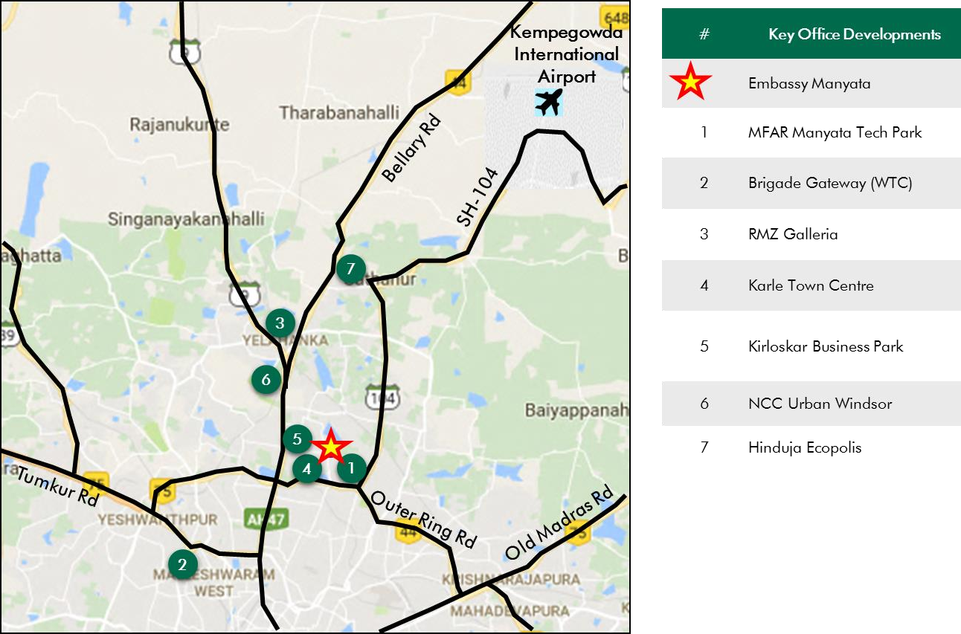

*Source: Consultants’ Research*

Shape: Based on site plan provided by the Client and visual inspection during the site visit, it is understood that the subject property is an irregular shaped land parcel.

Topography: Based on the site plan and as corroborated with our site visit, the site appears to be even and on the same level as abutting access roads and adjoining properties.

Frontage: Based on review of site plan, visual inspection and measurements made on Google maps, we understand that the frontage is approximately 250 meters along the ORR.

Accessibility: Based on the site map provided by the Client and visual inspection, the access to the subject property is by the service road, emanating from the northern section of the Outer Ring Road (viz. main arterial road circling Bengaluru) and this serves as the primary access to the subject property. By virtue of the same the property enjoys excellent accessibility and frontage.

Please refer Exhibit & Addenda for the site plan of the subject property.

* + 1. Legal Details

As per the title due diligence undertaken by King & Partridge and as provided by the Client, we understand that the exact address of the subject property is Rachenahalli Village, Bengaluru East Taluk, Nagavara Village, Bengaluru North Taluk, Bengaluru, Karnataka. Additionally, it is understood that the subject property is freehold in nature (excluding the M3 block which is being developed on a leasehold land parcel of approx. 6.64 Acres, with remaining lease term of approx. 58 years).

Further, this appraisal exercise is based on the premise that the subject property has a clear title and is free from any encumbrances, disputes, claims, etc. Consultants have not made any inquiries in this regard with the relevant legal/ statutory authorities.

* + 1. Town Planning

Zoning As per the RMP 2015, we understand that the subject property is zoned as “Industrial Hi-Tech” for IT/ITeS (SEZ) and IT/ITeS (Non-SEZ) use. As per the Occupancy Certificates it is located within the jurisdiction of Karnataka Industrial Areas Development Board (KIADB). The same has been considered for the purpose of this appraisal. Consultants have made no further inquiries with the local authorities in this regard.

The permissible land use adopted by Consultants for the subject property has been based on information/review of various documents provided by the Client. It must be noted that all factual data viz. permissible development control regulations, land area and achievable FSI have also been based on information/review of various

Approved Usage:

documents (such as title deed, plan sanction letter, site plan, etc.) provided by the Client or assumed based on building regulations, and no physical verification/ measurement has been undertaken for the purpose of this valuation exercise.

For the purpose of this exercise, it has been assumed that all developments (existing

/ under construction / proposed) adhere to building regulations as prescribed by the relevant authorities. Consultants have not validated the information provided by the Client with the relevant development authorities.

Based on Occupancy Certificates provided by the Client and visual inspection during our site visit, we understand that the subject property is an Office Park (SEZ & Non-SEZ), comprising of 27 operational blocks. The current use of the subject property has been provided by the Client and is broadly in agreement with the rules and regulations as prescribed by the local development authority. However, Consultants has not made any enquiries with the relevant local authorities to validate the same for its specific applicability to the subject property.

Restrictions: As per feedback received from the Client, there are no restrictions on the current use of the property.

Natural or induced hazards:

We are of the opinion that the project/ site has been developed to withstand natural or induced hazards (with the exception of extreme/ out of the ordinary hazards).

* + 1. Statutory Approvals, One time Sanctions & Periodic Clearances

Please refer section 18.3 on Statutory Approvals, One time Sanctions & Periodic Clearances

* + 1. Area Details, Type and Age of Existing Structures

The table below highlights the area details of the subject property:

|  |  |  |  |  |
| --- | --- | --- | --- | --- |
| **Subject Property** | **Developable area (sf)** | **Completed Area (sf)** | **Committed Area (sf)** | **Occupied Area (sf)** |
| Embassy Manyata | 22,079,613 | 11,751,174 | 11,479,349 | 11,479,349 |

*Source: Rent roll, lease deeds, Architect Certificate provided by Client*

The table below highlights the detailed area break-up of the subject development:

|  |  |  |  |  |
| --- | --- | --- | --- | --- |
| **Block Building Elevation SEZ/Non-SEZ Age Leasable Area (sf) Name (Years)**  Completed Block | | | | |
| Jacaranda (C1) | 2B+G+4 | Non-SEZ | 11 | 310,729 |
| Cedar (C2) | B+G+8 | SEZ | 11 | 498,527 |
| ELM (C4) | B+G+6 | SEZ | 11 | 419,435 |
| Alder (D1) | B+G+4 | SEZ | 14 | 223,981 |
| Maple (D2) | B+G+3 | SEZ | 14 | 215,458 |
| Redwood (D3) | B+G+10 | SEZ | 13 | 401,312 |
| Cypress (D4) | B+G+10 | SEZ | 13 | 526,462 |
| Beech (E1&FC) | B+G+3 | Non-SEZ | 12 | 164,945 |
| Ebony (G2) | 2B+G+8 | SEZ | 8 | 403,526 |
| Aspen (G4) | 2B+G+10 | SEZ | 8 | 448,743 |
| Rosewood (K) | B+G+4 | Non-SEZ | 14 | 218,215 |
| Magnolia (B) | B+G+3 | Non-SEZ | 14 | 280,538 |
| Silver Fir (L6) | B+G+10 | Non-SEZ | 9 | 365,601 |
| Mahogany (F2) | B+G+10 | SEZ | 11 | 753,358 |
| Silver Oak (E2) | G+7 | Non-SEZ | 12 | 512,418 |
| Pine (L5) | B+G+10 | Non-SEZ | 11 | 381,983 |
| Eucalyptus (H1) | B+G+6 | SEZ | 12 | 376,758 |
| Mulberry (G1) | 2B+G+8 | SEZ | 10 | 403,526 |
| Palm (F3) | 2B+G+10 | SEZ | 7 | 701,204 |
| G1-G2 Bridge (G1G2) | 5 | SEZ | 8 | 48,649 |

|  |  |  |  |  |
| --- | --- | --- | --- | --- |
| **Block Name** | **Building Elevat** | **ion SEZ/Non-SEZ** | **Age (Years)** | **Leasable Area (sf)** |
| Mountain Ash (H2) | 2B+G+10 | SEZ | 7 | 703,376 |
| Hazel (L3) | 2B+G+10 | SEZ | 5 | 498,610 |
| MFAR (MFAR Green) | 3B+G+11 | Non-SEZ | 5 | 231,000 |
| Teak (G3) | 2B+G+10 | SEZ | 5 | 784,186 |
| Philips (Philips) | B+G+4 | Non-SEZ | 14 | 144,736 |
| Banyan & Willow (Block L1 – L2) | 2B+G+10 | SEZ | 3 | 940,400 |
| NXT (Block A) | B+G+10 | Non-SEZ | <1 | 793,498 |
| Total |  |  |  | 11,751,174 |
|  |  | **Under-construction Blocks** |  |  |
| Block M3 – Phase 1 | NA | SEZ | NA | 997,057 |
| Block M3 – Phase 2 | NA | SEZ | NA | 597,789 |
| Front Parcel - Retail | NA | Non-SEZ | NA | 58,083 |
| Total |  |  |  | 1,652,929 |
|  |  | **Land Stage** |  |  |
| Block F-1 | NA | SEZ | NA | 708,000 |
| Block L-4 | NA | Non-SEZ | NA | 707,550 |
| Total |  |  |  | 1,415,550 |

*Source: Rent roll, lease deeds, Occupancy Certificate provided by Client*

In addition to the table blocks, the subject property also includes a proposed hospitality component with a developable area of 722,678 sf and a convention center with a developable area of 58,000 sf.

**Details**

**Completed Blocks**

**Under Construction Blocks**

**Land Stage Blocks**

Grade of the Building Grade A NA NA

LEED Certification Platinum NA NA

Structural Design B+G+3 to 3B+G+11 NA NA

Status of Finishing Warm Shell NA NA

Comments on Obsolescence The building is currently well

maintained

NA NA

*Source: Site visit, occupancy certificate, lease deeds, Indian Green Building Council certificate*

* + 1. Site Services and Finishes

**Particulars Details**

Handover condition Warm Shell

Passenger elevators Provided

Service elevators Provided

Power back-up Provided

Building management system Provided

Security systems Provided

Air conditioning (HVAC) Provided

Firefighting services Provided

Car parks provided MLCP, Basement, Covered and open car parks

*Source: Information provided by Client, site visit, lease deeds*

In addition to the above on-site facilities, amenities offered by the asset include intra-city transportation, outdoor sports zone, rooftop football arena, refurbished food court, etc. This enables the asset to offer an integrated business ecosystem to its occupiers.

* + 1. Condition & Repair

Based on information provided by the Client and corroborated with our visual inspection during the site visit, it is understood that the subject property is in good condition and is being maintained well. The subject property is developed and managed to international standards. Further it offers international standard infrastructure, best-in-class asset management and environment friendly green initiatives. Over the last few years Client has incurred repairs and maintenance expenses towards upgradation of information center and food court, cost spent towards construction of a Skywalk providing access to the subject property from Outer Ring Road, etc. The table below highlights the major repairs and maintenance work/ infrastructure upgrade works to be undertaken over the next few years:

|  |  |  |  |  |
| --- | --- | --- | --- | --- |
| **Expense Head** | **Total Cost (INR Mn) Total Cost T**  **Spent (INR Mn)** | | **otal Pending Cost (INR Mn)** | **Quarter of Completion** |
| 220 KV Sub-station | 1,531.17 | 1,394.23 | 136.94 | Q2, FY 2021 |
| Capex Works (Operations) | 1,041.53 | 41.49 | 1,000.04 | Q3, FY 2022 |
| Flyover | 2,086.17 | 648.12 | 1,438.05 | Q4, FY 2021 |
| Metro (Direct Park Access) | 320.00 | - | 320.00 | Q4, FY 2022 |
| Master plan Upgradation with 2,093.33 | | 554.66 | 1,538.67 | Q4, FY 2022 |

Road & Drainage Works

**Expense Head**

**Total Cost (INR Mn) Total Cost**

**Spent (INR Mn)**

**Total Pending Cost (INR Mn)**

**Quarter of Completion**

Park Lobby Upgrade 94.26 48.78 45.48 Q2, FY 2021

*Source – Information provided by the Client*

* + 1. Property Photographs

Please refer to the property photographs highlighted below:

Embassy Manyata

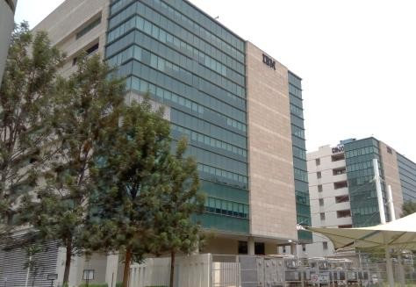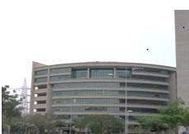

External view of the subject property (SP) External view of the SP

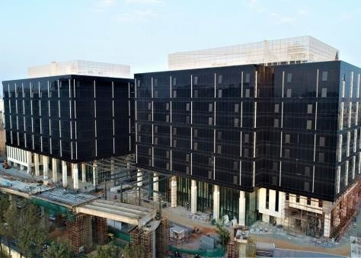

External view of the SP View of recently completed NXT block

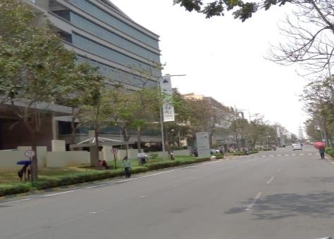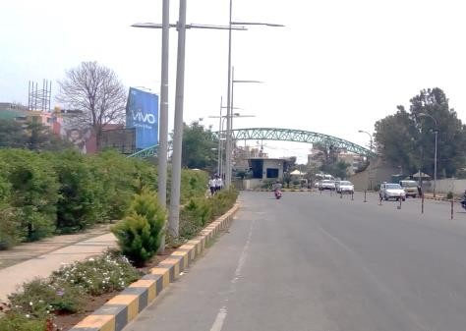

View of internal access road View of the primary access road/entrance

* 1. Tenancy Analysis
     1. Historical Committed Occupancy Rates

The table below highlights the historical occupancy rates at the subject development:

|  |  |  |  |
| --- | --- | --- | --- |
| **March 31, 2017** | **March 31, 2018** | **March 31, 2019** | **March 31, 2020** |
| 99.0% | 98.3% | 99.7% | 97.7%* |

*Source: Rent rolls provided by the Client, Indicative of committed occupancy;*Relatively lower occupancy levels on account of Front Parcel – Block NXT recently getting operational*

Embassy Manyata’s scale, quality and wide-ranging amenities have enabled it to attract and retain both domestic and multi-national marquee tenants. The scalability on offer has enabled occupiers to expand within the asset over the years

* + 1. Lease Expiry Analysis

The graph below highlights the area/leases due for expiry in the coming years:

**Lease Expiry**

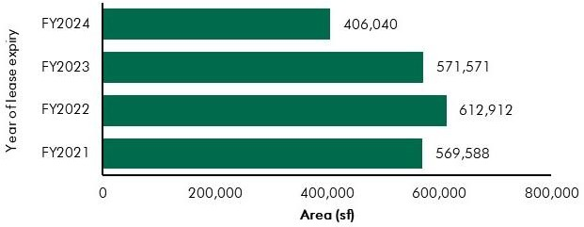

*Source: Rent Rolls and lease deeds (representative of financial year ending)*

Consultants have undertaken an in-depth analysis of the rent roll/ lease deeds shared by the Client, to understand the lease expiry schedule of top tenants at the subject property and rent for those spaces as of date of valuation. The intent of the same is to analyse the risk of tenant churn as well as assessing the re-leasing risk for the property along with opining on the timeframe to lease-up the spaces in case a significant vacancy arises at the property.

* + 1. Escalation Analysis

As per the review of recent executed leases at the subject property it is understood that the contracted escalation terms for these leases are in the range of 10.0% to 15.0% every 3 years are in line with the prevailing market practise witnessed across the sub market and Bengaluru.

* 1. Assumptions Rationale

As highlighted earlier, the subject property is an operational Office Park located near Hebbal, on Nagavara Outer Ring Road, Bengaluru. Hebbal region, especially the stretch from Hebbal flyover to Yelahanka is considered as one of the most established locations of North Bengaluru; primarily on account of the superior infrastructure initiatives, easy connectivity to the CBD and the International Airport via NH-44 and ORR. In addition, it was observed that majority of the developments along this stretch are a mix of commercial and residential properties.

Given the limited availability of land parcels in the initial stretches of Bellary Road, real estate development activity has been witnessed off NH-44 in locations such as Thanisandra Road, Jakkur Main Road, Hennur Road, Yelahanka and Doddaballapur Road. Further, the region is also characterised by Government promoted hardware and aerospace parks as well as planned townships. Owing to the presence of large land banks towards the later stretch of Bellary road (being held by prominent developers and expected to be developed in the near future) coupled with the infrastructure initiatives, we are of the opinion that the subject sub market is expected to transform from an emerging location to an active real estate hub in the medium term.

* + 1. Demand and Supply Dynamics
       1. *Demand, Supply and Vacancy Trends – Bengaluru and North Bengaluru sub market*

Total completed stock in Bengaluru as of Q4, 2019 is 157.47 msf, out of which North Bengaluru account for Approx. 12.5%.

|  |  |  |
| --- | --- | --- |
| **Particular** | **Bengaluru** | **North Bengaluru** |
| Cumulative completed office stock (Q4 2019) Cumulative occupied stock (Q4 2019) Current vacancy (Q4 2019)  Average annual office absorption (2014 – 2019) | Approx. 157.47 msf | Approx. 19.6 msf |
| Approx. 151.00 msf | Approx. 18.6 msf |
| Approx. 4.1% | Approx. 5.4% |
| 11.3 msf | 1.5 msf |

*Source: CBRE Research*

**Demand – Supply Dynamics (Bengaluru)**

16.0

14.0

Suply/Absorption (msf)

12.0

10.0

8.0

6.0

4.0

2.0

0

2014 2015 2016 2017 2018 2019

12.0%

10.0%



11.1%

10.4%

6.6%

5.1%

3.7%

4.1%

10.7 11.2 12.7 12.0 7.9 11.9 7.7 9.3 11.9 13.3 10.8 9.8

8.0%

6.0%

4.0%

2.0%

0.0%

Supply (msf) Net Absoprtion (msf) Vacancy (%)

*Source: CBRE Research; Note: Supply – refers to fresh completed supply added each year; Absorption – refers to the quantum of leasing witnessed in each year as part of completed space; the vacancy in the chart accounts for the gap between cumulative stock and occupied stock in the city in any given year;*

**Demand – Supply Dynamics (North Bengaluru)**

4.5

4.0

Suply/Absorption (msf)

3.5

3.0

2.5

2.0

1.5

1.0

0.5

0

2014 2015 2016 2017 2018 2019

20.0%

18.0%



17.2%

9.7%

8.5%

8.2%

5.4%

1.1%

0.9 1.0 3.9 1.5 0.9 1.9 1.1 1.2 2.4 2.3 0.5

1.0

16.0%

14.0%

Vacancy (%)

12.0%

10.0%

8.0%

6.0%

4.0%

2.0%

0%

Supply (msf) Net Absoprtion (msf) Vacancy (%)

*Source: CBRE Research; Note: Supply – refers to fresh completed supply added each year; Absorption – refers to the quantum of leasing witnessed in each year as part of completed space; the vacancy in the chart accounts for the gap between cumulative stock and demand in the city in any given year.*

The initial stretch of North Bengaluru, where subject property is located has emerged as a prominent growth corridor for office developments. Locations north of the subject property are gradually emerging as a prominent growth corridor owing to its connectivity to the international airport, good connectivity to

the city centre, availability of large tracts of developable land and residential inventory (completed and upcoming) to support the working population.

North Bengaluru sub market gained prominence in the city’s office space landscape, with the completion of Embassy REIT’s asset Embassy Manyata. The largest operational Office Park in Bengaluru gained prominence as it offered superior amenities for both occupiers and employees. With benefits such as infrastructure within the park ~ ample parking and provisions to host events, availability of quality office spaces and option of scalability, the park attracted occupier interest from various sectors. Proximity to the international airport acts as another demand driver for not only the subject property, but also the entire North Bengaluru sub market.

Availability of quality spaces and a sizable supply pipeline across organized business parks has placed this sub market on track to emerge as one of the long-term growth vectors for commercial leasing in Bengaluru.

* + - 1. *Key Developments in Sub Market*

The table below highlights the prominent developments in the subject sub market:

**Building Name**

**Development**

**Leasable Area**

**Approx. Vacancy**

**Quoted Rent**

|  |  |  |  |  |
| --- | --- | --- | --- | --- |
| Development 1 | **Type**  Non-SEZ | **(in msf)**  1.7 | **(%)**  Minimal | **(INR psf pm)**  90.0 – 95.0 |
| Development 2 | Non-SEZ | 0.3 | 3-5% | 65.0 – 70.0 |
| Development 3 | SEZ | 0.9 | Minimal | 75.0 – 80.0 |
| Development 4 | Non-SEZ | 0.4 | 5 - 10.0% | 80.0 – 85.0 |
| Development 5 | Non-SEZ | 0.5 | Minimal | 75.0 – 80.0 |

*Source: CBRE Research*

* + 1. Lease Rent Analysis

The current rent in subject sub market typically varies between INR 75.0 – 100.0 psf pm on leasable area basis depending upon specifications offered, location and accessibility of the development (viz. along/off the main arterial roads), quality of construction, developer brand, amenities offered, etc. In addition, the maintenance charge for these developments varies in the range of INR 8.0 – 12.0 psf pm. The parking charges in such developments range between INR 3,000 – 5,000 per bay per month for covered car parks.

Based on our market research we understand that the rent in the subject sub market has witnessed appreciation of approx. 7.6% between 2014 & 2019. Subject property is a major contributor to the supply in the sub market.

Introduction of supply in years 2012-14 led to subdued rent escalations. However, the market is witnessing an increase in the growth rate over the last 3-4 years and is expected to continue achieving

superior growth over the next 2 to 3 years, owing to lack of ready to move-in supply in large scale business parks.

The table below highlights some of the recent transacted rent for office parks/ assets in the influence region of the subject property:

|  |  |  |  |
| --- | --- | --- | --- |
| **Date of Transaction** | **Area (sf)** | **Tenant** | **Transacted Rent Value (INR psf pm)\*** |
| Q4, 2019 | 140,000 | Tenant 1 | 70.0 - 75.0 (WS) |
| Q4, 2019 | 7,500 | Tenant 2 | 73.0 - 77.0 (WS) |
| Q4, 2019 | 6,000 | Tenant 3 | 70.0 - 75.0 (WS) |
| Q3, 2019 | 15,000 | Tenant 4 | 73.0 - 77.0 (WS) |
| Q3, 2019 | 25,000 | Tenant 5 | 68.0 - 72.0 (WS) |
| Q2, 2019 | 20,000 | Tenant 6 | 73.0 - 77.0 (WS) |
| Q2, 2019 | 25,000 | Tenant 7 | 80.0 - 85.0 (WS) |
| Q2, 2019 | 120,000 | Tenant 8 | 68.0 - 72.0 (WS) |

*Source: CBRE Research* Rent is base rent (viz. exclusive of property tax & insurance) on leasable area basis; Note: W – Warm shell; FF*

*– Fully Fitted-out*

While ORR has been preferred sub market in the context of the city, North Bengaluru has been witnessing sustained occupier interest. However, supply has been largely concentrated in the subject property in North Bengaluru historically and has enabled EOP to successfully lease approx. 11 msf over the years.

While ORR is expected to be a preferred sub market over the next 3-4 years, North Bengaluru leads other sub markets on its potential in the medium to long term. This is largely attributable to North Bengaluru’s proximity to the International Airport, existing and proposed infrastructure initiatives, and ample availability of developable land parcels at competitive prices, growing residential catchment and connectivity to other parts of the city via Outer Ring road.

Given the development potential of the sub market and the development of residential/ lifestyle infrastructure, it will emerge as a preferred destination for corporates looking for office options for expansion/consolidation – resulting in increased market share going forward.

Embassy Manyata in North Bengaluru with its largest share in operational stock as well as development pipeline in the next 3-4 years is expected to be a prominent player in the North Bengaluru sub market (keeping in context its proximity to the city centre vis-à-vis properties with future development potential).

* 1. Value Assessment
     1. Adopted Methodology

We acknowledge that the approaches to valuation differ considerably and that for a particular purpose, alternative approaches to the valuation can be utilized subject to the Client’s consultations and giving due consideration to the Client’s requirements. Considering the objective of this exercise and the nature of asset involved, the value of the subject property has been assessed through the following approaches:

|  |  |
| --- | --- |
| **Particulars Completed Blocks Under Construction/ Land Stage**  **Blocks** | |
| **Valuation Methodology** | Office & Retail - Discounted Cash Flow Method (using rent reversion approach) Proposed Hotel - Discounted Cash Flow Method |

The sections below highlight detailed valuation workings for the subject property. Please note that the assumptions/ opinions highlighted in the subsequent sections are to be read in conjunction with Section

1.11 and the following:

*“In the current uncertain environment caused by the outbreak of the Novel Coronavirus (COVID-19), we have considered /* relooked *at various performance parameters and have adopted heuristic/ careful interventions (including but not limited to the points mentioned below) to our projected cashflows based on our view as of the date of valuation.*

* *Limited/ no growth in rent and ARR has been considered over the next few quarters*
* *Construction timelines have been delayed from the earlier estimates*
* *Considering challenges in the short term, timelines have been extended for new space take-up/ future leasing*
* *Additional fit-out period/ rent free months have been incorporated where fit-out works have commenced”*
  + 1. Area statement

Based on information, rent roll, lease deeds, architect certificate provided by the Client, we understand that subject property is an Office Park. Further, the table below highlights the area configuration of the subject property:

|  |  |  |  |  |
| --- | --- | --- | --- | --- |
| **Block** | **Total Area (sf)** | **Operational area (in sf)** | **Under Construction area (in sf)** | **Proposed area (in sf)** |
| SEZ Area | 10,650,357 | 8,347,511 | 1,594,846 | 708,000 |
| Non – SEZ Area | 4,111,213 | 3,403,663 | - | 707,550 |
| Retail | 58,083 | - | 58,083 |  |
| Total – Office/ Retail | 14,819,653 | 11,751,174 | 1,652,929 | 1,415,550 |
| Hotel (including convention  centre) | 619 keys  (Hotel - 722,678  Convention – 58,000) | - | 619 keys  (Hotel - 722,678  Convention – 58,000) |  |

Source: Architect certificates, rent roll, lease deeds; Note – office & retail refers to leasable area while hotel & convention refers to developable area

* + 1. Construction Timelines
       1. *Completed Blocks*

As highlighted earlier, the subject property has 11.75 msf of completed development. Further, Block NXT received its occupancy certificate in Q4 FY 2020 and cost of INR 738.9 Mn is pending towards final finishes, handover cost, etc. the same is expected to be spent by Q2 FY 2021.

* + - 1. *Under-Construction/ Proposed Blocks*

Based on visual inspection during the site visit and information provided by the Client, the following timelines for construction have been adopted for the purpose of this valuation exercise:

**Block**

**Leasable/ Developable**

**Construction**

**Construction**

**Construction**

**Construction**

|  |  |  |  |  |
| --- | --- | --- | --- | --- |
|  | **Area (sf)** | **Commencement** | **Completion\*** | **(% completion) Status** |
| Block L-4 | 707,550 | Q4, FY 2020 | Q4, FY 2023 | 0.0% Land Stage |
| Block M3 – Phase 1 | 997,057 | Q4, FY 2018 | Q2, FY 2023 | 23.8% Under-  Construction |
| Block M3 – Phase 2 | 597,789 | Q4, FY 2020 | Q1, FY 2024 | 0.0% Yet to Commence |
| Block F-1 | 708,000 | Q2, FY 2023 | Q3, FY 2025 | 0.0% Land Stage |
| Front Parcel - Retail | 58,083 | Q1, FY 2020 | Q4, FY 2022 | 29.7% Under-  Construction |
| Front Parcel - Convention Centre | 58,000# | Q1, FY 2020 | Q4, FY 2022 | 29.7% Under-  Construction |
| 5 Star Hotel | 412,375# | Q1, FY 2018 | Q4, FY 2022 | 31.9% Under-  Construction |
| 3 Star Hotel | 310,303# | Q1, FY 2018 | Q4, FY 2022 | 31.9% Under-  Construction |

*Source: Client’s inputs; *the timelines are mentioned as per Financial year beginning April to March*

* + 1. Absorption/ Leasing Velocity and Occupancy Profile
       1. *Completed Blocks*

In order to arrive at the future absorption levels at the subject property, we have analysed the historical demand and supply trends coupled with the estimation of future supply proposed to be introduced in the subject sub market.

Keeping the same in perspective, we opine that the vacant space in the subject property would be leased by end of Q1, FY 2022.

* + - 1. *Under-Construction/ Proposed Blocks*

The absorption period assumed for the subject development is based on market dynamics and extent of development in the relevant sub market, nature of subject development, competing supply of same nature, location within the respective sub market, etc. The table below highlights the absorption assumptions adopted for the subject development:

**Schedule**

|  |  |  |  |  |  |
| --- | --- | --- | --- | --- | --- |
| **Block Absorption FY 2021** | **FY 2022** | **FY 2023** | **FY 2024** | **FY 2025** | **Total** |
| Percentage - | - | 25.0% | 25.0% | 50.0% | 100.0% |
| Leasable - | - | 177,000 | 177,000 | 354,000 | 708,000 |
| Percentage - | 40.0% | 60.0% | - | - | 100.0% |
| Leasable - | 283,020 | 424,530 | - | - | 707,550 |
| Percentage - | 100% | - | - | - | 100.0% |
| Retail Leasable - | 58,083 | - | *-* | - | 58,083 |
| Total Absorption (%) - | 23.1% | 40.8% | 12.0% | 24.0% | 100.0% |
| Total Absorption (sf) - | 341,103 | 601,530 | 177,000 | 354,000 | 1,473,633 |

Block F-1 (%)

Area (sf)

Block L-4 (%)

Area (sf)

Front Parcel - (%)

Area (sf)

* + 1. Revenue Assumptions (Office & Retail)
       1. *Lease rent assumptions*
          1. Office Component

For the purpose of this appraisal exercise, the lease rent adopted for the area already leased is based on the rent roll/lease deeds shared by the Client. Further, an in-depth market research exercise has been undertaken to assess the prevailing rent values in the subject sub market. The same has been adopted for the vacant space for the purpose of this valuation exercise.

Based on our market study and based on the analysis of the rent roll provided by the Client, following rent has been adopted for the purpose of value assessment of the completed blocks at the subject property.

|  |  |  |  |  |
| --- | --- | --- | --- | --- |
| **Component** | **Leasable Area (sf)** | **Leased Area (sf)** | **Basis** | **Rent Adopted**  **(INR psf pm)\*** |
|  |  |  | Current Rent for Leased area | 59.7^ |
| **Office** | 11,751,174 | 11,479,349* | Marginal rent for reversion/ vacant area | 90.0 |

*Source: Rent roll provided by the Client; Valuer’s Assessment*, *\* Indicates committed occupancy*

*\* The rent mentioned above exclude other income such as CAM charges, parking income received from the tenants, etc.; ^weighted average warm shell rent for area already leased – as per rent roll/lease deeds shared by Client*

The above marginal rent assumption is adopted for the entire subject development. In addition to undertaking an in-depth market analysis, a detailed analysis of the rent rolls was also undertaken to understand aspects such as area occupied, current rent and expiry analysis of the key tenants in the park. Additionally, we also analysed the historical occupancy pattern at the subject development and lease-up time frame for spaces being vacated by tenants during the last 3 years. The lease-up time on an average was observed to be 1-3 months based on quantum of space being renewed/ re-leased.

Based on the size and scale of operations of tenants, the Valuer adopted individual marginal rent assumptions for larger tenants in the subject development. For the larger tenants (except key anchor tenants), we have assumed that post lease expiry, these spaces will revert to marginal rent prevailing at that point in time. However, given the large size of these spaces, the Client will require longer lease-up time. Therefore, we have adopted a higher lease-up time, ranging from 3 – 6 months depending on area to be leased.

**Area**

**Marginal Rent Strategy (Discount to Market Rent/ Lease-up Time)**

Leased area > 2.00 msf Renewal at 20.0% discount

Leased area > 0.30 < 2.00 msf Renewal at market (6 months lease-up time)

Leased area > 0.10 sq ft < 0.30 msf Renewal at market (3 months lease-up time)

*Source: Valuer Assessment*

As presented in the table above, all leases except for anchor tenants will be renewed at marginal rent, but with a longer lease-up time frame. Anchor tenants in the subject development have a history of renewing the spaces within subject property. Going forward, it is assumed that these anchor tenants will continue to renew their leases at the subject development; however, they will continue to attract a discount in rent compared to the marginal rent.

As per information provided by the Client, the office component on the front parcel will be high-end offering (viz. targeted at Non-IT operations offering superior specifications). Based on the above, we have adopted a 15.0% premium in rent for this space. Valuer opines that this Front Parcel is expected to achieve marginal rent in the range of INR 100.0 to 105.0 psf pm (say INR 103.5 psf pm) as on date of valuation.

* + - * 1. Retail Component

As per the information provided by the Client, it is understood that a retail space measuring 58,083 sf is envisaged as part of the Front Parcel in the proposed development. The retail space will operate as ancillary retail, providing convenience to the working population in the subject development as well as surrounding development. It has been observed that rent for retail spaces for similar developments (office space with ancillary retail) across Bengaluru command premium over office space rent, on account of better visibility (presence on lower floors) and better finishes as compared to the office spaces. Given the above, Valuer has assumed marginal rent in the range of INR 115.0 to 120.0 psf pm (say INR 117.0 psf pm) as on date of valuation.

* + - 1. *Rent Escalation*

Based on an analysis of existing lease rolls and recent leasing at the subject property, it was observed that the typical escalation clause in the subject property is approx. 15.0% after every three years, which is in-line with the trend observed in the market. The same has been adopted by Valuer for the vacant area and renewals at the subject property.

* + - 1. *Fit-out Rent*

As per the information (rent roll) provided by the Client, we understand that in addition to the lease rent, there is rent towards fit-outs for few of the tenants. The rent is in the range of INR 7.0 to 55.0 psf pm. For the purpose of this valuation, we have adopted the tenant wise fit-out details as provided in the rent roll.

Moreover, for the under-construction/proposed blocks, we have assumed that the development would be leased on warm shell specifications with no applicable fit-out rent on any lease.

* + - 1. *Parking Assumptions*

Based on the prevailing car parking rate in the subject development and North Bengaluru sub market, we have assumed a car park charge of INR 5,000 per month per bay, with 25.0% of car park allocated to a tenant to be free of cost. Effective car parking charges adopted for the purpose of this valuation is INR 3,750 per month per bay.

* + - 1. *Other Revenues*

In addition to lease rent revenues, office assets typically have additional sources of revenue. These include revenues on account of security deposit (refunded at the time of lease expiry / exit), other miscellaneous income (such as cell sites, retail areas, food court, etc.), etc.

Additionally, we understand that the CAM is being charged by an agency which is external to the interests of Embassy Office Parks REIT, hence we have not considered any margin on CAM during the holding period. However, at the time of notional exit, margin of CAM is included in the financials as per market benchmarks (i.e. INR 11.0 psf pm CAM and 15.0% margin on CAM).

The assumptions considered for the aforementioned revenue heads for the purpose of this valuation exercise are based on the rent roll & lease deeds provided by the Client. The same has been cross- checked with the prevailing market norms for other revenues and were found to be broadly in line.

The assumptions adopted for other revenues are as tabulated below:

|  |  |  |
| --- | --- | --- |
| **Nature of Income** | **Details** | **Units** |

Miscellaneous Income (Income from cell sites)

1.10%

(INR 85.4 mn)

% of gross rental income

Warm shell Security Deposit* 6 months No. of months’ warm shell rental

Parking Income (For vacant and UC development)^

INR 3,750 per car park

*Source: Client’s Inputs & Valuer’s assessment; * Refunded at the time of lease expiry/ exit; ^assumed at INR 5,000 per bay per month, with 25.0% free car park*

* + 1. Revenue Assumptions - Hotel
       1. ARR and Occupancy Assumptions

As per the information provided by the Client, we understand that there are two hotels (viz. 5 Star and 3 Star positioning – with management contracts in place with the Hilton Group for Hilton at Manyata and a Hilton Garden Inn at Manyata) are proposed to be developed in the subject property. The area details of the proposed hotels are mentioned in the table below:

|  |  |  |
| --- | --- | --- |
| **Components** | **No of Keys** | **Proposed area (in sf)** |

|  |  |  |
| --- | --- | --- |
| 5 Star Hotel | 266 | 412,375 |
| 3 Star Hotel | 353 | 310,303 |
| Total | 619 | 722,678 |

*Source: Client inputs*

The existing upscale hotels that are operational in the northern part of Bengaluru have achieved ARRs in the range of INR 7,500– 8,750 per room per night and occupancies in the range of 68.0-90.0%. Similarly, mid-scale business hotels that are operational in the vicinity of the subject property have achieved ARRs in the range of INR 4,800 – 5,200 per room per night and occupancies in the range of 65.0-80.0%.

Given the positioning & location of the subject development, performance of competing hotels in the subject sub market and development mix (part of a larger commercial development) etc., it is opined that ARRs for hotel component in the subject development would range from INR 7,700 – INR 8,300 per room night (viz. approx. INR 8,000 per room night) for the 5 Star hotel and INR 5,300 – INR 5,700 per room night (viz. approx. INR 5,500 per room night) for the 3 Star hotel. Additionally, the stabilized occupancy for the subject development is opined to be 70.0%, 2.5 years from the year of operation commencement.

* + - 1. Other Revenues

The revenue assumptions for the hotel component of the envisaged subject development have been enumerated in the table below:

|  |  |  |  |
| --- | --- | --- | --- |
| **Particulars** | **Unit** | **5 Star** | **3 Star** |
| Food & Beverage Revenue | (% of Room Revenue) | 100.0%* | 40.0% |
| MOD Revenue | (% of Room Revenue) | 15.0% | 15.0% |

*\*Note: higher income considered to factor income generated by convention space in the subject as the same would be managed by the hotel.*

* + - 1. Operating Cost

The following operating costs have been considered based on benchmarks available in the markets on various heads to arrive at the net cash flows for the purpose of this valuation exercise:

|  |  |  |
| --- | --- | --- |
| **Expense Head** | **5 Star** | **3 Star** |

Room Costs (as a % of room revenue) 15.0% 15.0%

|  |  |  |
| --- | --- | --- |
| **Expense Head** | **5 Star** | **3 Star** |

|  |  |  |
| --- | --- | --- |
| F&B costs (as a % of F&B revenue) | 45.0% | 45.0% |
| MOD Costs (as a % of MOD revenues) | 50.0% | 50.0% |
| Administrative expenses (as a % of total revenue) | 6.0% | 6.0% |
| Maintenance expenses (as a % of total revenue) | 5.0% | 5.0% |
| Operating Expenses (as a % of total revenue) | 11.0% | 11.0% |
| Marketing costs (as a % of total revenue) | 5.0% | 5.0% |
| Base management Fee (as a % of total revenue) | As per contract | As per contract |
| Management Incentive Fee (% of GOP) | As per contract | As per contract |

Annual Escalation of Operating Costs (viz. admin, maintenance, Op-ex)

5.0% 5.0%

Property Tax INR 3.5 psf INR 3.5 psf

*Source: Valuer’s Assessment & Client input*

* + 1. Expense Assumptions
       1. *Development Cost*

The following table highlights the assumptions towards the development cost for the under- construction/proposed blocks at the subject development:

|  |  |  |  |
| --- | --- | --- | --- |
| **Block** | **Cost of Construction (INR T**  **psf or INR Mn/Key)** | **otal Cost of Construction**  **(INR Mn)** | **Pending Cost to be Spent**  **(INR Mn)** |
| Block F-1 | 4,038.47 | 2,859.24 | 2,859.09 |
| Block L-4 | 4,205.43 | 2,975.55 | 2,958.11 |
| NXT ~ Block A (OC Received) | 4,346.62 | 3,449.04 | 738.89 |
| Front Parcel – Retail | 3,865.14 | 224.50 | 157.19 |
| Front Parcel - Convention Centre | 14,495.96 | 840.77 | 591.39 |
| 5 Star Hotel | 13.13/Key | 3,492.38 | 2,379.83 |
| 3 Star Hotel | 9.41/Key | 3,320.04 | 2,262.39 |

*Source: Client’s input; Block M3 covered as part of subsequent section;*

* + - 1. *Major Repair and improvements*

The following table highlights the assumptions towards the refurbishment expenses/ infrastructure upgrade works in the subject development:

|  |  |  |
| --- | --- | --- |
| **Expense Head** | **Total Pending Cost (INR Mn)** | **Quarter of Completion** |
| 220 KV Sub-station | 136.94 | Q2, FY 2021 |
| Capex Works (Operations) | 1,000.04 | Q3, FY 2022 |
| Flyover | 1,438.05 | Q4, FY 2021 |
| Metro (Direct Park Access) | 320 | Q4, FY 2022 |
| Master plan Upgradation with Road & Drainage Works | 1,538.67 | Q4, FY 2022 |
| Park Lobby Upgrade | 45.48 | Q2, FY 2021 |

Source Client Input; Valuer’s Assessment* the pending cost towards refurbishment is apportioned in equal proportion across remaining quarters from the date of valuation.

* + - 1. *Inputs pertaining to Block M3 – Phase 1*

As per information provided by the Client, the inputs pertaining to M3 block is highlighted in the table below:

|  |  |  |
| --- | --- | --- |
| **Particular** | **Amount (INR Mn)** | **Comments** |
| Total Development Consideration | INR 8,303 mn | NA |
| Development Consideration paid | INR 6,273 mn | Paid till date of valuation |
| Balance Development Consideration | INR 2,020 mn | Envisaged to be paid by Q2, FY 2023 |
| Refundable Security Deposit | INR 1,610 mn | Already paid |
| Security Deposit Refunded | INR 1,610 mn | Received |
| Annual Lease Payment | INR 0.10 mn | Fixed pay-out without any escalation |

*Source Client Input*

Based on information provided by the Client representative and under Co-developer agreement, EPDPL has assisted MPPL to obtain co-developer status as per provisions of SEZ Act. Client representative will be getting the rights to a contracted NOI of INR 76.3 psf pm from the date of operation commencement of block M3 Phase 1. In addition, Client representative shall pay a development consideration of INR 8,303 mn (out of which INR 6,273 mn has been paid as on date of valuation).

EPDPL received refundable security deposit of INR 1,610 mn from MPPL, which has been refunded as of date of valuation.

Further, revenue from this block would accrue for a period of 60 years from the date of commencement of development works.

As per the Development Management Agreement, it is understood that in case of any delay in completion of the project beyond 33 months (from the date of execution of the agreement - 8th March 2017), i.e. 7th December 2019, MPPL will be entitled to INR 57.2 Mn per month as penalty till completion of the development i.e. Q2, FY 2023.

* + - 1. *Inputs pertaining to Block M3 – Phase 2*

As per information provided by the Client representative, the inputs pertaining to M3 block Phase 2 is highlighted in the table below:

|  |  |  |
| --- | --- | --- |
| **Particular** | **Amount (INR Mn)** | **Comments** |
| Total Development Consideration | INR 7,367 mn | NA |
| Development Consideration paid | INR 4,256 mn | Paid till date of valuation |

**Particular Amount (INR Mn) Comments**

Balance Development Consideration INR 1,109 mn INR 2,002 mn

To be paid post acquisition of TDR i.e. Q2, FY 2021

Envisaged to be paid over Q3, FY 2021 to Q1, 2024

Annual Lease Payment INR 0.10 mn Fixed pay-out without any escalation

*Source Client Input*

Based on information provided by the Client and under Co-developer agreement dated 30th December 2019, EPDPL is in process of acquisition of TDR which can be utilized to construct additional area as part of Block M3, (called Block M3 – Phase 2) for an area totalling 597,789 sft. This will be an expansion to Phase 1. EPDPL has assisted MPPL to obtain co-developer status as per provisions of SEZ Act for Phase 1, which will now be extended to Phase 2 as well. Client will be getting the rights to contracted NOI of INR 95.0 psf pm (subject to escalation of 15% every 3 years) from the date of operation commencement of block M3 Phase 2. In addition, Client representative shall pay a development consideration of INR 7,367 mn (out of which INR 4,256 mn has been paid as on date of valuation). The above consideration will be paid in the following tranches:

* + - * + INR 4,256 mn as initial payment (the same is paid as of date of valuation).
        + INR 1,109 mn to be upon acquisition of TDR.
        + INR 2,002 mn to be paid during the course of construction.

Further, revenue from this block would accrue in line with revenues from Phase 1.

Additionally, as per the co-developer agreement, it is understood that MPPL is entitled to receive an interest income (payable every quarter), wherein interest rate is calculated per annum, as the higher of

1. 9.25% per annum and (ii) Base Rate (viz. actual all-inclusive rate of availing construction finance facility to make payment of the Development Consideration) + 1% till March 31, 2023; Base Rate + 1.5% from April 1, 2023 to December 31, 2023; and Base Rate + 2% from January 1, 2024 onwards. The interest income will be computed on any amount disbursed from MPPL to EPDPL.
   * + 1. *Operating Costs*

In addition to capital expenditure, a development typically has few recurring operation expenses required for the up-keep running of the development. Based on information provided by the Client and market assessment, following recurring expense assumptions have been adopted for the purpose of this valuation exercise (applicable to both completed and proposed blocks):

Nature of Expense Details Basis

Insurance, Legal and other professional charges

0.14%

(INR 10.8 mn)

% of gross rental income

Property Tax 6.52%*

(INR 507.0 mn)

% of gross rental income

Repair and Maintenance Reserve 1.0% % of gross rental income

Nature of Expense Details Basis

Asset management Fee^ 3.0% % of total income

Transaction cost on Exit 1.0% % of terminal value

*Source: Client Input; Valuer’s assessment; *Note – based on inputs provided by the Client, we understand that the property tax is paid at the beginning of every financial year wherein a 5.0% discount gets extended vis-à-vis pay-out during the end of the year and the same has been adopted for the purpose of our valuation; ^ Asset Management fees has been considered a below the NOI line item.*

* + 1. Other Assumptions
       1. *Vacancy provision*

Based on the prevailing market benchmarks, a vacancy provision of 2.5% has been adopted upon assessment of terminal value

* + - 1. *Revenue escalation*

Based on prevailing market condition, historical rent growth achieved by the subject property and our interactions with market participants, Valuer is of the option that the annual marginal rent growth for the subject property will be 2.5% till Q3, FY 2021 and then stabilize at of 5.0% going forward.

* + - 1. *Rent – free period*

Based on the trend prevalent in the subject sub market, we have considered a rent free period of 3 months for the subject property from the lease commencement date (for future / new leases)

* + - 1. *Brokerage*

Based on prevalent market dynamics, we have considered brokerage equivalent to 2 month of rental income for future / new leases

* + - 1. *CAM under recoveries*

We have highlighted expense towards maintenance as CAM under recoveries for months when no rental

/ CAM income is received

* + 1. Capitalization Rates

As highlighted in section 3.3, the cap rate adopted for the office spaces are 8% with an EV/ EBITDA multiple of 14 for the hotel component.

* + 1. Discount Rate

For discounting the cash flows, the appropriate discounting rate has been calculated on the basis of estimated ‘Weighted Average Cost of Capital’ (WACC). The detailed analysis of WACC rate adopted for the subject property has been detailed in Section 3.4 of this report.

* 1. Value of the Subject Property

Based on the above mentioned analysis, the value of the subject property is estimated as follows:

|  |  |  |  |
| --- | --- | --- | --- |
| Component | Value (INR Mn) |  | % Share |
| Operational Blocks | 129,952 |  | 84.4% |
| Under-Construction Blocks | 20,154 |  | 13.1% |
| Proposed Hotel | 3,800 |  | 2.5% |
| **Embassy Manyata** |  | **INR 153,906 Mn** |  |

##### Express Towers

* 1. Property Description

|  |  |
| --- | --- |
| **Brief Description** | |
| Particulars | **Details** |
| **Property Name** | Express Towers |
| **Address** | Plot No. 236, Block-III of Back bay Reclamation Estate, Barrister Rajni Patel Marg, Nariman Point, Mumbai |
| **Land Area** | 1.46 acres |
| **Leasable Area** | Total Completed Leasable Area – 0.47 msf |

*Source: Title Report, Architect Certificate*

* + 1. Site Details

Situation: ‘Express Towers’ is a completed operational city centre office located along Barrister Rajni Patel Marg in Nariman Point, Mumbai, Maharashtra. Express Towers is one of the iconic buildings and a trophy asset within the portfolio, with superior offering in the Central Business District, a highly preferred submarket by corporates (involving high capex spent in developing the space) and results in spaces being a preferred option for marquee occupiers within the submarket

Location: The subject property ‘Express Towers’ is a completed city centre office located opposite to The Oberoi and Trident Hotel in Nariman Point, Mumbai and has panoramic views of the city’s promenade (Marine Drive), South Mumbai and the Arabian Sea.

Further, the subject property forms a part of prime commercial hub of Mumbai (Central Business District of Mumbai) that houses various corporate offices of various banks, funds, developer offices, print media offices, shipping companies, foreign councils & embassies etc. Key commercial developments located in the vicinity of the subject building include Maker Chambers, Free Press House, Hoechst House, Mafatlal Centre etc.

Additionally, other key developments located in vicinity of the subject property includes prominent five-star hotels (namely The Oberoi and Trident Hotel), National Centre of Performing Arts (NCPA), NCPA residential complex, Brabourne & Wankhede cricket stadium, CR2 Mall, Government offices and Govt. buildings namely Mantralaya, Vidhan Bhavan (State Assembly), etc.

The distances from prominent key hubs to the subject property are presented below:

|  |  |
| --- | --- |
| ***Landmark*** | ***Distance (km)*** |
| Churchgate Railway Station | 1 – 2 |
| Chhatrapati Shivaji Terminus Railway Station | 2 – 3 |
| Bandra Kurla Complex (Alternate Business District) | 17 – 18 |
| Chhatrapati Shivaji Domestic Terminal | 24 – 25 |
| Chhatrapati Shivaji International Terminal | 27 – 28 |

*Source: Consultants’ research*

Surrounds: The subject property is surrounded as follows: North: Air India Building

South: Secondary access road and Nirmal Towers, Mafatlal Centre East: Secondary access road (Vidhan Bhavan Marg)

West: Primary access road (Barrister Rajni Patel Marg) and The Oberoi and Trident Hotel

Potential changes in surroundings:

As highlighted earlier, Nariman Point is the traditional Central Business District of the Mumbai city and has limited developable land. Further, dearth of vacant developable land, higher use of land due to residential demand, limited opportunity for redevelopment due to fragmented ownership structure witnessed across developments coupled with onerous construction regulations has resulted in negligible construction activity for new commercial buildings. The submarket is characterized by presence of few prominent hotels and older commercial buildings with constrained parking facilities.

Suitability of existing use:

Considering the profile of surrounding developments, the subject property is opined to be suited for its current use as a city centre office.

EMBASSY OFFICE PARKS MANAGEMENT SERVICES PRIVATE LIMITED | EMBASSY OFFICE PARKS REIT

The following map indicates the location of the subject property and surrounding developments:

**Location Map for the Subject Property**

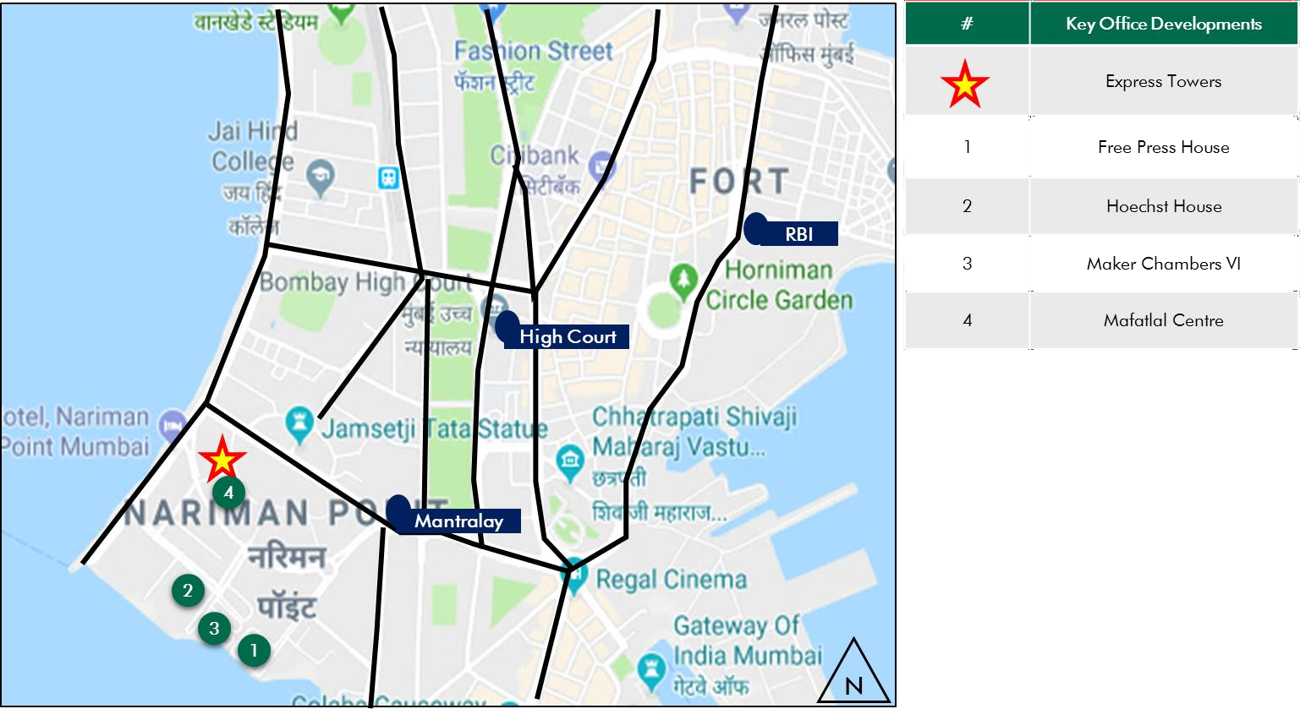

*Source: Consultants’ Research*

Shape: Based on site plan provided by the Client and visual inspection during the site visit, it is understood that the subject property is on a regular shaped land parcel.

Topography: Based on the site plan and as corroborated with our site visit, the site appears to be even and on the same level as abutting access roads and adjoining properties.

Frontage: Based on visual inspection and measurements made on Google maps, we understand that the frontage is approximately 110 meters along the Ramnath Goenka Marg.

Accessibility: The subject site comprises of multiple accesses wherein the primary access is Barrister Rajni Patel Marg (80 feet wide) abutting the western periphery of the site. The subject site can also be accessed via two secondary roads abutting the site along southern & eastern side.

* + 1. Legal Details

As per the title due diligence undertaken by Cyril Amarchand Mangaldas and as provided by the Client, we understand that the legal address of the subject property is Plot No. 236, Block-III of Back bay Reclamation Estate of Govt. of Maharashtra, C.S. No. 1910 of Fort Division, Mumbai. Additionally, it is understood that the subject property is freehold in nature.

Further, this valuation exercise is based on the premise that the subject property has a clear title and is free from any encumbrances, disputes, claims, etc. The Consultants have not made any inquiries in this regard with the relevant legal/ statutory authorities.

* + 1. Town Planning

Zoning As per the review of Occupancy Certificates provided by the Client, we understand that the subject property is zoned for ‘Office’ use. As per the Occupancy Certificate, it is located within the jurisdiction of Municipal Corporation of Greater Mumbai (MCGM) (earlier under Building Proposal division of Bombay Municipal Corporation). The same has been considered for the purpose of this valuation. The Consultants have made no further inquiries with the local authorities in this regard.

The permissible land use adopted by the Consultants for the subject property has been based on information / review of various documents provided by the Client. It must be noted that all factual data viz. permissible development control regulations, land area and achievable FSI have also been based on information/review of various documents (such as title deed, plan sanction letter, site plan, etc.) provided by the Client or assumed

based on building regulations, and no physical verification/ measurement has been undertaken for the purpose of this valuation exercise.

For the purpose of this exercise, it has been assumed that all developments adhere to building regulations as prescribed by the relevant authorities. The Consultants have not validated the information provided by the Client with the relevant development authorities.

Approved Usage:

Based on Occupancy Certificates provided by the Client and visual inspection during our site visit, we understand that the subject property is a commercial city centre office comprising of a single operational tower. The current use of the subject property has been provided by the Client and is broadly in agreement with the rules and regulations as prescribed by the local development authority. However, the Consultants have not made any enquiries with the relevant local authorities to validate the same for its specific applicability to the subject property.

Restrictions: As per feedback received from the Client, there are no restrictions on the current use of the property.

Natural or induced hazards:

We are of the opinion that the project/ site has been developed to withstand natural or induced hazards (with the exception of extreme/ out of the ordinary hazards).

* + 1. Statutory Approvals, One time Sanctions & Periodic Clearances

Please refer section 18.3 on Statutory Approvals, One time Sanctions & Periodic Clearances

* + 1. Area Details, Type and Age of Existing Structures

The table below highlights the detailed area break-up of the subject development:

**Subject Property**

**Developable Area Completed Committed Area (sf)* Leasable Area (sf) (sf)**

**Occupied Area (sf)**

Express Towers 315,245 472,377 441,851 441,851

*Source: Rent roll, Architect Certificate provided by Client; *represents achieved FSI area*

**Completed Blocks**

**Leasable Area (sf)**

**Age (Years)**

**SEZ/Non-SEZ**

**Building Elevation**

**Block Name**

Express Towers B+G+25 Non-SEZ 49 472,377

Total 472,377

*Source – Rent Roll, Architect Certificate provided by the Client*

**Details Completed Blocks**

Grade of the Building Grade A

LEED Certification* Silver

Structural Design G+25

Status of Finishing Bare Shell

Comments on Obsolescence The building is currently well maintained

\**Indian Green Building Council Certificate*

* + 1. Site Services and Finishes

**Particulars Details**

Handover condition Bare Shell

Passenger elevators Provided

Service elevators Provided

Power back-up Provided

Building management system Provided

Security systems Provided

Air conditioning Provided

Firefighting services Provided

Car parks provided Covered and open car parks

*Source: Information provided by Client and site visit by the Consultants; Lease Deed*

* + 1. Condition & Repair

Subject property is developed and managed to international standards offering best-in-class asset management and environment friendly green initiatives, which makes it a preferred option for domestic as wells as Multinational Corporations (MNCs). Based on information provided by the Client and site visit, it is understood that the subject property is in good condition, top-class facilities and is being maintained well. The property recently underwent a major repositioning program, which included façade replacement for the entire building exterior, lobby refurbishment, canopy installation, elevator revamp and enhanced security controls. The table below highlights the major repairs and maintenance work/ infrastructure upgrade works undertaken in the past few years:

|  |  |  |
| --- | --- | --- |
| Expense Head | Total Cost (INR Mn) | Completion Year* |
| Civil Works | 6.33 | NA |
| Consultancy Fees | 4.50 | NA |
| Façade | 29.00 | NA |
| Interior Works | 9.60 | NA |
| Civil Works | 28.00 | NA |
| Consultancy Fees | 3.25 | NA |
| Electrical Works | 4.14 | NA |
| Façade | 39.80 | NA |
| Interior Works | 12.50 | NA |
| Civil Works | 19.91 | NA |
| Consultancy Fees | 2.60 | NA |
| Façade | 21.90 | NA |
| Interior Works | 9.20 | NA |

*Source – Information provided by the Client *Completed over 2 – 3 years*

* + 1. Property Photographs

Please refer to the property photographs highlighted below:

Express Towers

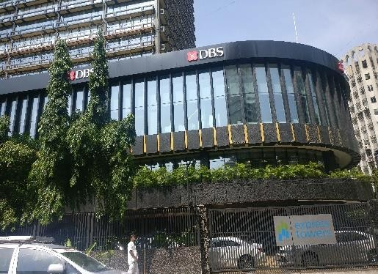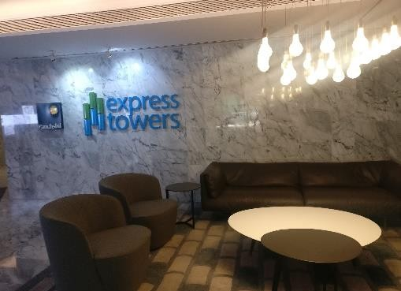

External view of the subject property (SP) View of the lobby

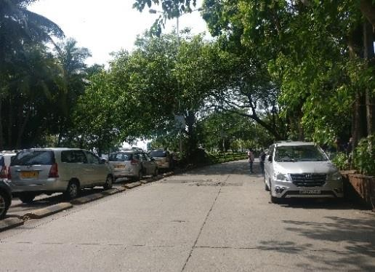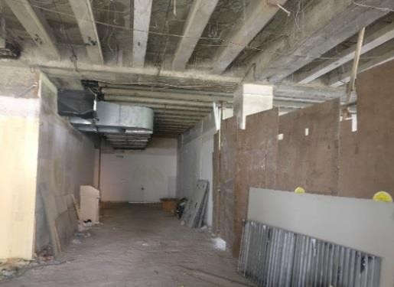

View of primary access road Internal view of a specific vacant unit

in Subject Development

* 1. Tenancy Analysis
     1. Historical Committed Occupancy Rates

The table below highlights the historical occupancy rates at the subject city centre office:

|  |  |  |  |
| --- | --- | --- | --- |
| **March 31, 2017** | **March 31, 2018** | **March 31, 2019** | **March 31, 2020** |
| 97.4% | 93.0% | 98.1% | 93.5% |

*Source: Rent rolls provided by the Client; Indicative of committed occupancy*

* + 1. Lease Expiry Analysis

The graph below highlights the area/leases due for expiry in the coming years:

**Lease Expiry**

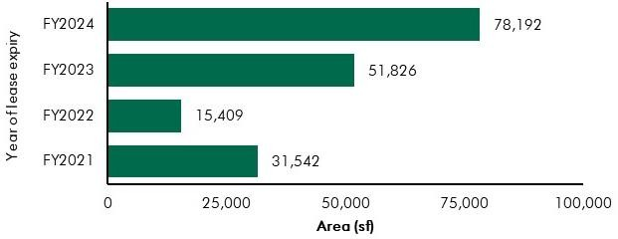

*Source: Rent Roll (representative of financial years)*

Consultants have undertaken an in-depth analysis of the rent roll/ lease deeds shared by the Client, to understand the lease expiry schedule of top tenants at the subject property and rent for those spaces as of date of valuation. The intent of the same is to analyse the risk of tenant churn as well as assessing the re-leasing risk for the property along with opining on the timeframe to lease-up the spaces in case a significant vacancy arises at the property.

* + 1. Escalation Analysis

As per the review of the recently executed leases at the subject property, it is understood that the contracted escalation terms for these leases are in the range of 10.0% to 15.0% every 3 years which are in line with the prevailing market practice witnessed across the submarket and MMR.

* 1. Assumptions Rationale

As highlighted earlier, the subject property is an operational city centre office located along Barrister Rajni Patel Marg, Nariman Point which is the heart of Central Business District (CBD) of Mumbai.

Erstwhile commercial district of Mumbai; major office locations include Fort, Nariman Point, Ballard Estate that are characterized by developed social infrastructure with prominent occupiers including government bodies, financial institutions, trading bourses, etc. The CBD is characterized by the presence of the most expensive and exclusive residential neighbourhoods, landmark hotels and other social and lifestyle infrastructure. It attracts marquee tenants and remains a hub for corporate headquarters and professional services as well as various Government and statutory authorities (such as Mantralaya, Bombay High Court, RBI). Presence of good quality residential dwelling options, proximity to quality healthcare, education and presence of retail options, have resulted in the emergence of the submarket as a self-sustaining region.

* + 1. Demand-Supply Dynamics

6.3.1.1 *Demand, Supply and Vacancy Trends – Mumbai and Central Business District submarket*

Total completed stock in Mumbai Metropolitan Region (MMR) and Central Business District (CBD) as of Q4, 2019 is 122.49 msf and 6.65 msf respectively.

|  |  |  |
| --- | --- | --- |
| **Particular** | **MMR** | **CBD** |
| Cumulative completed stock (Q4 2019) – (in msf) Current occupied stock (Q4 2019) (in msf) Current Vacancy (Q4 2019)  Average Annual Absorption (2014 – 2019) (in msf) | Approx. 122.49 | Approx. 6.65 |
| Approx. 96.81 | Approx. 6.30 |
| Approx. 21.0% | Approx. 5.2% |
| Approx. 5.27 | Approx. 0.04 |

*Source: CBRE Research*

Demand Supply Dynamics (Mumbai Metropolitan Region)

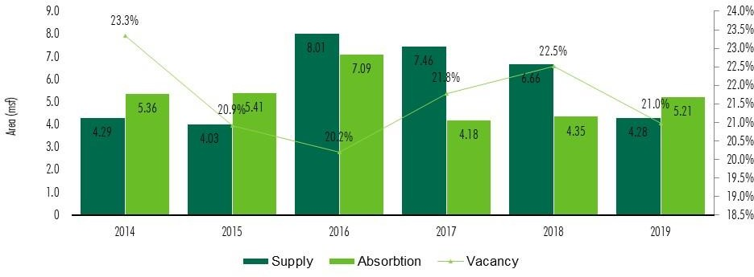

**Demand – Supply (Central Business District)**

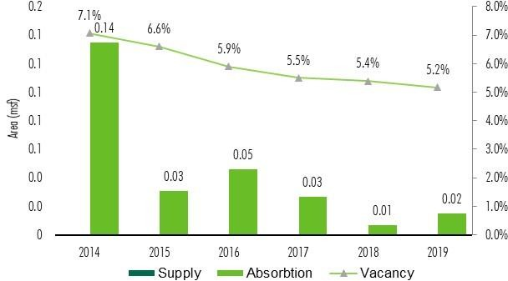

*Source: CBRE Research; *Data only includes Grade A, Multi Tenanted Buildings; with area > 75,000 sf*

*Note: Supply – refers to fresh completed supply added each year; Demand – refers to the quantum of leasing witnessed in each year as part of completed space; the vacancy in the chart accounts for the gap between cumulative stock and occupied stock in the city in any given year.*

Based on our interactions with the market intermediaries involved in the region, it was observed that the lease market rent for office space is primarily determined by the factors such as location, accessibility, type of development, related infrastructure provision for the site, building specifications etc.

Due to strong connectivity and presence of well-developed social infrastructure in the CBD, demand is expected to be stable in this sub-market. Absorption is largely driven by tenants providing high value services (such as consulting and financial services) and there are only a few buildings within the sub- market considered as Grade A offices. Given the market dynamics and development constraint due to

limited developable land in CBD, there has been no new significant supply introduced over the past few years. Stable demand and no new supply have resulted into a vacancy of approx. 5.2% as of December 31, 2019.

6.3.1.1 *Key Developments in Submarket*

The table below highlights the prominent competing developments in the subject submarket:

**Development Name**

Development Type

Leasable Area (in

Vacancy (%)

Base Market Rent (INR

|  |  |  |  |  |
| --- | --- | --- | --- | --- |
|  | | msf) |  | psf pm)* |
| Development 1 | Non-SEZ | 0.1 | Minimal | 200.0 – 250.0 |
| Development 2 | Non-SEZ | 0.2 | Minimal | 200.0 – 250.0 |
| Development 3 | Non-SEZ | 0.2 | 10.0% - 15.0% | 200.0 – 250.0 |
| Development 4 | Non-SEZ | 0.2 | Minimal | 175.0 – 200.0 |

*Source – CBRE Research; *All-inclusive quoted rental on leasable area (Inclusive of CAM and PT)*

* + 1. Lease Rent Analysis

The current quoted rents in subject submarket typically vary between INR 180.0 – 250.0 psf pm on leasable area basis depending upon specifications offered, location and accessibility of the development (viz. along/off the main arterial roads), quality of construction, amenities offered etc. In addition, the maintenance charge for these developments varies in the range of INR 4.0 – 18.0 psf pm.

The below mentioned table incorporated key transactions witnessed across the CBD submarket:

|  |  |  |  |
| --- | --- | --- | --- |
| Date of Transaction | Area (sf) | Tenant | Transacted Rent Value (INR psf pm)* |
| Q4, 2019 | 2,300 | Tenant 1 | 220.0 - 230.0 |
| Q2, 2019 | 6,500 | Tenant 2 | 155.0 - 165.0 |
| Q2, 2019 | 2,500 | Tenant 3 | 200.0 - 210.0 |

*Source – CBRE Research; *Bare Shell Rents exclusive of CAM*

As mentioned above the transacted market rent in CBD (other than the subject property) are typically in the range of INR 150.0 to 230.0 psf pm depending on building positioning, development grade, amenities provided, specifications of the development, tenant profile of the development, etc. Further, CAM charges are identified to be approx. INR 4.0 to 18.0 psf pm depending on the type of the structure.

Additionally, the location enjoys good connectivity, presence of well-developed social infrastructure and superior tenant profile. Further, the demand for commercial real estate in existing developments is expected to be stable in this sub-market largely due to limited supply of Grade A commercial office space.

The key occupiers shall remain companies in financial services sector and corporate offices of large domestic companies.

* 1. Value Assessment
     1. Adopted Methodology

We acknowledge that the approaches to valuation differ considerably and that for a particular purpose, alternative approaches to the valuation can be utilized subject to the Client’s consultations and giving due consideration to the Client’s requirements. Considering the objective of this exercise and the nature of asset involved, the value of the subject property has been assessed through the following approaches:

|  |  |
| --- | --- |
| **Particulars Completed Blocks** | |
| **Valuation Methodology** | Discounted Cash Flow Method (using rent reversion approach) |

The sections below highlight detailed valuation workings for the subject property. Please note that the assumptions/ opinions highlighted in the subsequent sections are to be read in conjunction with Section

1.11 and the following:

*“In the current uncertain environment caused by the outbreak of the Novel Coronavirus (COVID-19), we have considered /* relooked *at various performance parameters and have adopted heuristic/ careful interventions (including but not limited to the points mentioned below) to our projected cashflows based on our view as of the date of valuation.*

* *Limited/ no growth in rent has been considered over the next few quarters*
* *Considering challenges in the short term, timelines have been extended for new space take-up/ future leasing*
* *Additional fit-out period/ rent free months have been incorporated where fit-out works have commenced”*
  + 1. Area statement

Based on information/rent roll provided by the Client, we understand that subject property is a commercial city centre office. Further, the table below highlights the area configuration of the subject property:

**Components Completed leasable area (in sf)**

Office Area (Operational) 472,377

Total 472,377

*Source: Architect certificate and Rent roll provided by Client*

* + 1. Construction Timelines

*6.4.3.1Completed Blocks*

As highlighted earlier, the subject property has 472,377 sft of leasable area and hence there is no cost pending towards construction completion. However, a refurbishment cost of approx. INR 18.19 Mn (expected to be spent in the next quarter) is pending towards the same as of date of valuation.

* + 1. Absorption/ Leasing Velocity and Occupancy Profile

*6.4.4.1 Completed Blocks*

Based on the rent roll provided by the Client and visual inspection during the site visit, we understand that the subject property is fully operational and there are no under-construction or proposed blocks. As per the analysis of the rent roll, it was observed that subject property is approx. 93.5% leased (including the commitments). The table below highlights the absorption assumptions adopted for the vacant space within the subject development:

***Schedule***

|  |  |  |  |  |
| --- | --- | --- | --- | --- |
| ***Particular Absorption Q1 FY 2021*** | ***Q2 FY 2021*** | ***Q3 FY 2021*** | ***Q4 FY 2021*** | ***Total*** |
| Percentage (%) - | 30.35% | 19.28% | 50.37% | 100% |
| Express Towers  Leasable Area (sf) - | 9,264 | 5,885 | 15,377 | 30,526 |
| Cumulative Absorption (%) - | 30.35% | 49.63% | 100.00% | 100.0% |
| Cumulative Absorption (sf) - | 9,264 | 15,149 | 30,526 | 30,526 |

*Source – Valuer Assessment*

The valuation assumptions have been considered based on the Valuer’s assessment of the subject property and the submarket. Also, revenue assumptions, absorption period, etc. are based on market benchmarks and extent of vacancy in the submarket and competing supply.

* + 1. Revenue Assumptions (Office)
       1. *Lease rent assumptions*
          1. Office Component

For this valuation exercise, the lease rent adopted for the area already leased is based on the rent roll shared by the Client. Further, the Valuer has undertaken an in-depth market research exercise to assess the prevailing rent values in the subject submarket. The same has been adopted for the vacant space for the purpose of this valuation exercise.

Based on our market study and based on the analysis of the rent roll provided by the Client, following rents have been adopted for the purpose of value assessment of the subject property.

|  |  |  |  |  |
| --- | --- | --- | --- | --- |
| **Component** | **Completed Leasable Area (sf)** | **Leased Area (sf)** | **Basis** | **Rent Adopted* (INR/sf/month)** |
| **Office** | 472,377 | 441,851 | Current Rent for Leased area  Market rent for reversion/ vacant area | In Place Rent - 256.2^ Market Rent – 270.0 |

*Source: Rent roll provided by the Client; Valuer Assessment*

*\* The rents mentioned above exclude other income such as CAM charges, parking income received from the tenants, etc.; ^weighted average bare shell rent for area already leased including lease revenue from mobile towers – as per rent roll shared by Client*

The above market rent assumption is adopted for the entire city centre office. In addition to undertaking an in-depth market analysis, a detailed analysis of the rent roll was also undertaken to understand aspects such as area occupied, current rent and expiry analysis of the key tenants in the park. Additionally, the Valuer also analysed the historical occupancy pattern at the subject development and lease-up time frame for spaces being vacated by tenants during the last 3 years. The lease-up time was observed to be 2 - 6 months based on quantum of space being renewed/ re-leased.

Based on the size and scale of operations of these tenants, the Valuer has adopted individual market rent assumptions for larger tenants in the subject development. For larger tenants, we have assumed that post lease expiry, these spaces will revert to market rent prevailing at that point in time. However, given the large size of these spaces, the Client will require longer lease-up time. Therefore, the Valuer has adopted a higher lease-up time, ranging from 2 – 6 months depending on area to be leased.

**Area Range (in sf)**

**Marginal Rent Strategy (Discount to Market Rent / Lease-up Time)**

Leased Area >30,000 Renewal at market (6 months) Leased Area >10,000 and <30,000 Renewal at market (3 months) Leased Area <10,000 Renewal at market (2 months)

*Source: Valuer Assessment*

* + - 1. *Rent Escalation*

Based on an analysis of existing rent rolls, it was observed that the typical escalation clause in the subject property is approx. 15.0% after every three years, which is in-line with the trend observed in the market. The same has been adopted by the Valuer for the vacant area and renewals at the subject property.

* + - 1. *Fit-out Rents*

As per the information (rent roll) provided by the Client, we understand that in addition to the lease rent, there is an additional rent towards fit-out for few of the tenants. These rents are in the range of INR 40.0 to 50.0 psf pm. For this valuation, we have adopted the tenant wise fit-out rents as provided in the rent roll.

* + - 1. *Other Revenues*

In addition to lease rent revenues, commercial developments typically have additional sources of revenue. These include revenues because of security deposit (refunded at the time of lease expiry / exit), other miscellaneous income (such as cell sites, retail areas, food court, etc.), mark-up on Common Area Maintenance (CAM) charges/ CAM margin, etc.

The assumptions considered for the aforementioned revenue heads for the purpose of this valuation exercise are based on the rent roll/ information provided by the Client. The same has been cross-checked with the prevailing market norms for other revenues and were found to be broadly in line.

The assumptions adopted for other revenues are as tabulated below:

|  |  |  |
| --- | --- | --- |
| **Nature of Income** | **Details** | **Units** |

|  |  |  |
| --- | --- | --- |
| Bare shell Security Deposit* | 6 months | No. of months’ bare shell rent |
| Mark-Up on CAM/ CAM margin | 15.0% | % |

*Source: Client’s Inputs & Valuer assessment; *Refunded at the time of lease expiry/exit*

* + 1. Expense Assumptions
       1. *Major Repairs and Improvements*

The following table highlights the assumptions towards the refurbishment expenses in the subject development:

|  |  |  |
| --- | --- | --- |
| **Expense Head** | **Total Pending Cost (INR Mn) \*** | **Quarter of Completion** |
| Refurbishment Expenses | 18.19 | Q1, FY21 |
| *Source Client Input; Valuer Assessment.* |  |  |

* + - 1. *Other Expenses*

The following table highlights the assumptions towards other expenses in the subject development:

|  |  |  |
| --- | --- | --- |
| Nature of Expense | Details | Basis |
| Opex projects and admin expenses | 1.0% | % of total income |
| Asset Management Fee^ | 3.0% | % of gross rental income |
| Transaction cost on Exit | 1.0% | % of terminal value |

*Source: Client Input; Valuer assessment*

*^ Asset Management fee has been considered a below the NOI line item*

* + 1. Other Assumptions
       1. *Vacancy provision*

Based on the prevailing market benchmarks, a vacancy provision of 2.5% has been adopted upon assessment of terminal value

* + - 1. *Revenue escalation*

Based on prevailing market condition, historical market rent growth achieved by the subject property and our interactions with market participants, we are of the opinion that the annual rent growth for the subject property will be 3.0% from Q1, FY 2022 onwards.

* + - 1. *Rent – free period*

Based on the trend prevalent in the subject submarket, we have considered a rent-free period of 3 months for the subject property from the lease commencement date (for future / new leases)

* + - 1. *Brokerage*

Based on prevalent market dynamics, we have considered brokerage equivalent to 2 month of rental income for future / new leases

* + 1. Capitalization Rates

As highlighted in section 3.3, the cap rate adopted for the office spaces are 7.5%.

* + 1. Discount Rate

For discounting the cash flows, the appropriate discounting rate has been calculated based on estimated ‘Weighted Average Cost of Capital’ (WACC). The detailed analysis of WACC rate adopted for the subject property has been detailed in Section 3.4 of this report.

6.5 Value of the Subject Property

Based on the above-mentioned analysis, the value of the subject property is estimated as follows:

|  |  |  |  |
| --- | --- | --- | --- |
| Component | Value (INR Mn) |  | % Share |
| Express Towers | 17,866 |  | 100% |
| **Express Towers** |  | **INR 17,866 Mn** |  |

##### Embassy 247

* 1. Property Description

|  |  |
| --- | --- |
| **Brief Description** | |
| Particulars | **Details** |
| **Property Name** | Embassy 247 |
| **Address** | LBS Marg, Vikhroli West, Mumbai – 400083 |
| **Land Area** | 7.27 Acres |
| **Leasable Area** | Total Completed Leasable Area – 1.19 msf |

*Source: Title Report, Architect Certificate;*

* + 1. Site Details

Situation: Subject property – ‘Embassy 247’ is an operational office located along LBS

Road in Vikhroli West, Mumbai, Maharashtra.

Location: The subject property is located along LBS Road, Vikhroli West, Mumbai at approx. 10-12 km from the Chhatrapati Shivaji International Terminal. Based on the site visit, we understand that the subject property is accessible through LBS Road which is further connected to JVLR (Jogeshwari-Vikhroli Link Road) that connects eastern and western suburbs. Further it is in proximity to Vikhroli Railway Station (~1-2 km) and Kanjurmarg railway station at approx. 1-2 km away. Excellent transport connectivity with multiple metro and suburban railways stations near is a key differentiating factor in this sub-market, given an increasing focus by corporate occupiers on the ease of commute for their employees.

The distance of the subject property from some of the prominent nodes in the city is provided in the exhibit below:

|  |  |
| --- | --- |
| ***Landmark*** | ***Approx. distance (in km)*** |
| Jogeshwari Vikhroli Link Road | <1 |
| Eastern Express Highway | 1 – 2 |
| Kanjurmarg Railway Station | 1 – 2 |
| Vikhroli Railway Station | 1 – 2 |
| Chhatrapati Shivaji International Terminal | 10 – 12 |
| Chhatrapati Shivaji Domestic Terminal | 11 – 12 |
| Bandra Kurla Complex (part of ABD) | 12 – 14 |
| Nariman Point (part of CBD) | 28 – 30 |

*Source: Consultants’ research*

Surrounds: The subject property is surrounded as follows:

North: Commercial Development (HCC Ltd) South: Commercial Development (Raj Plaza) East: Railway line

West: Primary Access Road (LBS Road)

Potential changes in surroundings:

Vikhroli traditionally was an industrial submarket however over the recent years, there is a shift from industrial to residential / commercial activities. The subject submarket is now emerging as a residential hub and an emerging location for corporate occupiers.

Suitability of existing use:

Considering the profile of surrounding developments, the subject property is opined to be suited for its current use viz. IT/ITeS development (along with support retail)

EMBASSY OFFICE PARKS MANAGEMENT SERVICES PRIVATE LIMITED | EMBASSY OFFICE PARKS REIT



The following map indicates the location of the subject property and surrounding developments:

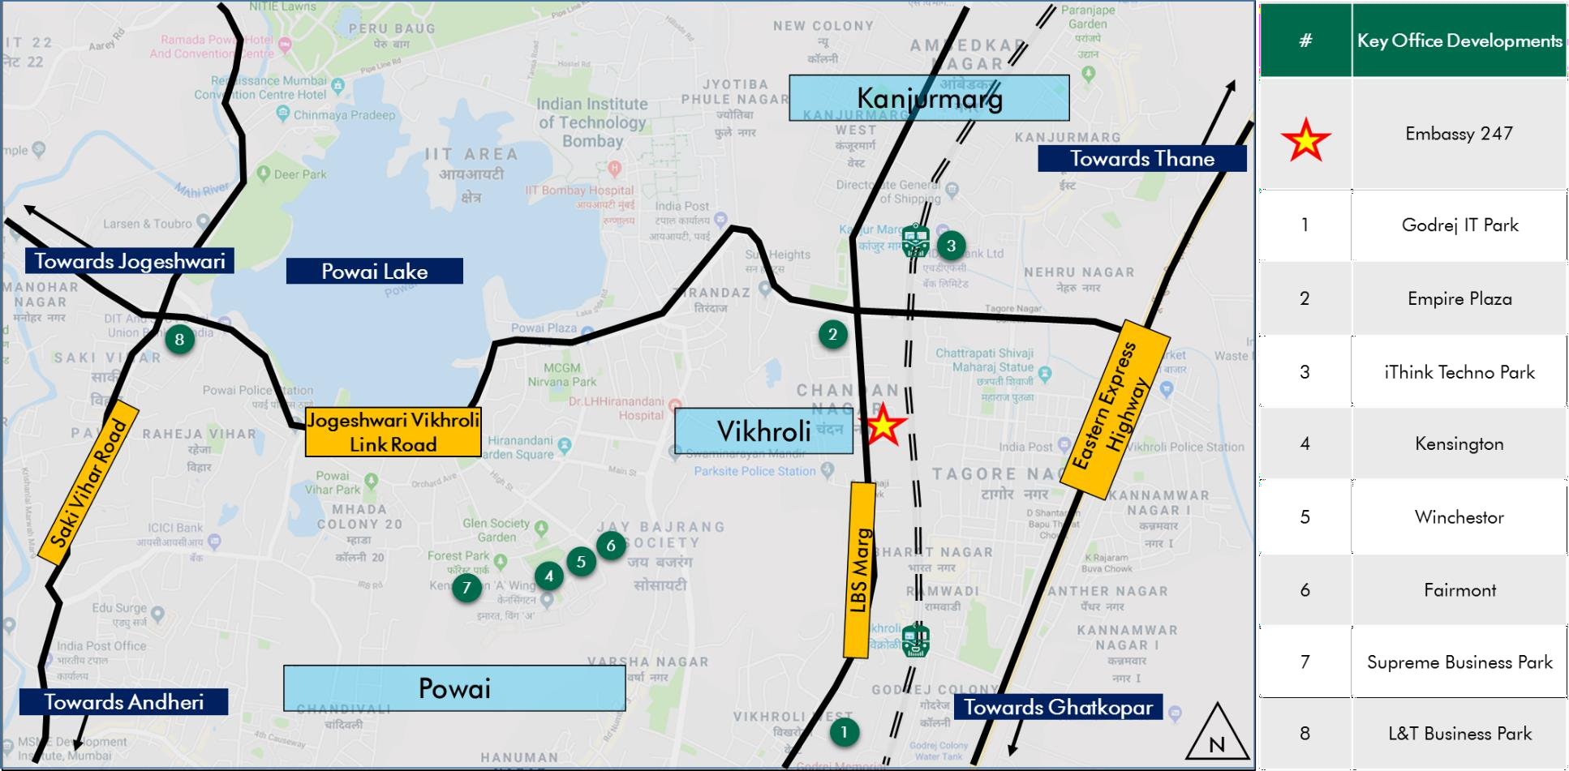

**Location Map for the Subject Property**

*Source: Consultants’ Research*

Shape: Based on site plan provided by the Client and visual inspection during the site visit, it is understood that the subject land parcel is irregular in shape.

Topography: Based on the site plan and as corroborated with our site visit, the site appears to be even and on the same level as abutting access roads and adjoining properties.

Frontage: Based on visual inspection and measurements made on Google maps, we understand that the frontage is approximately 150 meters along the LBS Marg.

Accessibility: Based on the site visit, it was observed that the subject property has primary access from Lal Bahadur Shastri (LBS) Road.

Please refer Exhibit & Addenda for the site plan of the subject property.

* + 1. Legal Details

As per the title due diligence undertaken by Little & Company and as provided by the Client, we understand that the legal address of the subject property is CTS No. 105, 105/1 to 38, 105/39 (pt), 105/39 (pt), 105/40-41, 105/42, 105/44 (pt), 106 and 107 of Village Hariyali, LBS Marg, Vikhroli (W), Mumbai, Maharashtra. Additionally, it is understood that the subject property is freehold in nature.

Further, this valuation exercise is based on the premise that the subject property has a clear title and is free from any encumbrances, disputes, claims, etc. The Consultants have not made any enquiries in this regard with the relevant legal/ statutory authorities.

* + 1. Town Planning

Zoning As per the Occupancy Certificates provided by the Client, we understand that the subject property is zoned for IT (Non-SEZ) use. As per the Occupancy Certificate, it is located within the jurisdiction of Municipal Corporation of Greater Mumbai (MCGM). The same has been considered for this valuation. The Consultants have made no further enquiries with the local authorities in this regard.

The permissible land use adopted by the Consultants for the subject property has been based on information/review of various documents provided by the Client. It must be noted that all factual data viz. permissible development control regulations, land area and achievable FSI have also been based on information/review of various documents (such as title deed, plan sanction letter, site plan, etc.) provided by the Client or assumed based on building regulations, and no physical verification/ measurement has been undertaken for this valuation exercise.

For this exercise, it has been assumed that all developments adhere to building regulations as prescribed by the relevant authorities. The Consultants have not validated the information provided by the Client with the relevant development authorities.

Approved Usage:

Based on Occupancy Certificates provided by the Client and visual inspection during our site visit, we understand that the subject property is an IT/ITeS (Non-SEZ) office building. The current use of the subject property has been provided by the Client and is broadly in agreement with the rules and regulations as prescribed by the local development authority. However, the Consultants have not made any enquiries with the relevant local authorities to validate the same for its specific applicability to the subject property.

Restrictions: As per feedback received from the Client, there are no restrictions on the current use of the property.

Natural or induced hazards:

We believe the project / site has been developed to withstand natural or induced hazards (except for extreme / out of the ordinary hazards).

* + 1. Statutory Approvals, One time Sanctions & Periodic Clearances

Please refer section 18.3 on Statutory Approvals, One time Sanctions & Periodic Clearances

EMBASSY OFFICE PARKS MANAGEMENT SERVICES PRIVATE LIMITED | EMBASSY OFFICE PARKS REIT

* + 1. Area Details, Type and Age of Existing Structures

The table below highlights the detailed area break-up of the subject development:

**Subject Property**

**Developable Area (sf)\***

**Completed Leasable Area (sf)**

**Committed Area (sf)**

**Occupied Area (sf)**

Embassy 247 858,271 1,189,544 1,108,424 1,108,424

*Source: Rent roll, Occupancy Certificate, Architect Certificate provided by Client; *represents achieved FSI area*

**Block**

**Building Elevation**

**SEZ/Non-SEZ**

**Age\***

**Leasable /Saleable Area**

|  |  |  |  |  |
| --- | --- | --- | --- | --- |
| **Name** |  |  | **(Years)** | **(sf)** |
|  |  | **Completed Blocks** |  |  |
| Wing A | 2B+G+11 | Non SEZ | 11 | 367,668 |
| Wing B | 2B+G+14 | Non SEZ | 11 | 460,481 |
| Wing C | 2B+G+11 | Non SEZ | 11 | 361,395 |
| Total |  |  |  | 1,189,544 |

* *For all the three wings viz. A, B & C, the part occupancy certificate has been received in 2009 and remaining in 2014 for upper 2 floors for all the wings*

**Details Completed Blocks**

Grade of the Building Grade A

LEED Certification* Gold (Core & Shell)

Structural Design 2B+G+11 (Wing A & C) 2B+G+14(Wing A)

Status of Finishing Warm Shell

Comments on Obsolescence The building is currently well maintained

* *Indian Green Building Council Certificate*

* + 1. Construction, Services and Finishes

**Particulars Details**

Handover condition Warm Shell

Passenger elevators Provided

Service elevators Provided

Power back-up Provided

Building management system Provided

Security systems Provided

Air conditioning Provided

Firefighting services Provided

Car parks provided MLCP and Basement Car parks

*Source: Information provided by Client; Lease Deed*

* + 1. Condition & Repair

Subject property is developed and managed to international standards offering best-in-class asset management, environment friendly green initiatives and state of art infrastructure / amenities such as food court, revamped lobby and forecourt which makes it a preferred option for domestic as wells as Multinational Corporations (MNCs). Based on information provided by the Client and site visit, it is understood that the subject property is in good condition and is being maintained well. The subject property houses a recently revamped food court and open landscaped areas and public spaces at the podium. A comprehensive upgrade program over the last two years has led to the asset being repositioned as a new-age corporate destination. The table below highlights the major repairs and maintenance work/ infrastructure upgrade works undertaken in the past few years:

|  |  |  |
| --- | --- | --- |
| Expense Head | Total Cost (INR Mn) | Quarter of Completion |
| New Operational office | 4.5 | Q3, FY 2016 |
| Lobby Refurbishment | 22 | Q3, FY 2017 |
| Landscaping & External Lobby Refurbishment | 24.09 | Q3, FY 2018 |
| Cooling Tower Refurbishment | 1.82 | Q3, FY 2018 |
| Fire Shaft Sealing | 1.94 | Q3, FY 2018 |
| Security System Upgradations | 3.27 | Q3, FY 2018 |
| Façade Upgrade | 23.63 | Q4, FY2021 |
| Signage Rebranding | 4.95 | Q4, FY2021 |
| Renovations- Civil Works | 10.55 | Q4, FY2021 |

*Source – Information provided by the Client*

* + 1. Property Photographs

Please refer to the property photographs highlighted below:

Embassy 247

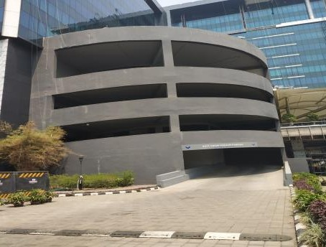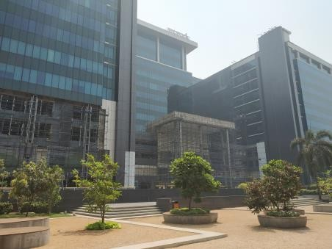

External view of the subject property (SP) External view of the SP

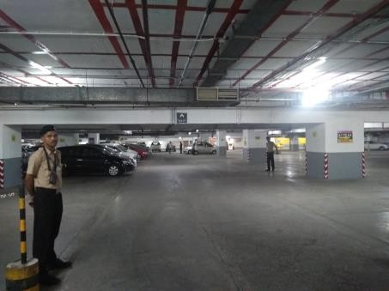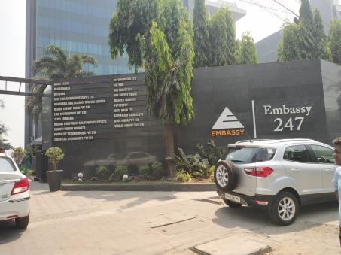

View of the Basement Car Park External view of the SP

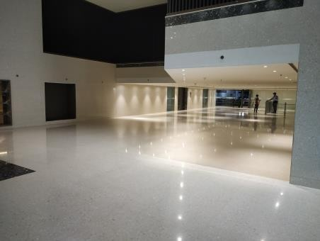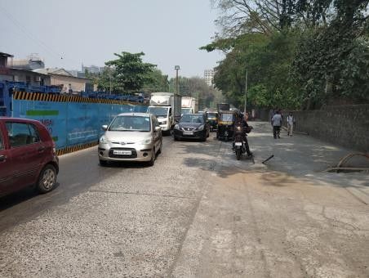

View of the internal lobby View of the primary access road/entrance

* 1. Tenancy Analysis
     1. Historical Committed Occupancy Rates

The table below highlights the historical occupancy rates at the subject development:

|  |  |  |  |
| --- | --- | --- | --- |
| **March 31, 2017** | **March 31, 2018** | **March 31st, 2019** | **March 31st, 2020** |
| 77.1% | 80.9% | 93.1% | 93.2% |

*Source: Analysis of rent rolls provided by the Client; Indicative of committed occupancy*

* + 1. Lease Expiry Analysis

The graph below highlights the area/leases due for expiry in the coming years:

**Lease Expiry**

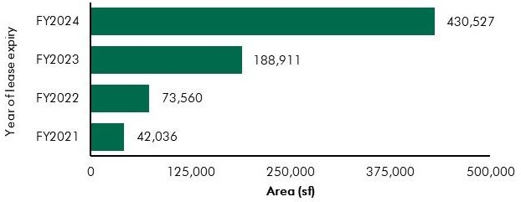

*Source: Rent Roll (representative of financial years)*

Consultants have undertaken an in-depth analysis of the rent roll/ lease deeds shared by the Client, to understand the lease expiry schedule of top tenants at the subject property and rent for those spaces as of date of valuation. The intent of the same is to analyse the risk of tenant churn as well as assessing the re-leasing risk for the property along with opining on the timeframe to lease-up the spaces in case a significant vacancy arises at the property.

* + 1. Escalation Analysis

As per the review of recent executed leases at the subject property it is understood that the contracted escalation terms for these leases are in the range of 10.0% to 15.0% every 3 years which are in line with the prevailing market practice witnessed across the submarket and MMR.

* 1. Assumptions Rationale

As highlighted earlier, the subject property is an operational commercial development located along LBS Road, Vikhroli which lies in Peripheral Business District (East) of Mumbai.

The Western part of the submarket is accessible by the LBS road while the Eastern part is bordered by the Eastern Express Highway. The prime residential area in the region lies along the Western side of the suburb, i.e. LBS Marg.

Traditionally, the submarket catered to demand emanating from industrial activities because of the presence of manufacturing companies like Godrej & Boyce, HCC, IndiaTubes Mills etc. Further, redevelopment activity of these industrial units leads to the emergence of this sublocation as a residential and commercial hub. Further, various infrastructure initiatives such as the Eastern Freeway, development of JVLR etc. which lead to improved connectivity to the airport, CBD, manpower pockets of the eastern and western suburbs are expected to garner significant demand for real estate in future. Presence of good quality residential dwelling options, proximity to quality healthcare & education and presence of retail options, results in a submarket to emerge as a self-sustaining region.

* + 1. Demand-Supply Dynamics
       1. *Demand, Supply and Vacancy Trends – Mumbai and Peripheral Business District submarket*

Total completed stock in Mumbai Metropolitan Region (MMR) and Peripheral Business District (PBD East) as of Q4, 2019 is 122.49 msf and 18.82 msf respectively.

|  |  |  |
| --- | --- | --- |
| **Particular** | **MMR** | **PBD (East)** |
| Cumulative completed stock (Q4 2019) – (in msf) Current occupied stock (Q4 2019) (in msf) Current Vacancy (Q4 2019)  Average Annual Absorption (2014 – 2019) (in msf)* | Approx. 122.49 | Approx. 18.82 |
| Approx. 96.81 | Approx. 15.14 |
| Approx. 21.0% | Approx. 19.5% |
| Approx. 5.27 | Approx. 0.52^ |

*Source: CBRE Research; *average annual absorption of technology and SEZ buildings in vicinity of Embassy 247 location (i.e. Powai, Vikhroli and Kanjurmarg);^ assuming zero absorption for years which had positive gross absorption but negative net absorption*

Demand Supply Dynamics (Mumbai Metropolitan Region)



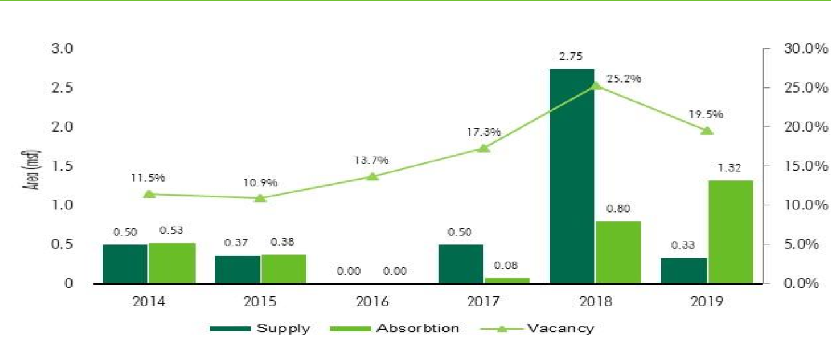

**Demand – Supply (Peripheral Business District - East)**

*Source: CBRE Research; * Data only includes Grade A, Multi Tenanted Buildings; with area > 75,000 sf*

*Note: Supply – refers to fresh completed supply added each year; Demand – refers to the quantum of leasing witnessed in each year as part of completed space; the vacancy in the chart accounts for the gap between cumulative stock and demand in the city in any given year.*

Technology developments that have been launched near Embassy 247 (such as Powai, Kanjurmarg and Vikhroli areas) have been successfully leased and currently there is limited future technology supply in this area. Due to superior asset management and recent upgrades, Embassy 247 has attracted high quality, new-age tenants.

* + - 1. *Key Developments in Submarket*

The table below highlights the prominent competing developments in the subject submarket:

**Development Name**

Development Type

Leasable Area (in

msf)

Vacancy (%) Market Rental (INR

psf pm)*

|  |  |  |  |  |
| --- | --- | --- | --- | --- |
| Development 1 | Non SEZ - IT | 0.9 | 5.0 – 10.0% | 100.0 - 110.0# |
| Development 2 | Non SEZ - IT | 0.5 | 20.0% - 25.0% | 95.0 - 105.0 |
| Development 3 | Non SEZ - IT | 0.7 | Minimal | 110.0 – 120.0 |
| Development 4 | Non SEZ - IT | 0.5 | Minimal | 140.0 - 150.0 |
| Development 5 | Non SEZ - IT | 0.25 | Minimal | 140.0 - 150.0 |

*Source: CBRE Research; *Warm Shell Market Rent exclusive of CAM and Property Tax; #including CAM and PT*

* + 1. Lease Rental Analysis

The current rent in submarket typically vary between INR 90.0 – 150.0 psf pm on leasable area basis depending upon specifications offered, location and accessibility of the development (viz. along/off the main arterial roads), quality of construction, developer brand, amenities offered, etc. In addition, the maintenance charge for these developments varies in the range of INR 8.0 – 13.0 psf pm. The parking charges in such developments range between INR 5,000 – 8,500 per bay per month for covered car parks.

Based on our market research, we understand that the rentals in the subject submarket have witnessed minimal appreciation in between 2014 & 2019. Although the existing developments in the market have seen a moderate rent growth of 1.7% p.a. between 2014 and 2019, limited IT supply in the market should support rental growth in the future for the technology buildings in the submarket.

The table below highlights some of the recent transacted rental values for IT/ITeS developments in the influence region of the subject property:

|  |  |  |  |
| --- | --- | --- | --- |
| Date of Transaction | Area (sf) | Tenant | Transacted Rental Value (INR psf pm)* |
| Q3, 2019 | 50,000 | Tenant 1 | 93.0 – 97.0 (BS) |
| Q2, 2019 | 50,000 | Tenant 2 | 93.0 – 97.0 (BS) |
| Q1, 2019 | 50,000 | Tenant 3 | 93.0 – 97.0 (BS) |

*Source – CBRE Research; * Rent excluding CAM and PT; BS – Bare Shell*

The sub-market offers plenty options of Grade ‘A’ technology developments in Powai, Vikhroli, Kanjurmarg. Further, there is a lack of planned grade A development in a foreseeable future. This is expected to reduce the vacancy levels in the sub-market while simultaneously increasing the lease rents

steadily. Affordable rents coupled with large format technology office spaces is expected to drive the sub- market going forward.

* 1. Value Assessment
     1. Adopted Methodology

We acknowledge that the approaches to valuation differ considerably and that for a particular purpose, alternative approaches to the valuation can be utilized subject to the Client’s consultations and giving due consideration to the Client’s requirements. Considering the objective of this exercise and the nature of asset involved, the value of the subject property has been assessed through the following approaches:

|  |  |
| --- | --- |
| **Particulars Completed Blocks** | |
| **Valuation Methodology** | Discounted Cash Flow Method (using rental reversion approach) |

The sections below highlight detailed valuation workings for the subject property. Please note that the assumptions/ opinions highlighted in the subsequent sections are to be read in conjunction with Section

1.11 and the following:

*“In the current uncertain environment caused by the outbreak of the Novel Coronavirus (COVID-19), we have considered /* relooked *at various performance parameters and have adopted heuristic/ careful interventions (including but not limited to the points mentioned below) to our projected cashflows based on our view as of the date of valuation.*

* *Limited/ no growth in rent has been considered over the next few quarters*
* *Considering challenges in the short term, timelines have been extended for new space take-up/ future leasing*
* *Additional fit-out period/ rent free months have been incorporated where fit-out works have commenced”*
  + 1. Area statement

Based on information/rent roll provided by the Client, we understand that subject property is a commercial city centre office. Further, the table below highlights the area configuration of the subject property:

**Components Completed leasable area (in sf)**

Office Area (Operational) 1,189,544

Total 1,189,544

*Source: Architect certificate and Rent roll provided by Client*

* + 1. Construction Timelines

*7.4.3.1 Completed Blocks*

As highlighted earlier, the subject property has 1.19 msf of completed leasable area and approx. 39.12 Mn of cost is to be incurred on refurbishments over the next 4 quarters as of date of valuation for the completed blocks.

* + 1. Absorption/ Leasing Velocity and Occupancy Profile

*7.4.4.1 Completed Blocks*

Based on the information provided by the Client, we understand that the subject property is fully operational. Based on the rent roll, it is observed that the subject property has a total leasable area of approx. 1,189,544 sf. Of the total leasable area, approx. 1,108,424 sf is leased and approx. 81,120 sf of space is vacant as on date of valuation.

Leasing timelines

The leasing period for the vacant space within the subject property is assumed based on demand-supply dynamics within the subject submarket as well as characteristics of the subject property. The table below highlights the absorption assumptions adopted for the vacant space within the subject development:

|  |  |  |  |  |
| --- | --- | --- | --- | --- |
| ***Particular Absorption Q1 FY 2021*** | ***Q2 FY 2021*** | ***Q3 FY 2021*** | ***Q4 FY 2021*** | ***Total*** |
| Percentage (%) -  Embassy 247 | 40.96% | 22.84% | 36.20% | 100% |
| Leasable Area (sf) - | 33,224 | 18,531 | 29,365 | 81,120 |
| Cumulative Absorption (%) - | 40.96% | 63.80% | 100.00% | 100.00% |
| Cumulative Absorption (sf) - | 33,224 | 51,755 | 81,120 | 81,120 |

***Schedule***

*Source: Valuer’s assessment*

The valuation assumptions have been considered based on the Valuer’s assessment of the subject property and the subject submarket. Also, revenue assumptions, absorption period, etc. are based on market benchmarks and extent of vacancy in the subject submarket and competing supply.

* + 1. Revenue Assumptions (Office)
       1. *Lease rent assumptions*
          1. Office Component

For the purpose of this valuation, the marginal rental adopted for the area already leased is based on the rent roll shared by the Client. Further, the Valuer has undertaken an in-depth market research exercise to assess the prevailing rental values in the subject submarket. The same has been adopted for the vacant space for the purpose of this valuation exercise.

Based on our market study and based on the analysis of the rent roll provided by the Client, following rent has been adopted for the purpose of value assessment of the subject property.

|  |  |  |  |  |
| --- | --- | --- | --- | --- |
| **Component** | **Completed Leasable Area (sf)** | **Leased Area (sf)** | **Basis** | **Rental Adopted* (INR/sf/month)** |
|  |  |  | Current Rent for Leased area | 99.4^ |
| **Office** | 1,189,544 | 1,108,424 | Market rental for reversion/ vacant area of office space | 110.0** |

*Source: Rent roll provided by the Client; Valuer Assessment*; *\* The rent mentioned above exclude other income such as CAM charges, parking income received from the tenants, etc.; ^weighted average warm shell rental for area already leased – as per rent roll shared by Client; ** Inclusive of car park rent*

In addition to undertaking an in-depth market analysis, a detailed analysis of the rent rolls was also undertaken to understand aspects such as area occupied, current rental and expiry analysis of the key tenants in the development. Additionally, the Valuer also analysed the historical market occupancy pattern and lease-up time frame for spaces being vacated by tenants during the last 3 years. The lease- up time was observed to be 2 - 6 months based on quantum of space being renewed / re-leased.

For the larger tenants, the Valuer has assumed that post lease expiry, these spaces will revert to market rent prevailing at that point in time. However, given the large size of these spaces, the Client will require longer lease-up time. Therefore, the Valuer has adopted a higher lease-up time, ranging from 2 – 6 months depending on area to be leased.

**Area Range (in sf) Market Rental Strategy (Lease-up Time)**

Leasable Area >25,000 and <40,000 Renewal at market (2 months)

Leasable Area >50,000 and <100,000 Renewal at market (4 months) Leasable Area >100,000 Renewal at market (6 months)

*Source: Valuer Assessment*

* + - 1. *Rent Escalation*

Based on an analysis of existing lease rolls, it was observed that the typical escalation clause in the subject property is approx. 15.0% after every three years, which is in-line with the trend observed in the market. The same has been adopted by the Valuer for the vacant area and renewals at the subject property.

* + - 1. *Fit-out Rentals*

As per the information (rent roll) provided by the Client, we understand that there is no fit-out rental being charged to any tenant in the subject property.

* + - 1. *Other Revenues*

In addition to lease rent revenues, commercial developments typically have additional sources of revenue. These include revenues because of security deposit (refunded at the time of lease expiry / exit), other miscellaneous income (such as cell sites, retail areas, food court, etc.), mark-up on Common Area Maintenance (CAM) charges/ CAM margin, etc.

The assumptions considered for the aforementioned revenue heads for the purpose of this valuation exercise are based on the rent roll/ information provided by the Client. The same has been cross-checked with the prevailing market norms for other revenues and were found to be broadly in line.

The assumptions adopted for other revenues are as tabulated below: -

|  |  |  |
| --- | --- | --- |
| Nature of Income | Details | Basis |
| Miscellaneous Income (Income from cell sites) | 1.0% | % of rental income |
| Bare shell Security Deposit* | 6 months | No. of months’ bare shell rent |
| Mark-Up on CAM/ CAM margin | 15.0% | % |

*Source: Client’s Inputs & Valuer’s assessment; *Refunded at the time of lease expiry/exit*

* + 1. Expense Assumptions
       1. *Major Repairs and Improvements*

The following table highlights the inputs towards the refurbishment costs expected for the subject development:

**Particular Refurbishment cost to be spent**

Embassy 247 INR 39.1 Mn – expected to be spent over next 4 quarters

*Source: Client’s input; Valuer’s Assessment*

* + - 1. *Other Expenses*

The following table highlights the assumptions towards other expenses in the subject development:

|  |  |  |
| --- | --- | --- |
| Nature of Expense | Details | Basis |
| Opex projects and admin expenses | 1.0% | % of total income |
| Asset Management Fee^ | 3.0% | % of gross rental income |
| Transaction cost on Exit | 1.0% | % of terminal value |

*Source: Client Input; Valuer assessment*

*^ Asset Management fee has been considered a below the NOI line item*

* + 1. Other Assumptions
       1. *Vacancy provision*

Based on the prevailing market benchmarks and the subject property profile, a vacancy provision of 2.5% has been adopted upon assessment of terminal value.

* + - 1. *Revenue escalation*

Based on prevailing market condition, historical market rent growth achieved by the subject property and our interactions with market participants, we are of the opinion that the annual rent growth for the subject property will be 3.0% from Q1, FY 2022 onwards.

* + - 1. *Rent – free period*

Based on the trend prevalent in the subject submarket, we have considered a rent-free period of 3 months for the subject property from the lease commencement date (for future / new leases)

* + - 1. *Brokerage*

Based on prevalent market dynamics, we have considered brokerage equivalent to 2 months of rental income for future / new leases

* + 1. Capitalization Rates

As highlighted in section 3.3, the cap rate adopted for the office spaces are 8%.

* + 1. Discount Rate

For discounting the cash flows, the appropriate discounting rate has been calculated based on estimated ‘Weighted Average Cost of Capital’ (WACC). The detailed analysis of WACC rate adopted for the subject property has been detailed in Section 3.4 of this report.

7.5 Value of the Subject Property

Based on the above-mentioned analysis, the value of the subject property is estimated as follows:

|  |  |  |  |
| --- | --- | --- | --- |
| Component | Value (INR Mn) |  | % Share |
| Operational Blocks | 16,624 |  | 100.0% |
| **Embassy 247** |  | **INR 16,624 Mn** |  |

##### First International Financial Centre (FIFC)

* 1. Property Description

|  |  |
| --- | --- |
| **Brief Description** | |
| Particulars | **Details** |
| **Property Name** | First International Financial Centre (FIFC) |
| **Address** | Plot no. C-54 & C-55, G-Block, Bandra Kurla Complex Road, Bandra Kurla Complex, Mumbai, Maharashtra-400051 |
| **Land Area** | Total 1.99 Acres |
| **Leasable Area** | Total Operational Area* – 658,390 sf  Total Leasable area (under the purview of this valuation) – 360,947 sf |

*Source: Architect Certificate, Title Report, MMRDA Lease Deed; *denotes the total operational area of the subject development*

* + 1. Site Details

Situation: ‘First International Financial Centre’ (FIFC) is an operational Grade-A city centre office located along Bandra Kurla Complex Road, Bandra Kurla Complex, Mumbai, Maharashtra – 400051. FIFC is a sought-after front-office development in the BKC sub-market given its superior design, high quality specifications, institutional management, marquee occupants, efficient floor plate and availability of contiguous stacks and renowned F&B options.

Location: The subject property is located in Bandra Kurla Complex (part of ABD) which has emerged as one of the most prominent corporate destinations today due to the presence of major financial institutions, Non-banking financial corporations (NBFC), major government run or aided corporate entities (NSE, IL&FS and private equity funds etc.). BKC, a planned commercial / corporate hub by MMRDA, connects the Western Suburbs through Western Express highway and the Eastern Suburbs and Thane through Santacruz Chembur Link Road and Eastern Express Highway. Further, the sub-market is situated in proximity to domestic and international terminal of the airport.

The distances from key hubs to the subject property are presented in the table below:

|  |  |
| --- | --- |
| Landmark | Distance (km) |
| Bandra Kurla Complex | <1 |
| Bandra Railway Station | 5 – 6 |
| Eastern Express Highway | 5 – 7 |
| Bandra Worli Sea Link | 6 – 8 |
| Chhatrapati Shivaji Domestic Terminal | 6 – 7 |
| Chhatrapati Shivaji International Terminal | 7 – 9 |
| Nariman Point (CBD) | 18 – 22 |

*Source: Consultants’ research*

Surrounds: The property is surrounded as follows:

North: Primary access road (BKC Road) South: Secondary access road

East: Vacant Land Parcel (MMRDA land parcel)

West: Commercial Development (TCG Financial Centre)

Potential changes in surroundings:

The subject sub-market (BKC) is an established commercial district of the City and has witnessed significant development activity (across commercial developments, hospitality and residential/staff quarters) in the past. Considering the location advantage (viz. centre of the City) and related connectivity benefit, the subject region is expected to continue to grow as a commercial destination.

Suitability of existing use:

Considering the profile of surrounding developments, the subject property is opined to be suited for its current use viz. commercial office development (along with support retail).

Shape: Based on the visual inspection, we understand that the subject land parcel is regular in shape.

Topography: Based on the site plan and as corroborated with our site visit, the site appears to be even and on the same level as abutting access roads and adjoining properties.

Frontage: Based on review of site plan, visual inspection and measurements made on Google maps, we understand that the frontage is approximately 100 meters along the Bandra Kurla Complex Road.

Accessibility: Based on site visit, it was observed that the subject property is accessible through Bandra Kurla Complex Road, which acts as the primary access. Also, the subject property is accessible through an internal road, which acts as a secondary access road for the development. Vehicular access to the subject property is through secondary access road.

EMBASSY OFFICE PARKS MANAGEMENT SERVICES PRIVATE LIMITED | EMBASSY OFFICE PARKS REIT

The following map indicates the location of the subject property and surrounding developments:

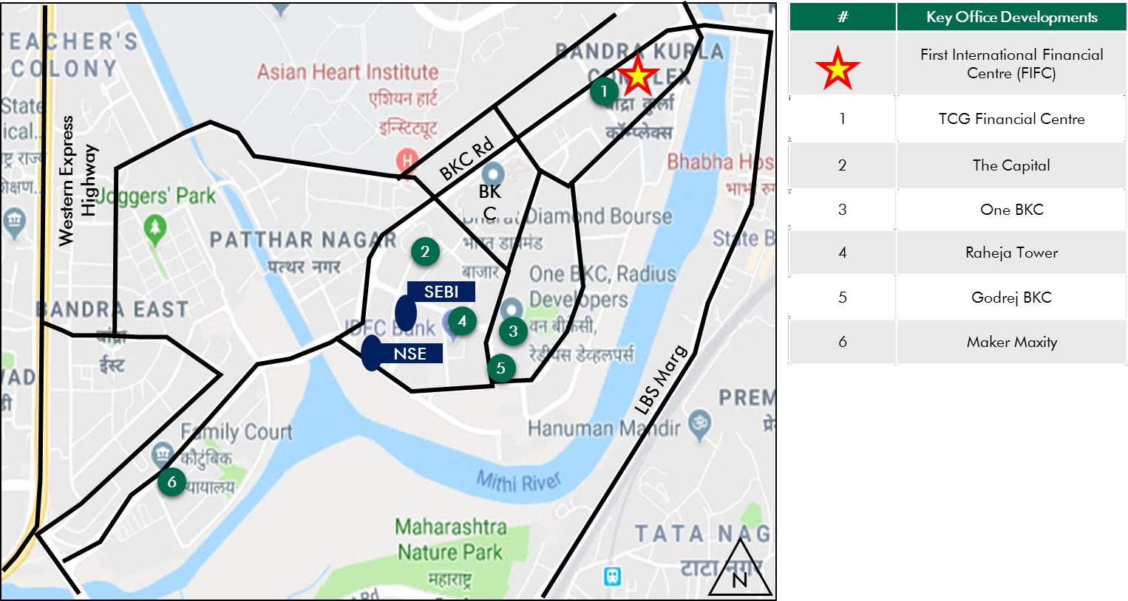

**Location Map for the Subject Property**

*Source: Consultants’ Research*

* + 1. Legal Details

As per the title due diligence undertaken by Shardul Amarchand Mangaldas & Co. and as provided by the Client, we understand that the legal address of the subject property is Plot no C-54, C-55, G-Block, Bandra Kurla Complex Road, Bandra Kurla Complex, Mumbai, Maharashtra – 400051. Additionally, it is understood that the subject property is leasehold in nature, with remaining lease term of approx. 68 years.

Further, this valuation exercise is based on the premise that the subject property has a clear title and is free from any encumbrances, disputes, claims, etc. The Consultants have not made any inquiries in this regard with the relevant legal/ statutory authorities.

* + 1. Town Planning

Zoning Based on review of MMRDA lease deed provided by the client, it is identified that the subject property is a commercial zoned land parcel. The same has been considered for the purpose of this valuation. The Consultants have made no further inquiries with the local authorities in this regard.

The permissible land use adopted by the Consultants for the subject property has been based on information/review of MMRDA Lease Deed provided by the Client. It must be noted that all factual data viz. permissible development control regulations, land area and achievable FSI have also been based on information/review of various documents (such as title deed, plan sanction letter, site plan, etc.) provided by the Client or assumed based on building regulations, and no physical verification/ measurement has been undertaken for the purpose of this valuation exercise.

For the purpose of this exercise, it has been assumed that all developments (existing / under construction / proposed) adhere to building regulations as prescribed by the relevant authorities. The Consultants have not validated the information provided by the Client with the relevant development authorities.

Approved Usage:

Based on occupancy certificates provided by the Client and visual inspection during our site visit, we understand that the subject property is an operational office. The current use of the subject property has been provided by the Client and is broadly in agreement with the rules and regulations as prescribed by the local development authority. However, the Consultants have not made any enquiries with the relevant local authorities to validate the same for its specific applicability to the subject property.

Restrictions: As per feedback received from the Client, there are no restrictions on the current use of the property.

Natural or induced hazards:

We believe the project/ site has been developed to withstand natural or induced hazards (with the exception of extreme / out of the ordinary hazards).

* + 1. Statutory Approvals, One time Sanctions & Periodic Clearances

Please refer section 18.3 on Statutory Approvals, One time Sanctions & Periodic Clearances

* + 1. Area Details, Type and Age of Existing Structures

The table below highlights the detailed area break-up of the subject development:

**Development Name Developable Area (sf)** Completed Leasable**

**Area (sf)**

**Committed Area (sf)**

**Occupied Area (sf)**

FIFC 438,854** 360,947# 280,810 280,810

*Source: Rent roll/ Architect Certificate provided by the Client; #Leasable area under the purview of this valuation exercise; ** represents achieved FSI area*

|  |  |  |  |  |
| --- | --- | --- | --- | --- |
| **Block Building Elevation SEZ/Non-SEZ Age (Years) Leasable Area (sf) Name**  **Completed Blocks** | | | | |
| FIFC | 2B+G+13 | Non-SEZ | 8 | 360,947# |
| Total |  |  |  | 360,947 |

*Source: Rent roll, Occupancy Certificate provided by Client; #Leasable area under the purview of this valuation exercise*

**Details Completed Blocks**

Grade of the Building Grade A

LEED Certification Gold (Core & Shell) *

Structural Design (2B + G + up to 13 upper floors) Status of Finishing Warm Shell

Comments on Obsolescence The building is currently well maintained

*\*Indian Green Building Council certificate*

* + 1. Site Services and Finishes

**Particulars Details**

Handover condition Warm Shell

Passenger elevators Provided

Service elevators Provided

Power back-up Provided

Building management system Provided

Security systems Provided

Air conditioning Provided

Firefighting services Provided

Car park provision MLCP / Covered car parks

*Source: Information provided by Client, Site Visit, Lease Deeds*

* + 1. Condition & Repair

Subject property is developed and managed to international standards offering best-in-class asset management and environment friendly green initiatives, which makes it a preferred option for domestic as wells as Multinational Corporations (MNCs). Based on information provided by the Client and site visit, it is understood that the subject property is in good condition and is being maintained well. The table below highlights the major repairs and maintenance work/ infrastructure upgrade works undertaken in the past few years:

|  |  |  |
| --- | --- | --- |
| **Expense Head** | **Total Cost (INR mn)** | **Quarter of Completion** |
| Lobby Renovation | 66.00 | Q2, FY 2020 |
| Signage Rebranding | 2.00 | Q2, FY 2020 |
| Remediation Work | 563.00 | Q3, FY 2019 |

*Source: Information provided by Client*

* + 1. Property Photographs

Please refer to the property photographs highlighted below:

First International Financial Centre (FIFC)

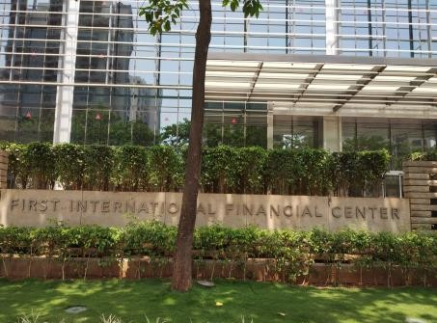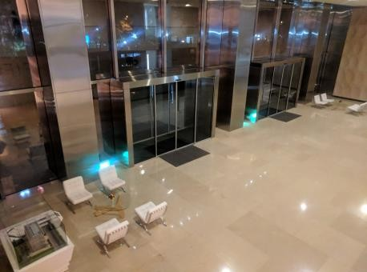

External view of the subject property Entrance Lobby of the subject property

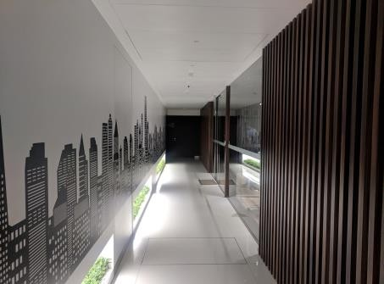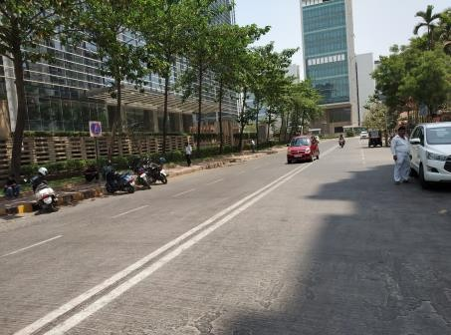

View of FIFC office lobby View of Access Road

* 1. Tenancy Analysis
     1. Historical Committed Occupancy Rates

The table below highlights the historical occupancy rates at the subject development:

|  |  |  |  |
| --- | --- | --- | --- |
| **March 31, 2017** | **March 31, 2018** | **March 31, 2019** | **March 31, 2020** |
| 19.6% | 44.0% | 60.8% | 77.8% |

*Source: Analysis of rent rolls provided by the Client*

* + 1. Lease Expiry Analysis

The graph below highlights the area/leases due for expiry in the coming years:

**Lease Expiry**

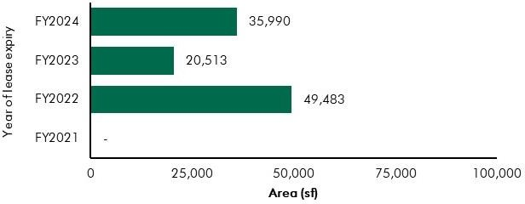

*Source: Rent Roll (representative of financial years)*

Consultants have undertaken an in-depth analysis of the rent roll/ lease deeds shared by the Client, to understand the lease expiry schedule of top tenants at the subject property and rent for those spaces as of date of valuation. The intent of the same is to analyse the risk of tenant churn as well as assessing the re-leasing risk for the property along with opining on the timeframe to lease-up the spaces in case a significant vacancy arises at the property.

* + 1. Escalation Analysis

As per the review of recently executed leases at the subject property, it is understood that the contracted escalation terms for these leases are in the range of 5.0% every year or 15.0% every 3 years which are in line with the prevailing market practice witnessed across the sub-market and MMR region.

* 1. Assumptions Rationale

As highlighted earlier, the subject property is an operational office located along Bandra Kurla Complex Road, Bandra Kurla Complex, Mumbai.

Bandra Kurla Complex (“BKC”), part of Mumbai’s Alternate Business District (ABD) sub-market has emerged as one of the most important office destinations in Mumbai due to the presence of major financial institutions as well as other large corporates (such as pharmaceutical companies & consulting firms) and government entities. BKC is well-connected to the rest of the city via road and rail. The sub- market is well connected to the residential suburbs and other commercial hubs of Mumbai through the Western and Eastern Express highways. Further, there are residential pockets in the locality of the complex as well as established social and physical infrastructure including hotels and hospitals.

* + 1. Demand and Supply Dynamics
       1. *Demand, Supply and Vacancy Trends – MMR and Alternate Business District (ABD) Sub-market*

Total completed stock in Mumbai Metropolitan Region (MMR) and Alternate Business District (ABD) as of Q4, 2019 is 122.49 msf and 13.41 msf respectively.

|  |  |  |
| --- | --- | --- |
| **Particular** | **MMR** | **ABD** |
| Cumulative completed stock (Q4 2019) – (in msf) Current occupied stock (Q4 2019) (in msf) Current Vacancy (Q4 2019)  Average Annual Absorption (2014 – 2019) (in msf) | Approx. 122.49 | Approx. 13.41 |
| Approx. 96.81 | Approx. 11.16 |
| Approx. 21.0% | Approx. 16.8% |
| Approx. 5.27 | Approx. 0.65 |

*Source: CBRE Research*

**Demand – Supply Dynamics (MMR)**



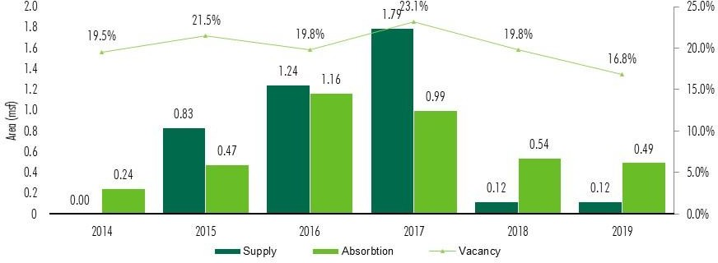 **Demand – Supply Dynamics (ABD)**

*Source: CBRE Research; Note: Supply – refers to fresh completed supply added each year; Absorption – refers to the quantum of leasing witnessed in each year as part of completed space; the vacancy in the chart accounts for the gap between cumulative stock and demand in the city in any given year.*

Bandra Kurla Complex (a part of ABD) has presence of a number of multinational companies in the banking, financial services, insurance and pharmaceuticals sector. Additionally, the sub-market enjoys excellent social and physical infrastructure including hotels, hospitals, etc. BKC has witnessed sustained leasing activity from the financial services sector and given strong network effect due to presence of various banks and other financial sector players, is likely to continue as the preferred hub for financial services tenants in Mumbai.

* + - 1. *Key Developments in Sub-Market*

The table below highlights the prominent / competing developments in the subject sub-market:

**Development Name**

**Development Type**

**Leasable Area (msf)**

**Approx. Vacancy (%)**

**Rent (INR psf pm)#**

Development 1 Non-SEZ 0.8 5.0 – 10.0% 420.0 – 430.0

Development 2 Non-SEZ 0.6 2.5 – 5.0% 300.0 – 310.0

Development 3 Non-SEZ 1.2 10.0 – 15.0% 300.0 – 310.0

*Source: CBRE Research; #All-inclusive quoted rental on leasable area*

* + 1. Lease Rent Analysis

The current rents in subject sub-market typically vary between INR 300.0 – 430.0 psf pm on leasable area basis depending upon specifications offered, location and accessibility of the development (viz. along/off the main arterial roads), quality of construction, developer brand, amenities offered, etc. Further, CAM charges (included in the above-mentioned rents) are identified to be approx. INR 15.0 to

20.0 psf pm depending on the type of the structure. The parking charges in such developments range between INR 10,000 – 15,000 per bay per month for covered car parks.

The table below highlights some of the recent lease transactions for developments in the influence region of the subject property:

|  |  |  |  |
| --- | --- | --- | --- |
| **Date of Transaction** | **Area (sf)** | **Tenant** | **Transacted Rent Value (INR psf pm) \*** |
| Q4, 2019 | 6,500 | Tenant 1 | 420.0 – 430.0 (Furnished) |
| Q4, 2019 | 20,000 | Tenant 2 | 420.0 – 430.0 (Furnished) |
| Q3, 2019 | 6,500 | Tenant 3 | 370.0 – 380.0 (Furnished) |
| Q3, 2019 | 15,000 | Tenant 4 | 375.0 – 385.0 (BS) |
| Q3, 2019 | 3,500 | Tenant 5 | 375.0 – 385.0 (BS) |
| Q3, 2019 | 70,000 | Tenant 6 | 240.0 – 250.0 (BS) |
| Q2, 2019 | 25,000 | Tenant 7 | 240.0 – 250.0 (BS) |
| Q2, 2019 | 135,000 | Tenant 8 | 240.0 – 250.0 (WS) |
| Q1, 2019 | 25,000 | Tenant 9 | 315.0 - 325.0# (WS) |

*Source: CBRE Research* Rents are exclusive of CAM but includes PT on leasable area basis; Note: WS – Warm shell;* #Inclusive *of CAM, PT*

Considering BKC being at heart of Mumbai city along with superior connectivity from the entire MMR, superior infrastructure within BKC, planned infrastructure developments, increased occupier interest and stickiness of quality tenants towards grade-A developments, the rentals are expected to witness upward movements.

* 1. Value Assessment
     1. Adopted Methodology

We acknowledge that the approaches to valuation differ considerably and that for a particular purpose, alternative approaches to the valuation can be utilized subject to the Client’s consultations and giving due consideration to the Client’s requirements. Considering the objective of this exercise and the nature of asset involved, the value of the subject property has been assessed through the following approaches:

|  |  |
| --- | --- |
| **Particulars Completed Blocks** | |
| **Valuation Methodology** | Discounted Cash Flow Method (using rent reversion approach) |

The sections below highlight detailed valuation workings for the subject property. Please note that the assumptions/ opinions highlighted in the subsequent sections are to be read in conjunction with Section

1.11 and the following:

*“In the current uncertain environment caused by the outbreak of the Novel Coronavirus (COVID-19), we have considered /* relooked *at various performance parameters and have adopted heuristic/ careful interventions (including but not limited to the points mentioned below) to our projected cashflows based on our view as of the date of valuation.*

* *Limited/ no growth in rent has been considered over the next few quarters*
* *Considering challenges in the short term, timelines have been extended for new space take-up/ future leasing*
* *Additional fit-out period/ rent free months have been incorporated where fit-out works have commenced”*
  + 1. Area statement

Based on information/rent roll provided by the Client, we understand that subject property is a commercial city centre office. Further, we understand that the total leasable area of the subject development is 658,390 sf. But, from the rent roll provided by the client, the total leasable area considered for the purpose of this valuation is 360,947 sf.

* + 1. Construction/ Refurbishment Timelines

*8.4.3.1 Completed Blocks*

As highlighted earlier, the subject property has 360,947 sf of leasable area under the purview of this valuation exercise and a refurbishment cost of approx. INR 65.00 Mn (expected to be spent in next 4 quarters) is pending towards the same as of date of valuation.

* + 1. Absorption/ Leasing Velocity and Occupancy Profile

*8.4.4.1 Completed Blocks*

In order to arrive at the future absorption levels at the subject property, we have analysed the historical demand and supply trends coupled with the estimation of future supply proposed to be introduced in the subject sub-market.

The total leasable area of the development is approx. 360,947 sf and the total occupied space as on date of valuation admeasure approx. 280,810 sf. The table below highlights the absorption assumptions adopted for the vacant space within the subject development:

|  |  |  |  |  |
| --- | --- | --- | --- | --- |
| ***Particular Absorption Q2 FY 2021*** | ***Q3 FY 2021*** | ***Q4 FY 2021*** | ***Q1 FY 2022*** | ***Total*** |
| Percentage (%) - | 23.26% | 38.37% | 38.37% | 100% |
| FIFC  Leasable Area (sf) - | 18,640 | 30,748 | 30,748 | 80,137 |
| Cumulative Absorption (%) - | 23.26% | 61.63% | 100% | 100% |
| Cumulative Absorption (sf) - | 18,640 | 49,388 | 80,137 | 80,137 |

***Schedule***

*Source – Valuer Assessment*

The valuation assumptions have been considered based on the Valuer’s assessment of the subject property and the subject sub-market. Also, revenue assumptions, absorption period etc. are based on market benchmarks and extent of vacancy in the subject sub-market and competing supply.

* + 1. Revenue Assumptions
       1. *Lease rent assumptions*

For this valuation exercise, the lease rent adopted for the area already leased is based on the rent roll shared by the Client. Further, the Valuer has undertaken an in-depth market research exercise to assess the prevailing rents in the subject sub-market. The same has been adopted for the vacant space for this valuation exercise.

Based on market assessment and analysis of the rent roll provided by the Client, following rents have been adopted for value assessment of the subject property.

|  |  |  |  |  |
| --- | --- | --- | --- | --- |
| **Component** | **Leasable Area (sf)** | **Leased Area**  **(sf)** | **Basis** | **Marginal Rent Adopted\***  **(INR psf pm)** |
|  |  |  | Current Rent for Leased area (Office/ Retail) | 296.5^ |
| **Leasable Area** | 360,947 | 280,810 |  |  |
|  |  |  | Marginal rent for reversion/ vacant area | Office – 285.0 |

*Source: Rent roll provided by the Client; Valuer Assessment*

*\* The rents mentioned above exclude other income such as CAM charges, parking income received from the tenants, fit-out incomes etc.;*

*^weighted average warm shell rent for area already leased – as per rent roll shared by Client;*

The above marginal rent assumption is adopted for the entire subject development. In addition to undertaking an in-depth market analysis, a detailed analysis of the rent rolls was also undertaken to understand aspects such as area occupied, current rent and expiry analysis of the key tenants in the development. Additionally, the Valuer also analysed the historical occupancy pattern at the subject sub- market and lease-up time frame for spaces being vacated by tenants during the last 3 years. The lease- up time was observed to be 2 - 5 months based on quantum of space being renewed/ re-leased.

For the larger tenants, the Valuer assumed that post lease expiry, these spaces will revert to market rent prevailing at that point in time. However, given the large size of these spaces, the Client will require longer lease-up time. Therefore, the Valuer has adopted a higher lease-up time, ranging from 2 – 5 months depending on area to be leased.

**Component (in sf)**

**Market Rent Strategy (Discount to Market Rent/ Lease-up Time)**

Leasable Area > 50,000 Renewal at market (5 months) Leased Area >30,000 and <50,000 Renewal at market (2 months)

*Source: Valuer Assessment*

* + - 1. *Rent Escalation*

Based on an analysis of existing lease rolls, it was observed that the typical escalation clause in the subject property is either 5.0% per annum or 15.0% every three years, which is in-line with the trend observed in the market. The same has been adopted by the Valuer for the vacant area.

* + - 1. *Fit-out Rents*

As per the information (rent roll) provided by the Client, we understand that in addition to the lease rents, there is rent towards fit-outs for one of the tenants. The rent is INR 16.0 psf pm. For this valuation, we have adopted the tenant wise fit-out details as provided in the rent roll.

* + - 1. *Other Revenues*

In addition to lease rent revenues, commercial developments typically have additional sources of revenue. These include revenues because of security deposit (refunded at the time of lease expiry / exit), other miscellaneous income (such as cell sites, retail areas, food court, etc.), mark-up on Common Area Maintenance (CAM) charges/ CAM margin, etc.

The assumptions considered for the aforementioned revenue heads for the purpose of this valuation exercise are based on the rent roll/ information provided by the Client. The same has been cross-checked with the prevailing market norms for other revenues and were found to be broadly in line.

The assumptions adopted for other revenues are as tabulated below:

|  |  |  |
| --- | --- | --- |
| **Nature of Income** | **Details** | **Units** |

Bare shell Security Deposit* 6 months No. of months’ bare shell rent

|  |  |  |
| --- | --- | --- |
| **Nature of Income** | **Details** | **Units** |

Mark-Up on CAM/ CAM margin 15.0% %

*Source: Client’s Inputs & Valuer assessment; *Refunded at the time of lease expiry/exit*

* + 1. Expense Assumptions
       1. *Major Repairs and Improvements*

Based on the information shared by the Client, a total refurbishment costs amounting to INR 65 Mn is to be incurred in the next 4 quarters. The same has been considered for the purpose of this valuation exercise.

* + - 1. *Other Expenses*

The following table highlights the assumptions towards other expenses in the subject development:

|  |  |  |
| --- | --- | --- |
| Nature of Expense | Details | Basis |
| Opex projects and admin expenses | 1.0% | % of total income |
| Asset Management Fee^ | 3.0% | % of gross rental income |
| Transaction cost on Exit | 1.0% | % of terminal value |

*Source: Client Input; Valuer assessment*

*^ Asset Management fee has been considered a below the NOI line item*

* + 1. Other Assumptions
       1. *Vacancy provision*

Based on the prevailing market benchmarks, historical & current occupancy for the subject property, etc. a vacancy provision of 2.5% has been adopted upon assessment of terminal value

* + - 1. *Revenue escalation*

Based on prevailing market condition, historical market rent growth achieved by the subject property and our interactions with market participants, we are of the opinion that the annual rent growth for the subject property will be 3.0% from Q1, FY 2022 onwards.

* + - 1. *Rent – free period*

Based on the trend prevalent in the subject sub-market, we have considered a rent - free period of 3 months for the subject property from the lease commencement date (for future / new leases)

* + - 1. *Brokerage*

Based on prevalent market dynamics, we have considered brokerage equivalent to 2 months of rental income for future / new leases

* + 1. Capitalization Rates

The capitalization rate adopted for the office spaces is 7.75%.

* + 1. Discount Rate

For discounting the cash flows, the appropriate discounting rate has been calculated on the basis of estimated ‘Weighted Average Cost of Capital’ (WACC). The detailed analysis of WACC rate adopted for the subject property has been detailed in Section 3.4 of this report.

8.5 Value of the Subject Property

Based on the above-mentioned analysis, the value of the subject property is estimated as follows:

|  |  |  |  |
| --- | --- | --- | --- |
| Component | Value (INR mn) |  | % Share |
| FIFC | 13,911 |  | 100.0% |
| **FIFC** |  | **INR 13,911 Mn** |  |

##### Embassy TechZone

* 1. Property Description

|  |  |
| --- | --- |
| **Brief Description** | |
| Particulars | **Details** |
| **Property Name** | Embassy TechZone |
| **Address** | Plot No. 3/A and Plot No. 3/B, Rajiv Gandhi Infotech Park, Hinjewadi, Phase-II, Village Marunji, Taluka Mulshi, District Pune, Maharashtra. |
| **Land Area** | Total 67.45 acres |
|  | Total Completed Leasable Area ~ 2.16 mn sf |
| **Leasable Area** | Total Under Construction Leasable Area ~ 0.88 mn sf |
|  | Total Proposed Leasable Area ~ 2.43 mn sf |

*Source: Title Report, Architect Certificate*

* + 1. Site Details

Situation: Embassy TechZone is an office park located in Phase 2, Rajiv Gandhi Infotech Park, Hinjewadi, Pune, Maharashtra

Location: The subject property is a high quality open campus office park and is one of the largest developments in its submarket. The submarket is a prominent commercial technology hub of Pune city which has presence of major SEZ developments like Embassy TechZone (subject property), Quadron, Blue Ridge, Ascendas International Tech Park, etc. Further, the submarket also has presence of IT parks like Pesh Infotech, Indo Global Software Tech Park, Radius Tech Park, Panchshil Tech Park, etc. In addition, some of the campuses of IT majors such as Wipro, Infosys, Emerson Innovations, HCL, etc are also located in the submarket.

Apart from IT/ITeS developments, the subject micro-market is also witnessing an increasing residential activity primarily catering to demand of the working populace of Hinjewadi & nearby micro-markets. Key residential projects in the micro-markets includes developments by prominent players like Kohinoor Developers, Paranjape Schemes, TCG, Xrbia, Kolte Patil, Mittal Brothers, Shapoorji, etc. The subject micro- market is surrounded by other notable markets like Wakad, Tathawade, etc. which are located along the Mumbai – Bengaluru Bypass Highway. Further, the micro- market has adequate social and physical infrastructure to support the working and resident population. Some of the social infrastructure development in the micro- market include Blue Ridge Public School, Pawar Public School, Sanjeevani Hospital, Ruby Hall Clinic, etc.

The distances from key hubs to the subject property are presented in the table below:

Landmark Distance (km)

National Highway 48 (Mumbai – Bengaluru bypass highway) 5 – 6

Pune Railway Station 20 -21

CBD (Peth Areas) 20 – 21

Pune International Airport 26 – 27

*Source: Consultants’ Research*

Surrounds: The property is surrounded as follows:

North: Air Castles (residential development) South: Wipro Phase II Campus

East: Vacant Land West: Vacant Land

Potential changes in surroundings:

With the advent of IT sector in the country, Hinjewadi (the submarket) was developed as a technology hub of the city. Over the years, Rajiv Gandhi Infotech park has been developed across 3 phases.

The boost in commercial real estate segment prompted the development of the submarket as a residential market to cater to the housing needs of the working populace.

The submarket is expected to witness sustainable growth in technology segment with development of further phases of various office parks. This increase of commercial supply will be proportionally matched by residential supply from developments like Megapolis, Life Republic, Blue Ridge, EON homes, Godrej 24, etc.

Suitability of existing use:

Considering the profile of surrounding developments, the subject property is opined to be suited for its current use viz. office park.

Shape: Based on the visual inspection, we understand that the subject land parcel is broadly rectangular in shape.

Topography: Based on our site visit, the site appears to be even and on the same level as abutting access roads.

Frontage: Based on visual inspection and measurements made on Google maps, we understand that subject property has a frontage of approximately 32 m along the internal road emanating from main Hinjewadi phase 2 road.

Accessibility: As mentioned earlier, the subject site is located in Phase 2 of Rajiv Gandhi IT Park, Hinjewadi, Pune. The property has access through an internal road emanating from Hinjewadi Phase 2 road.

EMBASSY OFFICE PARKS MANAGEMENT SERVICES PRIVATE LIMITED | EMBASSY OFFICE PARKS REIT

The following map indicates the location of the subject property and surrounding developments:

**Location Map for the Subject Property**

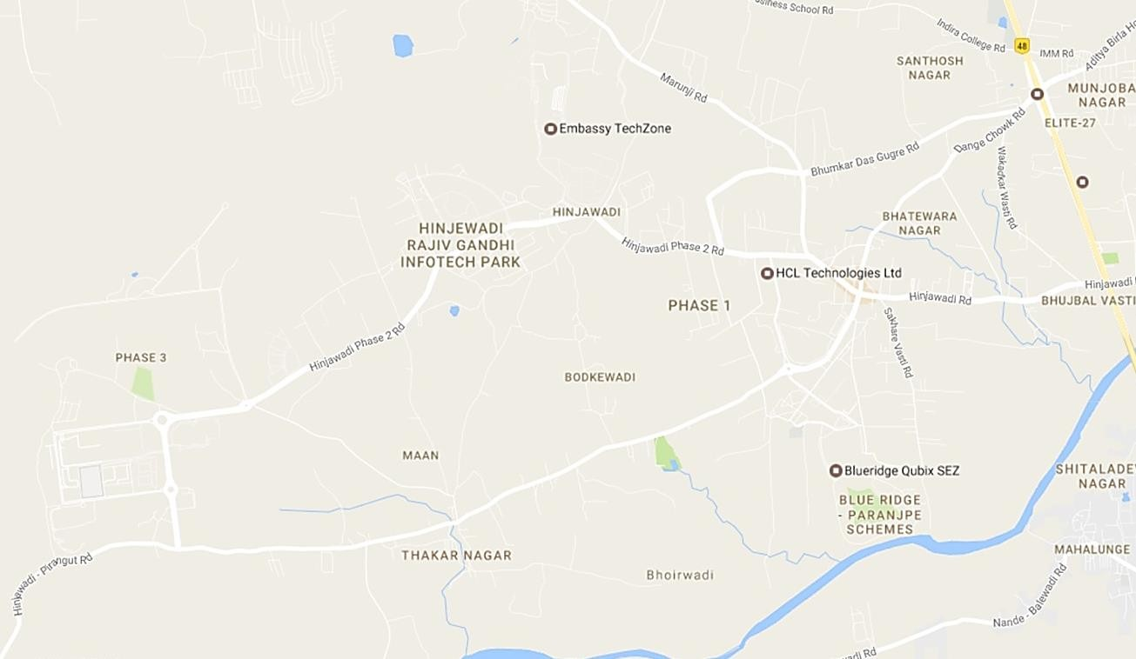

Towards

Mumbai

Marunji Road

Embassy Quadron

Infosys

Wipro

Campus

Embassy Qubix

1

Int’l

Biotech

Park

2

Hinjewadi Phase

1

Infosys

1 International Tech Park

Wipro

Campus

Shivaji Chowk

Towards Pune

TCS

Tech

Mahindra

3

3 Radius Tech Park

Megapolis

Blue Ridge

Township

4

Towards

Pirangut

*Map Not to Scale (For Representation Purposes Only)*

Embassy Tech Zone

Embassy Quadron

Embassy Qubix

Rajiv Gandhi

Infotech Park

Embassy Techzone

4 Blue Ridge - Ascendas

Hinjewadi Road

2 Panchshil Tech Park

Hinjewadi Phase

3

Hinjewadi Ph

2 Road

Dange

Chowk Road

Hinjewadi Phase

2

# Key Office Developments

*Source: Consultants’ Research*

* + 1. Legal Details

As per the title due diligence undertaken by King and Partridge and as provided by the Client, we understand that the exact address of the subject property is Plot No. 3/A and Plot No. 3/B, Rajiv Gandhi Infotech Park, Hinjewadi, Phase-II, Village Marunji, Taluka Mulshi, District Pune, Maharashtra. Additionally, it is understood that the subject property is leasehold in nature, with remaining lease term of approx. 80 years.

Further, this valuation exercise is based on the premise that the subject property has a clear title and is free from any encumbrances, disputes, claims, etc. We has not made any inquiries in this regard with the relevant legal/ statutory authorities.

* + 1. Town Planning

Zoning As per the title due diligence report and Client inputs, it was identified that the subject property is a commercial zoned land parcel, granted on lease by Maharashtra Industrial Development Corporation (MIDC), and is approved for development of an office Park. The same has been considered for the purpose of this valuation. The Consultants have made no further inquiries with the local authorities in this regard.

The permissible land use adopted by the Consultants for the subject property has been based on information/review of various documents provided by the Client. It must be noted that all factual data viz. permissible development control regulations, land area and achievable FSI have also been based on information/review of various documents (such as title deed, plan sanction letter, site plan, etc.) provided by the Client or assumed based on building regulations, and no physical verification/ measurement has been undertaken for the purpose of this valuation exercise.

For the purpose of this exercise, it has been assumed that all developments (existing / under construction / proposed) adhere to building regulations as prescribed by the relevant authorities. The Consultants have not validated the information provided by the Client with the relevant development authorities.

Approved Usage:

Based on occupancy certificates provided by the Client and visual inspection during our site visit, we understand that the subject property is an office park, comprising of 6 operational blocks. The current use of the subject property has been provided by the Client and is broadly in agreement with the rules and regulations prescribed by the local development authorities. However, the Consultants have not made any enquiries with the relevant local authorities to validate the same for its specific applicability to the subject property.

Restrictions: As per feedback received from the Client, there are no restrictions on the current use of the property.

Natural or induced hazards:

We are of the opinion that the project/ site has been developed to withstand natural or induced hazards (with the exception of extreme/ out of the ordinary hazards).

* + 1. Statutory Approvals, One Time Sanctions & Periodic Clearances

Please refer section 18.3 on Statutory Approvals, One time Sanctions & Periodic Clearances

EMBASSY OFFICE PARKS MANAGEMENT SERVICES PRIVATE LIMITED | EMBASSY OFFICE PARKS REIT

* + 1. Area Details, Type and Age of Existing Structures

The table below highlights the detailed area break-up of the subject development:

**Development Name**

**Developable Area (Sf)**

**Total Leasable Area (Sf)**

**Completed Leasable Area (Sf)**

**Committed Area (Sf)**

**Occupied Area (Sf)**

Embassy TechZone 9,484,366 5,472,946 2,160,055 2,028,651 2,028,651

*Source: Rent roll, lease deeds, Architect Certificate provided by Client*

|  |  |  |  |  |
| --- | --- | --- | --- | --- |
| **Block Building Elevation SEZ/Non-SEZ Age (Years) Leasable Area (sf) Name**  **Completed Blocks** | | | | |
| Colorado | S2+S1+G+5 | SEZ | 11 | 263,424 |
| Mississippi | S2+S1+G+5 | SEZ | 11 | 264,783 |
| Congo | G+10 | SEZ | 8 | 514,533 |
| Rhine | G+8 | SEZ | 8 | 508,504 |
| Mekong | G+9 | SEZ | 7 | 301,419 |
| Nile | B+G+7 | SEZ | 10 | 298,967 |
| Food Court | G+1 | - | - | 8,425 |
| Total |  |  |  | 2,160,055 |
|  |  | **Under Construction** |  |  |
| Hudson | NA | SEZ | NA | 458,177 |
| Ganges | NA | SEZ | NA | 422,438 |
| Total |  |  |  | 880,615 |
|  |  | **Proposed** |  |  |
| Block 4 | NA | SEZ | NA | 472,316 |
| Block 9 | NA | SEZ | NA | 978,517 |
| Block 10 | NA | SEZ | NA | 941,754 |
| Volga | NA | SEZ | NA | 39,689 |
| Total |  |  |  | 2,432,276 |

*Source: Rent roll, Architect Certificate, Occupancy Certificate provided by Client*

**Details**

**Completed Blocks**

**Under Construction Blocks**

**Land Stage Blocks**

Grade of the Building Grade A - -

LEED Certification* Gold (Mekong Block 1.6) - -

IGBC Certification# Platinum - -

- -

Structural Design Varied (S + G + Up to 10 upper floors)

Status of Finishing Warm Shell - -

Comments on Obsolescence The building is currently well

maintained

- -

Source: Client, *\*U.S. Green Building Council certificate, #Indian Green Building Council*

* + 1. Site Services and Finishes

**Particulars Details**

Handover condition Warm Shell

Passenger elevators Provided

Service elevators Provided

Power back-up Provided

Building management system Provided

Security systems Provided

Air conditioning Provided

Firefighting services Provided

Car parks provided Covered/open car parks

*Source: Information provided by Client, site visit, lease deeds*

Additionally, based on inputs provided by the Client coupled with visual inspection, Embassy TechZone offers various on-site facilities and amenities, including intra-park shuttle services, breakout zone, sports ground, fitness centre, training centre and an amphitheatre

* + 1. Condition & Repair

Subject property is developed and managed to international standards offering best-in-class asset management and environment friendly green initiatives, which makes it a preferred option for domestic as wells as Multinational Corporations (MNCs). Based on information provided by the Client and site visit, it is understood that the subject property is in good condition and is being maintained well. The table below highlights the major repairs and maintenance work/ infrastructure upgrade works to be undertaken in next few years:

Expense Heads

Total Cost (INR Mn)

Total Cost

Total Pending Cost

FY Quarter of

|  |  |  |  |  |
| --- | --- | --- | --- | --- |
| Electrical Power Upgradation | 141.46 | Spent (INR Mn)  92.94 | (INR Mn)  48.52 | Completion  Q3, 2023 |
| Land Scape Development & lighting | 1.79 | 0.80 | 0.99 | Q1, 2022 |
| Park Lobby Upgrade | 29.44 | 18.04 | 11.40 | Q3, 2023 |
| Boundary Wall Construction (West side) | 41.23 | - | 41.23 | Q3, 2023 |
| Entrance Gateway Scheme | 83.27 | 45.33 | 37.94 | Q3, 2023 |
| Sports Facility | 15.99 | - | 15.99 | Q4, 2021 |

|  |  |  |  |  |
| --- | --- | --- | --- | --- |
| Expense Heads | Total Cost (INR Mn | ) S Total Cost ) pent (INR Mn | Total Pending Cost (INR Mn) | FY Quarter of Completion |
| HSD Yard | 12.50 | 4.64 | 7.86 | Q2, 2021 |
| Signages | 5.78 | 1.30 | 4.48 | Q2, 2021 |
| Phase III Capex | 40.40 | 0.00 | 40.40 | Q4, 2021 |
| Others | 44.00 | 14.14 | 29.85 | Q4, 2021 |
| Works by ESPL | 84.29 | 32.58 | 51.71 | Q4, 2021 |
| Works by EPDPL | 209.54 | 70.69 | 138.85 | Q1, 2022 |

*Source: Information provided by Client*

* + 1. Property Photographs

Please refer to the property photographs highlighted below:

|  |  |  |
| --- | --- | --- |
| Embassy TechZone | | |
|  |  |  |

External view of the subject property (SP) ~ Rhine Block

External view of the SP ~ Mississippi Block

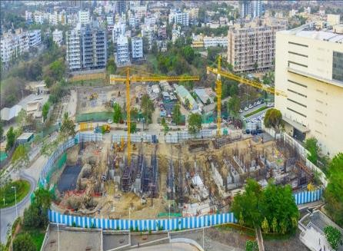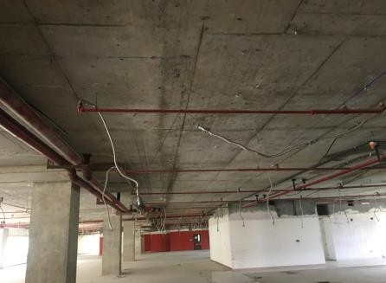

View of Under Construction Blocks ~ Hudson & Ganges

View of one of the vacant spaces in SP

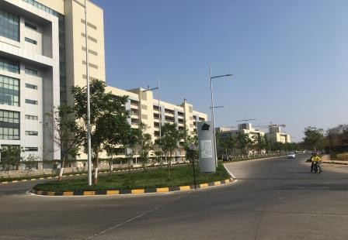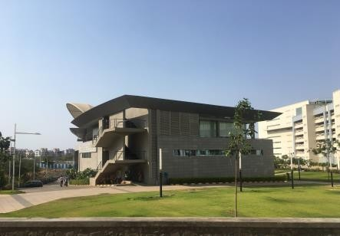

View of internal access road View of the food court

* 1. Tenancy Analysis
     1. Historical Committed Occupancy Rates

The table below highlights the historical occupancy rates at the subject development:

|  |  |  |  |
| --- | --- | --- | --- |
| **March 31, 2017** | **March 31, 2018** | **March 31, 2019** | **March 31, 2020** |
| 77.9% | 86.8% | 84.9% | 93.9% |

*Source: Rent rolls provided by the Client, Indicative of committed occupancy*

* + 1. Lease Expiry Analysis

The graph below highlights the area/leases due for expiry in the coming years:

**Lease Expiry**

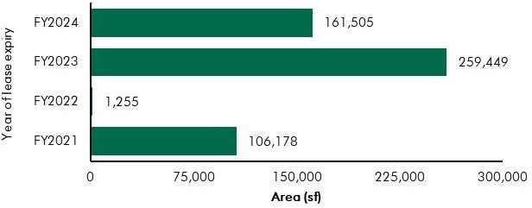

*Source: Rent Roll (representative of financial years)*

Consultants have undertaken an in-depth analysis of the rent roll/ lease deeds shared by the Client, to understand the lease expiry schedule of top tenants at the subject property and rent for those spaces as of date of valuation. The intent of the same is to analyse the risk of tenant churn as well as assessing the re-leasing risk for the property along with opining on the timeframe to lease-up the spaces in case a significant vacancy arises at the property.

* + 1. Escalation Analysis

As per the review of recently executed lease deeds at the subject property, it is understood that the contracted escalation terms for these leases are in the range of 12% to 15% every 3 years which are in line with the prevailing market practice witnessed across the submarket and Pune.

* 1. Assumptions Rationale

As highlighted earlier, the subject property is a commercial development situated within the submarket of Hinjewadi which lies in the western periphery of Pune city. The submarket has presence of established

technology parks under the 3 phases of Rajiv Gandhi Infotech Park. The region is characterised by quality grade commercial space, well laid physical infrastructure along with increasing residential activity. The connectivity of the subject submarket to the rest of the city is facilitated by the Mumbai – Bengaluru Bypass Highway.

Considering the growth of the subject submarket as one of the most prominent technology hubs of the city, the locality has witnessed a steady and sustainable supply of residential development for the working populace. Going forward, the profile of the submarket is expected to be cemented as one of the sought out technology destination of the city along with residential developments to support the working populace.

* + 1. Demand and Supply Dynamics

*9.3.1.1 Demand, Supply and Vacancy Trends – Pune and West Pune submarket*

Total completed stock in Pune as of Q4, 2019 is 53.52 mn sf, out of which West Pune account for Approx. 19%.

|  |  |  |
| --- | --- | --- |
| **Particular** | **Pune** | **West Pune** |
| Cumulative completed office stock (Q4 2019) Cumulative occupied stock (Q4 2019) Current Vacancy (Q4 2019)  Average Absorption (2014 – 2019) | Approx. 53.5 msf | Approx. 10.0 msf |
| Approx. 50.5 msf | Approx. 9.6 msf |
| Approx. 5.6% | Approx. 3.5% |
| Approx. 3.68 msf | Approx. 0.58 msf |

*Source: CBRE Research*

**Demand – Supply Dynamics (Pune)**

5.0

4.5

4.0

Area (million sq ft)

3.5

3.0

2.5

2.0

1.5

1.0

0.5

0.0

2014 2015 2016 2017 2018 2019

Supply Absorption Vacancy (%)

14%

12%

12.8%

4.4

4.5

4.1

4.1

3.6

3.5 9.5%

3.2

3.2

3.3

6.8%

2.7

2.2

2.3

5.4%

5.6%

4.4%

10%

8%

Vacancy (%)

6%

4%

2%

0%

**Demand – Supply Dynamics (West Pune)**

1.6

1.4

1.2

Area (million sq ft)

1.0

0.8

0.6

0.4

0.2

0.0

2014 2015 2016 2017 2018 2019

Supply Absorption Vacancy (%)

16%

14%

1.5 14.4%

12.3%

1.1

11.5%

8.5%

0.9

0.8

0.6

0.6

4.6%

3.5%

0.2

0.3

0.1

0.0

0.0

0.0

12%

10%

Vacancy (%)

8%

6%

4%

2%

0%

*Source: CBRE Research; Note: Supply – refers to fresh completed supply added each year; Absorption – refers to the quantum of leasing witnessed in each year as part of completed space; the vacancy in the chart accounts for the gap between cumulative stock and demand in the city in any given year.*

Rajiv Gandhi Infotech Park developed by Maharashtra Industrial Development Corporation (MIDC), located within Hinjewadi and has developed as a prominent commercial destination within Pune. The Infotech Park commenced its development activities during 1998 and has been developed in three phases I, II and III over the years. Additionally, by the virtue of ease of access through Mumbai-Bengaluru bypass road, the region has evinced considerable interest from tenants. Further, owing to demand for residential developments from the IT populace, local and national level developers have launched residential

townships in the region. Infrastructure initiatives developed (and planned) by the state government augment the overall attractiveness of the region.

*9.3.1.2 Key Developments in submarket*

The table below highlights the prominent competing developments in the submarket:

**Building Name**

**Development Type**

**Leasable Area**

**Rents (INR/sf/month)**

**Approx. Vacancy (%)**

|  |  |  |  |  |
| --- | --- | --- | --- | --- |
|  | | **(in sf)** |  | |
| Development 1 | IT SEZ | 1.5 | 45 – 50 | 4.0 - 6.0% |
| Development 2 | IT | 0.2 | 40 – 45 | Minimal |
| Development 3 | IT | 0.4 | 50 – 55 | 25.0 – 30.0% |
| Development 4 | IT SEZ | 1.9 | 45 – 50 | Minimal |
| Development 5 | IT | 0.2 | 60 – 65 | 20.0 – 25.0% |
| Development 6 | IT SEZ | 1.5 | 45 – 50 | Minimal |
| Development 7 | IT SEZ | 1.9 | 45 – 50 | 18.0 - 22.0% |

*Source: CBRE Research*

* + 1. Lease Rent Analysis

As highlighted earlier, the current rents in submarket vary between INR 40 – 50 psf pm on leasable area depending upon specifications offered, location and accessibility of the development, quality of construction, developer brand, amenities offered, etc. In addition, the maintenance charge for these developments varies in the range of INR 8 – 12 psf pm. The parking charges in such developments range between INR 2,500 – 3,500 per bay per month for covered car parks. The number of car park slots available to every tenant is 1 car park slot for every 1,000 sf leased.

Based on our market research, we understand that rent in the submarket have witnessed an average appreciation of approx. 6.7% between 2014 & 2019.

The table below highlights some of the recently transacted leases for technology developments in the influence region of the subject property:

|  |  |  |  |
| --- | --- | --- | --- |
| **Date of Transaction** | **Area (sf)** | **Tenant** | **Transacted Rent Value (INR psf pm)\*** |
| Q4, 2019 | 80,000 | Tenant 1 | 48.00 - 52.00 (WS) |
| Q1, 2019 | 11,000 | Tenant 2 | 60.00 - 65.00 (FF) |
| Q1, 2019 | 15,000 | Tenant 3 | 38.00 - 42.00 (WS) |

*Source: CBRE Research* Rents are gross rents (viz. exclusive of property tax & insurance) on leasable area basis; Note: WS – Warm shell; FF – Fully Fitted-out*

Given the attributes such as location, connectivity, support infrastructure (residential & social developments), planned infrastructure initiatives, strong investor and corporates interest, and the nature of operations, demand for commercial real estate is expected to remain stable in the western part of

Pune. Further, due to availability of larger sized land parcels, and competitive capital and rentals values vis-à-vis other peripheral locations such as East Pune, sustained occupier interest is envisaged for the larger market. A stable demand pipeline for the under construction/land stage buildings is expected and thus rentals will continue to witness stable appreciation. It is envisaged that prominent tenants are likely to continue their operations in West Pune submarket resulting in limited churn and range bound vacancy pressures over medium to long term.

Subject property with its prominent share in the operational stock as well as in the development pipeline of Grade A SEZ space over the next 3-4 years, is expected to continue being a prominent development in the West Pune submarket.

* 1. Value Assessment
     1. Adopted Methodology

We acknowledge that the approaches to valuation differ considerably and that for a particular purpose, alternative approaches to the valuation can be utilized subject to the Client’s consultations and giving due consideration to the Client’s requirements. Considering the objective of this exercise and the nature of asset involved, the value of the subject property has been assessed through the following approaches:

|  |  |
| --- | --- |
| **Particulars Completed Blocks Under Construction/ Land Stage**  **Blocks** | |
| **Valuation Methodology** | Discounted Cash Flow Method (using rent reversion approach) |

The sections below highlight detailed valuation workings for the subject property. Please note that the assumptions/ opinions highlighted in the subsequent sections are to be read in conjunction with Section

1.11 and the following:

*“In the current uncertain environment caused by the outbreak of the Novel Coronavirus (COVID-19), we have considered /* relooked *at various performance parameters and have adopted heuristic/ careful interventions (including but not limited to the points mentioned below) to our projected cashflows based on our view as of the date of valuation.*

* *Limited/ no growth in rent has been considered over the next few quarters*
* *Construction timelines have been delayed from the earlier estimates*
* *Considering challenges in the short term, timelines have been extended for new space take-up/ future leasing*
* *Additional fit-out period/ rent free months have been incorporated where fit-out works have commenced”*
  + 1. Area statement

Based on information/rent roll provided by the Client, we understand that subject property is a commercial office park. Further, the table below highlights the area configuration of the subject property:

**Component**

**Completed Leasable area (in sf)**

**Under Proposed Construction Development area (in**

|  |  |  |  |
| --- | --- | --- | --- |
|  | | **area (in sf)** | **sf)** |
| Office | 2,151,630 | 880,615 | 2,392,587 |
| Other ~ Food court, training centre, etc. | 8,425 | - | 39,689 |
| Total | 2,160,055 | 880,615 | 2,432,276 |

*Source: Rent roll provided by Client / Architect Certificate*

* + 1. Construction Timelines
       1. *Completed Blocks*

As highlighted earlier, the subject property has 2.16 mn sf of completed development and no pending cost to complete is remaining as of date of valuation for the completed blocks.

* + - 1. *Under-Construction/ Proposed Blocks*

Based on information provided by the Client, the following timelines for construction have been adopted for the purpose of this valuation exercise:

**Block**

**Leasable Area**

**Construction**

**Construction Completion**

|  |  |  |  |
| --- | --- | --- | --- |
|  | **(sf)** | **Commencement** |  |
| Hudson | 458,177 | Ongoing | FY 2023 |
| Ganges | 422,438 | Ongoing | FY 2023 |
| Block 4 | 472,316 | FY 2023 | FY 2024 |
| Block 9 | 978,517 | FY 2024 | FY 2025 |
| Block 10 | 941,754 | FY 2025 | FY 2026 |
| Volga Training Centre | 39,689 | FY 2021 | FY 2022 |
| Total | 3,312,891 |  |  |

*Source: Client’s inputs; *The timelines are mentioned as per Financial year beginning April to March*

* + 1. Absorption/ Leasing Velocity and Occupancy Profile
       1. *Completed Blocks*

In order to arrive at the future absorption levels at the subject property, we have analysed the historical demand and supply trends coupled with the estimation of future supply proposed to be introduced in the submarket.

Keeping the same in perspective, we opine that the vacant space at the subject property in the completed blocks would be leased by end of FY 2021.

EMBASSY OFFICE PARKS MANAGEMENT SERVICES PRIVATE LIMITED | EMBASSY OFFICE PARKS REIT

* + - 1. *Under-Construction/ Proposed Blocks*

The absorption period assumed for the subject development is based on market dynamics and extent of development in the relevant submarket, nature of subject development, competing supply of same nature, location within the respective submarket, etc. The table below highlights the absorption assumptions adopted for the subject development:

***Particular***

***Absorption Schedule***

***FY 2020 FY 2021 FY 2022***

***FY 2023***

***FY 2024***

***FY 2025***

***FY 2026***

***FY 2027***

***Total***

Hudson Ganges Block 4

Block 9

Block 10 Volga

Percentage (%) - - - 80% 20% - - - 100% Leasable Area (sf) - - - 366,542 91,635 - - - 458,177

Percentage (%) - - 20% 80% - - - - 100% Leasable Area (sf) - - 84,488 337,950 - - - - 422,438

Percentage (%) - - - - 100% - - - 100% Leasable Area (sf) - - - - 472,316 - - - 472,316 Percentage (%) - - - - - 70% 30% - 100% Leasable Area (sf) - - - - - 684,962 293,555 - 978,517

Percentage (%) - - - - - - 70% 30% 100% Leasable Area (sf) - - - - - - 659,228 282,526 941,754

Percentage (%) - - 100% - - - - - 100%

Leasable Area (sf) - - 39,689 - - - - - 39,689



Total Absorption (%) 0% 0% 4% 25% 42% 63% 91% 100% 100%

Total Absorption (sf) 0 0 124,177 828,669 1,392,620 2,077,582 3,030,365 3,312,891 3,312,891

*Source: Valuer’s assessment*

* + 1. Revenue Assumptions
       1. *Lease rent assumptions*

For the purpose of this valuation exercise, the lease rent adopted for the area already leased is based on the rent rolls shared by the Client. Further, the Valuer has undertaken an in-depth market research exercise to assess the prevailing rent values in the submarket. The same has been adopted for the vacant space for the purpose of this valuation exercise.

Based on our market study and based on the analysis of the rent rolls provided by the Client, following rents have been adopted for the purpose of value assessment of the subject property.

|  |  |  |  |  |
| --- | --- | --- | --- | --- |
| **Component** | **Leasable Area (sf)** | **Leased Area (sf)** | **Basis** | **Rent Adopted* (INR**  **psf pm)** |
| **Office** | 2,151,630 | 2,028,651 | In place Rent | 49.6^ |
|  |  |  | Market rent for reversion/ vacant area | 48.0 |

*Source: Rent roll provided by the Client; Valuer Assessment*

*\* The rents mentioned above exclude other income such as CAM charges, parking income received from the tenants, etc.; ^weighted average warm shell rent for area already leased – as per rent roll shared by Client*

The above market rent assumption is adopted for the entire subject development. In addition to undertaking an in-depth market analysis, a detailed analysis of the rent rolls was also undertaken to understand aspects such as area occupied, current rent and expiry analysis of the key tenants in the park. Additionally, the Valuer has also analysed the historical occupancy pattern of the market/ subject development and lease-up time frame for spaces being vacated by tenants during the last 3 years. The lease-up time was observed to be 3 - 9 months based on quantum of space being renewed/ re-leased.

Based on the size and scale of operations of these tenants, we have adopted individual market rent assumptions for larger tenants in the subject development.

**Tenant Market Rent Strategy (Discount to Market Rent/ Lease-up Time)**

Anchor Tenant Renewal at 15% discount

*Source: Valuer Assessment*

* + - 1. *Rent Escalation*

Based on analysis of existing lease rolls, it was observed that the typical escalation clause in the subject property is approx. 15% after every three years, which is in-line with the trend observed in the market. The same has been adopted by Valuer for the vacant area in completed blocks and proposed blocks.

* + - 1. *Fit-out Rentals*

As per the information (rent rolls) provided by the Client’s representative, we understand that in addition

to the lease rents, there is rent towards fit outs for few of the tenants. The rents are in the range of INR

18 to 40 psf pm. For the purpose of this valuation, we have adopted the tenant wise fit-out details as provided in the rent roll.

Moreover, for the proposed blocks, we have assumed that the development would be leased on warm shell specifications with no applicable fit-out rents on any lease.

* + - 1. *Parking Assumptions*

Based on the prevailing car parking rate in the subject development and West Pune submarket, we have assumed a car park charge of INR 3,000 per month per bay, with 50% of car park allocated to a tenant to be free of cost. Effective car parking charges adopted for the purpose of this valuation is INR 1,500 per month per bay.

* + - 1. *Other Revenues*

In addition to lease rent revenues, office developments typically have additional sources of revenue. These include revenues on account of security deposit (refunded at the time of lease expiry / exit), other miscellaneous income (such as cell sites, retail areas, food court, etc.), etc.

The assumptions considered for the aforementioned revenue heads for the purpose of this valuation exercise are based on the rent roll/ information provided by the Client. The same has been cross-checked with the prevailing market norms for other revenues and were found to be broadly in line.

The assumptions adopted for other revenues are as tabulated below:

|  |  |  |
| --- | --- | --- |
| **Nature of Income** | **Details** | **Units** |

Miscellaneous Income (Income from food court and cell sites)

0.93% % of rent income

Warm shell Security Deposit* 6 months No. of months’ warm shell rent

Parking Income (For vacant and UC development)

INR 1,500^ per car park

Mark-Up on CAM/ CAM margin** 20% %

*Source: Client’s representative & Valuer assessment; * Refunded at the time of lease expiry/ exit; ^Parking rates are approx. INR 3,000 per bay and the Valuer has assumed that 50% of the total bays are chargeable ** Additionally, we understand that the CAM is being charged by an agency which is external to the interests of Embassy Office Parks REIT, hence we have not considered any margin on CAM during the holding period. However, at the time of notional exit, margin on CAM is included in the financials as per market benchmarks*

* + 1. Expense Assumptions
       1. *Development Cost*

The following table highlights the assumptions towards the development cost for the under- construction/proposed blocks at the subject development:

**Block**

**Cost of Construction (INR/sf)\***

**Total Cost of Construction Pending Cost to be Spent (INR Mn) (INR Mn)**

Hudson 4,106 1,881.47 1,545.65

Ganges 4,087 1,726.66 1,496.24

|  |  |  |  |
| --- | --- | --- | --- |
| **Block** | **Cost of Construction (INR/sf)\*** | **Total Cost of Construction (INR Mn)** | **Pending Cost to be Spent (INR Mn)** |
| Block 4 | 4,188 | 1,978.04 | 1,978.04 |
| Block 9 | 4,280 | 4,188.40 | 4,188.40 |
| Block 10 | 4,467 | 4,206.49 | 4,206.49 |
| Volga Training Centre | 6,994 | 277.60 | 277.60 |

*Source: Client’s input*

* + - 1. *Major Repairs and Improvements*

The following table highlights the assumptions towards the refurbishment expenses/ infrastructure upgrade works in the subject development:

Expense Heads

Total Cost (INR Mn)

Total Cost

Total Pending Cost

FY Quarter of

|  |  |  |  |  |
| --- | --- | --- | --- | --- |
| Electrical Power Upgradation | 141.46 | Spent (INR Mn)  92.94 | (INR Mn)  48.52 | Completion  Q3, 2023 |
| Land Scape Development & lighting | 1.79 | 0.80 | 0.99 | Q1, 2022 |
| Park Lobby Upgrade | 29.44 | 18.04 | 11.40 | Q3, 2023 |
| Boundary Wall Construction (West side) | 41.23 | - | 41.23 | Q3, 2023 |
| Entrance Gateway Scheme | 83.27 | 45.33 | 37.94 | Q3, 2023 |
| Sports Facility | 15.99 | - | 15.99 | Q4, 2021 |
| HSD Yard | 12.50 | 4.64 | 7.86 | Q2, 2021 |
| Signages | 5.78 | 1.30 | 4.48 | Q2, 2021 |
| Phase III Capex | 40.40 | 0.00 | 40.40 | Q4, 2021 |
| Others | 44.00 | 14.14 | 29.85 | Q4, 2021 |
| Works by ESPL | 84.29 | 32.58 | 51.71 | Q4, 2021 |
| Works by EPDPL | 209.54 | 70.69 | 138.85 | Q1, 2022 |

*Source Client Input; Based on Valuer Assessment, the pending cost towards refurbishment is apportioned in equal proportion across remaining quarters from the date of valuation.*

* + - 1. *Operating Cost*

In addition to capital expenditure, a development typically has few recurring operation expenses required for the up-keep running of the development. Based on information provided by the Client and market assessment, following recurring expense assumptions have been adopted for the purpose of this valuation exercise (applicable to both completed and proposed blocks):

|  |  |  |
| --- | --- | --- |
| Nature of Expense | Details | Basis |
| Insurance, Legal and other professional charges | 0.21% | % of gross rent income |
| Property Tax | 1.04%* | % of gross rent income |
| Repair and Maintenance Reserve | 1.00% | % of gross rent income |
| Asset management Fee^ | 3.00% | % of income |
| Transaction cost (on exit) | 1.00% | % of terminal value |

*Source: Client Input; Valuer assessment; *Note – based on inputs provided by the Client, we understand that the property tax is paid at the beginning of every financial year wherein a 5% discount gets extended vis-à-vis pay-out during the end of the year and the same has been adopted for the purpose of our valuation. ^ Asset Management fees has been considered a below the NOI line item.*

* + 1. Other Assumptions
       1. *Vacancy provision*

Based on the prevailing market benchmarks, a vacancy provision of 2.5% has been adopted during the course of operation and upon assessment of terminal value

* + - 1. *Revenue escalation*

Based on prevailing market condition, historical rent growth achieved by the subject property and our interactions with market participants, we are of the opinion that the annual rent growth for the subject property will be 5.0% from Q4, FY 2021 onwards

* + - 1. *Rent – free period*

Based on the trend prevalent in the submarket, we have considered a rent-free period of 3 months for the subject property from the lease commencement date (for future / new leases)

* + - 1. *Brokerage*

Based on prevalent market dynamics, we have considered brokerage equivalent to 2 month of rent income for future / new leases

* + - 1. *CAM under recoveries*

We have highlighted expense towards maintenance as CAM under recoveries for months when no rent

/ CAM income is received

* + 1. Capitalization Rates

As highlighted in section 3.3, the cap rate adopted for the office space is 8.25%.

* + 1. Discount Rate

For discounting the cash flows, the appropriate discounting rate has been calculated on the basis of estimated ‘Weighted Average Cost of Capital’ (WACC). The detailed analysis of WACC rate adopted for the subject property has been detailed in Section 3.4 of this report.

9.5 Value of the Subject Property

Based on the above mentioned analysis, the value of the subject property is estimated as follows:

|  |  |  |  |
| --- | --- | --- | --- |
| Component | Value (INR Mn) |  | % Share |
| Operational Blocks | 14,929 |  | 71% |
| Under Construction/ Proposed Blocks | 6,103 |  | 29% |
| **Embassy TechZone** |  | **INR 21,032 Mn** |  |

##### Embassy Quadron

* 1. Property Description

|  |  |
| --- | --- |
| **Brief Description** | |
| Particulars | **Details** |
| **Property Name** | Embassy Quadron |
| **Address** | Plot No. 28, Rajiv Gandhi Infotech Park, Hinjewadi Phase II, Man Village, Mulshi Taluka, Pune District, Maharashtra |
| **Land Area** | Total 25.52 acres |
| **Leasable Area** | Total Operational Area – 1.89 million sft |

*Source: Title Report, Architect Certificate;*

* + 1. Site Details

Situation: ‘Embassy Quadron’ is an office park located at Plot No. 28, Hinjewadi Phase II, Rajiv Gandhi Infotech Park, Pune, Maharashtra

Location: The subject property is located in a prominent commercial technology hub of Pune city which has presence of major SEZ developments such as Embassy TechZone, Embassy Quadron (Subject Property), Qubix, Ascendas International Tech Park, etc. Further, the submarket also has presence of IT parks like Pesh Infotech, Indo Global Software Tech Park, Radius Tech Park, Panchshil Tech Park, etc. In addition, some of the campuses of IT majors such as Wipro, Infosys, Emerson Innovations, HCL, etc are also located in the same micro market.

Apart from IT/ITeS developments, the subject micro-market is also witnessing an increasing residential activity primarily catering to demand of the working populace of Hinjewadi & nearby micro-markets. Key residential projects in the micro-markets includes developments by prominent players like Kohinoor Developers, Paranjape Schemes, TCG, Xrbia, Kolte Patil, Mittal Brothers, Shapoorji, etc. The subject micro- market is surrounded by other notable markets like Wakad, Tathawade, etc. which are located along the Mumbai – Bengaluru Bypass Highway. Further, the micro- market has adequate social and physical infrastructure to support the working and resident population. Some of the social infrastructure development in the micro- market include Blue Ridge Public School, Pawar Public School, Sanjeevani Hospital, Ruby Hall Clinic, etc.

The distances from key hubs to the subject property are presented in the table below:

**Landmark Distance (km)**

National Highway 48 (Mumbai – Bengaluru bypass highway) 7 - 8

Pune Railway Station 22 - 23

CBD (Peth Areas) 22 – 23

Pune International Airport 26 – 27

*Source: Consultants’ Research*

Surrounds: The property is surrounded as follows: North: Vacant Land

South: Hinjewadi Main road (Primary Access) East: Residential Development (Tinsel Town) West: Vacant Land

Potential changes in surroundings:

With the advent of IT sector in the country, Hinjewadi (the subject micro-market) was developed as an IT/ITeS hub of the city. Over the years, Rajiv Gandhi Infotech park has been developed across 3 phases.

The boost in commercial real estate segment also prompted to the development of the micro-market as a residential market to cater the housing needs of the working populace. This led to the development of various residential townships by major developers of Pune city.

The micro-market is expected to witness sustainable growth in IT/ITeS segment with development of future phases of various office parks. This increase of commercial supply will be proportionally matched by residential supply from developments like Megapolis, Life Republic, Blue Ridge, EON homes, Godrej 24, etc.

Suitability of existing use:

Considering the profile of surrounding developments, the subject property is opined to be suited for its current use viz. office park.

Shape: Based on the visual inspection, we understand that the subject land parcel is irregular in shape.

Topography: Based on the site plan and as corroborated with our site visit, the site appears to be even and on the same level as abutting access roads and adjoining properties

Frontage: Based on review of site plan, visual inspection and measurements made on Google maps, we understand that the frontage of the property is approximately 320 meters along the Hinjewadi Phase 2 road.

Accessibility: The subject property has access from the Hinjewadi Phase 2 road.

EMBASSY OFFICE PARKS MANAGEMENT SERVICES PRIVATE LIMITED | EMBASSY OFFICE PARKS REIT

The following map indicates the location of the subject property and surrounding developments:

**Location Map for the Subject Property**



Towards

Mumbai

Marunji Road

Embassy Quadron

Infosys

Wipro

Campus

1

Int’l

Biotech

Park

Embassy Qubix

2

Hinjewadi Phase

1

Infosys

1 International Tech Park

Wipro

Campus

Shivaji Chowk

Towards Pune

TCS

Tech

Mahindra

3

3 Radius Tech Park

Megapolis

Blue Ridge

Township

4

Towards

Pirangut

*Map Not to Scale (For Representation Purposes Only)*

Embassy Tech Zone

Embassy Quadron

Embassy Qubix

Rajiv Gandhi

Infotech Park

Embassy Techzone

4 Blue Ridge - Ascendas

Hinjewadi Road

2 Panchshil Tech Park

Hinjewadi Phase

3

Hinjewadi Ph

2 Road

Dange

Chowk Road

Hinjewadi Phase

2

# Key Office Developments

*Source: Consultants’ Research*

* + 1. Legal Details

As per the title due diligence undertaken by Cyril Amarchand Mangaldas and as provided by the Client, we understand that the exact address of the subject property is Plot No. 28, Rajiv Gandhi Infotech Park, Hinjewadi Phase II, Man Village, Mulshi Taluka, Pune District, Maharashtra. Additionally, it is understood that the subject property is leasehold in nature, with remaining lease term of approx. 80 years.

Further, this valuation exercise is based on the premise that the subject property has a clear title and is free from any encumbrances, disputes, claims, etc. The Consultants have not made any inquiries in this regard with the relevant legal/ statutory authorities.

* + 1. Town Planning

Zoning As per the title due diligence report and Client inputs, it was identified that the subject property is a commercial zoned land parcel, granted on lease by Maharashtra Industrial Development Corporation (MIDC), and is approved for development of an office park. The same has been considered for the purpose of this valuation. The Consultants have made no further inquiries with the local authorities in this regard.

The permissible land use adopted by the Consultants for the subject property has been based on information/review of various documents provided by the Client. It must be noted that all factual data viz. permissible development control regulations, land area and achievable FSI have also been based on information/review of various documents (such as title deed, plan sanction letter, site plan, etc.) provided by the Client or assumed based on building regulations, and no physical verification/ measurement has been undertaken for the purpose of this valuation exercise.

For the purpose of this exercise, it has been assumed that all developments (existing / under construction / proposed) adhere to building regulations as prescribed by the relevant authorities. The Consultants have not validated the information provided by the Client with the relevant development authorities.

Approved Usage:

Based on occupancy certificates provided by the Client and visual inspection during our site visit, we understand that the subject property is a technology office park, comprising of 4 operational blocks. The current use of the subject property has been provided by the Client and is broadly in agreement with the rules and regulations prescribed by the local development authorities. However, the Consultants have not made any enquiries with the relevant local authorities to validate the same for its specific applicability to the subject property.

Restrictions: As per feedback received from the Client, there are no restrictions on the current use of the property.

Natural or induced hazards:

We are of the opinion that the project/ site has been developed to withstand natural or induced hazards (with the exception of extreme/ out of the ordinary hazards).

* + 1. Statutory Approvals, One Time Sanctions & Periodic Clearances

Please refer section 18.3 on Statutory Approvals, One time Sanctions & Periodic Clearances

* + 1. Area Details, Type and Age of Existing Structures

The table below highlights the detailed area break-up of the subject development:

**Development Name**

**Developable Area Completed Leasable (Sft)* Area (Sft)**

**Committed Area (Sft)**

**Occupied Area (Sft)**

Embassy Quadron 1,564,050 1,894,674 1,496,150 1,485,278

*Source: Rent roll, lease deeds, Architect Certificate provided by Client; *represents achieved FSI area*

|  |  |  |  |  |
| --- | --- | --- | --- | --- |
| **Block Building Elevation SEZ/Non-SEZ Age (Years) Leasable Area (sft) Name** | | | | |
|  |  | Completed Blocks |  |  |
| Block 1 | LG+UG+5 | SEZ | 12 | 439,124 |
| Block 2 | LG+UG+4 | SEZ | 12 | 366,861 |
| Block 3 | LG+UG+5 | SEZ | 11 | 471,893 |
| Block 4 | LG+10 | SEZ | 9 | 616,796 |
| Total |  |  |  | 1,894,674 |

*Source: Rent roll, Occupancy Certificate provided by Client;*

**Details**

**Completed Blocks**

**Under Construction Blocks**

**Land Stage Blocks**

Grade of the Building Grade A - -

LEED Certification* Gold - -

- -

Structural Design Varied (LG + UG + Up to 10 upper floors)

Status of Finishing Warm Shell - -

Comments on Obsolescence The building is currently well

maintained

- -

*Source: Client, *U.S. Green Building Council certificate*

* + 1. Site Services and Finishes

**Particulars Details**

Handover condition Warm Shell

Passenger elevators Provided

Service elevators Provided

Power back-up Provided

Building management system Provided

Security systems Provided

Air conditioning Provided

Firefighting services Provided

Car parks provided Covered/open car parks

*Source: Information provided by Client, Site Visit, lease deeds*

Additionally, based on inputs provided by the Client coupled with visual inspection, Embassy Quadron offers its occupiers a 2,000+ seat food court (including alfresco seating), indoor sports zone, fitness centre, day-care facilities, refurbished lobbies, enhanced landscaping and various retail offerings.

* + 1. Condition & Repair

Based on information provided by the Client, it is understood that the subject property is in good condition and is being maintained well. The table below highlights the major repairs and maintenance work/ infrastructure upgrade works undertaken in the past few years and the works to be undertaken over the next few years:

|  |  |  |
| --- | --- | --- |
| **Expense Heads** | **Total Cost (INR Mn)** | ***Quarter of Completion*** |
| STP Revamp | 4.53 | Q1, FY 2017 |
| Food Court | 8.68 | Q2, FY 2017 |
| WTP | 2.29 | Q3, FY 2017 |
| Painting | 0.83 | Q4, FY 2017 |
| Expansion Joint and Waterproofing | 0.18 | Q4, FY 2017 |
| TCS Space Repair (Q1) | 63.26 | Q1, FY 2018 |
| ACP Sheet Replacement | 19.91 | Q1, FY 2018 |
| LED lights for basement parking | 0.30 | Q2, FY 2018 |
| Basement parking painting | 0.35 | Q2, FY 2018 |
| Signage Rebranding | 8.11 | Q2, FY 2021 |
| Fire Hydrant Line Upgrade | 25.00 | Q1, FY 2022 |
| Reinstatement works for Block Q4 and Q1B | 8.00 | Q2, FY 2021 |

*Source: Information provided by Client*

* + 1. Property Photographs

Please refer to the property photographs highlighted below:

Embassy Quadron

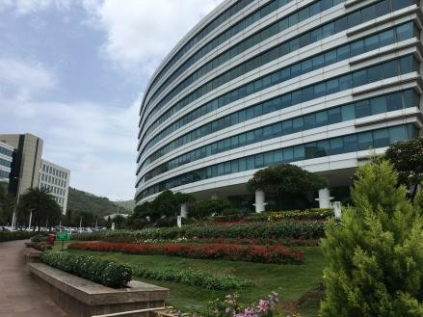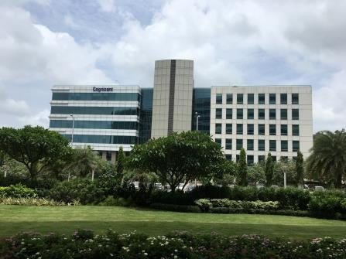

External view of the subject property (SP) ~ Block 4

External view of the SP

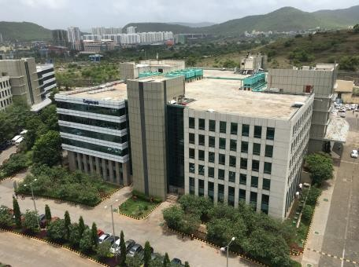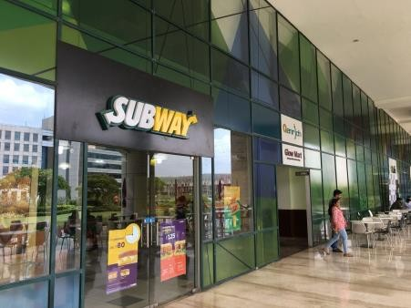

External view of the SP View of the food court

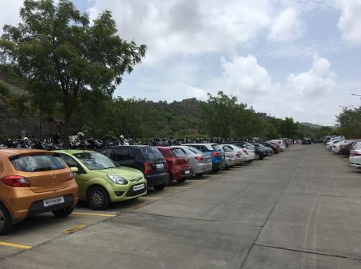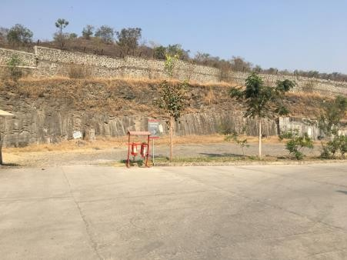

View of open air parking Open parking at the subject development

* 1. Tenancy Analysis
     1. Historical Committed Occupancy Rates

The table below highlights the historical occupancy rates at the subject development:

|  |  |  |  |
| --- | --- | --- | --- |
| **March 31, 2017** | **March 31, 2018** | **March 31, 2019** | **March 31, 2020** |
| 99.7% | 98.5% | 91.4% | 79.0% |

*Source: Rent rolls provided by the Client; Indicative of committed occupancy*

* + 1. Lease Expiry Analysis

The graph below highlights the area/leases due for expiry in the coming years:

**Lease Expiry**

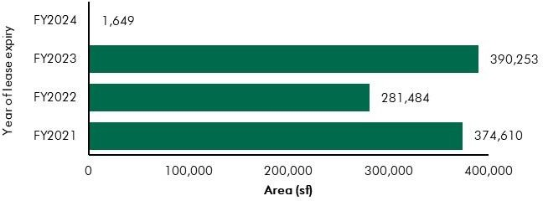

*Source: Rent Roll (representative of financial years)*

Consultants have undertaken an in-depth analysis of the rent roll/ lease deeds shared by the Client, to understand the lease expiry schedule of top tenants at the subject property and rent for those spaces as of date of valuation. The intent of the same is to analyse the risk of tenant churn as well as assessing the re-leasing risk for the property along with opining on the timeframe to lease-up the spaces in case a significant vacancy arises at the property.

* + 1. Escalation Analysis

As per the review of recent executed leases at the subject property it is understood that the contracted escalation terms for these leases are in the range of 10% to 15% every 3 years which are in line with the prevailing market practice witnessed across the submarket and Pune.

* 1. Assumptions Rationale

As highlighted earlier, the subject property is a commercial development situated within the submarket of Hinjewadi which lies in the western periphery of Pune city. The submarket has presence of established technology parks under the 3 phases of Rajiv Gandhi Infotech Park. The region is characterised by quality grade commercial space, well laid physical infrastructure along with increasing residential activity. The connectivity of the subject submarket to the rest of the city is facilitated by the Mumbai – Bengaluru Bypass Highway.

Considering the growth of the subject submarket as one of the most prominent technology hubs of the city, the locality has witnessed a steady and sustainable supply of residential development for the working populace. Going forward, the profile of the submarket is expected to be cemented as one of the sought out technology destination of the city along with residential developments to support the working populace.

* + 1. Demand and Supply Dynamics

*10.3.1.1 Demand, Supply and Vacancy Trends – Pune and West Pune submarket*

Total completed stock in Pune as of Q4, 2019 is 53.52 mn sf, out of which West Pune account for Approx. 19%.

|  |  |  |
| --- | --- | --- |
| **Particular** | **Pune** | **West Pune** |
| Cumulative completed office stock (Q4 2019) Cumulative occupied stock (Q4 2019) Current Vacancy (Q4 2019)  Average Absorption (2014 – 2019) | Approx. 53.5 msf | Approx. 10.0 msf |
| Approx. 50.5 msf | Approx. 9.6 msf |
| Approx. 5.6% | Approx. 3.5% |
| Approx. 3.68 msf | Approx. 0.58 msf |

*Source: CBRE Research*

**Demand – Supply Dynamics (Pune)**

5.0

4.5

4.0

Area (million sq ft)

3.5

3.0

2.5

2.0

1.5

1.0

0.5

0.0

2014 2015 2016 2017 2018 2019

Supply Absorption Vacancy (%)

14%

12%

12.8%

4.4

4.5

4.1

4.1

3.6

3.5 9.5%

3.2

3.2

3.3

6.8%

2.7

2.2

2.3

5.4%

5.6%

4.4%

10%

8%

Vacancy (%)

6%

4%

2%

0%

**Demand – Supply Dynamics (West Pune)**

1.6

1.4

1.2

Area (million sq ft)

1.0

0.8

0.6

0.4

0.2

0.0

2014 2015 2016 2017 2018 2019

Supply Absorption Vacancy (%)

16%

14%

1.5 14.4%

12.3%

1.1

11.5%

8.5%

0.9

0.8

0.6

0.6

4.6%

3.5%

0.2

0.3

0.1

0.0

0.0

0.0

12%

10%

Vacancy (%)

8%

6%

4%

2%

0%

*Source: CBRE Research; Note: Supply – refers to fresh completed supply added each year; Absorption – refers to the quantum of leasing witnessed in each year as part of completed space; the vacancy in the chart accounts for the gap between cumulative stock and demand in the city in any given year.*

Rajiv Gandhi Infotech Park developed by Maharashtra Industrial Development Corporation (MIDC), located within Hinjewadi and has developed as a prominent commercial destination within Pune. The Infotech Park commenced its development activities during 1998 and has been developed in three phases I, II and III over the years. Additionally, by the virtue of ease of access through Mumbai-Bengaluru bypass road, the region has evinced considerable interest from tenants. Further, owing to demand for residential developments from the IT populace, local and national level developers have launched residential

townships in the region. Infrastructure initiatives developed (and planned) by the state government augment the overall attractiveness of the region.

*10.3.1.2 Key Developments in Micro Market*

The table below highlights the prominent / competing developments in the subject micro market:

**Building Name**

**Development Type**

**Leasable Area**

**Rents (INR/sf/month)**

**Approx. Vacancy (%)**

|  |  |  |  |  |
| --- | --- | --- | --- | --- |
|  | | **(in sf)** |  | |
| Development 1 | IT SEZ | 1.5 | 45 – 50 | 4.0 - 6.0% |
| Development 2 | IT | 0.2 | 40 – 45 | Minimal |
| Development 3 | IT | 0.4 | 50 – 55 | 25.0 – 30.0% |
| Development 4 | IT SEZ | 1.9 | 45 – 50 | Minimal |
| Development 5 | IT | 0.2 | 60 – 65 | 20.0 – 25.0% |
| Development 6 | IT SEZ | 1.5 | 45 – 50 | Minimal |
| Development 7 | IT SEZ | 2.2 | 45 – 50 | 5.0 - 7.0% |
| *Source: CBRE Research* |  |  |  |  |

* + 1. Lease Rental Analysis

As highlighted earlier, the current rentals in subject micro market vary between INR 40 – 50 per sft per month on leasable area depending upon specifications offered, location and accessibility of the development), quality of construction, developer brand, amenities offered, etc. In addition, the maintenance charge for these developments varies in the range of INR 8 – 12 per sft per month. The parking charges in such developments range between INR 2,500 – 3,500 per bay per month for covered car parks. The number of car park slots available to every tenant is 1 car park slot for every 1,000 sft leased.

Based on our market research, we understand that rent in the submarket have witnessed an average appreciation of approx. 6.7% between 2014 & 2019.

The table below highlights some of the recently transacted leases for technology developments in the influence region of the subject property:

|  |  |  |  |
| --- | --- | --- | --- |
| **Date of Transaction** | **Area (sft)** | **Tenant** | **Transacted Rental Value (INR/sft/month)\*** |
| Q4, 2019 | 80,000 | Tenant 1 | 48.00 - 52.00 (WS) |
| Q4, 2019 | 40,000 | Tenant 2 | 60.00 - 65.00 (FF) |
| Q3, 2019 | 125,000 | Tenant 3 | 45.00 - 50.00 (WS) |
| Q3, 2019 | 45,000 | Tenant 4 | 45.00 - 50.00 (WS) |
| Q2, 2019 | 125,000 | Tenant 5 | 60.00 - 65.00 (FF) |
| Q2, 2019 | 240,000 | Tenant 6 | 60.00 - 65.00 (FF) |
| Q1, 2019 | 11,000 | Tenant 7 | 60.00 - 65.00 (FF) |
| Q1, 2019 | 15,000 | Tenant 8 | 38.00 - 42.00 (WS) |

|  |  |  |  |
| --- | --- | --- | --- |
| **Date of Transaction** | **Area (sft)** | **Tenant** | **Transacted Rental Value (INR/sft/month)\*** |
| Q1, 2019 | 25,000 | Tenant 9 | 58.00 - 62.00 (FF) |

*Source: CBRE Research* Rentals are gross rentals (viz. exclusive of property tax & insurance) on leasable area basis; Note: WS – Warm shell; FF – Fully Fitted-out*

Given the attributes such as location, connectivity, support infrastructure (residential & social developments), planned infrastructure initiatives, strong investor and corporates interest, and the nature of operations, demand for commercial real estate is expected to remain stable in the western part of Pune. Further, due to availability of larger sized land parcels, and competitive capital and rentals values vis-à-vis other peripheral locations such as East Pune, sustained occupier interest is envisaged for the larger market. A stable demand pipeline for the under construction/land stage buildings is expected and thus rentals will continue to witness stable appreciation. It is envisaged that prominent tenants are likely to continue their operations in West Pune submarket resulting in limited churn and range bound vacancy pressures over medium to long term.

* 1. Value Assessment
     1. Adopted Methodology

We acknowledge that the approaches to valuation differ considerably and that for a particular purpose, alternative approaches to the valuation can be utilized subject to the Client’s consultations and giving due consideration to the Client’s requirements. Considering the objective of this exercise and the nature of asset involved, the value of the subject property has been assessed through the following approaches:

|  |  |
| --- | --- |
| **Particulars Completed Blocks Under Construction/ Land Stage**  **Blocks** | |
| **Valuation Methodology** | Discounted Cash Flow Method (using rental reversion approach) |

The sections below highlight detailed valuation workings for the subject property. Please note that the assumptions/ opinions highlighted in the subsequent sections are to be read in conjunction with Section

1.11 and the following:

*“In the current uncertain environment caused by the outbreak of the Novel Coronavirus (COVID-19), we have considered /* relooked *at various performance parameters and have adopted heuristic/ careful interventions (including but not limited to the points mentioned below) to our projected cashflows based on our view as of the date of valuation.*

* *Limited/ no growth in rent has been considered over the next few quarters*
* *Considering challenges in the short term, timelines have been extended for new space take-up/ future leasing*
* *Additional fit-out period/ rent free months have been incorporated where fit-out works have commenced”*
  + 1. Area statement

Based on information/rent roll provided by the Client, we understand that subject property is an office park. Further, the table below highlights the area configuration of the subject property:

|  |  |
| --- | --- |
| **Components** | **Operational leasable area (in sft)** |
| Office space | 1,843,236 |
| Retail | 22,887 |
| Food Court | 28,551 |
| Total | 1,894,674 |

*Source: Rent roll provided by Client*

* + 1. Construction Timelines

*10.4.3.1 Completed Blocks*

As highlighted earlier, the subject property has 1.9 million sft of completed development and no pending cost to complete is remaining as of date of valuation for the completed blocks.

* + 1. Absorption/ Leasing Velocity and Occupancy Profile

*10.4.4.1 Completed Blocks*

In order to arrive at the future absorption levels at the subject property, we have analysed the historical demand and supply trends coupled with the estimation of future supply proposed to be introduced in the subject submarket.

Keeping the same in perspective, we opine that the vacant space in the subject property would be leased by end of Q2, FY 2022.

* + 1. Revenue Assumptions
       1. *Lease rent assumptions*

For the purpose of this valuation exercise, the lease rental adopted for the area already leased is based on the rent roll shared by the Client. Further, the Valuer has undertaken an in-depth market research exercise to assess the prevailing rental values in the submarket. The same has been adopted for the vacant space for the purpose of this valuation exercise.

Based on our market study and based on the analysis of the rent roll provided by the Client, following rentals have been adopted for the purpose of value assessment of the subject property.

|  |  |  |  |  |
| --- | --- | --- | --- | --- |
| **Component** | **Leasable Area (sft)** | **Leased Area (sft)** | **Basis** | **Rental Adopted* (INR/sft/month)** |
|  |  |  | Current Rent for Leased area | 43.2^ |
| **Office** | 1,894,674 | 1,496,150 | Marginal rent for reversion/ vacant area | 48.0 |

*Source: Rent roll provided by the Client; Valuer Assessment*

*\* The rentals mentioned above exclude other income such as CAM charges, parking income received from the tenants, etc.; ^weighted average warm shell rental for area already leased – as per rent roll shared by Client*

In addition to undertaking an in-depth market analysis, a detailed analysis of the rent rolls was also undertaken to understand aspects such as area occupied, current rental and expiry analysis of the key tenants in the park. Additionally, we have also analysed the historical occupancy pattern of the market/ subject development and lease-up time frame for spaces being vacated by tenants during the last 3 years. The lease-up time was observed to be 3 – 9 months based on quantum of space being renewed

/ re-leased.

Based on the size and scale of operations of these tenants, the Valuer has adopted individual market rent assumptions for larger tenants in the subject development. For the larger tenants, we have assumed that post lease expiry, these spaces will revert to market rent prevailing at that point in time. However, given the large size of these spaces, the Client will require longer lease-up time. Therefore, the we have adopted a higher lease-up time, ranging from 6 – 9 months depending on area to be leased.

* + - 1. *Rent Escalation*

Based on analysis of existing lease rolls, it was observed that the typical escalation clause in the subject property is approx. 15% after every three years, which is in-line with the trend observed in the market. The same has been adopted by the Valuer for the vacant area.

* + - 1. *Fit-out Rentals*

As per the information (rent roll) provided by the Client, we understand that in addition to the lease rentals, there is rental of about INR 18 per sft per month towards fit-outs for one tenant (as mentioned in rent roll). The Valuer has adopted the same for the purpose of this valuation.

* + - 1. *Parking Assumptions*

Based on the prevailing car parking rate in the subject development and West Pune submarket, we have assumed a car park charge of INR 3,000 per month per bay, with 50% of car park allocated to a tenant to be free of cost. Effective car parking charges adopted for the purpose of this valuation is INR 1,500 per month per bay.

* + - 1. *Other Revenues*

In addition to lease rent revenues, office developments typically have additional sources of revenue. These include revenues on account of security deposit (refunded at the time of lease expiry / exit), other miscellaneous income (such as cell sites, retail areas, food court, etc.), mark-up on Common Area Maintenance (CAM) charges/ CAM margin, etc.

The assumptions considered for the aforementioned revenue heads for the purpose of this valuation exercise are based on the rent roll/ information provided by the Client. The same has been cross-checked with the prevailing market norms for other revenues and were found to be broadly in line.

The assumptions adopted for other revenues are as tabulated below: -

|  |  |  |
| --- | --- | --- |
| **Nature of Income** | **Details** | **Units** |

|  |  |  |
| --- | --- | --- |
| Miscellaneous Income | 0.51% | % of rental income |
| Warm shell Security Deposit* | 6 months | No. of months’ warm shell rental |
| Parking Income ^ | INR 1,500 | per car park |
| Mark-Up on CAM/ CAM margin | 20.0% | % |

*Source: Client’s representative & Valuer assessment; * Refunded at the time of lease expiry/ exit; ^Parking rates are approx. INR 3,000 per bay and the Valuer has assumed that 50% of the total bays are chargeable*

* + 1. Expense Assumptions
       1. *Refurbishment expenses*

The following table highlights the assumptions towards the refurbishment expenses/ infrastructure upgrade works in the subject development:

Expense Head Total Pending Cost (INR Mn) * Quarter of Completion

Signage Rebranding 3.2 Q2, FY 2021

Fire Hydrant Line Upgrade 24.8 Q1, FY 2022

Reinstatement works for Block Q4 and Q1B 8.0 Q2, FY 2021

*Source Client input*

* + - 1. *Other Cost*

The following table highlights the assumptions towards the other expenses in the subject development:

|  |  |  |
| --- | --- | --- |
| Nature of Expense | Details | Basis |
| Opex projects and admin expenses | 1.0% | % of total income |
| Asset Management Fee^ | 3.0% | % of gross rental income |
| Transaction cost on Exit | 1.00% | % of terminal value |

*Source: Client Input/ Valuer assessment, ^ Asset Management fee has been considered a below the NOI line item*

* + 1. Other Assumptions
       1. *Vacancy provision*

Based on the prevailing market benchmarks and the subject property profile a vacancy provision of 2.5% has been adopted upon assessment of terminal value

* + - 1. *Revenue escalation*

Based on prevailing market condition, historical rent growth achieved by the subject property and our interactions with market participants, we are of the opinion that the annual rent growth for the subject property will be 5.0% from Q4, FY 2021 onwards

* + - 1. *Rent – free period*

Based on the trend prevalent in the subject micro – market, we have considered a rent free period of 3 months for the subject property from the lease commencement date (for future / new leases)

* + - 1. *Brokerage*

Based on prevalent market dynamics, we have considered brokerage equivalent to 2 month of rental income for future / new leases

* + 1. Capitalization Rates

As highlighted in section 3.3, the cap rate adopted for the office space is 8.25%.

* + 1. Discount Rate

For discounting the cash flows, the appropriate discounting rate has been calculated on the basis of estimated ‘Weighted Average Cost of Capital’ (WACC). The detailed analysis of WACC rate adopted for the subject property has been detailed in Section 3.4 of this report.

10.5 Value of the Subject Property

Based on the above mentioned analysis, the value of the subject property is estimated as follows:

|  |  |  |  |
| --- | --- | --- | --- |
| Component | Value (INR Mn) |  | % Share |
| Operational Blocks | 13,838 |  | 100% |
| **Embassy Quadron** |  | **INR 13,838 Mn** |  |

##### Embassy Qubix

* 1. Property Description

|  |  |
| --- | --- |
| **Brief Description** | |
| Particulars | **Details** |
| **Property Name** | Embassy Qubix |
| **Address** | Plot No.2, Blue Ridge Township, Near Rajiv Gandhi Infotech Park – Phase I, Hinjewadi, Pune, Maharashtra 411057 |
| **Land Area** | 25.16 Acres |
| **Leasable Area** | Total Leasable Area – 1,450,494 sf |

*Source: Title Report, Rent Roll*

* + 1. Site Details

Situation: Subject property – ‘Embassy Qubix’ is an operational commercial development located in Blue Ridge Township, near Rajiv Gandhi Infotech Park – Phase I, Hinjewadi, Pune, Maharashtra.

Location: The subject property is located in one of the prominent commercial (IT/ITeS) hubs of Pune city which has presence of major SEZ developments such as Embassy Qubix (subject property), Quadron, TechZone, Ascendas International Tech Park, etc. The asset is part of a larger integrated township in West Pune housing various residential towers, schools and retail components. This provides a walk to work eco-system for its occupiers and their employees which significantly adds to the unique proposition of this asset.

Further, the micro-market also has presence of IT parks like Pesh Infotech, Indo Global Software Tech Park, Radius Tech Park, Panchshil Tech Park, etc. In addition, some of the campuses of IT majors such as Wipro, Infosys, Emerson Innovations, HCL, etc. are also located in the micro market.

Apart from IT/ITeS developments, the subject micro-market is also witnessing an increasing residential activity primarily catering to demand of the working populace of Hinjewadi & nearby micro-markets. Key residential projects in the micro-markets includes developments by prominent players like Kohinoor Developers, Paranjape Schemes, TCG, Xrbia, Kolte Patil, Mittal Brothers, Shapoorji, etc. The subject micro-market is surrounded by other notable markets like Wakad, Tathawade, etc. which are located along the Mumbai – Bengaluru Bypass Highway. Further, the micro-market has adequate social and physical

infrastructure to support the working and resident population. Some of the social infrastructure development in the micro-market include Blue Ridge Public School, Pawar Public School, Sanjeevani Hospital, Ruby Hall Clinic, etc.

The distances from key hubs to the subject property are presented in the table below:

**Landmark Distance (km)**

National Highway 48 (Mumbai-Pune-Bengaluru) 3 - 4

Pune CBD (Peth Areas) 18 – 19

Pune Railway Station 19 – 20

Pune International Airport 23 - 24

*Source: Consultants’ Research*

Surrounds: The subject property is surrounded as follows:

* North: Symbiosis Institute of International Business
* South: Internal Township Road and Blue Ridge Township
* East: Radius Tech Park
* West: Primary Access Road

Potential changes in surroundings:

With the advent of IT sector in the country, Hinjewadi (the subject micro-market) was developed as an IT/ITeS hub of the city. Over the years, Rajiv Gandhi Infotech park has been developed across 3 phases.

The boost in commercial real estate segment also prompted to the development of the micro-market as a residential market to cater the housing needs of the working populace. This led to the development of various residential townships by major developers of Pune city.

The micro-market is expected to witness sustainable growth in IT/ITeS segment with development of future phases of various office parks. This increase of commercial supply will be proportionally matched by residential supply from developments like Megapolis, Life Republic, Blue Ridge, EON homes, Godrej 24, etc.

Suitability of existing use:

Considering the profile of surrounding developments, the subject property is opined to be suited for its current use viz. IT office park.

Shape: The site has a general rectangular configuration and is bounded by Blueridge township internal road on three of its sides.

Topography: Based on the site plan and as corroborated with our site visit, the site appears to be even and on the same level as abutting access roads and adjoining properties.

Frontage: Based on review of site plan, visual inspection and measurements made on Google maps, we understand that the frontage of the subject property is approximately 300 meters along the primary access road.

Accessibility: The subject property can be accessed via an internal road connecting the property with Phase I of the Rajiv Gandhi InfoTech Park.

EMBASSY OFFICE PARKS MANAGEMENT SERVICES PRIVATE LIMITED | EMBASSY OFFICE PARKS REIT

The following map indicates the location of the subject property and surrounding developments:

**Location Map for the Subject Property**



Towards

Mumbai

Marunji Road

Embassy Quadron

Infosys

Wipro

Campus

1

Int’l

Biotech

Park

Embassy Qubix

2

Hinjewadi Phase

1

Infosys

1 International Tech Park

Wipro

Campus

Shivaji Chowk

Towards Pune

TCS

Tech

Mahindra

3

3 Radius Tech Park

Megapolis

Blue Ridge

Township

4

Towards

Pirangut

*Map Not to Scale (For Representation Purposes Only)*

Embassy Tech Zone

Embassy Quadron

Embassy Qubix

Rajiv Gandhi

Infotech Park

Embassy Techzone

4 Blue Ridge - Ascendas

Hinjewadi Road

2 Panchshil Tech Park

Hinjewadi Phase

3

Hinjewadi Ph

2 Road

Dange

Chowk Road

Hinjewadi Phase

2

# Key Office Developments

*Source: Consultants’ Research*

* + 1. Legal Details

As per the title due diligence undertaken by Cyril Amarchand Mangaldas and as provided by the Client, we understand that the exact address of the subject property is Plot no 2, Blue Ridge Township, Near Rajiv Gandhi Infotech Park – I, Hinjewadi, Pune, Maharashtra 411057. Additionally, it is understood that the subject property is freehold in nature.

Further, this appraisal exercise is based on the premise that the subject property has a clear title and is free from any encumbrances, disputes, claims, etc. The Consultants have not made any inquiries in this regard with the relevant legal/ statutory authorities.

* + 1. Town Planning

Zoning As per the Occupancy Certificates provided by the Client, we understand that the subject property is an IT SEZ development and is zoned as “Commercial IT/ ITeS”. As per the Occupancy Certificate, we understand that the subject property is located within the jurisdiction of Maharashtra Industrial Development Corporation (MIDC). The same has been considered for the purpose of this appraisal. The Consultants have made no further inquiries with the local authorities in this regard.

The permissible land use adopted by the Consultants for the subject property has been based on information/review of various documents provided by the Client. It must be noted that all factual data viz. permissible development control regulations, land area and achievable FSI have also been based on information/review of various documents (such as title deed, plan sanction letter, site plan, etc.) provided by the Client or assumed based on building regulations, and no physical verification/ measurement has been undertaken for the purpose of this valuation exercise.

For the purpose of this exercise, it has been assumed that all developments adhere to building regulations as prescribed by the relevant authorities. The Consultants have not validated the information provided by the Client with the relevant development authorities.

Approved Usage:

Based on Occupancy Certificates provided by the Client and visual inspection during our site visit, we understand that the subject property is a Commercial IT SEZ office park (along with support retail), comprising of 6 operational office blocks. The current use of the subject property has been provided by the Client and is broadly in agreement with the rules and regulations as prescribed by the local development authority. However, the Consultants have not made any enquiries with the relevant local authorities to validate the same for its specific applicability to the subject property.

Restrictions: As per feedback received from the Client, there are no restrictions on the current use of the property.

Natural or induced hazards:

We are of the opinion that the project/ site has been developed to withstand natural or induced hazards (with the exception of extreme/ out of the ordinary hazards).

* + 1. Statutory Approvals, One Time Sanctions & Periodic Clearances

Please refer section 18.3 on Statutory Approvals, One time Sanctions & Periodic Clearances

* + 1. Area Details, Type and Age of Existing Structures

The table below highlights the detailed area break-up of the subject development:

**Development Name**

**Developable Area (Sf)\***

**Completed Area (Sf)**

**Committed Area (Sf)**

**Occupied Area (Sf)**

Embassy Qubix 1,084,669 1,450,494 1,447,290 1,447,290

*Source: Rent roll, lease deeds, Architect Certificate provided by Client; *represents achieved FSI area*

**Block Name**

**Building Elevation**

**Completed Blocks**

**SEZ/Non- SEZ**

**Age (Years)**

**Leasable Area (sf)**

Building IT 1 Ground + 6 floors IT SEZ 7 310,339

Building IT 2 Ground + 6 floors IT SEZ 7 143,500

Building IT 3 Ground + 6 floors IT SEZ 7 313,178

Building IT 4 Ground + 6 floors IT SEZ 6 213,524

Building IT 5 Ground + 6 floors IT SEZ 5 214,064

Building IT 6 Ground + 6 floors IT SEZ 7 255,889

Total 1,450,494

*Source: Rent roll, Occupancy Certificates provided by the Client*

**Details Completed Blocks**

Grade of the Building Grade A

LEED Certification NA

Structural Design G+6

Status of Finishing Warm Shell

Comments on Obsolescence The building is currently well maintained

*Source: Client, *U.S. Green Building Council certificate*

* + 1. Construction, Services and Finishes

**Particulars Details**

Handover condition Warm Shell

Passenger elevators Provided

Service elevators Provided

Power back-up Provided

Building management system Provided

Security systems Provided

Air conditioning Provided

Firefighting services Provided

Car parks provided MLCP, Basement, Covered and open car parks

*Source: Information provided by Client*

Additionally, based on inputs provided by the Client coupled with visual inspection, Embassy Qubix offers its occupiers a full suite of amenities, including a recently fully renovated food court, refurbished lobbies, and a 150-seat auditorium, etc.

* + 1. Condition & Repair

Based on information provided by the Client and our inspection during the site visit, it is understood that the subject property is in good condition and is being maintained well. Subject property offers international standard infrastructure, best-in-class asset management and environment friendly green initiatives. Over the last few years, Client has incurred repairs and maintenance expenses towards upgradation the park. The table below highlights the major repairs and maintenance work/ infrastructure upgrade works undertaken in the past few years and the works to be undertaken over the next few years:

|  |  |  |  |  |
| --- | --- | --- | --- | --- |
| Expense Head To | tal Cost (INR Mn) | Total Cost  Spent (INR Mn) | Total Pending Cost  (INR Mn) | Quarter of  Completion |
| Cooling Tower Fills | 1.60 | 1.60 | 0 | Q2, FY 2015 |
| New Operational office | 2.00 | 2.00 | 0 | Q3, FY 2015 |
| Electrical Shaft Fire Seal | 1.90 | 1.90 | 0 | Q4, FY 2015 |
| Food Court | 124.00 | 124.00 | 0 | Q2, FY 2016 |
| HVAC Segregation | 24.5 | 24.5 | 0 | Q2, FY 2016 |
| Management Office | 6.46 | 6.46 | 0 | Q3, FY 2016 |
| Painting | 6.65 | 6.65 | 0 | Q4, FY 2016 |
| Expansion Joint and Waterproofing | 2.21 | 2.21 | 0 | Q1, FY 2017 |
| OWC | 1.04 | 1.04 | 0 | Q1, FY 2017 |
| STP Augmentation | 14.34 | 14.34 | 0 | Q2, FY 2017 |
| Barricading | 1.60 | 1.60 | 0 | Q3, FY 2017 |
| Signages | 1.20 | 1.20 | 0 | Q3, FY 2017 |
| Retail | 85.54 | 85.54 | 0 | Q4, FY 2017 |
| Signage Rebranding | 9.0 | 4.0 | 5.0 | Q2, FY 2021 |
| *Source: Information provided by Client* |  |  |  |  |

* + 1. Property Photographs

Please refer to the property photographs highlighted below:

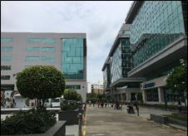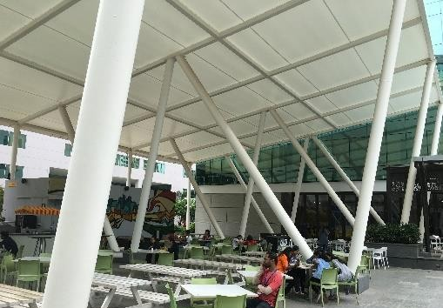

Embassy Qubix

External view of the subject property View of Food court (a part of subject property)

View of subject property View of the primary access road

Internal access road

View of the subject property

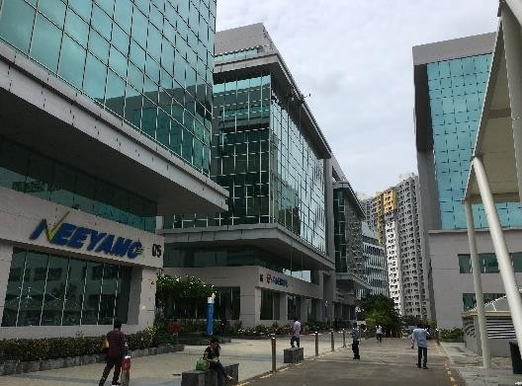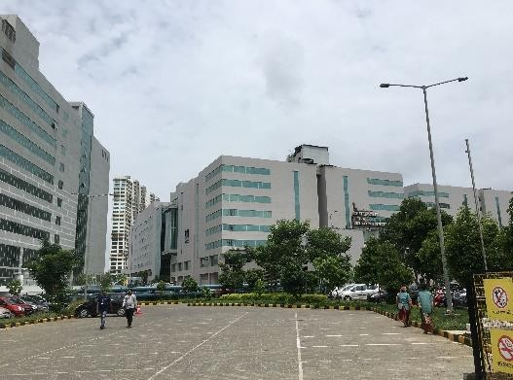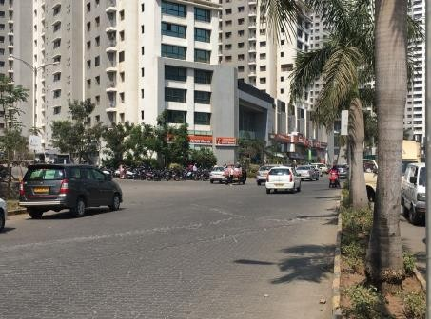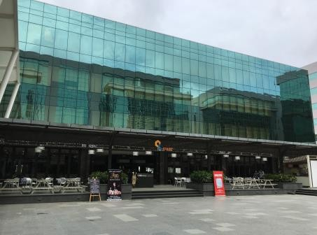

* 1. Tenancy Analysis
     1. Historical Committed Occupancy Rates

The table below highlights the historical occupancy rates at the subject development:

|  |  |  |  |
| --- | --- | --- | --- |
| **March 31, 2017** | **March 31, 2018** | **March 31, 2019** | **March 31, 2020** |
| 96.98% | 99.98% | 100.00% | 99.78% |

*Source: Rent rolls provided by the Client; Indicative of committed occupancy*

* + 1. Lease Expiry Analysis

The graph below highlights the area/leases due for expiry in the coming years:

**Lease Expiry**

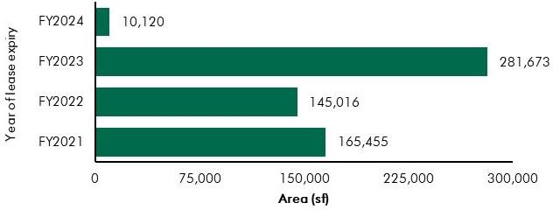

*Source: Rent Roll (representative of financial years)*

Consultants have undertaken an in-depth analysis of the rent roll/ lease deeds shared by the Client, to understand the lease expiry schedule of top tenants at the subject property and rent for those spaces as of date of valuation. The intent of the same is to analyse the risk of tenant churn as well as assessing the re-leasing risk for the property along with opining on the timeframe to lease-up the spaces in case a significant vacancy arises at the property.

* + 1. Escalation Analysis

As per the review of recent executed leases at the subject property it is understood that the contracted escalation terms for these leases are in the range of 10% to 15% every 3 years which are in line with the prevailing market practice witnessed across the micro-market and Pune.

* 1. Assumptions Rationale

As highlighted earlier, the subject property is a commercial development situated within the submarket of Hinjewadi which lies in the western periphery of Pune city. The submarket has presence of established

technology parks under the 3 phases of Rajiv Gandhi Infotech Park. The region is characterised by quality grade commercial space, well laid physical infrastructure along with increasing residential activity. The connectivity of the subject submarket to the rest of the city is facilitated by the Mumbai – Bengaluru Bypass Highway.

Considering the growth of the subject submarket as one of the most prominent technology hubs of the city, the locality has also witnessed a steady and sustainable supply of residential development catering to the demand of the working populace. Going forward, the profile of the submarket is expected to be cemented as one of the sought out technology destination of the city along with residential developments to support the working populace.

* + 1. Demand and Supply Dynamics

*11.3.1.1 Demand, Supply and Vacancy Trends – Pune and West Pune micro-market*

Total completed stock in Pune as of Q4, 2019 is 53.52 mn sf, out of which West Pune account for Approx. 19%.

|  |  |  |
| --- | --- | --- |
| **Particular** | **Pune** | **West Pune** |
| Cumulative completed office stock (Q4 2019) Cumulative occupied stock (Q4 2019) Current Vacancy (Q4 2019)  Average Absorption (2014 – 2019) | Approx. 53.5 msf | Approx. 10.0 msf |
| Approx. 50.5 msf | Approx. 9.6 msf |
| Approx. 5.6% | Approx. 3.5% |
| Approx. 3.68 msf | Approx. 0.58 msf |

*Source: CBRE Research*

**Demand – Supply Dynamics (Pune)**

5.0

4.5

4.0

Area (million sq ft)

3.5

3.0

2.5

2.0

1.5

1.0

0.5

0.0

2014 2015 2016 2017 2018 2019

Supply Absorption Vacancy (%)

14%

12%

12.8%

4.4

4.5

4.1

4.1

3.6

3.59.5%

3.2

3.2

3.3

6.8%

2.7

2.2

2.3

5.4%

5.6%

4.4%

10%

8%

Vacancy (%)

6%

4%

2%

0%

**Demand – Supply Dynamics (West Pune)**

1.6

1.4

1.2

Area (million sq ft)

1.0

0.8

0.6

0.4

0.2

0.0

2014 2015 2016 2017 2018 2019

Supply Absorption Vacancy (%)

16%

14%

1.514.4%

12.3%

1.1

11.5%

8.5%

0.9

0.8

0.6

0.6

4.6%

3.5%

0.2

0.3

0.1

0.0

0.0

0.0

12%

10%

Vacancy (%)

8%

6%

4%

2%

0%

*Source: CBRE Research; Note: Supply – refers to fresh completed supply added each year; Absorption – refers to the quantum of leasing witnessed in each year as part of completed space; the vacancy in the chart accounts for the gap between cumulative stock and demand in the city in any given year.*

Rajiv Gandhi Infotech Park developed by Maharashtra Industrial Development Corporation (MIDC), located within Hinjewadi and has developed as a prominent commercial destination within Pune. The Infotech Park commenced its development activities during 1998 and has been developed in three phases I, II and III over the years. Additionally, by the virtue of ease of access through Mumbai-Bengaluru bypass road, the region has evinced considerable interest from tenants. Further, owing to demand for residential developments from the IT populace, local and national level developers have launched residential

townships in the region. Infrastructure initiatives developed (and planned) by the state government augment the overall attractiveness of the region.

*11.3.1.2 Key Developments in Micro Market*

The table below highlights the prominent / competing developments in the subject micro market:

**Building Name**

**Development Type**

**Leasable Area**

**Rents (INR/sf/month)**

**Approx. Vacancy (%)**

|  |  |  |  |  |
| --- | --- | --- | --- | --- |
|  | | **(in sf)** |  | |
| Development 1 | IT SEZ | 1.5 | 45 – 50 | 4.0 - 6.0% |
| Development 2 | IT | 0.2 | 40 – 45 | Minimal |
| Development 3 | IT | 0.4 | 50 – 55 | 25.0 – 30.0% |
| Development 4 | IT SEZ | 1.9 | 45 – 50 | Minimal |
| Development 5 | IT | 0.2 | 60 – 65 | 20.0 – 25.0% |
| Development 6 | IT SEZ | 1.9 | 45 – 50 | 18.0 - 22.0% |
| Development 7 | IT SEZ | 2.2 | 45 – 50 | 5.0 - 7.0% |

*Source: CBRE Research*

* + 1. Lease Rental Analysis

As highlighted earlier, the current rentals in subject micro market vary between INR 40 – 50 psf pm on leasable area depending upon specifications offered, location and accessibility of the development, quality of construction, developer brand, amenities offered, etc. In addition, the maintenance charge for these developments varies in the range of INR 8.00 – 12.00 psf pm. The parking charges in such developments range between INR 2,500 – 3,500 per bay per month for covered car parks. The number of car park slots available to every tenant is 1 car park slot for every 1,000 sf leased.

Based on our market research, we understand that prevalent rent in the submarket have witnessed an average appreciation of approx. 6.7% between 2014 & 2019.

The table below highlights some of the recently transacted rental values for technology developments in the influence region of the subject property:

|  |  |  |  |
| --- | --- | --- | --- |
| **Date of Transaction** | **Area (sf)** | **Tenant** | **Transacted Rental Value (INR psf pm) \*** |
| Q4, 2019 | 80,000 | Tenant 1 | 48.00 - 52.00 (WS) |
| Q4, 2019 | 40,000 | Tenant 2 | 60.00 - 65.00 (FF) |
| Q3, 2019 | 125,000 | Tenant 3 | 45.00 - 50.00 (WS) |
| Q3, 2019 | 45,000 | Tenant 4 | 45.00 - 50.00 (WS) |
| Q2, 2019 | 125,000 | Tenant 5 | 60.00 - 65.00 (FF) |
| Q2, 2019 | 240,000 | Tenant 6 | 60.00 - 65.00 (FF) |

|  |  |  |  |
| --- | --- | --- | --- |
| **Date of Transaction** | **Area (sf)** | **Tenant** | **Transacted Rental Value (INR psf pm) \*** |
| Q1, 2019 | 25,000 | Tenant 7 | 58.00 - 62.00 (FF) |

*Source: CBRE Research* Rentals are gross rentals (viz. exclusive of property tax & insurance) on leasable area basis; Note: WS – Warm shell*

Given the attributes such as location, connectivity, support infrastructure (residential & social developments), planned infrastructure initiatives, strong investor and corporates interest, nature of operations, etc, demand for commercial real estate is expected to remain stable in the Western part of Pune. Further, due to availability of larger sized land parcels, and competitive capital and rentals values vis-à-vis other peripheral locations such as East Pune, sustained occupier interest is envisaged for the market. A stable demand pipeline for the under construction/land stage buildings is expected and thus rentals will continue to witness stable appreciation. It is envisaged that prominent tenants are likely to continue their operations in West Pune micro-markets resulting in limited churn and range bound vacancy pressures over medium to long term.

* 1. Value Assessment
     1. Adopted Methodology

We acknowledge that the approaches to valuation differ considerably and that for a particular purpose, alternative approaches to the valuation can be utilized subject to the Client’s consultations and giving due consideration to the Client’s requirements. Considering the objective of this exercise and the nature of asset involved, the value of the subject property has been assessed through the following approaches:

|  |  |
| --- | --- |
| **Particulars Completed Blocks** | |
| **Valuation Methodology** | Discounted Cash Flow Method (using rental reversion approach) |

The sections below highlight detailed valuation workings for the subject property. Please note that the assumptions/ opinions highlighted in the subsequent sections are to be read in conjunction with Section

1.11 and the following:

*“In the current uncertain environment caused by the outbreak of the Novel Coronavirus (COVID-19), we have considered /* relooked *at various performance parameters and have adopted heuristic/ careful interventions (including but not limited to the points mentioned below) to our projected cashflows based on our view as of the date of valuation.*

* *Limited/ no growth in rent has been considered over the next few quarters*
* *Considering challenges in the short term, timelines have been extended for new space take-up/ future leasing*
* *Additional fit-out period/ rent free months have been incorporated where fit-out works have commenced”*
  + 1. Area statement

Based on information/rent roll provided by the Client, we understand that subject property is a commercial IT SEZ office park. Further, the table below highlights the area configuration of the subject property.

|  |  |
| --- | --- |
| ***Particulars*** | ***Approx. leasable area (in sf)*** |
| Building IT 1 | 310,339 |
| Building IT 2 | 143,500 |
| Building IT 3 | 313,178 |
| Building IT 4 | 213,524 |
| Building IT 5 | 214,064 |
| Building IT 6 | 255,889 |
| Total | 1,450,494 |
| *Source: Rent roll provided by Client* |  |

* + 1. Construction Timelines

*11.4.3.1 Completed Blocks*

As highlighted earlier, the subject property has 1.45 mn sf of completed office park and no pending cost to complete is remaining as of date of valuation for the completed blocks.

* + 1. Absorption/ Leasing Velocity and Occupancy Profile

*11.4.4.1 Completed Blocks*

Based on the rent roll provided by the Client and visual inspection during the site visit, we understand that the subject property is fully operational and there are no under-construction blocks. As per the analysis of the rent roll, it was observed that the subject development has negligible vacancy as on date of valuation.

* + 1. Revenue Assumptions
       1. *Lease rent assumptions*

For the purpose of this appraisal exercise, the lease rental adopted for the area already leased is based on the rent roll shared by the Client. Further, the Valuer has undertaken an in-depth market research exercise to assess the prevailing rental values in the subject micro-market. The same has been adopted for the vacant space for the purpose of this valuation exercise.

Based on our market study and based on the analysis of the rent roll provided by the Client, following rentals have been adopted for the purpose of value assessment of the subject property.

|  |  |  |  |  |
| --- | --- | --- | --- | --- |
| **Component** | **Leasable Area (sf)** | **Leased Area (sf)** | **Basis** | **Rental Adopted\***  **(INR psf pm)** |
|  |  |  | Current Rent for Leased area | 38.9^ |
| **Office** | 1,450,494 | 1,447,290 | Marginal rental for reversion/ vacant area | 48.0 |

*Source: Rent roll provided by the Client; Valuer Assessment*

*\* The rentals mentioned above exclude other income such as CAM charges, parking income received from the tenants, etc.;*

*^weighted average warm shell rental for area already leased – as per rent roll shared by Client*

The above market rent assumption is adopted for the entire subject development. In addition to undertaking an in-depth market analysis, a detailed analysis of the rent rolls was also undertaken to understand aspects such as area occupied, current rental and expiry analysis of the key tenants in the park. Additionally, we also analysed the historical occupancy pattern at the subject micro-market/ subject development and lease-up time frame for spaces being vacated by tenants during the last 3 years. The lease-up time was observed to be 3 - 9 months based on quantum of space being renewed/ re-leased.

Based on the size and scale of operations of these tenants, the Valuer adopted individual market rent assumptions for larger tenants in the subject development. For the larger tenants, we have assumed that

post lease expiry, these spaces will revert to market rent prevailing at that point in time. However, given the large size of these spaces, the Client will require longer lease-up time.

**Tenant Market Rental Strategy (Discount to Market Rent/ Lease-up Time)**

Anchor Tenants Renewal at 15% discount to market rent

Anchor Tenants Renewal at market (6 months for >90k sf)

*Source: Valuer Assessment*

* + - 1. *Rent Escalation*

Based on an analysis of existing lease rolls, it was observed that the typical escalation clause in the subject property is in the range of 10% to 15% every three years, which is in-line with the trend observed in the market. The same has been adopted by the Valuer for the vacant area.

* + - 1. *Fit-out Rentals*

As per the information (rent roll) provided by the Client, we understand that there is no fit-outs rental being charged to any tenant in the subject property.

* + - 1. *Parking Assumptions*

Based on the prevailing car parking rate in the subject development and subject micro-market, we have assumed a car park charge of INR 3,000 per month per bay, with 50% of car park allocated to a tenant to be free of cost. Effective car parking charges adopted for the purpose of this valuation is INR 1,500 per month per bay.

* + - 1. *Other Revenues*

In addition to lease rent revenues, office developments typically have additional sources of revenue. These include revenues on account of security deposit (refunded at the time of lease expiry / exit), other miscellaneous income (such as cell sites, retail areas, food court), mark-up on Common Area Maintenance (CAM) charges/ CAM margin, etc.

The assumptions considered for the aforementioned revenue heads for the purpose of this valuation exercise are based on the rent roll/ information provided by the Client. The same has been cross-checked with the prevailing market norms for other revenues and were found to be broadly in line.

The assumptions adopted for other revenues are as tabulated below:

|  |  |  |
| --- | --- | --- |
| **Nature of Income** | **Details** | **Units** |

|  |  |  |
| --- | --- | --- |
| Miscellaneous Income | 0.80% | % of rental income |
| Warm shell Security Deposit* | 6 months | No. of months’ warm shell rental |
| Parking Income ^ | INR 1,500 | per car park |
| Mark-Up on CAM/ CAM margin | 20.0% | % |

*Source: Client’s Inputs & Valuer assessment; * Refunded at the time of lease expiry/ exit; ^assumed at INR 3,000 per bay per month, with 50% free car park*

* + 1. Expense Assumptions
       1. *Refurbishment expenses*

The following table highlights the assumptions towards the refurbishment expenses in the subject development:

Expense Head

Total Pending Cost (INR Mn) *

Quarter of Completion

Signage Rebranding 5.0 Q2, FY 2021

*Source Client input*

* + - 1. *Other Cost*

The following table highlights the assumptions towards the other expenses in the subject development:

|  |  |  |
| --- | --- | --- |
| Nature of Expense | Details | Basis |
| Opex projects and admin expenses | 1.0% | % of total income |
| Asset Management Fee^ | 3.0% | % of gross rental income |
| Transaction cost on Exit | 1.00% | % of terminal value |

*Source: Valuer assessment; ^ Asset Management fee has been considered a below the NOI line item*

* + 1. Other Assumptions
       1. *Vacancy provision*

Based on the prevailing market benchmarks, a vacancy provision of 2.5% has been adopted upon assessment of terminal value

* + - 1. *Revenue escalation*

Based on prevailing market condition, historical rent growth achieved by the subject property and our interactions with market participants, we are of the opinion that the annual rent growth for the subject property will be 5.0% from Q4, FY 2021 onwards

* + - 1. *Rent – free period*

Based on the trend prevalent in the subject micro – market, we have considered a rent-free period of 3 months for the subject property from the lease commencement date (for future / new leases)

* + - 1. *Brokerage*

Based on prevalent market dynamics, we have considered brokerage equivalent to 2 month of rental income for future / new leases

* + 1. Capitalization Rates

As highlighted in section 3.3, the cap rate adopted for the office space is 8.25%.

* + 1. Discount Rate

For discounting the cash flows, the appropriate discounting rate has been calculated on the basis of estimated ‘Weighted Average Cost of Capital’ (WACC). The detailed analysis of WACC rate adopted for the subject property has been detailed in Section 3.4 of this report.

11.5 Value of the Subject Property

Based on the above-mentioned analysis, the value of the subject property is estimated as follows:

|  |  |  |  |
| --- | --- | --- | --- |
| Component | Value (INR Mn) |  | % Share |
| Operational Blocks | 10,085 |  | 100% |
| **Embassy Qubix** |  | **INR 10,085 Mn** |  |

##### Embassy Oxygen

* 1. Property Description

|  |  |
| --- | --- |
| **Brief Description** | |
| **Particulars** | **Details** |
| **Property Name** | Embassy Oxygen |
| **Address** | Plot No. – 07, Sector 144, Noida, Uttar Pradesh, India |
| **Land Area** | 24.83 acres/ 100,498 sqm |
| **Leasable Area** | Completed Blocks – 2.52 msf Proposed Blocks – 0.74 msf |

*Source: Lease Deed (dated September 21, 2007), Title Report, Architect Certificate*

* + 1. Site Details

Situation: Subject property – ‘Embassy Oxygen’ is a partly operational office park located at Sector

144, Noida, Uttar Pradesh.

Location: The subject property is located in Sector – 144, Noida in close proximity to Noida – Greater Noida Expressway and is one of the few high-quality, institutionally-owned office assets in the sub-market. The property is amongst the largest office parks in the city and one of only few SEZ developments in its sub-market. The subject property is well connected to other parts of Noida and Delhi on account of its strategic location i.e. close proximity to the Noida – Greater Noida expressway and DND Expressway (located at a distance of approx. 16 – 17 km from the subject property). Further, the subject property is also located in close proximity to Greater Noida, which is an upcoming real estate vector.

The subject vector, i.e. Noida – Greater Noida Expressway is an emerging commercial / residential vector of Noida. The said vector has witnessed significant real estate activity in the past (as the region comprises of initial set of sectors, which were earmarked for private real estate development) and houses various large-scale organized real estate projects such as integrated residential townships, commercial developments, IT parks/ SEZs, etc. from prominent developers.

Further, the subject sub-market has emerged as a preferred business destination on account of availability of large-scale integrated office parks and well-laid infrastructure. Few of the investment grade commercial developments (IT/ITeS) located in the subject region include Embassy Oxygen (‘the subject property’), Candor TechSpace, Assotech Business Cresterra, Advant Navis Business Park, Stellar 135, Express Trade Towers 2,

etc. Due to its affordable rents in the context of Delhi NCR, established infrastructure, access to employee talent pools, the sub-market witnesses robust occupier demand.

The subject sub-market viz. Noida – Greater Noida Expressway also houses various residential developments across different segments such as Saha Amadeus, Eldeco Utopia, Paras Tiera, Logix Blossom County, Logix Zest, Omaxe Forest, Sikka Kaamna Greens, Sikka Karnam Greens, etc. Further, the said vector is also home to large integrated residential township developments such as Jaypee Wishtown, Unitech Golf and Country Club, etc.

Moreover, the said vector has emerged as a prominent institutional vector housing Jaypee Hospital (a multi-speciality hospital) and Amity University (an educational campus spread across an area of approx. 64 acres offering a wide range of Graduate as well as Post Graduate Programs). The region also comprises of reputed international as well as national schools such as Pathways, Shiv Nadar School, Lotus Valley International School, etc.

The distances from key hubs to the subject property are presented in the table below:

|  |  |
| --- | --- |
| **Landmark** | **Distance (km)** |
| Sector-18, Central Business District (CBD) of Noida | 16 – 17 |
| DND Flyway | 16 – 17 |
| Connaught Place, CBD of Delhi | 29 – 30 |
| New Delhi Railway Station | 29 – 30 |
| Indira Gandhi International Airport, Delhi | 38 – 39 |

*Source: Consultants’ Research*

Surrounds: The subject property is surrounded as follows:

Potential changes in surroundings:

North: Green Belt

South: Approx. 24 m wide access road

East: Other’s property (Plot No. – 08, Sector 144)

West: Approx. 45 m wide access road (primary access road)

As mentioned above, the subject sub-market is an emerging commercial hub of Noida and is witnessing significant development activity. Also, the region has contributed the highest share in the absorption pie of Noida.

Further, with the addition of new supply and favourable outlook towards the subject region from technology sector, it is expected that the subject sub-market would emerge as a prominent commercial hub of Noida in the short to medium term.

Moreover, the construction of MRTS rail link connecting Noida with Greater Noida (passing through the subject region) has been completed, which has significantly enhanced the attractiveness of the subject location.

Suitability of existing use:

Considering the profile of surrounding developments, the subject property is opined to be suited for its current use viz. IT/ ITeS SEZ office park.

EMBASSY OFFICE PARKS MANAGEMENT SERVICES PRIVATE LIMITED | EMBASSY OFFICE PARKS REIT

The following map indicates the location of the subject property and surrounding developments:

**Location Map for the Subject Property**

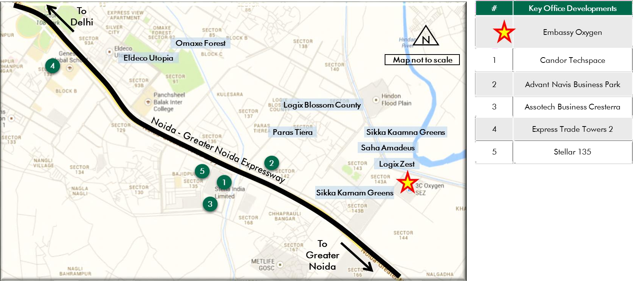

*Source: Consultants’ Research*

Shape: Based on site plan provided by the Client and visual inspection during the site visit, it is understood that the subject land parcel is largely regular in shape.

Topography: Based on the site plan and as corroborated with our site visit, the site appears to be even and on the same level as abutting access roads and adjoining properties.

Accessibility: Based on site map provided by the Client coupled with visual inspection undertaken, it was observed that the primary access to the subject property is by an approx. 45 m wide sector road (emanating from Noida – Greater Noida Expressway) located towards the west of the subject property. In addition, the property is also accessible by an internal sector road of Sector 144, which is an approx. 24 m wide road located towards the south of the subject property. The subject property enjoys significant frontage along both the access roads.

Frontage: Based on review of site plan, visual inspection and measurements made on Google maps, we understand that the subject site has a frontage of approximately 280 meters along the primary access road (viz. approx. 45 m wide sector road) and approximately 350 meters along the 24 m wide internal sector road.

Please refer Exhibit & Addenda for the site plan of the subject property.

* + 1. Legal Details

As per the title due diligence undertaken by M/s. Cyril Amarchand Mangaldas and lease deed (dated September 21, 2007) provided by the Client, we understand that the exact address of the subject property is Plot No. – 07, Sector 144, Noida, Uttar Pradesh. Additionally, it is understood that the subject property is leasehold in nature, with remaining lease term of approx. 77 years.

Further, this valuation exercise is based on the premise that the subject property has a clear title and is free from any encumbrances, disputes, claims, etc. The Consultants have not made any inquiries in this regard with the relevant legal/ statutory authorities.

* + 1. Town Planning

Zoning: As per the Occupancy Certificates/ Lease Deed provided by the Client, we understand that the subject property is zoned for Institutional Use (with permission for IT/ ITeS SEZ development). It is located within the jurisdiction of New Okhla Industrial Development Authority (NOIDA). The same has been considered for the purpose of this valuation. The Consultants have made no further inquiries with the local authorities in this regard.

The permissible land use adopted by the Consultants for the subject property has been based on review of Noida Master Plan and various documents/ information

provided by the Client. It must be noted that all factual data viz. permissible development control regulations, land area and achievable FSI have also been based on information/review of various documents (such as title report, lease deed, plan sanction letter, site plan, etc.) provided by the Client or assumed based on building regulations, and no physical verification/ measurement has been undertaken for the purpose of this valuation exercise.

For the purpose of this exercise, it has been assumed that all developments adhere to building regulations as prescribed by the relevant authorities. The Consultants have not validated the information provided by the Client with the relevant development authorities.

Approved Usage: Based on Occupancy Certificates provided by the Client and visual inspection during our site visit, we understand that the subject property is an office park, comprising of 8 operational office blocks and a food court. The current use of the subject property has been provided by the Client and is broadly in agreement with the rules and regulations as prescribed by the local development authority. However, the Consultants have not made any enquiries with the relevant local authorities to validate the same for its specific applicability to the subject property.

Restrictions: As per feedback received from the Client, there are no restrictions on the current use of the property.

Natural or induced hazards:

We are of the opinion that the project/ site has been developed to withstand natural or induced hazards (with the exception of extreme/ out of the ordinary hazards).

* + 1. Statutory Approvals, One Time Sanctions & Periodic Clearances

Please refer section 18.3 on Statutory Approvals, One time Sanctions & Periodic Clearances

* + 1. Area Details, Type and Age of Existing Structures

The table below highlights the detailed area break-up of the subject development:

|  |  |  |
| --- | --- | --- |
| **Development Name Developable Completed Area (sf)** | **Committed Area (sf)** | **Occupied Area (sf)** |
| Embassy Oxygen 2,597,065 2,517,307 | 2,114,985 | 1,975,774 |
| *Source: Rent roll, Architect Certificate provided by Client; *represents achieved FSI area* | | |

**Area (sf)\***

**Block**

**Building**

**SEZ/Non-SEZ**

**Age**

**Leasable Area (sf)**

|  |  |  |  |  |
| --- | --- | --- | --- | --- |
| **Name** | **Elevation** |  | **(Years)** |  |
| **Completed Blocks** |  |  |  |  |
| A | B + G + 7 | SEZ | 9 | 249,181 |
| B | B + G + 8 | SEZ | 9 | 224,346 |
| C | B + G + 8 | SEZ | 8 | 254,896 |
| D | G + 4 | SEZ | 9 | 204,561 |
| E | B + S + G + 9 | SEZ | 7* | 279,770 |
| F | B + S + G + 7 | SEZ | 7 | 243,313 |
| 3 | B + S + G + 12 | SEZ | 2 | 459,434 |
| Food Court | B + S + G | SEZ | 2 | 31,022 |
| 2 | B + S + G + 12 | SEZ | 0 | 570,784 |
| Total |  |  |  | 2,517,307 |
| **Proposed Blocks** |  |  |  |  |
| 1 | B + S + G + 12 | SEZ | NA | 737,000 |
| Total |  |  |  | 737,000 |

*Source: Rent roll, Occupancy/ Completion Certificates provided by Client*

*\* Excluding 9th floor*

|  |  |  |  |
| --- | --- | --- | --- |
| **Details** | **Completed Blocks** | **Under Construction Blocks** | **Proposed Blocks** |
| Grade of the Building | Grade A | NA | NA |
| LEED Certification | Gold | NA | Gold Pre-Certification |
| Structural Design | B+S+G to B+S+G+12 | NA | B+S+G+12 |
| Status of Finishing | Warm Shell | NA | NA |

Comments on Obsolescence The building is currently well

maintained

NA NA

*Source: Rent roll/ information provided by Client, Site visit undertaken by the Consultants*

* + 1. Site Services and Finishes

**Particulars Details**

Handover condition Warm Shell

Passenger elevators Provided

Service elevators Provided

Power back-up Provided

Building management system Provided

Security systems Provided

Air conditioning Provided

Firefighting services Provided

Car parks provided Covered and open car parks

*Source: Information provided by Client, Site visit undertaken by the Consultants, lease deeds*

* + 1. Condition & Repair

Subject property is developed and managed to international standards offering best-in-class asset management and environment friendly green initiatives, which makes it a preferred option for domestic as wells as Multinational Corporations (MNCs). Embassy Oxygen’s open campus-style provides occupiers with reliable infrastructure, landscaped greenspace, a recently revamped food court and a suite of tenant amenities (such as a sports zone, auditorium, café, fitness centre and day-care facilities). Based on information provided by the Client and site visit, it is understood that the subject property is in good condition and is being maintained well. The table below highlights the major repairs and maintenance work/ infrastructure upgrade works undertaken (in the past few years)/ currently being undertaken/ proposed to be undertaken at the subject development:

|  |  |  |  |
| --- | --- | --- | --- |
| **Expense Head** | **Total Cost (INR Mn)** | **Balance Cost (INR Mn)** | **Quarter of Completion** |
| Site Office | 6.77 | - | Q2, FY 2016 |
| Management Office (ESPL) | 2.14 | - | Q2, FY 2017 |
| Tower D - painting & crack repairing | 0.86 | - | Q2, FY 2017 |
| Bituminous Road | 2.00 | - | Q2, FY 2017 |
| Food Court (Tower A) | 46.34 | - | Q3, FY 2017 |
| CCTV | 10.05 | - | Q3, FY 2017 |
| Fire doors | 4.16 | - | Q3, FY 2017 |
| Tower E 9th Floor - building upgradation | 73.65 | - | Q4, FY 2017 |

|  |  |  |  |
| --- | --- | --- | --- |
| **Expense Head** | **Total Cost (INR Mn)** | **Balance Cost (INR Mn)** | **Quarter of Completion** |
| Tower E 9th Floor - lift upgradation | 10.32 | - | Q4, FY 2017 |
| Tower E 9th Floor (GlobalLogic Incubation) | 57.55 | - | Q4, FY 2017 |
| STP 2 | 2.03 | - | Q4, FY 2017 |
| Tower A - ACP Work | 1.63 | - | Q4, FY 2017 |
| Signages | 3.67 | - | Q1, FY 2018 |
| Building painting | 9.18 | - | Q1, FY 2018 |
| Expansion joint and waterproofing | 34.59 | - | Q2, FY 2018 |
| Structure Strengthening | 8.10 | - | Q2, FY 2018 |
| BMS | 7.74 | - | Q3, FY 2018 |
| Common Infrastructure Costs | 71.99 | 4.57 | Q1, FY 2021 |
| Signage Rebranding | 7.83 | 4.81 | Q1, FY 2021 |
| Incubation space in FC | 36.81 | 36.81 | Q2, FY 2021 |

*Source: Information provided by Client*

* + 1. Property Photographs

Please refer to the property photographs highlighted below:

Embassy Oxygen

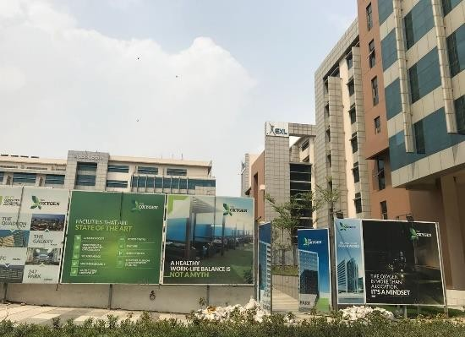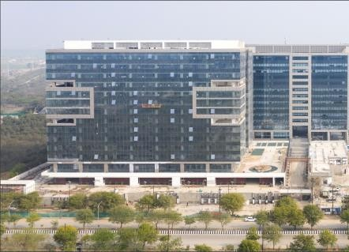

External view of the SP View of recently completed Tower 2

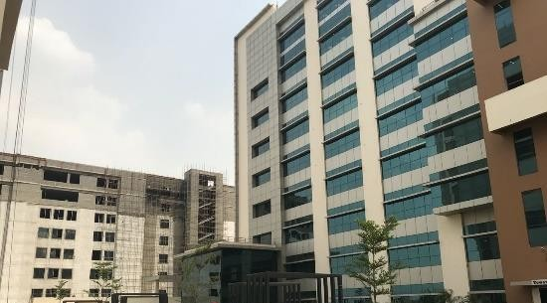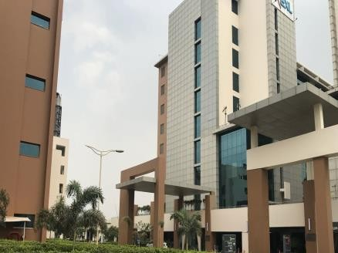

External view of the SP External view of the SP

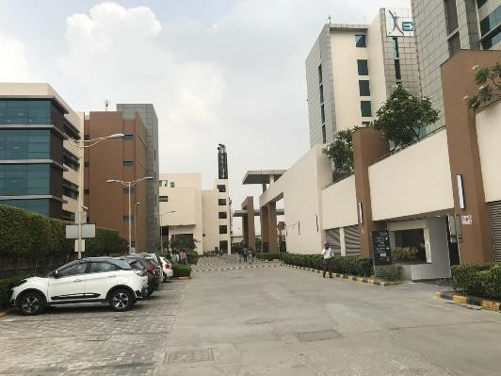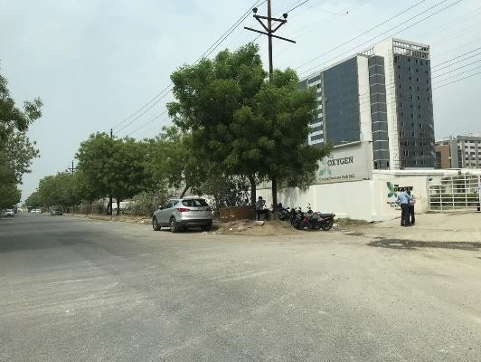

View of internal road View of the primary access road/entrance

* 1. Tenancy Analysis
     1. Historical Committed Occupancy Rates

The table below highlights the historical occupancy rates at the subject development:

|  |  |  |  |
| --- | --- | --- | --- |
| **March 31, 2017** | **March 31, 2018** | **March 31, 2019** | **March 31, 2020** |
| 100.0% | 100.0% | 91.9%* | 84.0%* |

*Source: Rent rolls provided by the Client; Indicative of committed occupancy*

*\* Does not include the area under hard option*

* + 1. Lease Expiry Analysis

The graph below highlights the area/leases due for expiry in the coming years:

**Lease Expiry**

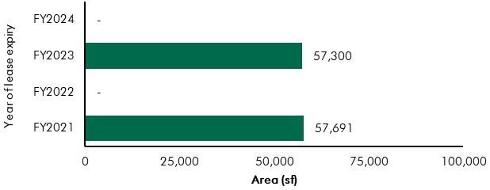

*Source: Rent Roll (representative of financial years)*

Consultants have undertaken an in-depth analysis of the rent roll/ lease deeds shared by the Client, to understand the lease expiry schedule of top tenants at the subject property and rent for those spaces as of date of valuation. The intent of the same is to analyse the risk of tenant churn as well as assessing the re-leasing risk for the property along with opining on the timeframe to lease-up the spaces in case a significant vacancy arises at the property.

* + 1. Escalation Analysis

As per the review of recently executed leases at the subject property, it is understood that the contracted escalation terms for these leases are 15% every 3 years, which are in line with the prevailing market practice witnessed across the sub-market and Noida.

* 1. Assumptions Rationale

As highlighted earlier, the subject property is located in Sector 144 towards the geographical south – eastern periphery of Noida City. The subject region is well connected to other parts of Noida and Delhi owing to its strategic location in proximity to Noida – Greater Noida Expressway, which makes it easily accessible from other regions of NCR.

Noida-Greater Noida Expressway is emerging as an integrated development corridor with provision for large-scale IT parks, SEZs, corporate office space, and developments across other real estate segments. This vector has witnessed significant development activity over the past few years in commercial office segment with facilities being developed by local as well as national developers. The region has witnessed robust demand from the technology sector, owing to its positioning as a technology hub and strategic location. Further, the emergence of technology as the main driver of commercial office space demand has led to emergence of a few IT SEZ developments in the region. The expressway also comprises of some prominent educational institutions such as Genesis Global School, Panchsheel Balak Inter College, Delhi Public School, Amity University, Lotus Valley International School, Pathway’s World School, etc. and hospitals such as Jaypee Hospital, JS Hospital, Felix Hospital, etc.

The commercial activity hubs along the Noida – Greater Noida Expressway can be divided into two blocks viz. Sectors 125 – 127 forming the first block which are located in proximity to Delhi and predominantly comprise of IT/ITeS developments. Majority of the developments along this stretch are completed. The prominent buildings in this block are Logix Technology Park, Tech Boulevard, Windsor IT Park, 8 Square, Tapasya, etc.

The second block comprises of sectors located towards Greater Noida along the expressway, such as sectors 132, 135, 142, 144, etc. which has notified SEZs as well as IT parks. The subject property forms a part of this block. The developments in this block are in different stages of planning and construction. This region is emerging as an important commercial hub owing to the spillover of demand from the first block which has limited availability of large sized land parcels. This region is perceived as a preferred destination for technology companies seeking expansion, consolidation or entry strategies in Noida owing to established infrastructure, excellent connectivity, availability of large consolidated spaces, etc. Some of the prominent commercial developments in the sub-market are Embassy Oxygen (‘the subject property’), Candor TechSpace, Assotech Business Cresterra, Advant Navis Business Park, Stellar 135, Express Trade Towers 2, etc.

Further, the commercial developments in this vector are supported by various residential developments across different segments and other social infrastructure. Some of the prominent residential developments in the region are Eldeco Utopia, Paras Tiera, Logix Blossom County, Logix Zest, Omaxe Forest, Saha Amadeus, etc.

* + 1. Demand and Supply Dynamics
       1. *Demand, Supply and Vacancy Trends – Noida and Noida – Greater Noida Expressway sub-market*

Total completed Grade A office stock in Noida as of Q4, 2019 is approx. 20.87 msf (for competition set), out of which Noida-Greater Noida Expressway accounts for approx. 53.5%.

|  |  |  |
| --- | --- | --- |
| **Particular** | **Noida (competition set)\***^ | **Noida-Greater Noida Expressway\***^ |
| Cumulative completed office stock (Q4 2019) Cumulative occupied stock (Q4 2019) Current Vacancy (Q4 2019)  Average Annual Office Absorption (2014 – 2019) | Approx. 20.87 msf | Approx. 11.17 msf |
| Approx. 18.43 msf | Approx. 9.86 msf |
| Approx. 11.7% | Approx. 11.7% |
| Approx. 1.28 msf | Approx. 0.66 msf |

*Source: CBRE Research*

*\* The Noida commercial market is highly fragmented and comprises of commercial buildings which do not qualify as a competition set for Embassy REIT properties. The characteristics of these buildings are inferior as compared to typical Grade A commercial buildings and the ownership is typically on strata holding basis. Hence, for the purpose of analysing the demand and supply dynamics of Noida, the total stock has been bifurcated to include a competition set, comprising of buildings with area not less than 75,000 sf, an open plan office with large size floor plates, adequate ceiling height, 24 X 7 power back-up, supply of telephone lines, infrastructure for access to internet, central air-conditioning, spacious and well decorated lobbies, circulation areas, lift services, sufficient parking facilities, etc.*

*^includes IT/ ITeS and SEZ stock*

**Demand – Supply Dynamics (Noida)**

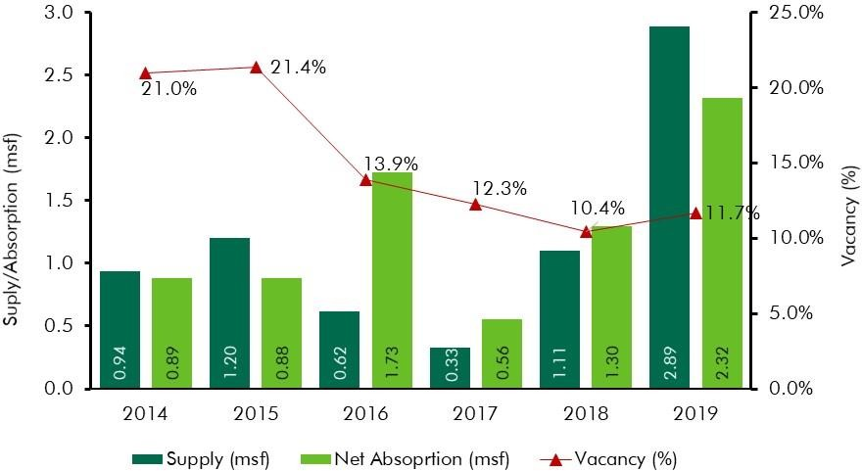

**Demand – Supply Dynamics (Noida-Greater Noida Expressway)**

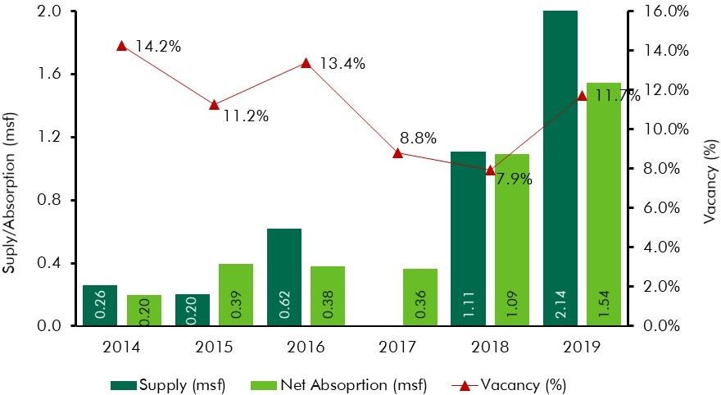

*Source: CBRE Research; Note: Supply – refers to fresh completed supply added each year; Absorption – refers to the quantum of leasing witnessed in each year as part of completed space; the vacancy in the chart accounts for the gap between cumulative stock and occupied stock in any given year*

As mentioned earlier, the subject region has emerged as a preferred business destination on account of availability of large-scale integrated IT parks and well-laid infrastructure. Further, the emergence of technology as the main driver of commercial office space demand has led to emergence of large integrated SEZ developments in the subject region such as Candor TechSpace located in Sector 135, Embassy Oxygen (‘the subject property’) located in Sector 144, etc. Few of the other investment grade commercial developments (IT/ITeS) located in the subject region include Assotech Business Cresterra, Advant Navis Business Park, Stellar 135, Express Trade Towers 2, etc.

Availability of good quality office space at affordable rents, presence of skilled manpower along with good connectivity and improved infrastructure are some of the reasons that have spurred demand for office space from corporate occupiers.

* + - 1. *Key Developments in Sub-Market*

The table below highlights the prominent competing developments located in the subject sub-market (completed blocks):

**Building Name**

**Development**

**Leasable Area**

**Approx.**

**Quoted Rent (INR psf**

|  |  |  |  |  |
| --- | --- | --- | --- | --- |
|  | **Type** | **(in msf)** | **Vacancy (%)** | **pm)** |
| Development 1 | IT/ ITeS SEZ | 2.9 | < 5% | 52.0 – 58.0 |
| Development 2 | IT/ ITeS | 1.2 | 15% - 20% | 52.0 – 58.0 |
| Development 3 | IT/ ITeS | 0.6 | 10% - 15% | 48.0 – 52.0 |
| Development 4 | IT/ ITeS | 0.7 | < 5% | 48.0 – 52.0 |

*Source: CBRE Research*

* + 1. Lease Rent Analysis

As highlighted above, the current rents in subject sub-market typically vary between INR 45.0 – 55.0 psf pm on leasable area basis (for warm shell spaces) depending upon specifications offered, location and accessibility of the development (viz. along/off the main roads), quality of construction, developer brand, amenities offered, space off take, related infrastructure provision for the site, distance from the key hubs of the city, etc.

Based on our market research, we understand that the rents in the subject sub-market have witnessed an average annual appreciation of approx. 5.1% between 2014 and 2019. Further, the said appreciation in the region is understood to be on account of low vacancy levels coupled with rising interest from technology occupiers. Hence, with low levels of ready to move-in supply in large-scale business parks coupled with sustained occupier interest, the market is expected to continue to achieve steady growth going forward.

The table below highlights some of the recent transacted rental values for office developments in the influence region of the subject property:

|  |  |  |  |
| --- | --- | --- | --- |
| **Date of Transaction** | **Area (sf)** | **Tenant** | **Transacted Rent (INR psf pm)\*** |
| Q1, 2020 | 25,000 | Tenant 1 | 55.0 - 58.0 (WS) |
| Q1, 2020 | 90,000 | Tenant 2 | 50.0 - 55.0 (WS) |
| Q4, 2019 | 25,000 | Tenant 3 | 50.0 - 55.0 (WS) |
| Q4, 2019 | 100,000 | Tenant 4 | 53.0 - 57.0 (WS) |
| Q4, 2019 | 25,000 | Tenant 5 | 53.0 - 57.0 (WS) |
| Q4, 2019 | 25,000 | Tenant 6 | 55.0 - 58.0 (WS) |
| Q3, 2019 | 25,000 | Tenant 7 | 55.0 - 58.0 (WS) |
| Q3, 2019 | 15,000 | Tenant 8 | 53.0 - 57.0 (WS) |
| Q2, 2019 | 100,000 | Tenant 9 | 53.0 - 57.0 (WS) |
| Q2, 2019 | 45,000 | Tenant 10 | 53.0 - 57.0 (WS) |
| Q1, 2019 | 140,000 | Tenant 11 | 45.0 - 50.0 (WS) |

*Source: CBRE Research* Rents are gross rents (viz. exclusive of property tax & insurance) on leasable area basis; Note: WS – Warm shell; FF – Fully Fitted-out*

The subject vector is characterized by presence of operational multi-tenanted IT / ITeS SEZs in addition to various IT Parks by prominent real estate players. The region has witnessed significant demand for office space primarily on account its superior infrastructure availability/ connectivity and presence of large-scale residential and social infrastructure facilitates in the vicinity. Presence of good quality residential dwelling options, proximity to quality healthcare and education facilities and presence of retail options has resulted in the emergence of the subject sub-market as a self-sustaining destination.

The rentals across the subject vector for IT developments have witnessed steady growth over the last 4 – 5 years on the back of sustained occupier demand and limited availability of ready to occupy Grade-A developments. Further, the completion of various infrastructure initiatives (such as FNG Expressway, metro connectivity, etc.) coupled with the significant residential inventory completion (in short to medium term) in the subject region is expected to enhance the profile of the subject location and would have an inherent impact on the office space demand which is expected to remain stable. Hence, going forward, given the demand for office space in this vector, ongoing infrastructure initiatives, low vacancy levels and superior development quality, the subject sub-market is expected to witness a consistent increase in rentals.

* 1. Value Assessment
     1. Adopted Methodology

We acknowledge that the approaches to valuation differ considerably and that for a particular purpose, alternative approaches to valuation can be utilized subject to the Client’s consultations and giving due consideration to the Client’s requirements. Considering the objective of this exercise and the nature of asset involved, the value of the subject property has been assessed through the following approach:

|  |  |
| --- | --- |
| **Particulars Completed Blocks Under Construction/ Proposed**  **Blocks** | |
| **Valuation Methodology** | Discounted Cash Flow Method (using rental reversion approach) |

The sections below highlight detailed valuation workings for the subject property. Please note that the assumptions/ opinions highlighted in the subsequent sections are to be read in conjunction with Section

1.11 and the following:

*“In the current uncertain environment caused by the outbreak of the Novel Coronavirus (COVID-19), we have considered /* relooked *at various performance parameters and have adopted heuristic/ careful interventions (including but not limited to the points mentioned below) to our projected cashflows based on our view as of the date of valuation.*

* *Limited/ no growth in rent has been considered over the next few quarters*
* *Construction timelines have been delayed from the earlier estimates*
* *Considering challenges in the short term, timelines have been extended for new space take-up/ future leasing*
* *Additional fit-out period/ rent free months have been incorporated where fit-out works have commenced”*
  + 1. Area statement

Based on information/rent roll provided by the Client, we understand that subject property is an office park. Further, the table below highlights the area configuration of the subject property:

**Component Leasable area (in sf)**

Completed Blocks 2,517,307

Under Construction Blocks NA

Proposed Blocks 737,000

Total 3,254,307

*Source: Architect Certificate and Rent roll provided by Client*

**Block**

**Leasable Area (sf) Construction**

**Commencement**

**Construction Completion**

**Construction (% completion)\*\***

**Construction Status**

* + 1. Construction Timelines
       1. *Completed Blocks*

As highlighted earlier, the subject property has approx. 2.52 msf of completed development as of date of valuation. Further, as highlighted earlier, occupancy certificate for Tower 2 has been recently received. However, there is a cost of INR 381.87 Mn pending to be spent towards the same as of date of valuation.

* + - 1. *Under-Construction/ Proposed Blocks*

Based on information provided by the Client, the following timelines for construction have been adopted for the purpose of this valuation exercise:

*Tower 1* 737,000 Q2, FY 2021 Q2, FY 2023 2.6% Land Stage

*Source: Client’s inputs/ Valuer assessment *the timelines are mentioned as per financial year beginning April to March*

*\*\* Highlights the cost incurred as a percentage of budgeted cost*

* + 1. Absorption/ Leasing Velocity and Occupancy Profile
       1. *Completed Blocks*

As per the analysis of the rent roll, it was observed that there is a vacancy of approx. 296,111 sf (excluding hard options) in the completed blocks at the subject property as of date of valuation and we are of the opinion that the same would be leased by Q1, FY 2022.

* + - 1. *Under-Construction/ Proposed Blocks*

The absorption period assumed for the subject development is based on market dynamics and extent of development in the relevant sub-market, nature of subject development, competing supply of same nature, location within the respective sub-market, etc. The table below highlights the absorption assumptions adopted for the subject development:

|  |  |  |  |  |  |
| --- | --- | --- | --- | --- | --- |
| ***Particular Absorption Schedule*** | ***Till 31st March 2020\**** | ***FY 2021*** | ***FY 2022*** | ***FY 2023*** | ***Total*** |
| Percentage (%) | - | - | 60.0% | 40.0% | 100.0% |
| Leasable Area (sf) | - | - | 442,200 | 294,800 | 737,000 |

*Tower 1*

*Source: Valuer assessment*

*\* Area leased/ committed till date of valuation as per Client’s inputs*

* + 1. Revenue Assumptions
       1. *Lease rent assumptions*

For the purpose of this valuation exercise, the lease rent adopted for the area already leased is based on the rent roll shared by the Client. Further, the Valuer has undertaken an in-depth market research exercise to assess the prevailing rental values in the subject sub-market. The same has been adopted for reversion/ vacant space for the purpose of this valuation exercise.

Based on our market study and based on the analysis of the rent roll provided by the Client, following rents have been adopted for the purpose of value assessment of the subject property.

|  |  |  |  |  |
| --- | --- | --- | --- | --- |
| **Component** | **Leasable Area (sf)** | **Leased Area (sf)** | **Basis** | **Rent Adopted* (INR**  **psf pm)** |
|  |  |  | Current Rent for Leased area | 47.9^ |
| **Office** | 3,254,307 | 2,114,985** | Marginal rent for reversion/ vacant area | 54.0 |

*Source: Rent roll provided by the Client; Valuer Assessment*

*\* The rents mentioned above exclude other income such as CAM charges, parking income received from the tenants, etc.*

*\*\* Includes committed area; ^weighted average warm shell rent for area already leased – as per rent roll shared by Client*

The above marginal rent assumption is adopted for the subject development. In addition to undertaking an in-depth market analysis, a detailed analysis of the rent rolls was also undertaken to understand aspects such as area occupied, current rent and expiry analysis of the key tenants in the park. Additionally, the Valuer has also analysed the historical occupancy pattern at the subject development and the sub – market and lease-up time frame for spaces being vacated by tenants during the last 3 years. The lease-up time was observed to be 3 – 6 months based on quantum of space being renewed/ re-leased.

Based on the size and scale of operations of these tenants, we have adopted individual marginal rent assumptions for larger tenants in the subject development. For the larger tenants, we have assumed that post lease expiry, these spaces will revert to marginal rent prevailing at that point in time. However, given the large size of these spaces, a longer lease-up time, ranging from 3 – 6 months depending on area to be leased, has been incorporated.

**Area (msf) Marginal Rent Strategy**

Leasable Area > 0.35 msf Renewal at market (6 months lease-up time)

Leasable Area between 0.20 msf and 0.35 msf Renewal at market (3 months lease-up time)

*Source: Valuer Assessment*

As presented in the table above, larger tenants will be renewed at market, but with a longer lease-up time frame.

* + - 1. *Rent Escalation*

Based on an analysis of existing lease rolls, it was observed that the typical escalation clause in the subject property is approx. 15% after every three years, which is in-line with the trend observed in the market. The same has been adopted by the Valuer for the vacant area and renewals at the subject property.

* + - 1. *Fit-out Rent*

As per the information (rent roll) provided by the Client, we understand that currently, the subject development does not receive any separate income from fit-out rentals from any of the tenants.

Moreover, for the vacant area (in completed/proposed blocks), we have assumed that the same would be leased on warm shell specifications with no applicable fit-out rentals on any lease.

* + - 1. *Other Revenues*

In addition to lease rent revenues, office parks typically have additional sources of revenue. These include revenues on account of security deposit (refunded at the time of lease expiry / exit), other miscellaneous income (such as parking, cell sites, retail areas, food court, kiosks, etc.), mark-up on Common Area Maintenance (CAM) charges/ CAM margin, etc.

The assumptions considered for the aforementioned revenue heads for the purpose of this valuation exercise are based on the rent roll/ information provided by the Client. The same has been cross-checked with the prevailing market norms for other revenues and were found to be broadly in line.

The assumptions adopted for other revenues are as tabulated below:

**Nature of Income Details Units**

Miscellaneous Income (Income from parking, cell sites, retail areas, food court, kiosks, etc.)

1.7%

(INR 16.34 Mn)

% of rental income

Warm shell Security Deposit* 6 months No. of months’ warm shell rental

Mark-Up on CAM/ CAM margin 15.0% %

*Source: Client’s Inputs & Valuer assessment; * Refunded at the time of lease expiry/ exit*

* + 1. Expense Assumptions
       1. *Development Cost*

The following table highlights the assumptions towards the development cost for the proposed block at the subject development:

**Block**

**Cost of Construction (INR Total Cost of Construction Pending Cost to be Spent psf) (INR Mn) (INR Mn)**

*Tower 1* 4,003 2,950.00 2,872.97

*Source: Client’s input; Contingencies and escalations have been factored as part of the cost projections provided by the Client*

* + - 1. *FSI Purchase Cost*

Based on inputs of the Client, a cost of INR 70.00 Mn towards purchase of additional FSI has been factored in our valuation workings.

* + - 1. *Refurbishment Expenses – Development level expenses*

The following table highlights the assumptions towards the refurbishment expenses/ infrastructure upgrade works in the subject development:

|  |  |  |
| --- | --- | --- |
| Nature of Expense | Total Pending Cost (INR Mn)* | Quarter of Completion |
| Signage Rebranding | 4.81 | Q1, FY 2021 |
| Incubation space in FC | 36.81 | Q2, FY 2021 |
| Common Infrastructure Costs | 4.57 | Q1, FY 2021 |
| Tower 2 ML Retrofit Cost | 91.10 | Q2, FY 2021 |

*Source Client Input; Valuer Assessment*

* + - 1. *Other Expenses*

The following table highlights the assumptions towards other expenses in the subject development:

|  |  |  |
| --- | --- | --- |
| Nature of Expense | Details | Unit |
| Annual Lease Rentals (payable to NOIDA Authority) | INR 14.70 Mn* | INR Mn per annum |
| Opex projects and admin expenses | 1.0% | % of total income |
| Asset Management Fee^ | 3.0% | % of gross rental income |
| Transaction cost on Exit | 1.0% | % of terminal value |

*Source: Client Input; Valuer assessment*

*\* Represents the current lease rental payable as on date of valuation. The same shall be escalated by 50% at the end of every 10 years*

*^ Asset Management fee has been considered a below the NOI line item*

* + 1. Other Assumptions
       1. *Vacancy provision*

Based on the prevailing market benchmarks, a vacancy provision of 2.5% has been adopted upon assessment of terminal value

* + - 1. *Revenue escalation*

Based on prevailing market condition, historical rent growth achieved by the subject property and our interactions with market participants, we are of the opinion that the annual rent growth for the subject property will be 5.0% from Q4, FY 2021 onwards.

* + - 1. *Rent – free period*

Based on the trend prevalent in the subject sub – market, we have considered a rent free period of 3 months for the subject property from the lease commencement date (for future / new leases)

* + - 1. *Brokerage*

Based on prevalent market dynamics, we have considered brokerage equivalent to 2 months of rental income for future / new leases

* + 1. Capitalization Rates

As highlighted in section 3.3, the cap rate adopted for the office space is 8.25%.

* + 1. Discount Rate

For discounting the cash flows, the appropriate discounting rate has been calculated on the basis of estimated ‘Weighted Average Cost of Capital’ (WACC). The detailed analysis of WACC rate adopted for the subject property has been detailed in Section 3.4 of this report.

12.5 Value of the Subject Property

Based on the above mentioned analysis, the value of the subject property is estimated as follows:

|  |  |  |  |
| --- | --- | --- | --- |
| Component | Value (INR Mn) |  | % Share |
| Completed Blocks | 19,492 |  | 91.0% |
| Under-Construction/ Proposed Blocks | 1,924 |  | 9.0% |
| **Embassy Oxygen** |  | **INR 21,416 Mn** |  |

##### Embassy Galaxy

* 1. Property Description

|  |  |
| --- | --- |
| **Brief Description** | |
| **Particulars** | **Details** |
| **Property Name** | Embassy Galaxy |
| **Address** | A-44 & 45, Sector 62, Noida, Uttar Pradesh, India – 201309 |
| **Land Area** | 9.88 acres/ 40,000 sqm |
| **Leasable Area** | Completed Bocks – 1.36 msf |

*Source: Lease Deed (dated March 27, 2006), Title Report, Architect Certificate*

* + 1. Site Details

Situation: Subject property – ‘Embassy Galaxy’ is an operational office park located at Sector 62, Noida, Uttar Pradesh.

Location: The subject property is located in Sector – 62, Noida which is an established commercial vector situated towards the northern periphery of the city and is a preferred office destination in Noida. The property is accessible via an approx. 45 m wide internal sector road of Sector 62. The subject property is well connected to other parts of Noida and Delhi owing to its strategic location i.e. it is situated in close proximity to National Highway (NH) – 24/ Delhi-Meerut Expressway (located at a distance of approx. 1 km and provides direct connectivity with Eastern and Central Delhi), which makes it easily accessible from other regions of NCR (National Capital Region).

As mentioned earlier, the subject vector, i.e. Sector 62 is an established commercial vector of Noida. The said vector has been earmarked for institutional development (which permits IT/ITeS usage) by Noida Authority and the same has resulted in the emergence of the said vector as an alternate business district for the city of Noida. The subject region has witnessed significant development activity (across IT/ITeS office space) over the past few years. Few of the prominent investment grade office developments located in the subject region include 3C Green Boulevard, Stellar IT Park, Logix Cyber Park, Candor Techspace, Embassy Galaxy (‘the subject property‘), Okaya Center, etc.

By virtue of being promoted as an institutional sector, the subject vector also comprises of some prominent educational institutions such as Jaypee Business

School, Symbiosis Law School, IIM Lucknow (Noida Campus), etc. In addition to this, Fortis Hospital (a prominent hospital in the region) is also located in close proximity to the subject property. The subject property is also located in proximity to established residential hubs such as Indirapuram, Vaishali, etc. which offer a range of affordable to mid-end housing options and also enables a walk-to-work culture.

The distances from key hubs to the subject property are presented in the table below:

|  |  |
| --- | --- |
| **Landmark** | **Distance (km)** |
| NH – 24/ Delhi-Meerut Expressway | 0 – 1 |
| Sector-18, Central Business District (CBD) of Noida | 9 – 10 |
| DND Flyway | 10 – 11 |
| Connaught Place, CBD of Delhi | 18 – 19 |
| New Delhi Railway Station | 18 – 19 |
| Indira Gandhi International Airport, Delhi | 31 – 32 |

*Source: Consultants’ Research*

Surrounds: The immediate surrounding of the subject property is as follows:

Potential changes in surroundings:

* North: Other’s property
* South: Approx. 45 m wide internal sector road (primary access road)
* East: Other’s property
* West: Other’s property

As highlighted earlier, the subject sub-market has emerged as an alternate business district to the city of Noida and has witnessed significant supply across commercial office developments. Moreover, few developments in the region are currently under construction and are expected to be completed in the short to medium term.

Additionally, an MRTS rail link connecting Noida City Centre (Sector – 32) to Sector

– 62 touching NH-24 has been jointly developed by DMRC (Delhi Metro Rail Corporation) and NMRC (Noida Metro Rail Corporation). The said corridor is an extension to the existing metro line (till Noida City Centre) which directly connects Noida to Connaught Place (CBD of Delhi) and further up to Dwarka (situated close to Delhi International Airport and Gurgaon). The stretch passes through Sector-71 crossing and provides connectivity to Sectors 32, 34, 35, Hoshiarpur, Sectors 51,

52, 71, Sarfabad, Sectors 60, 61, 62, 63 and NH-24. The same was opened to public in March 2019.

Moreover, NH – 24/ Delhi-Meerut Expressway (located at a distance of approx. 1 km from subject property) is being converted to a 16-lane expressway providing dedicated 8 lanes on the main carriage-way and additional 8 lanes for transit traffic to the city nodes. The development work on the same is currently under progress and is expected to be completed by Year 2020 – 21.

Thus, considering the development activity witnessed and ongoing infrastructure initiatives, the attractiveness of the subject sub-market is expected to enhance in the short-medium term.

Suitability of existing use:

Considering the profile of surrounding developments, the subject property is opined to be suited for its current use viz. IT/ ITeS office park.

EMBASSY OFFICE PARKS MANAGEMENT SERVICES PRIVATE LIMITED | EMBASSY OFFICE PARKS REIT

The following map indicates the location of the subject property and surrounding developments:

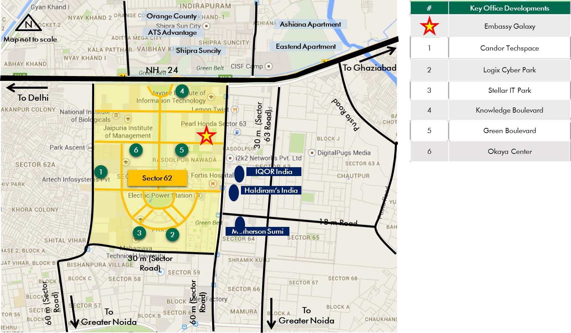

**Location Map for the Subject Property**

*Source: Consultants’ Research*

Shape: Based on the review of site plan provided by the Client and visual inspection undertaken during the site visit, it is understood that the subject land parcel is regular in shape.

Topography: Based on the site plan and as corroborated with our site visit, the site appears to be even and on the same level as abutting access road and adjoining properties.

Accessibility: Based on the review of site plan provided by the Client coupled with visual inspection undertaken, it was observed that the access to the subject property is via a sector road of Sector 62, which is an approx. 45 m wide road located towards the south of the subject property. The subject property enjoys significant frontage along the access road.

Frontage: Based on review of site plan, visual inspection and measurements made on Google maps, we understand that the subject site has a frontage of approximately 200 meters along the access road.

Please refer Exhibit & Addenda for the site plan of the subject property.

* + 1. Legal Details

As per the title due diligence undertaken by M/s Cyril Amarchand Mangaldas and lease deed (dated March 27, 2006) provided by the Client, we understand that the exact address of the subject property is A-44 & 45, Sector 62, Noida, Uttar Pradesh. Additionally, it is understood that the subject property is leasehold in nature, with remaining lease term of approx. 76 years.

Further, this valuation exercise is based on the premise that the subject property has a clear title and is free from any encumbrances, disputes, claims, etc. The Consultants have not made any inquiries in this regard with the relevant legal/ statutory authorities.

* + 1. Town Planning

Zoning As per the review of Occupancy Certificates / Lease Deed provided by the Client, we understand that the subject property is zoned for Institutional Use (with permission for IT/ ITeS development). It is located within the jurisdiction of New Okhla Industrial Development Authority (NOIDA). The same has been considered for the purpose of this valuation. The Consultants have made no further inquiries with the local authorities in this regard.

The permissible land use adopted by the Consultants for the subject property has been based on review of Noida Master Plan and various documents/ information provided by the Client. It must be noted that all factual data viz. permissible development control regulations, land area and achievable FSI have also been based on information/review

Approved Usage:

of various documents (such as title report, lease deed, plan sanction letter, site plan, etc.) provided by the Client or assumed based on building regulations, and no physical verification/ measurement has been undertaken for the purpose of this valuation exercise.

For the purpose of this exercise, it has been assumed that all developments adhere to building regulations as prescribed by the relevant authorities. The Consultants have not validated the information provided by the Client with the relevant development authorities.

Based on Occupancy Certificates provided by the Client and visual inspection during our site visit, we understand that the subject property is an operational office park, comprising of 5 blocks. The current use of the subject property has been provided by the Client and is broadly in agreement with the rules and regulations as prescribed by the local development authority. However, the Consultants have not made any enquiries with the relevant local authorities to validate the same for its specific applicability to the subject property.

Restrictions: As per feedback received from the Client, there are no restrictions on the current use of the property.

Natural or induced hazards:

We are of the opinion that the project/ site has been developed to withstand natural or induced hazards (with the exception of extreme/ out of the ordinary hazards).

* + 1. Statutory Approvals, One Time Sanctions & Periodic Clearances

Please refer section 18.3 on Statutory Approvals, One time Sanctions & Periodic Clearances

* + 1. Area Details, Type and Age of Existing Structures

The table below highlights the detailed area break-up of the subject development:

|  |  |  |
| --- | --- | --- |
| **Development Name Developable Completed Area (sf)** | **Committed Area (sf)** | **Occupied Area (sf)** |
| Embassy Galaxy 1,018,420 1,357,029 | 1,342,494 | 1,342,494 |
| *Source: Rent roll, Architect Certificate provided by Client, * represents achieved FSI area* | | |

**Area (sf)\***

**Block**

**Building Elevation**

**SEZ/Non-SEZ**

**Age**

**Leasable Area**

|  |  |  |  |  |
| --- | --- | --- | --- | --- |
| **Name** |  |  | **(Years)** | **(sf)** |
| **Completed Blocks** |  |  |  |  |
| A | 2B + G + 5 | Non SEZ |  | 278,374 |
| B | 2B + G + 6 | Non SEZ |  | 344,329 |
| C | 2B + G + 10 | Non SEZ | 9 to 13 years | 318,156 |
| D | 2B + G + 10 | Non SEZ |  | 403,872 |
| E | 2B + G + 2 | Non SEZ |  | 12,298 |
| Total |  |  |  | 1,357,029 |

*Source: Rent roll, Occupancy/ Completion Certificate provided by Client*

**Details Completed Blocks**

Grade of the Building Grade A

IGBC Certification Gold

Structural Design 2B+G+2 to 2B+G+10

Status of Finishing Warm Shell

Comments on Obsolescence The building is currently well maintained

*Source: Rent roll/ information provided by Client, Site visit undertaken by the Consultants*

* + 1. Site Services and Finishes

**Particulars Details**

Handover condition Warm Shell

Passenger elevators Provided

Service elevators Provided

Power back-up Provided

Building management system Provided

Security systems Provided

Air conditioning Provided

Firefighting services Provided

Car parks provided Covered and open car parks

*Source: Information provided by Client, Site visit undertaken by the Consultants, lease deeds*

The property is an open-campus style development with a range of amenities including a recently refurbished state-of-the-art food court, cafes and numerous retail options.

* + 1. Condition & Repair

Subject property is developed and managed to international standards offering best-in-class asset management and environment friendly green initiatives, which makes it a preferred option for domestic as wells as Multinational Corporations (MNCs). Based on information provided by the Client and site visit, it is understood that the subject property is in good condition and is being maintained well. The table below highlights the major repairs and maintenance work/ infrastructure upgrade works undertaken (in the past few years)/ currently being undertaken at the subject development:

|  |  |  |  |
| --- | --- | --- | --- |
| **Expense Head T** | **otal Cost (INR mn)** | **Balance Cost (INR mn) Quarter of**  **Completion** | |
| Operations Office | 7.35 | - | Q2, FY 2017 |
| Retail Phase I | 10.39 | - | Q3, FY 2017 |
| Installation of New Elevators in Towers C and D | 12.83 | - | Q4, FY 2017 |
| Exterior paintwork | 3.13 | - | Q1, FY 2018 |
| Fiserv Relocation | 9.24 | - | Q3, FY 2018 |
| Looks Relocation | 1.50 | - | Q3, FY 2018 |
| Retail Phase II | 98.73 | - | Q3, FY 2018 |
| Structural Strengthening of all towers | 6.75 | - | Q3, FY 2018 |
| Signage | 6.32 | - | Q3, FY 2018 |
| Water Proofing | 56.05 | - | Q3, FY 2018 |
| Basement Upgradation | 5.60 | - | Q4, FY 2018 |
| Central Courtyard | 34.26 | - | Q4, FY 2018 |
| DG Pipe Replacement | 3.49 | - | Q4, FY 2018 |
| Signage Rebranding | 8.02 | 4.17 | Q1, FY 2021 |

*Source: Information provided by Client*

* + 1. Property Photographs

Please refer to the property photographs highlighted below:

Embassy Galaxy

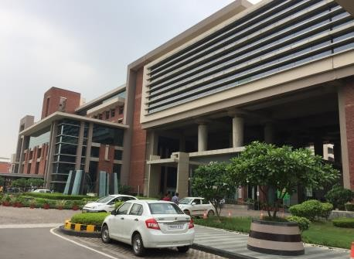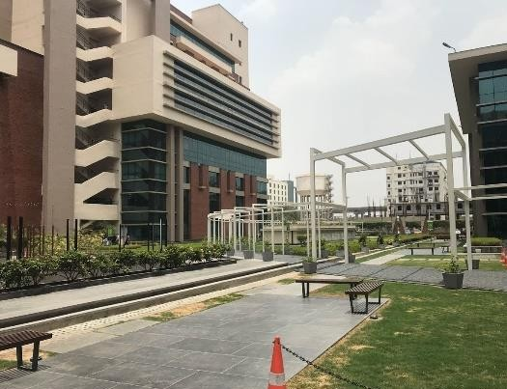

External view of the subject property (SP) External view of the SP

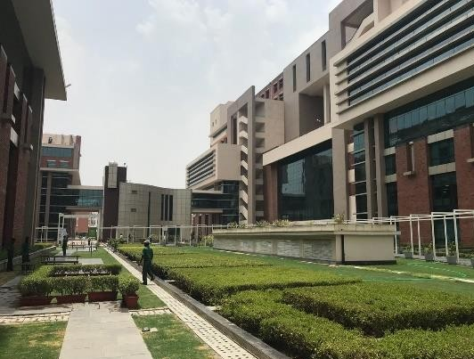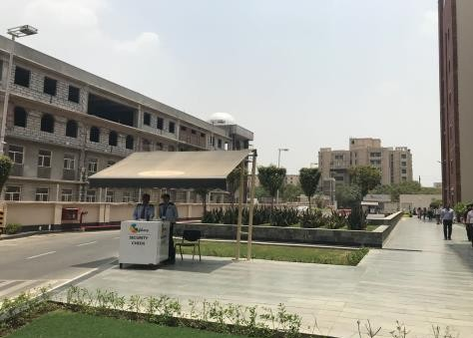

View of landscaping at the SP Internal view of the SP

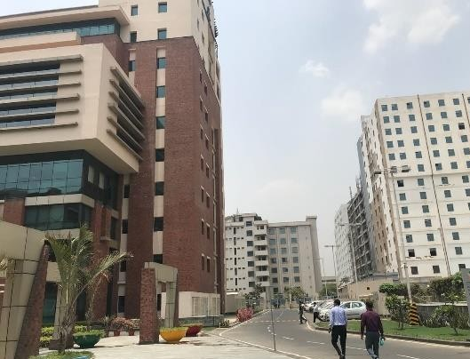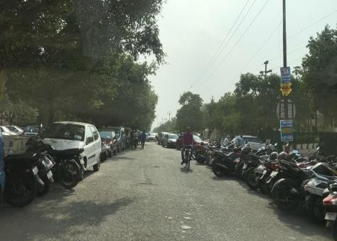

View of internal access road View of the primary access road/entrance

* 1. Tenancy Analysis
     1. Historical Committed Occupancy Rates

The table below highlights the historical occupancy rates at the subject development:

|  |  |  |  |
| --- | --- | --- | --- |
| **March 31, 2017** | **March 31, 2018** | **March 31, 2019** | **March 31, 2020** |
| 98.94% | 99.97% | 100.0% | 98.9% |

*Source: Rent rolls provided by the Client; Indicative of committed occupancy*

* + 1. Lease Expiry Analysis

The graph below highlights the area/leases due for expiry in the coming years:

**Lease Expiry**

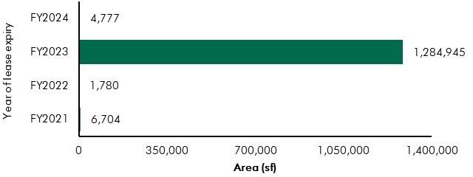

*Source: Rent Roll (representative of financial years)*

Consultants have undertaken an in-depth analysis of the rent roll/ lease deeds shared by the Client, to understand the lease expiry schedule of top tenants at the subject property and rent for those spaces as of date of valuation. The intent of the same is to analyse the risk of tenant churn as well as assessing the re-leasing risk for the property along with opining on the timeframe to lease-up the spaces in case a significant vacancy arises at the property.

* + 1. Escalation Analysis

As per the review of recently executed leases at the subject property, it is understood that the contracted escalation terms for these leases are 15% every 3 years, which are in line with the prevailing market practice witnessed across the sub-market and Noida.

* 1. Assumptions Rationale

As highlighted earlier, the subject property is an operational office park located in Sector 62, an established commercial hub of Noida situated towards the geographical northern periphery of Noida

City. The subject region is well connected to other parts of Noida and Delhi owing to its strategic location in proximity to NH – 24, which makes it easily accessible from other regions of NCR.

The subject sub-market has witnessed significant development activity over the past few years in commercial office segment with facilities being developed by local as well as regional developers. The subject sub-market has witnessed robust demand from the technology sector, owing to its positioning as a technology hub. Sector 62 also comprises of some prominent educational institutions such as Jaypee Business School, Symbiosis Law School, IIM Lucknow (Noida Campus), etc. In addition to this, Fortis Hospital is also located in the subject region. The region is also located in proximity to established residential hubs such as Indirapuram, Vaishali, etc. which offer a range of affordable to mid-end housing options.

Sector 62 is perceived as a favourable destination for technology companies owing to established infrastructure, excellent connectivity, cluster of similar companies in the immediate vicinity, etc. Some of the prominent commercial developments in the subject sub-market are Stellar IT Park, Embassy Galaxy (‘the subject property’), Knowledge Boulevard, Candor Techspace, Logix Cyber Park, Green Boulevard, Okaya Center, etc.

Further, due to sustained demand and positive future perception of the subject vector, a few developers have commenced construction of commercial developments in the subject sub-market. Additionally, relatively lower rentals and significant grade A supply in the subject sub-market, has led to emergence of the subject vector as a prominent technology hub of Noida as well as NCR.

* + 1. Demand and Supply Dynamics
       1. *Demand, Supply and Vacancy Trends – Noida and Sector 62/ Peripheral Noida sub-market*

Total completed Grade A office stock in Noida as of Q4, 2019 is approx. 20.87 msf (for competition set), out of which Sector 62/ Peripheral Noida accounts for approx. 33.52%.

|  |  |  |
| --- | --- | --- |
| **Particular** | **Noida (competition set)\***^ | **Sector 62/ Peripheral Noida\***^ |
| Cumulative completed office stock (Q4 2019) Cumulative occupied stock (Q4 2019) Current Vacancy (Q4 2019)  Average Annual Office Absorption (2014 – 2019) | Approx. 20.87 msf | Approx. 7.00 msf |
| Approx. 18.43 msf | Approx. 6.29 msf |
| Approx. 11.7% | Approx. 10.1% |
| Approx. 1.28 msf | Approx. 0.45 msf |

*Source: CBRE Research*

*\* The Noida commercial market is highly fragmented and comprises of commercial buildings which do not qualify as a competition set for Embassy REIT properties. The characteristics of these buildings are inferior as compared to typical Grade A commercial buildings and the ownership is typically on strata holding basis. Hence, for the purpose of analysing the demand and supply dynamics of Noida, the total stock has been bifurcated to include a competition set, comprising of buildings with area not less than 75,000 sf, an open plan*

*office with large size floor plates, adequate ceiling height, 24 X 7 power back-up, supply of telephone lines, infrastructure for access to internet, central air-conditioning, spacious and well decorated lobbies, circulation areas, lift services, sufficient parking facilities, etc.*

*^includes IT/ ITeS and SEZ stock*



**Demand – Supply Dynamics (Noida)**

**Demand – Supply Dynamics (Sector 62/ Peripheral Noida)**

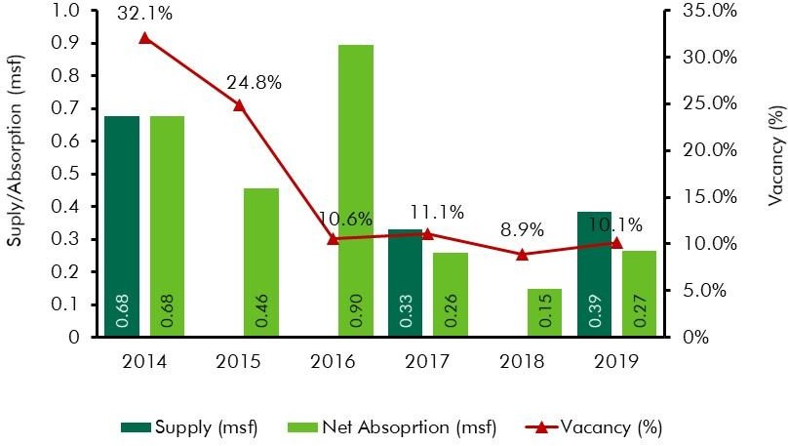

*Source: CBRE Research; Note: Supply – refers to fresh completed supply added each year; Absorption – refers to the quantum of leasing witnessed in each year as part of completed space; the vacancy in the chart accounts for the gap between cumulative stock and occupied stock in any given year*

As mentioned earlier, the subject region is an established commercial vector of Noida. The said vector has been earmarked for institutional development (which permits IT/ITeS usage) by Noida Authority and the same has resulted in the emergence of the said vector as an alternate business district for the city of Noida. The subject region has witnessed significant development activity (across IT/ITeS office space) over the past few years. Few of the prominent office developments located in the subject region include 3C Green Boulevard, Stellar IT Park, Logix Cyber Park, Candor Techspace, Embassy Galaxy (‘the subject property‘), Okaya Center, etc.

The subject region has witnessed significant demand from technology occupiers. Availability of good quality office space at affordable rents, presence of skilled manpower along with good connectivity and improved infrastructure are some of the reasons that have spurred demand for office space from corporate occupiers.

* + - 1. *Key Developments in Sub-Market*

The table below highlights the prominent competing developments in the subject sub-market (completed blocks):

**Building Name**

**Development Type**

**Leasable Area**

**Approx.**

**Rent (INR psf pm)**

|  |  |  |  |  |
| --- | --- | --- | --- | --- |
|  | | **(in msf)** | **Vacancy (%)** |  |
| Development 1 | IT/ ITeS | 1.9 | 20% - 25% | 45.0 – 50.0 |
| Development 2 | IT/ ITeS | 1.2 | < 5% | 40.0 – 45.0 |
| Development 3 | IT/ ITeS | 0.6 | 4% - 6% | 45.0 – 50.0 |
| Development 4 | IT/ ITeS | 0.7 | Minimal | 45.0 – 50.0 |
| Development 5 | IT/ ITeS | 0.7 | Minimal | 45.0 – 50.0 |
| Development 6 | IT/ ITeS | 0.8 | 4% - 6% | 45.0 – 50.0 |

*Source: CBRE Research*

* + 1. Lease Rent Analysis

As highlighted above, the current rents in subject sub-market typically vary between INR 40.0 – 50.0 psf pm on leasable area basis (for warm shell spaces) depending upon specifications offered, location and accessibility of the development (viz. along/off the main roads), quality of construction, developer brand, amenities offered, space off take, related infrastructure provision for the site, distance from the key hubs of the city, etc.

Based on our market research, we understand that the rents in the subject sub-market have witnessed an average annual appreciation of approx. 4.6% between 2014 and 2019. Further, the said appreciation in the region is understood to be on account of low vacancy levels in the developments coupled with rising interest from technology occupiers. Hence, with low levels of ready to move-in supply in large- scale business parks coupled with limited upcoming supply and sustained occupier demand, the market is expected to continue to achieve steady growth going forward.

The table below highlights some of the recent transacted rental values for office developments in the influence region of the subject property:

|  |  |  |  |
| --- | --- | --- | --- |
| **Date of Transaction** | **Area (sf)** | **Tenant** | **Transacted Rent (INR psf pm)\*** |
| Q1, 2020 | 5,500 | Tenant 1 | 45.0 - 50.0 (WS) |
| Q1, 2020 | 25,000 | Tenant 2 | 45.0 - 50.0 (WS) |
| Q4, 2019 | 25,000 | Tenant 3 | 45.0 - 50.0 (WS) |
| Q4, 2019 | 30,000 | Tenant 4 | 40.0 – 45.0 (WS) |
| Q4, 2019 | 10,000 | Tenant 5 | 65.0 - 70.0 (FF) |
| Q4, 2019 | 12,000 | Tenant 6 | 63.0 - 67.0 (FF) |
| Q3, 2019 | 13,000 | Tenant 7 | 45.0 - 50.0 (WS) |
| Q2, 2019 | 18,000 | Tenant 8 | 43.0 - 47.0 (WS) |
| Q2, 2019 | 30,000 | Tenant 9 | 40.0 - 45.0 (WS) |

*Source: CBRE Research* Rents are gross rents (viz. exclusive of property tax & insurance) on leasable area basis; Note: WS – Warm shell; FF – Fully Fitted-out*

The rentals in the subject vector for IT/ITeS developments have witnessed steady growth over the last 4 – 5 years owing to sustained occupier demand and limited availability of ready to occupy Grade-A developments. Further, the completion of various infrastructure initiatives (such as metro connectivity, widening of NH 24, etc.) is expected to further enhance the profile of the subject location in the short to medium term. Hence, going forward, given the demand for office space in this vector, proximity to key residential hubs of Indirapuram, Vaishali, etc. (offering affordable to mid-end housing options), completed/ ongoing infrastructure initiatives, low vacancy levels, limited upcoming supply and continued interest of occupiers, the subject sub-market is expected to witness a consistent increase in rentals.

* 1. Value Assessment
     1. Adopted Methodology

We acknowledge that the approaches to valuation differ considerably and that for a particular purpose, alternative approaches to valuation can be utilized subject to the Client’s consultations and giving due consideration to the Client’s requirements. Considering the objective of this exercise and the nature of asset involved, the value of the subject property has been assessed through the following approach:

|  |  |  |
| --- | --- | --- |
| **Particulars** | **Completed Blocks** | **Under Construction/ Proposed Blocks** |
| **Valuation Methodology** | Discounted Cash Flow Method (using rental reversion approach) | NA |

The sections below highlight detailed valuation workings for the subject property. Please note that the assumptions/ opinions highlighted in the subsequent sections are to be read in conjunction with Section

1.11 and the following:

*“In the current uncertain environment caused by the outbreak of the Novel Coronavirus (COVID-19), we have considered /* relooked *at various performance parameters and have adopted heuristic/ careful interventions (including but not limited to the points mentioned below) to our projected cashflows based on our view as of the date of valuation.*

* *Limited/ no growth in rent has been considered over the next few quarters*
* *Considering challenges in the short term, timelines have been extended for new space take-up/ future leasing*
* *Additional fit-out period/ rent free months have been incorporated where fit-out works have commenced”*
  + 1. Area statement

Based on information/rent roll provided by the Client, we understand that the subject property is an office park. Further, the table below highlights the area configuration of the subject property:

**Component Leasable area (in sf)**

Completed Blocks 1,357,029

Under Construction Blocks -

Proposed Blocks -

Total 1,357,029

*Source: Architect certificate and Rent roll provided by Client*

* + 1. Construction Timelines

As highlighted earlier, the subject property has approx. 1.36 msf of completed office development with no pending cost to complete as of date of valuation for the completed blocks.

* + 1. Absorption/ Leasing Velocity and Occupancy Profile

Based on the rent roll provided by the Client and visual inspection during the site visit, we understand that the subject property is fully operational and there are no under-construction blocks. As per the analysis of the rent roll, it was observed that there is a vacancy of approx. 14,535 sf at the subject property as of date of valuation and we are of the opinion that the same would be leased by Q3, FY 2021.

* + 1. Revenue Assumptions
       1. *Lease rent assumptions*

For the purpose of this valuation exercise, the lease rent adopted for the area already leased is based on the rent roll shared by the Client. Further, the Valuer has undertaken an in-depth market research exercise to assess the prevailing rental values in the subject sub-market. The same has been adopted for reversion/ vacant space for the purpose of this valuation exercise.

Based on our market study and based on the analysis of the rent roll provided by the Client, following rents have been adopted for the purpose of value assessment of the subject property.

|  |  |  |  |  |
| --- | --- | --- | --- | --- |
| **Component** | **Leasable Area (sf)** | **Leased Area (sf)** | **Basis** | **Rent Adopted* (INR**  **psf pm)** |
|  |  |  | Current Rent for Leased area | 33.7^ |
| **Office** | 1,357,029 | 1,342,494 | Marginal rent for reversion/ vacant area | 45.0 |

*Source: Rent roll provided by the Client; Valuer Assessment*

*\* The rents mentioned above exclude other income such as CAM charges, parking income received from the tenants, etc.*

*^weighted average warm shell rent for area already leased – as per rent roll shared by Client*

The above marginal rent assumption is adopted for the subject development. In addition to undertaking an in-depth market analysis, a detailed analysis of the rent rolls was also undertaken to understand aspects such as area occupied, current rent and expiry analysis of the key tenants in the park. Additionally, the Valuer also analysed the historical occupancy pattern at the subject development and the sub – market and lease-up time frame for spaces being vacated by tenants during the last 3 years. The lease-up time was observed to be 3 – 6 months based on quantum of space being renewed/ re- leased.

Based on the size and scale of operations of these tenants, the Valuer adopted individual marginal rent assumptions for larger tenants in the subject development. The details of the same have been tabulated below:

**Area (msf) Marginal Rent Strategy**

Leasable Area > 0.35 msf Renewal at market (6 months lease-up time)/ Renewal at 10% discount

Leasable Area between 0.20 msf and 0.35 msf Renewal at market (3 months lease-up time)/ Renewal at 5% discount

*Source: Valuer Assessment*

As presented in the table above, larger tenants will either be renewed at market (with a longer lease-up time frame) or they will attract a discount in rents compared to the market.

* + - 1. *Rent Escalation*

Based on an analysis of existing lease rolls, it was observed that the typical escalation clause in the subject property is approx. 15% after every three years, which is in-line with the trend observed in the market. The same has been adopted by the Valuer for the vacant area and renewals at the subject property.

* + - 1. *Fit-out Rent*

As per the information (rent roll) provided by the Client, we understand that currently, the subject development does not receive any income from fit-out rentals from any of the tenants.

* + - 1. *Other Revenues*

In addition to lease rent revenues, office parks typically have additional sources of revenue. These include revenues on account of security deposit (refunded at the time of lease expiry / exit), other miscellaneous income (such as parking, cell sites, retail areas, food court, kiosks, etc.), mark-up on Common Area Maintenance (CAM) charges/ CAM margin, etc.

The assumptions considered for the aforementioned revenue heads for the purpose of this valuation exercise are based on the rent roll/ information provided by the Client. The same has been cross-checked with the prevailing market norms for other revenues and were found to be broadly in line.

The assumptions adopted for other revenues are as tabulated below:

**Nature of Income Details Unit**

Miscellaneous Income (Income from parking, cell sites, retail areas, food court, kiosks, etc.)

4.1%

(INR 20.86 Mn)

% of rental income

Warm shell Security Deposit* 6 months No. of months’ warm shell rental

Mark-Up on CAM/ CAM margin 20.0% %

*Source: Client’s Inputs & Valuer assessment; * Refunded at the time of lease expiry/ exit*

* + 1. Expense Assumptions
       1. *Refurbishment Expenses – Development level expenses*

The following table highlights the assumptions towards the refurbishment expenses in the subject development:

Nature of Expense Total Pending Cost (INR Mn)* Quarter of Completion

Signage Rebranding 4.17 Q1, FY 2021

*Source Client Input; Valuer Assessment*

* + - 1. *Other Expenses*

The following table highlights the assumptions towards other expenses in the subject development:

|  |  |  |
| --- | --- | --- |
| Nature of Expense | Details | Unit |
| Annual Lease Rentals (payable to NOIDA Authority) | INR 5.66 Mn* | INR Mn per annum |
| Opex projects and admin expenses | 1.0% | % of total income |
| Asset Management Fee^ | 3.0% | % of gross rental income |
| Transaction cost on Exit | 1.0% | % of terminal value |

*Source: Client Input; Valuer assessment*

*\* Represents the current lease rental payable as on date of valuation. The same shall be escalated by 50% at the end of every 10 years;*

*^ Asset Management fee has been considered a below the NOI line item*

* + 1. Other Assumptions
       1. *Vacancy provision*

Based on the prevailing market benchmarks, a vacancy provision of 2.5% has been adopted upon assessment of terminal value.

* + - 1. *Revenue escalation*

Based on prevailing market condition, historical rent growth achieved by the subject property and our interactions with market participants, we are of the opinion that the annual rent growth for the subject property will be 5.0% from Q4, FY 2021 onwards.

* + - 1. *Rent – free period*

Based on the trend prevalent in the subject sub – market, we have considered a rent free period of 3 months for the subject property from the lease commencement date (for future / new leases)

* + - 1. *Brokerage*

Based on prevalent market dynamics, we have considered brokerage equivalent to 2 months of rental income for future / new leases

* + 1. Capitalization Rates

As highlighted in section 3.3, the cap rate adopted for the office space is 8.25%.

* + 1. Discount Rate

For discounting the cash flows, the appropriate discounting rate has been calculated on the basis of estimated ‘Weighted Average Cost of Capital’ (WACC). The detailed analysis of WACC rate adopted for the subject property has been detailed in Section 3.4 of this report.

13.5 Value of the Subject Property

Based on the above mentioned analysis, the value of the subject property is estimated as follows:

|  |  |  |  |
| --- | --- | --- | --- |
| Component | Value (INR Mn) |  | % Share |
| Completed Blocks | 8,696 |  | 100.0% |
| **Embassy Galaxy** |  | **INR 8,696 Mn** |  |

##### Embassy GolfLinks

* 1. Property Description

|  |  |
| --- | --- |
| **Brief Description** | |
| Particulars | **Details** |
| **Property Name** | Embassy GolfLinks |
| **Address** | Challaghatta Village, Varthur Hobli, Mahadevapura, Bengaluru East Taluk, Bengaluru, Karnataka |
| **Land Area** | Based on the review of the title report, we understand that the land area of the subject property under the ownership of the Client is 37.11 Acres |
| **Leasable/Saleable Area** | Total Operational Area – 2.74 msf |

*Source: Title Report, Architect Certificate*

* + 1. Site Details

Situation: Subject property – Embassy GolfLinks is an operational Office Park located in Challaghatta Village, Varthur Hobli, Mahadevapura, Bengaluru East Taluk, Bengaluru, Karnataka.

Location: The subject property is located in the heart of Bengaluru city, along the Koramangala – Indiranagar Intermediate Ring Road towards the eastern part of

Bengaluru, in close proximity to the Domlur Flyover. The immediate surroundings of the subject property comprises of large aggregates of land owned by the Defence Services of the Country and prominent developments such as the Embassy GolfLinks (“the subject property”), Karnataka Golf Association, Diamond District, DivyaSree Greens, Maruthi Infotech Park etc. and also in proximity to affluent residential neighbourhood. In addition, the subject property is located in proximity to locations such as Indiranagar, Koramangala etc. which are considered as established residential and commercial locations within the city enabling easy access for the employees of GolfLinks’ occupiers. The Old Airport road, (a prominent vector, located in close proximity to the subject property) connects the city centre to locations such as Marathahalli, Outer Ring Road, Whitefield, etc. The location is marked by presence of prominent hotels (viz. Leela Palace, Royal Orchid, Hilton, etc.) and hospitals (viz. Manipal Hospital, Cloud 9, etc.).

The distances from key hubs to the subject property are presented in the table below:

|  |  |
| --- | --- |
| **Landmark** | **Distance (km)** |
| Domlur Flyover | <1 |
| Indiranagar | 1 – 2 |
| Koramangala | 2 – 3 |
| MG Road (CBD) | 7 – 8 |
| Bengaluru International Airport | 43 – 45 |

*Source: Consultants’ Research*

Surrounds: The subject property is surrounded as follows:

* North: Private Property (Residential development and KGA Golf Course)
* South: Defence Land
* East: KGA Golf Course
* West: Primary access road (Intermediate Ring Road)

Potential changes in surroundings:

The subject sub market is amongst the most prominent commercial hubs in the non-CBD area of the Bengaluru office market and enjoys good connectivity and accessibility through the Intermediate Ring Road. The first notable development in the subject region was Diamond District, by India Builders Corporation, a dense mixed used development comprising of commercial office developments, residential apartments and support retail. Further, from 2003 onwards, the subject region has witnessed emergence of commercial developments such as Embassy GolfLinks (subject property), DivyaSree Greens, Maruthi Info Tech etc. Prominent hotels located in the immediate vicinity of the subject property includes The Leela Palace, Hilton (within the larger development), Royal Orchid, The Paul etc. which emerged owing to the tourist demand on account of presence of Old International Airport and demand from commercial developments located in the subject region. Going forward, the location is expected to witness limited real estate activity on account of lack of developable land with large proportion of vacant land currently under the ownership of Defence services.

Suitability of existing use:

Considering the profile of surrounding developments, the subject property is opined to be suited for its current use viz. Office Park.

EMBASSY OFFICE PARKS MANAGEMENT SERVICES PRIVATE LIMITED | EMBASSY OFFICE PARKS REIT

The following map indicates the location of the subject property and surrounding developments:

**Location Map for the Subject Property**

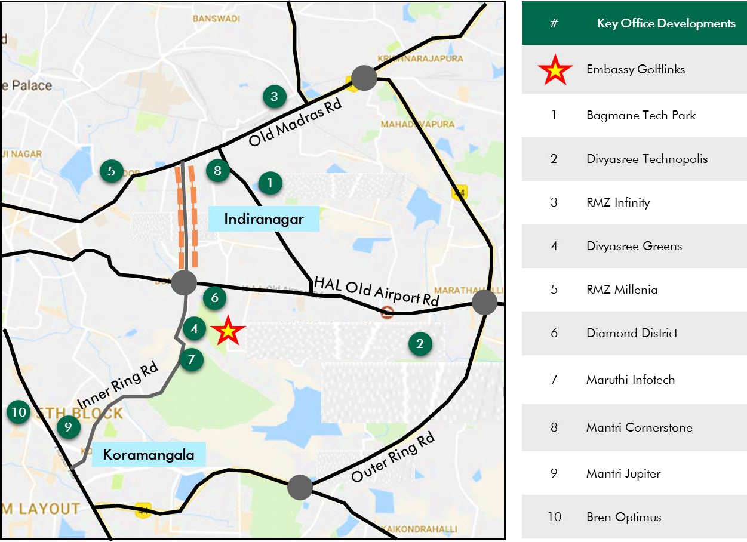

*Source: Consultants’ Research*

Shape: Based on site plan provided by the Client and visual inspection during the site visit, it is understood that the subject property is an irregular shaped land parcel.

Topography: Based on the site plan and as corroborated with our site visit, the site appears to be even and on the same level as abutting access roads and adjoining properties.

Frontage: Based on review of site plan, visual inspection and measurements made on Google maps, we understand that the frontage is approximately 30 meters along the along the primary access road (viz. Inner Ring Road).

Accessibility: Based on site maps provided by the Client coupled with visual inspection undertaken, it was observed that the subject property is accessible by the Intermediate Ring Road, which acts as the primary. The subject property can also be accesses through Wind Tunnel Road, which acts as a secondary access for the development.

Please refer Exhibit & Addenda for the site plan of the subject property.

* + 1. Legal Details

As per the title due diligence undertaken by King & Partridge and as provided by the Client, we understand that the exact address of the subject property is Challaghatta Village, Varthur Hobli, Mahadevapura, Bengaluru East Taluk, Bengaluru, Karnataka. Additionally, it is understood that the subject property is freehold in nature.

Further, this appraisal exercise is based on the premise that the subject property has a clear title and is free from any encumbrances, disputes, claims, etc. We have not made any inquiries in this regard with the relevant legal/ statutory authorities.

* + 1. Town Planning

Zoning As per the RMP 2015, we understand that the subject property is zoned as “Industrial Hi- Tech”. As per the Occupancy Certificates it is located within the jurisdiction of Bengaluru Development Authority (BDA) (earlier under Office of City Municipal Council, Mahadevapura). The same has been considered for the purpose of this appraisal. We has made no further inquiries with the local authorities in this regard.

The permissible land use adopted by the Consultants’ for the subject property has been based on information/review of various documents provided by the Client. It must be noted that all factual data viz. permissible development control regulations, land area and achievable FSI have also been based on information/review of various documents (such as title deed, plan sanction letter, site plan, etc.) provided by the Client or assumed

Approved Usage:

based on building regulations, and no physical verification/ measurement has been undertaken for the purpose of this valuation exercise.

For the purpose of this exercise, it has been assumed that all developments adhere to building regulations as prescribed by the relevant authorities. We has not validated the information provided by the Client with the relevant development authorities.

Based on Occupancy Certificates provided by the Client and visual inspection during our site visit, we understand that the subject property is a Commercial (Non-SEZ) Office Park, comprising of 14 operational blocks. The current use of the subject property has been provided by the Client and is broadly in agreement with the rules and regulations as prescribed by the local development authority. However, we have not made any enquiries with the relevant local authorities to validate the same for its specific applicability to the subject property.

Restrictions: As per feedback received from the Client, there are no restrictions on the current use of the property.

Natural or induced hazards:

We are of the opinion that the project/ site has been developed to withstand natural or induced hazards (with the exception of extreme/ out of the ordinary hazards).

* + 1. Statutory Approvals, One Time Sanctions & Periodic Clearances

Please refer section 18.3 on Statutory Approvals, One time Sanctions & Periodic Clearances

EMBASSY OFFICE PARKS MANAGEMENT SERVICES PRIVATE LIMITED | EMBASSY OFFICE PARKS REIT

* + 1. Area Details, Type and Age of Existing Structures

The table below highlights the area details of the subject property:

|  |  |  |  |  |
| --- | --- | --- | --- | --- |
| **Subject Property** | **Developable area (sf)** | **Completed Area (sf)** | **Committed Area (sf)** | **Occupied Area (sf)** |
| Embassy GolfLinks | 3,709,892 | 2,737,442 | 2,690,359 | 2,690,359 |

Source: *Rent roll, lease deeds, Architect Certificate provided by Client*

The table below highlights the detailed area break-up of the subject development:

|  |  |  |  |  |
| --- | --- | --- | --- | --- |
| **Block**  **Name** | **Building Elevatio** | **n SEZ/Non-SEZ** | **Age**  **(Years)** | **Leasable Area (sf)** |
|  |  | **Completed Blocks** |  |  |
| Augusta | B+G+5 | Non SEZ | 13 | 171,249 |
| Blue Bay | B+G+3 | Non SEZ | 14 | 225,313 |
| Crystal Downs | B+G+3 | Non SEZ | 15 | 205,000 |
| Eagle Ridge | B+G+3 | Non SEZ | 14 | 153,150 |
| Fairwinds | B+G+5 | Non SEZ | 14 | 188,217 |
| Fountain Head | B+G+2 | Non SEZ | 14 | 148,474 |
| Pacific Dunes | B+G+7 | Non SEZ | 16 | 297,748 |
| Peach Tree | B+G+8 | Non SEZ | 15 | 373,119 |
| Pine Valley | B+G+4 | Non SEZ | 13 | 444,577 |
| Prince Ville | 2B+G+9 | Non SEZ | 13 | 27,485 |
| Rivera FC | B+G+1 | Non SEZ | 15 | 62,242 |
| St. Andrews | 2B+G+7 | Non SEZ | 14 | 98,886 |
| Sunningdale | B+G+3 | Non SEZ | 14 | 82,270 |
| Torrey Pines | B+G+5 | Non SEZ | 13 | 259,712 |
| Total |  |  |  | 2,737,442 |

*Source: Rent roll, lease deeds, Architect Certificate, Occupancy Certificate provided by Client*

**Details Completed Blocks**

Grade of the Building Grade A

LEED Certification NA

Structural Design B+G+3 to 2B+G+9

Status of Finishing Warm Shell

Comments on Obsolescence The building is currently well maintained

*Source: Client provided Rent Roll, lease deeds, approval documents, etc.*

* + 1. Site Services and Finishes

**Particulars Details**

Handover condition Warm Shell

Passenger elevators Provided

Service elevators Provided

Power back-up Provided

Building management system Provided

Security systems Provided

Air conditioning (HVAC) Provided

Firefighting services Provided

Car parks provided MLCP, Basement, Covered and open car parks

*Source: Information provided by Client, site visit, lease deeds*

Based on information provided by the Client and visual inspection, the park offers high end specifications, a lush green landscape and community spaces offering a full suite of amenities to its occupiers including various F&B options, intra-park shuttles, golf-buggy services, ambulance and crèche.

* + 1. Condition & Repair

Based on information provided by the Client, it is understood that the subject property is in good condition and is being maintained well. The subject property is developed and managed to international standards. Further it offers international standard infrastructure, best-in-class asset management and environment friendly green initiatives. The table below highlights the major repairs and maintenance/ infrastructure upgrade works to be undertaken over the next few years:

|  |  |  |  |  |  |
| --- | --- | --- | --- | --- | --- |
| **Expense Head Total Cost (INR Mn) Total Cost**  **Spent (INR Mn)** | | | **Total Pending Cost Quarter of (INR Mn) Completion** | | |
| Master Plan Upgradation | 139.36 | 102.94 | 36.43 | Q2, FY | 2022 |
| Lobby Upgrade | 39.50 | 33.21 | 6.29 | Q3, FY | 2021 |
| Pyramid Food Court | 64.63 | 57.70 | 6.93 | Q3, FY | 2021 |
| Fairwinds Refurbishment | 39.83 | 28.43 | 11.40 | Q3, FY | 2021 |
| St Andrews - Refurb works | 54.63 | 51.56 | 3.07 | Q3, FY | 2021 |
| Fountain Head - Refurb works | 63.58 | 38.75 | 24.82 | Q3, FY | 2021 |
| Augusta - Refurb Works | 102.83 | 101.03 | 1.80 | Q3, FY | 2021 |
| Army land drain works | 100.00 | 0.00 | 100.00 | Q4, FY | 2022 |

|  |  |  |  |  |  |
| --- | --- | --- | --- | --- | --- |
| **Expense Head Total Cost (INR Mn) Total Cost**  **Spent (INR Mn)** | | | **Total Pending Cost Quarter of (INR Mn) Completion** | | |
| Signage Works | 17.00 | 0.00 | 17.00 | Q2, FY | 2021 |
| GS Exit Refurb Works | 225.73 | 128.80 | 96.93 | Q4, FY | 2021 |
| Other Refurb Expenses | 274.67 | 15.45 | 259.22 | Q3, FY | 2021 |

*Source: Information provided by Client*

* + 1. Property Photographs

Please refer to the property photographs highlighted below:

Embassy GolfLinks

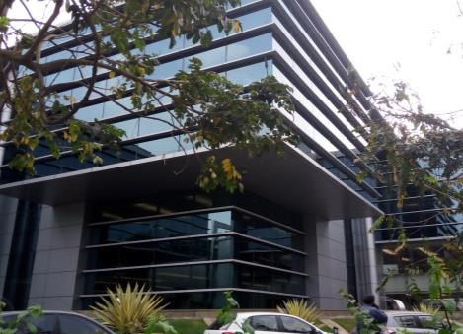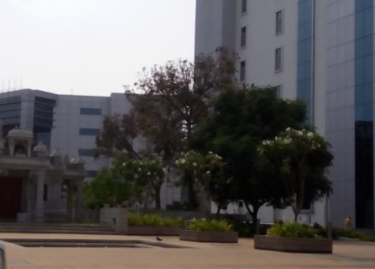

External view of the subject property (SP) External view of the SP

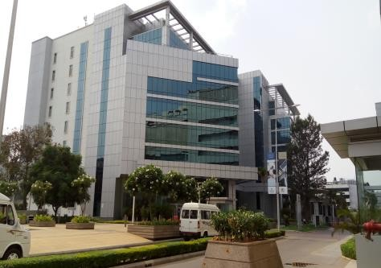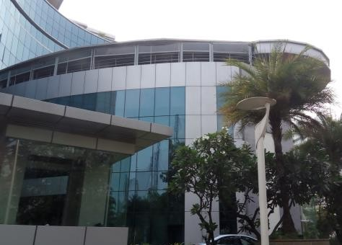

External view of the SP External view of the SP

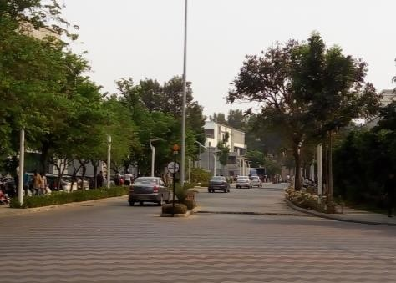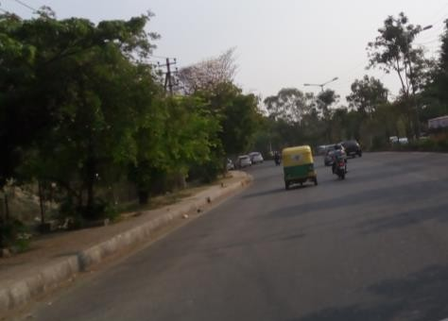

View of internal access road View of the primary access road

* 1. Tenancy Analysis
     1. Historical Committed Occupancy Rates

The table below highlights the historical occupancy rates at the subject development:

|  |  |  |  |
| --- | --- | --- | --- |
| **March 31, 2017** | **March 31, 2018** | **March 31, 2019** | **March 31, 2020** |
| 100.0% | 100.0% | 98.0% | 98.3% |

*Source: Rent rolls provided by the Client, Indicative of committed occupancy*

* + 1. Lease Expiry Analysis

The graph below highlights the area/leases due for expiry in the coming years:

**Lease Expiry**

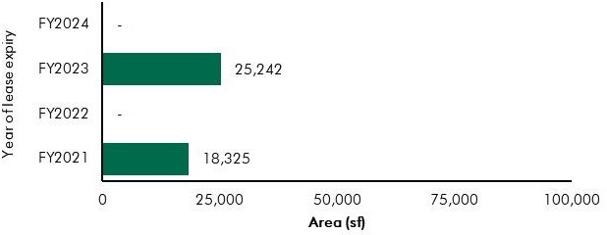

*Source: Rent Rolls and lease deeds (representative of financial year ending)*

Consultants have undertaken an in-depth analysis of the rent roll/ lease deeds shared by the Client, to understand the lease expiry schedule of top tenants at the subject property and rent for those spaces as of date of valuation. The intent of the same is to analyse the risk of tenant churn as well as assessing the re-leasing risk for the property along with opining on the timeframe to lease-up the spaces in case a significant vacancy arises at the property.

* + 1. Escalation Analysis

As per the review of recent executed leases at the subject property it is understood that the contracted escalation terms for these leases are in the range of 10.0% to 15.0% every 3 years are in line with the prevailing market practise witnessed across the sub market and Bengaluru.

* 1. Assumptions Rationale

The subject property is located along Intermediate Ring Road, which connects Indiranagar to Koramangala. The erstwhile International Airport and spill over of activities from the CBD initiated the

commencement of commercial activities and redevelopment of residential houses in the sub market. On account of good connectivity to CBD, the subject region started witnessing large scale commercial developments such as Embassy GolfLinks (subject property), Diamond District etc. in early 2000. Increased commercial activities in the subject sub market have led to the transformation of the residential profile around the subject sub market to a preferred location for the affluent and further led to commensurate increase in capital values. The subject sub market has also emerged as a retail destination and is primarily in the form of high-street formats housing standalone units, typically witnessed along the 100 feet road.

In addition, the subject sub market is well connected by various prominent roads such as the Intermediate Ring Road, Old Airport Road and the Old Madras road which has made the subject sub market easily accessible to the city centre, established residential locations of Koramangala, Old Airport Road etc. and commercial office destinations such as Whitefield, Old Madras Road etc. The Metro, which passes through Indiranagar and Swami Vivekanand road, has further increased the connectivity of the region.

This location is also home to several educational institutions and hospitals, which emerged, owing to the large residential catchment. Some of the prominent educational institutes include Cauvery High School, Frank Anthony Public School and prominent hospitals include Manipal Hospital, ESI Hospital, Chinmaya Mission Hospital, Sai Baba Hospital, etc. In addition, the sub market has presence of recreational developments such as Domlur club, Indiranagar club, etc. catering to the upper middle class and affluent populace.

* + 1. Demand and Supply Dynamics

*14.3.1.1 Demand, Supply and Vacancy Trends – Bengaluru and Extended Business District (EBD) sub-market*

Total completed stock in Bengaluru as of Q4, 2019 is 157.47 msf, out of which EBD account for Approx. 13.20%.

|  |  |  |
| --- | --- | --- |
| **Particular** | **Bengaluru** | **EBD** |
| Cumulative completed office stock (Q4 2019) Cumulative occupied stock (Q4 2019) Current vacancy (Q4 2019)  Average annual office absorption (2014 – 2019) | Approx. 157.47 msf | Approx. 20.76 msf |
| Approx. 151.00 msf | Approx. 20.52 msf |
| Approx. 4.1% | Approx. 1.2% |
| 11.3 msf | 1.10 msf |

*Source: CBRE Research*

**Demand – Supply Dynamics (Bengaluru)**

16.0

14.0

Suply/Absorption (msf)

12.0

10.0

8.0

6.0

4.0

2.0

0

2014 2015 2016 2017 2018 2019

12.0%

10.0%



11.1%

10.4%

6.6%

5.1%

3.7%

4.1%

10.7

12.7 12.0 7.9 11.9 7.7 9.3 11.9 13.3 10.8 9.8

11.2

8.0%

6.0%

4.0%

2.0%

0.0%

Supply (msf) Net Absoprtion (msf) Vacancy (%)

**Demand – Supply Dynamics (EBD)**

#### 2.5

Suply/Absorption (msf)

2.0

1.5

1.0

0.5

0

2014 2015 2016 2017 2018 2019

20.0%

15.0%



17.6%

2.1

1.5

1.2

7.6%

0.8

0.8

0.9

0.6

0.4

0.3

0.2

1.3%

0.9%

0.3

1.2%

0.3

0.3%

Vacancy (%)

10.0%

5.0%

0%

Supply (msf) Net Absoprtion (msf) Vacancy (%)

*Source: CBRE Research; Note: Supply – refers to fresh completed supply added each year; Absorption – refers to the quantum of leasing witnessed in each year as part of completed space; the vacancy in the chart accounts for the gap between cumulative stock and demand in the city in any given year.*

The Extended Business District (EBD) brought about the first wave of expansion of Technology corporates in the city in the early 2000s. The region has since witnessed the development of a few large technology parks as well as a number of small and medium sized commercial office developments. With the presence of large campus-styled developments such as the Embassy GolfLinks (subject property), occupiers have since migrated their operations from CBD into this region. Occupiers across industries with space requirement of 0.10 – 0.15 msf could lease an entire building in parks such as the Embassy GolfLinks, resulting in benefits such as standalone occupancy as well as campus style environment.

Additionally, over the period of time, the EBD sub-market was seen as a location by CBD tenants to move their high value operations into the region. A case in point is a prominent Financial Services occupier, who relocated from the CBD region into the EBD (Embassy GolfLinks), leasing a block within the EOP Park for their operations. In addition, tenants within EBD have also expanded within the business parks where they have been operating. A case in point is a consulting and research occupier which has taken additional space over the years within subject property. Further, large MNC corporates who have expanded into other markets such as ORR, Whitefield, etc. have retained space as part of business parks in EBD (largely for senior management staff as well as high-value operations) owing to proximity to prominent residential pockets and high-street destinations of the EBD.

Prominent office locations in the EBD sub market include Domlur-Intermediate Ring Road, Indiranagar, Koramangala, Old Airport Road, parts of Old Madras Road, CV Raman Nagar, etc. Prominent developments in the sub market include Embassy GolfLinks on the Intermediate Ring Road, Bagmane Tech Park in CV Raman Nagar, Divyasree Technopolis Off Old Airport Road and RMZ Infinity on Old Madras Road, etc.

*14.3.1.2 Key Developments in Sub Market*

The table below highlights the prominent competing developments in the subject sub market:

**Building Name**

**Development**

**Leasable Area**

**Approx. Vacancy**

**Quoted Rent**

|  |  |  |  |  |
| --- | --- | --- | --- | --- |
| Development 1 | **Type**  Non-SEZ | **(in msf)**  3.1 | **(%)**  Minimal | **(INR psf pm)**  115.0 – 125.0 |
| Development 2 | Non-SEZ | 2.6 | Minimal | 95.0 – 105.0 |
| Development 3 | Non-SEZ | 1.3 | Minimal | 95.0 – 105.0 |
| Development 4 | Non-SEZ | 0.7 | Minimal | 105.0 – 115.0 |
| Development 5 | Non-SEZ | 0.6 | Minimal | 115.0 – 120.0 |
| Development 6 | Non-SEZ | 0.5 | Minimal | 80.0 – 90.0 |
| Development 7 | Non-SEZ | 0.4 | Minimal | 100.0 – 110.0 |

*Source: CBRE Research*

* + 1. Lease Rent Analysis

The current rent in subject sub market typically vary between INR 95.0 – 125.0 psf pm on leasable area basis depending upon specifications offered, location and accessibility of the development (viz. along/off the main arterial roads), quality of construction, developer brand, amenities offered, etc. Recent leases in the subject property range between INR 140.0 – 150.0 psf pm. In addition, the maintenance charge for these developments varies in the range of INR 8.0 – 13.0 psf pm. The parking charges in such developments range between INR 3,500 – 6,000 per bay per month for covered car parks.

Based on our market research the rent in the subject sub market has witnessed appreciation of approx. 10.8% in between 2014 & 2019. Given limited competition from upcoming supply in the micro-market, subject property will continue to retain its market position as a landmark development in EBD.

The table below highlights some of the recent transacted rent values for Office Park in the influence region of the subject property:

|  |  |  |  |
| --- | --- | --- | --- |
| **Date of Transaction** | **Area (sf)** | **Tenant** | **Transacted Rent Value (INR psf pm)\*** |
| Q4, 2019 | 20,000 | Tenant 1 | 130.0 - 135.0 (WS) |
| Q4, 2019 | 240,000 | Tenant 2 | 80.0 - 85.0 (WS) |
| Q4, 2019 | 15,000 | Tenant 3 | 93.0 - 97.0 (WS) |
| Q3, 2019 | 70,000 | Tenant 4 | 108.0 - 112.0 (WS) |
| Q3, 2019 | 150,000 | Tenant 5 | 108.0 - 112.0 (WS) |
| Q2, 2019 | 20,000 | Tenant 6 | 113.0 - 117.0 (WS) |
| Q2, 2019 | 25,000 | Tenant 7 | 113.0 - 117.0 (WS) |
| Q2, 2019 | 20,000 | Tenant 8 | 103.0 - 107.0 (WS) |
| Q2, 2019 | 35,000 | Tenant 9 | 105.0 - 110.0 (WS) |
| Q2, 2019 | 15,000 | Tenant 10 | 88.0 - 92.0 (WS) |
| Q1, 2019 | 35,000 | Tenant 11 | 108.0 - 112.0 (WS) |
| Q1, 2019 | 45,000 | Tenant 12 | 108.0 - 112.0 (WS) |

*Source: CBRE Research*

*\* Rent is gross rent (viz. exclusive of property tax & insurance) on leasable area basis; Note: WS – Warm shell; FF – Fully Fitted-out*

Given the location advantage, presence of a well-developed social infrastructure and nature of operations by tenants in the Extended Business District (EBD), demand for commercial real estate is expected to be stable in this sub market. EBD is expected to continue as a preferred destination for occupiers engaged in activates higher in the value chain. Due to limited space availability in the operational buildings and sustained occupier interest in the market, future churn and space as part of under construction developments are expected to cater to future occupier interests in EBD.

Rent will continue to witness stable appreciation, as prominent tenants are expected to continue to carry out their high-value operations from EBD sub market, hence resulting in limited churn and lower vacancy pressures.

* 1. Value Assessment
     1. Adopted Methodology

We acknowledge that the approaches to valuation differ considerably and that for a particular purpose, alternative approaches to the valuation can be utilized subject to the Client’s consultations and giving due consideration to the Client’s requirements. Considering the objective of this exercise and the nature of asset involved, the value of the subject property has been assessed through the following approaches:

|  |  |  |
| --- | --- | --- |
| **Particulars** | **Completed Blocks** | **Under Construction/ Land Stage**  **Blocks** |
| **Valuation Methodology** | Discounted Cash Flow Method (using rent reversion approach) | NA |

The sections below highlight detailed valuation workings for the subject property. Please note that the assumptions/ opinions highlighted in the subsequent sections are to be read in conjunction with Section

1.11 and the following:

*“In the current uncertain environment caused by the outbreak of the Novel Coronavirus (COVID-19), we have considered /* relooked *at various performance parameters and have adopted heuristic/ careful interventions (including but not limited to the points mentioned below) to our projected cashflows based on our view as of the date of valuation.*

* *Limited/ no growth in rent has been considered over the next few quarters*
* *Considering challenges in the short term, timelines have been extended for new space take-up/ future leasing*
* *Additional fit-out period/ rent free months have been incorporated where fit-out works have commenced”*
  + 1. Area statement

Based on information/rent roll, lease deeds provided by the Client, we understand that subject property is an Office Park. Further, the table below highlights the area configuration of the subject property:

**Components Operational leasable area (in sf)**

Office Area 2,737,442

Total 2,737,442

*Source: Architect certificate and Rent roll provided by Client*

* + 1. Construction Timelines

*14.4.3.1 Completed Blocks*

As highlighted earlier, the subject property has 2.74 msf of leasable area and no pending cost to complete is remaining as of date of valuation for the completed blocks.

* + 1. Absorption/ Leasing Velocity and Occupancy Profile

*14.4.4.1 Completed Blocks*

Based on the rent roll provided by the Client and occupancy certificates, we understand that the subject property is fully operational and there are no under-construction blocks. As per the analysis of the rent roll, it was observed that there are vacant spaces in the subject property. The subject property is 98.3% leased as of date of valuation. In order to arrive at the future absorption levels at the subject property, we have analysed the historical demand and supply trends coupled with the estimation of future supply proposed to be introduced in the subject sub market.

Keeping the same in perspective, we opine that the vacant space in the subject property would be leased by end of Q3, FY 2021.

* + 1. Revenue Assumptions
       1. *Lease rent assumptions*

For the purpose of this appraisal exercise, the lease rent adopted for the area already leased is based on the rent roll shared by the Client. Further, we has undertaken an in-depth market research exercise to assess the prevailing marginal rent values in the sub market. The same has been adopted for the vacant space/ on reversion of existing leases to market (duly factoring escalation) for the purpose of this valuation exercise.

Based on our market study and based on the analysis of the rent roll and lease deeds provided by the Client, following rent have been adopted for the purpose of value assessment of the subject property.

|  |  |  |  |  |
| --- | --- | --- | --- | --- |
| **Component** | **Leasable Area (sf)** | **Leased Area (sf)\*** | **Basis** | **Rent Adopted (INR psf pm)** |
|  |  |  | Current Rent for Leased area | 114.8 |
| **Office** | 2,737,442 | 2,690,359 | Marginal rent for reversion/ vacant area | 148.0 |

*Source: Rent roll provided by the Client; Valuer’s Assessment*; *\* Indicates committed occupancy*

The above marginal rent assumption is adopted for the entire subject property. In addition to undertaking an in-depth market analysis, a detailed analysis of the rent roll was also undertaken to understand aspects such as area occupied, current rent and expiry analysis of the key tenants in the park. Additionally, we also analysed the historical occupancy pattern at the subject development and lease-up time frame for spaces being vacated by tenants during the last 3 years. The lease-up time was observed to be 3 - 9 months based on quantum of space being renewed/ re-leased.

Based on the size and scale of operations of these tenants, we adopted individual marginal rent assumptions for larger tenants in the subject development. For the larger tenants (except large anchor), we assumed that post lease expiry, these spaces will revert to marginal rent prevailing at that point in

time. However, given the large size of these spaces, the Client will require longer lease-up time. Therefore, Valuer has adopted a higher lease-up time, ranging from 6 – 9 months depending on area to be leased.

**Area Marginal Rent Strategy (Discount to Market Rent/ Lease-up Time)**

Leased area > 0.50 msf Renewal at 20.0% discount for smaller spaces

Renewal at 35.0% discount for larger spaces

Leased area > 0.20 < 0.50 msf Renewal at market (9 months lease-up time) Leased area > 0.10 msf Renewal at market (6 months lease-up time)

*Source: Valuer’s Assessment*

As presented in the table above, all leases except for anchor tenant will be renewed at marginal rent, but with a longer lease-up time frame. Anchor tenant in the subject development has a history of renewing the spaces within subject property. Going forward, it is assumed that the anchor tenant will continue to renew its leases at the subject development; however, they will continue to attract a discount in rent compared to the marginal rent.

* + - 1. *Rent Escalation*

Based on an analysis of existing lease rolls and lease deeds, it was observed that the typical escalation clause for recent leases in the subject property is approx. 15.0% after every three years, which is in-line with the trend observed in the market. The same has been adopted by Valuer for the vacant area and renewals at the subject property.

* + - 1. *Parking Assumptions*

Based on the prevailing car parking rate in the subject development and EBD sub market, we have assumed a car park charge of INR 6,000 per month per bay, with 25.0% of car park allocated to a tenant to be free of cost. Effective car parking charges adopted for the purpose of this valuation is INR 4,500 per month per bay.

* + - 1. *Revenue from Cinnabar Hills Block*

As per the information provided by the Client, it is understood that the Client has leased 56,014 sf in one of the landowner’s block “Cinnabar Hills” and have subleased the same to another tenant. The terms of lease are highlighted in the table below:

|  |  |  |
| --- | --- | --- |
| **Nature of Income** | **Details** | **Escalation Terms** |

Rent Outflow to Landowner INR 57.25 psf pm* 7.0% every 3 years

Rent Inflow from Tenant INR 100.00 psf pm 12.0% every 3 years

*Source: Client; cash flows from the space considered till lease expiry i.e. October 2030; * Additional outflow of INR 142,500 per month towards car parking rental*

* + - 1. *Facebook Sub-Lease Revenue from Facebook Sublease*

As per the information provided by the Client, it is understood that the Client has leased 119,554 sf in one of the landowner’s block “St. Andrews” and have subleased the same to another tenant. The terms of lease are highlighted in the table below:

|  |  |  |
| --- | --- | --- |
| **Nature of Income** | **Details\*** | **Escalation Terms** |

|  |  |  |
| --- | --- | --- |
| Rent Outflow to Landowner | INR 135.5 psf pm | 15.0% every 3 years on base rent |
| Rent Inflow from Tenant | INR 140.4 psf pm | 15.0% every 3 years on base rent |

*Source: Client; cash flows from the space considered till lease expiry i.e. October 2030; * includes car parking rental*

* + - 1. *Other Revenues*

In addition to lease rent revenues, office assets/parks typically have additional sources of revenue. These include revenues on account of security deposit (refunded at the time of lease expiry / exit), other miscellaneous income (such as cell sites, retail areas, food court, etc.), etc.

Additionally, we understand that the CAM is being charged by an agency which is external to the interests of the Client, hence we have not considered any margin on CAM during the holding period. However, at the time of notional exit, margin of CAM is included in the financial as per market benchmarks (i.e. INR 11.0 psf pm CAM and 15.0% margin on CAM).

The assumptions considered for the aforementioned revenue heads for the purpose of this valuation exercise are based on the rent roll provided by the Client. The same has been cross-checked with the prevailing market norms for other revenues and were found to be broadly in line.

The assumptions adopted for other revenues are as tabulated below:

|  |  |  |
| --- | --- | --- |
| **Nature of Income** | **Details** | **Units** |

Miscellaneous Income (Income from cell sites)

1.3%

(INR 48.73 mn pa)

% of gross rental income

Warm shell Security Deposit* 6 months No. of months’ warm shell rental

Parking Income (For vacant and UC development)^

INR 4,500 per car park

*Source: Client’s Inputs & Valuer’s assessment; * Refunded at the time of lease expiry/ exit; ^assumed at INR 6,000 per bay per month, with 25.0% free car park*

* + 1. Expense Assumptions
       1. *Major Repair and improvements*

The following table highlights the assumptions towards the refurbishment expenses/ infrastructure upgrade works in the subject development:

|  |  |  |
| --- | --- | --- |
| **Expense Head** | **Total Pending Cost (INR Mn)** | **Quarter of Completion** |
| Master Plan Upgradation | 36.43 | Q2, FY 2022 |

|  |  |  |
| --- | --- | --- |
| **Expense Head** | **Total Pending Cost (INR Mn)** | **Quarter of Completion** |
| Lobby Upgrade | 6.29 | Q3, FY 2021 |
| Pyramid Food Court | 6.93 | Q3, FY 2021 |
| Fairwinds Refurbishment | 11.40 | Q3, FY 2021 |
| St Andrews - Refurb works | 3.07 | Q3, FY 2021 |
| Fountain Head - Refurb works | 24.82 | Q3, FY 2021 |
| Augusta - Refurb Works | 1.80 | Q3, FY 2021 |
| Army land drain works | 100.00 | Q4, FY 2022 |
| Signage Works | 17.00 | Q2, FY 2021 |
| GS Exit Refurb Works | 96.93 | Q4, FY 2021 |
| Other Refurb Expenses | 259.22 | Q3, FY 2021 |

*Source Client Input; Valuer’s Assessment* the pending cost towards refurbishment is apportioned in equal proportion across remaining quarters from the date of start of the refurbishment works (dates as per financial year)*

* + - 1. *Operating Cost*

In addition to capital expenditure, a development typically has a few recurring operation expenses required for the up-keep running of the development. Based on information provided by the Client and market assessment, following recurring expense assumptions have been adopted for the purpose of this valuation exercise:

Nature of Expense Details Basis

Insurance, Legal and other professional charges

0.05%

(INR 2.0 mn)

% of gross rental income

Property Tax 2.10%*

|  |  |  |
| --- | --- | --- |
|  | (INR 77.0 mn) |  |
| Repair and Maintenance Reserve | 1.0% | % of gross rental income |
| Asset management Fee | 1.0%^ | % of total revenue |
| Transaction cost on Exit | 1.0% | % of terminal value |

% of gross rental income

*Source: Client Input; Valuer’s assessment; *Note – based on inputs provided by the Client, we understand that the property tax is paid at the beginning of every financial year wherein a 5.0% discount gets extended vis-à-vis pay-out during the end of the year and the same has been adopted for the purpose of our valuation; ^ Asset Management fees has been considered a below the NOI line item.*

* + 1. Other Assumptions
       1. *Vacancy provision*

Based on the prevailing market benchmarks, a vacancy provision of 2.5% has been adopted upon assessment of terminal value

* + - 1. *Revenue escalation*

Based on prevailing market condition, historical rent growth achieved by the subject property and our interactions with market participants, Valuer is of the option that the annual rent growth for the subject property will be 2.5% till Q3, FY 2021 and then stabilize at 5.0% going forward.

* + - 1. *Rent – free period*

Based on the trend prevalent in the subject sub market, we have considered a rent free period of 3 months for the subject property from the lease commencement date (for future / new leases)

* + - 1. *Brokerage*

Based on prevalent market dynamics, we have considered brokerage equivalent to 2 month of rental income for future / new leases

* + - 1. *CAM under recoveries*

We have highlighted expense towards maintenance as CAM under recoveries for months when no rental

/ CAM income is received

* + 1. Capitalization Rates

As highlighted in section 3.3, the cap rate adopted for the office space is 8%.

* + 1. Discount Rate

For discounting the cash flows, the appropriate discounting rate has been calculated on the basis of estimated ‘Weighted Average Cost of Capital’ (WACC). The detailed analysis of WACC rate adopted for the subject property has been detailed in Section 3.4 of this report.

14.5 Value of the Subject Property

Based on the above mentioned analysis, the value of the subject property is estimated as follows:

|  |  |  |  |
| --- | --- | --- | --- |
| Component | Value (INR Mn) |  | % Share |
| Operational area | 54,027 |  | 100.0% |
| **Embassy GolfLinks** |  | **INR 54,027 Mn\*** |  |

*Note: The valuation presented is for 100% interest in the asset. However, based on inputs provided by the Client, the REIT hold 50% of the interests in the asset (viz. 27,014 Mn)*

##### Embassy One

* 1. Property Description

|  |  |
| --- | --- |
| Particulars | **Details** |
| **Property Name** | Embassy One |
| **Address** | Bellary Road, Ganga Nagar, Bengaluru, Karnataka |
| **Land Area** | Based on review of the title report, we understand that the total land area of the subject property under the ownership of the Client is approximately 5.62 Acres (which incrementally includes residential component). The interest being valued as part of this assessment is an undivided  share of 3.19 Acres (for the office, retail and hospitality components). |
| **Area Details** | Leasable area - Office and Retail Area – 0.25 msf Developable area - Hotel - 0.51 msf (230 keys) |

*Source: Title Report, Architect Certificate*

* + 1. Site Details

Situation: Subject property – ‘Embassy One’ is a mixed-use development located Bellary Road, Ganga Nagar, Bengaluru, Karnataka. The development comprises of a hotel (viz. Four Seasons – India’s second such hotel), premium offices and retail space on the podium and lower level targeted at premium international brands. There is also a high-end residential (Four Seasons branded and serviced) as part of the larger development.

Location: Subject site is located in a premium location on the main arterial Bellary Road between Bengaluru Airport and the CBD, approx. 6-7 km from MG Road. The stretch between the CBD and Mekhri circle is recognized as a premium residential and hospitality hub of Bengaluru. Subject location lies in close proximity to premium residential colonies of Sheshadripuram, Sadashiva Nagar, Dollars colony, Fraser Town, Jayamahal, etc., which house affluent population of businessmen community, ministers, etc.

In addition, Bengaluru’s prestigious Golf course, Bengaluru Golf Club (BGC) and Race Course are located along the road leading to the subject site. Further, the location is considered an established hub for premium hotels, housing prominent 5 star hotels such as Windsor Manor, Lalit Ashok & Taj Westend.

On account of being in close proximity to the Outer Ring Road, the subject property enjoys good connectivity to other established sub markets such as Yeshwanthpur, KR Puram, Whitefield, Sarjapur Outer ring road, etc.

The distances from key hubs to the subject property are presented in the table below:

|  |  |
| --- | --- |
| **Landmark** | **Distance (km)** |
| Mekhri circle | 1-2 km |
| Hebbal Junction/ ORR Junction | 3-4 km |
| M.G. Road (CBD) | 6-7 km |
| Yelahanka Junction | 11-12 km |
| Bengaluru International Airport | 27-28 km |

*Source: Consultants’ Research*

Surrounds: The subject property is surrounded as follows: North: HMT Bhawan

South: Secondary access road

East: Private Property (Residential development) West: Bellary Road (Primary access road)

Potential changes in surroundings:

The subject location is an established residential hub in Bengaluru. In addition, the immediate surroundings have presence of Defense/ Institutional developments such as Air Force Training Command, DGQA Residential Quarters, etc. Thus, there is negligible availability of land in close proximity to the subject development for further development.

However, north of the subject property, locations such as Hebbal and Yelahanka which form part of North Bengaluru sub market have witnessed heightened real estate activity subsequent to commencement of the Bengaluru International Airport operations in 2008. As a consequence, the northern quadrant of Bengaluru has witnessed increasing residential activity by both local and national developers and the area is further expected to herald significant activity across all real estate components in the medium term and thus emerge as a prominent growth vector in Bengaluru. In addition, infrastructure initiatives such as the completion of Outer Ring Road, elevated expressway connecting Hebbal to airport improved the connectivity of the subject property.

Going forward, infrastructure initiatives such as the extension of the Metro Rail Phase 2 which is expected to connect Nagawara to other part of the metro network is expected to further improve the connectivity of the region to other established locations.

Suitability of existing use:

Considering the profile of surrounding developments, the subject property is opined to be suited for its current use viz. mixed-use development with commercial office, retail and hospitality component.

The following map indicates the location of the subject property and surrounding developments:

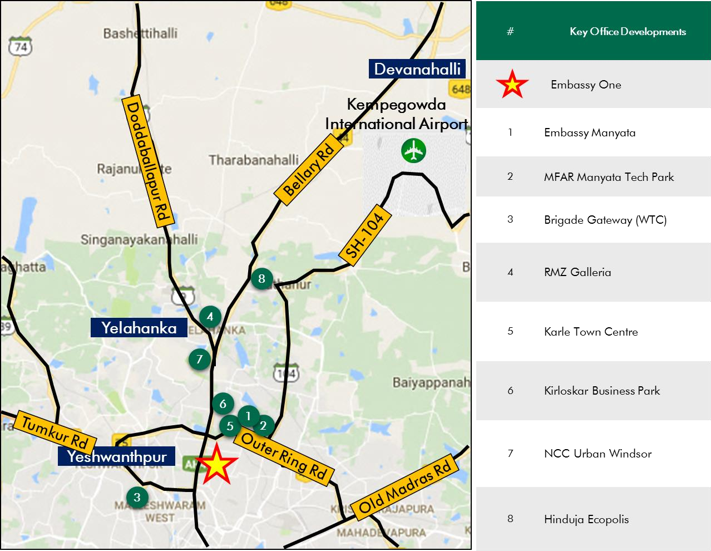

**Location Map for the Subject Property**

*Source: Consultants’ Research*

Shape: Based on information provided by the Client, we understand that the subject land parcel is a L-shaped land parcel.

Topography: Based on the site plan and as corroborated with our site visit, the site appears to be even and on the same level as abutting access roads and adjoining properties.

Frontage: Based on review of site plan, visual inspection and measurements made on Google maps, we understand that the frontage is approximately 35 meters along the Bellary Road.

Accessibility: It is understood that the access to the subject property is from Bellary Road, which connects the city center to Bengaluru International Airport and other key hubs across the city. This serves as the primary access to the subject property. In addition, the subject property can be accessed via a secondary access road towards the south of the development. By virtue of the same the property enjoys excellent accessibility and frontage. Please refer Exhibit & Addenda for the site plan of the subject property.

* + 1. Legal Details

As per the title due diligence undertaken by Jayashree Sridhar and as provided by the Client, we understand that the exact address of the subject property is Bellary Road, Ganga Nagar, Bengaluru, Karnataka. Additionally, it is understood that the subject property is freehold in nature.

Further, this appraisal exercise is based on the premise that the subject property has a clear title and is free from any encumbrances, disputes, claims, etc. we have not made any inquiries in this regard with the relevant legal/ statutory authorities.

* + 1. Town Planning

Zoning As per RMP 2015, we understand that the zoning for the subject property is Residential mixed use located along Mutation Corridor. The same has been adopted for the purpose of the valuation exercise. Further, as the subject property is located along the mutation corridor, thereby allowing flexibility on the land use.

The permissible land use adopted by Consultants for the subject property has been based on information/review of various documents provided by the Client. It must be noted that all factual data viz. permissible development control regulations, land area and achievable FSI have also been based on information/review of various documents (such as title deed, plan sanction letter, site plan, etc.) provided by the

Client or assumed based on building regulations, and no physical verification/ measurement has been undertaken for the purpose of this valuation exercise.

For the purpose of this exercise, it has been assumed that all developments (existing

/ under construction / proposed) adhere to building regulations as prescribed by the relevant authorities. We have not validated the information provided by the Client with the relevant development authorities.

Approved Usage:

Based on the information provided by the Client, we understand that the subject property is a mixed-use development with office, retail and hospitality components.

Restrictions: As per feedback received from the Client, there are no restrictions on the current use of the property.

Natural or induced hazards:

We are of the opinion that the project/ site has been developed to withstand natural or induced hazards (with the exception of extreme/ out of the ordinary hazards).

* + 1. Statutory Approvals, One Time Sanctions & Periodic Clearances

Please refer section 18.3 on Statutory Approvals, One time Sanctions & Periodic Clearances

EMBASSY OFFICE PARKS MANAGEMENT SERVICES PRIVATE LIMITED | EMBASSY OFFICE PARKS REIT

* + 1. Area Details, Type and Age of Existing Structures

The table below highlights the area detail of the subject property

|  |  |  |  |  |
| --- | --- | --- | --- | --- |
| **Subject Property** | **Developable area (sf)** | **Completed Area (sf)** | **Committed Area (sf)** | **Occupied Area (sf)** |
| Embassy One | 878,079 | 250,096 | 13,775 | 13,775 |

*Source: Rent Roll, Architect Certificate provided by Client*

The table below highlights the detailed area break-up of the subject development:

|  |  |  |  |  |
| --- | --- | --- | --- | --- |
| **Block Building Elevation SEZ/Non-SEZ Age Leasable Area (sf) Name (Years)**  Completed Blocks | | | | |
| Office and Retail Block | 3B+G+14 | Non-SEZ | 2 | 250,096 |
| Hotel – Four Seasons at Embassy One (230 Keys) | 3B+G+19 | NA | 1 | NA |
| Total |  |  |  | 250,096 |

*Source: Rent Roll, Occupancy Certificate, architect certificate, approval documents and Client Inputs*

**Details Completed Blocks**

Grade of the Building Grade A

LEED Certification Gold

Structural Design 3B+G+14 / 3B+G+19

Status of Finishing Warm Shell

Comments on Obsolescence The building is currently well maintained

*Source: Client input, approval documents, occupancy certificate, Indian Green Building Council certificate*

* + 1. Site Services and Finishes

**Particulars Details**

Handover condition Warm Shell

Passenger elevators Provided

Service elevators Provided

Power back-up Provided

Building management system Provided

Security systems Provided

Air conditioning (HVAC) Provided

Firefighting services Provided

Car parks provided Basement, Covered and open car parks

*Source: Information provided by Client, site visit, lease deeds*

* + 1. Condition & Repair

Based on inputs provided by the Client and visual inspection, we understand that the subject property has recently commenced operations and is being maintained well. The table below highlights the planned capex to be undertaken for the subject property.

|  |  |  |  |  |
| --- | --- | --- | --- | --- |
| **Expense Head Total Cost (INR M** | | **n) Total Cost T**  **Spent (INR Mn)** | **otal Pending Cost**  **(INR Mn)** | **Quarter of**  **Completion** |
| Retail Wall | 5.50 | - | 5.50 | Q2, FY2021 |
| Marketing Suite, etc. | 26.00 | 8.47 | 17.52 | Q3, FY2021 |
| Embassy One Façade Light | 45.00 | - | 45.00 | Q3, FY2021 |

*Source: Information provided by Client*

* + 1. Property Photographs

Please refer to the property photographs highlighted below:

Embassy One

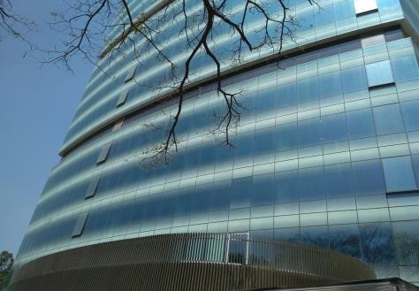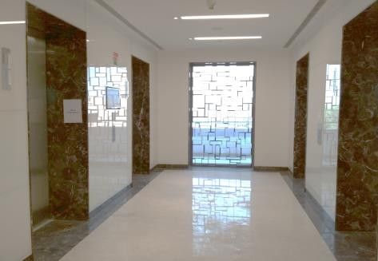

External view of the subject property (SP) Internal view of the SP

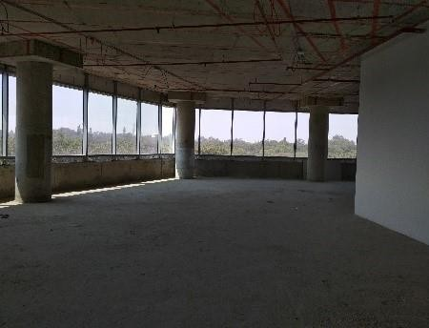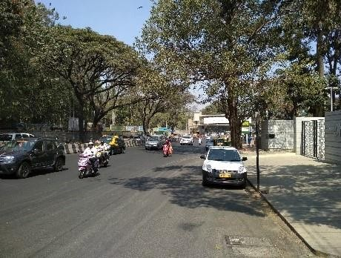

Internal View of office area Primary access road



Internal View of retail area View of hotel area

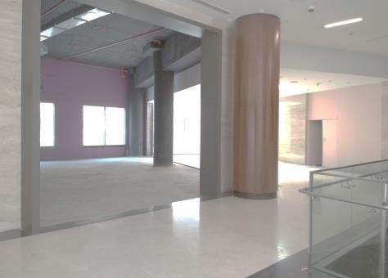

* 1. Assumptions Rationale

The subject property is mixed use development located along Bellary Road, Ganga Nagar, Bengaluru. The stretch between the CBD and Mekhri circle is recognized as a premium residential and hospitality hub of Bengaluru. Subject location lies in close proximity to premium residential colonies of Sheshadripuram, Sadashiva Nagar, Dollars colony, Fraser Town, Jayamahal, etc., which house affluent population of businessmen community, ministers, etc.

* + 1. Demand and Supply Dynamics

*15.2.1.1 Demand, Supply and Vacancy Trends – Bengaluru and EBD sub market*

Total completed stock in Bengaluru as of Q4, 2019 is 157.47 msf, out of which Extended Business District of Bengaluru account for Approx. 13.20%.

|  |  |  |
| --- | --- | --- |
| **Particular** | **Bengaluru** | **EBD** |
| Cumulative completed office stock (Q4 2019) | Approx. 157.47 msf | Approx. 20.76 msf |
| Cumulative occupied stock (Q4 2019) | Approx. 151.00 msf | Approx. 20.52 msf |
| Current vacancy (Q4 2019) | Approx. 4.1% | Approx. 1.2% |
| Average annual office absorption (2014 –  2019) | 11.3 msf | 1.10 msf |

*Source: CBRE Research*

**Demand – Supply Dynamics (Bengaluru)**

#### 16.0

14.0

Suply/Absorption (msf)

12.0

10.0

8.0

6.0

4.0

2.0

0

2014 2015 2016 2017 2018 2019

12.0%

10.0%



11.1%

10.4%

6.6%

5.1%

3.7%

4.1%

10.7

12.7 12.0 7.9 11.9 7.7 9.3 11.9 13.3 10.8 9.8

11.2

8.0%

6.0%

4.0%

2.0%

0.0%

Supply (msf) Net Absoprtion (msf) Vacancy (%)

**Demand – Supply Dynamics (EBD)**

#### 2.5

Suply/Absorption (msf)

2.0

1.5

1.0

0.5

0



17.6%

2.1

1.5

1.2

7.6%

0.8

0.8

0.9

0.6

0.4

0.3

0.2

1.3%

0.9%

0.3

1.2%

0.3

0.3%

2014 2015 2016 2017 2018 2019

Supply (msf) Net Absoprtion (msf) Vacancy (%)

20.0%

15.0%

Vacancy (%)

10.0%

5.0%

0%

*Source: CBRE Research; Note: Supply – refers to fresh completed supply added each year; Absorption – refers to the quantum of leasing witnessed in each year as part of completed space; the vacancy in the chart accounts for the gap between cumulative stock and demand in the city in any given year.*

Commercial

Given the high-end office space offering within the subject development, we have benchmarked the subject property with other high-end office developments/City Centric Offices within the City. However, unlike Delhi and Mumbai, Bengaluru is still at a nascent stage as far as branded commercial office spaces are concerned. There are few high quality commercial developments in the city which are centrally located and have been built to international standards of specifications and amenities. These high-end office developments have been witnessed to command a premium over other commercial offices (primarily owing to their strategic location and product offering).

The table below highlights prominent high-end office development located within Bengaluru City:

|  |  |  |  |
| --- | --- | --- | --- |
| **Development Name** | **Development**  **Type** | **Total Leasable Area (msf)** | **Vacancy (%)** |
| Development 1 | Non-SEZ | 0.5 | < 5.0% |
| Development 2 | Non-SEZ | 0.2 | Minimal |
| Development 3 | Non-SEZ | 0.7 | Minimal |
| Development 4 | Non-SEZ | 0.1 | 5.0 – 10.0% |
| Development 5 | Non-SEZ | 1.1 | Minimal |

*Source: CBRE Research*

Retail

Bengaluru by virtue of being the hub for information technology sector in India is one of the fastest growing cities, which is strongly reflected in the real estate market dynamics of the city. The increasing presence of Technology professionals (with significant influx of professionals from other states in India) in the population has resulted in enhanced consumer spending, leading to an expansion of the retail sector in the city.

The retail sector in Bengaluru was traditionally concentrated in the CBD (MG Road, Brigade Road and Commercial Street) and surrounding areas (Residency Road and Magrath Road) and was typically characterized by high street shopping formats. The limited availability of space in the CBD and presence of huge catchment population in suburban and peripheral locations eventually led to the spill-over of retail activity to Koramangala, Indiranagar and Old Airport Road in the East, Jayanagar and Bannerghatta Road in the South and Malleshwaram in the North of the city.

Hospitality

The key demand driver for hospitality activity in Bengaluru has been the consistent growth of the corporate sector with development in the Information Technology and the Information Technology Enabled Services sector.

CBD which consists of locations such as M.G. Road and other significant roads (such as Residency Road, Richmond Road, Lavelle Road, St. Marks Road and Ulsoor) emerging out of M.G. Road constitute the Central Business District (CBD) of Bengaluru. JW Marriot (adjacent to UB City), Ritz Carlton (Residency Road), Shangri-La (Palace Road), Taj West End (Race Course Road) are a few prominent premium hotel projects in the CBD area. Factors such as central location and business image have resulted in a distinct premium for all locations within this zone. Owing to the significant commercial activity in CBD and the central location of the zone being well connected with other sub markets, the area is characterized by significant number of hospitality projects with relatively higher ARRs and Occupancy rates.

The northern periphery of the city has witnessed heightened real estate activity in the last 2-3 years primarily on account of the Bengaluru International Airport development at Devanahalli. North zone has gradually captured the attention of major developers and corporate entities in the city. On this account, the north-western part of the city has witnessed emergence of few 5 star hotels in the last few years.

The existing upscale hotels that are operational across Bengaluru have achieved ARRs in the range of INR 11,800 – 12,500 per room per night and occupancies in the range of 73.0 - 80.0%.

15.2.2 Rent

Based on our interactions with the market players and developers in the region, it was observed that the lease rent for office space is primarily determined by the factors such as location, accessibility, space off take, type of development, related infrastructure provision for the site, distance from the key hubs of the city, services provided, etc. However, the premium charged by high end projects in the city is primarily on account of the location (most of them located at the city center) and the international standards of construction along with the high-end specifications and amenities being offered.

Rent values of comparable high-end office space available for lease have been analysed & discussed below. The prevailing quoted lease rent for high-end office developments in the city ranges between INR

150.0 – 200.0 psf pm, on warm shell basis; depending upon factors highlighted earlier.

The table below highlights the quoted rent across key developments located in the subject sub market:

|  |  |  |  |
| --- | --- | --- | --- |
| **Development Name** | **Development Type** | **Total Leasable Area (ms** | **f) Quoted Rent (INR psf**  **pm)** |
| Development 1 | Non-SEZ | 0.4 | 190.0 – 210.0 |
| Development 2 | Non-SEZ | 0.7 | 200.0 – 220.0 |
| Development 3 | Non-SEZ | 0.1 | 160.0 – 170.0 |
| Development 4 | Non-SEZ | 1.1 | 145.0 – 155.0 |
| *Source: CBRE Research* |  |  |  |

Further, the table below highlights few recent lease transactions for the subject sub market:

**Transaction Date**

**Tenant**

**(Non-SEZ /SEZ)**

**Leasable Area**

**Base Rent (INR psf**

|  |  |  |  |  |
| --- | --- | --- | --- | --- |
| Q3, 2019 | Tenant 1 | Non-SEZ | **(sf)**  10,000 | **pm))**  135.0 - 145.0 (WS) |
| Q3, 2019 | Tenant 2 | Non-SEZ | 25,000 | 120.0 - 130.0 (WS) |
| Q3, 2019 | Tenant 3 | Non-SEZ | 30,000 | 125.0 - 135.0 (WS) |
| Q2, 2019 | Tenant 4 | Non-SEZ | 45,000 | 130.0 - 140.0 (WS) |
| Q2, 2019 | Tenant 5 | Non-SEZ | 10,000 | 100.0 - 110.0 (WS) |
| Q2, 2019 | Tenant 6 | Non-SEZ | 65,000 | 105.0 - 115.0 (WS) |
| Q1, 2019 | Tenant 7 | Non-SEZ | 35,000 | 155.0 - 165.0 (WS) |

**Transaction Date**

**Tenant**

**(Non-SEZ /SEZ)**

**Leasable Area (sf)**

**Base Rent (INR psf pm))**

Q1, 2019 Tenant 8 Non-SEZ 60,000 145.0 - 155.0 (WS)

*Source: CBRE Research*

Based on information received from the Client we understand that the subject property offers office spaces with high end specifications and amenities and is a part of an integrated development housing a Hotel Four Seasons at Embassy One. Hence, it is opined that subject development would achieve a marginal rent of INR 145.0 to 150.0 psf pm (say INR 147.0 psf pm) as on date of valuation.

Retail

Some of the recent transactions witnessed in the comparable developments have been highlighted below:

|  |  |  |
| --- | --- | --- |
| **Tenant** | **Leasable Area (sf)** | **Base Rent (INR psf pm)** |
| Tenant 1 | 600 | 300 - 325* |
| Tenant 2 | 700 | 380 - 400* |
| Tenant 3 | 550 | 425 - 450* |
| Tenant 4 | 550 | 380 - 400* |
| Tenant 5 | 400 | 340 - 360* |
| Tenant 6 | 1,000 | 250 - 275 |
| Tenant 7 | 500 | 240 - 260 |

*Source: CBRE Research; *on carpet basis with a loading of 100.0%*

Additionally, as per information provided by the Client we understand that the retail development as part of the subject property is spread across two floors i.e. ground floor and lower ground floor. As per typical market practise and trend observed in retail developments across the city, it is observed that rent for lower ground floor spaces are typically at a discount of 25.0-30.0% from ground floor rent on account of inferior positioning and visibility. Additionally, premium/high-end brand desire superior positioning in a retail development and prefer operating from the ground floor and thus are willing to pay a premium on account of rent. Considering the same, we are of the opinion that rent for lower ground floor space in the subject property will be at a 25.0 – 30.0% discount from ground floor rent.

After due consideration of the strategic location of subject property, the development i.e. considering that the development is a part of a mixed-use development housing a Hotel Four Seasons at Embassy One and that the retail spaces will offer international quality of specifications and amenities, it is opined that the subject development can achieve a marginal rent of approx. INR 195.0 to 205.0 psf pm (say INR

200.0 psf pm) for the ground floor as on date of valuation. As mentioned earlier, the stores on lower ground floor will command a discount over ground floor rent to the tune of 25.0-30.0%. Factoring the

same, the weighted average marginal rent for the retail area in the subject property is opined to be in the range of approx. INR 165.0 to 175.0 psf pm (say INR 170.0 psf pm).

Hospitality

To opine on the ARRs and Occupancy for the hotel in the subject property, we have benchmarked the existing high-end hotels across Bengaluru city. The existing upscale hotels that are operational across Bengaluru have achieved ARRs in the range of INR 11,800 – 12,500 per room per night and occupancies in the range of 73.0 - 80.0%.

Given the positioning & location of the subject development, performance of competing hotels and development mix (part of a larger mixed-use development) etc., it is opined that ARRs for hotel component in the subject development would range from INR 10,000 – INR 11,000 per room night (viz. approx. INR 10,500 per room night). Additionally, the stabilized occupancy for the subject development is opined to be 70%, 2.5 years from the year of operation commencement.

* 1. Value Assessment
     1. Adopted Methodology

We acknowledge that the approaches to valuation differ considerably and that for a particular purpose, alternative approaches to the valuation can be utilized subject to the Client’s consultations and giving due consideration to the Client’s requirements. Considering the objective of this exercise and the nature of asset involved, the value of the subject property has been assessed through the following approaches:

|  |  |
| --- | --- |
| **Particulars Completed Blocks** | |
| **Valuation Methodology** | Office & Retail - Discounted Cash Flow Method (using rent reversion approach) Hotel - Discounted Cash Flow Method |

The sections below highlight detailed valuation workings for the subject property. Please note that the assumptions/ opinions highlighted in the subsequent sections are to be read in conjunction with Section

1.11 and the following:

*“In the current uncertain environment caused by the outbreak of the Novel Coronavirus (COVID-19), we have considered /* relooked *at various performance parameters and have adopted heuristic/ careful interventions (including but not limited to the points mentioned below) to our projected cashflows based on our view as of the date of valuation.*

* *Limited/ no growth in rent and ARR has been considered over the next few quarters*
* *Considering challenges in the short term, timelines have been extended for new space take-up/ future leasing*
* *Additional fit-out period/ rent free months have been incorporated where fit-out works have commenced*
* *For the hotel, occupancy has been rationalized in the short term”*
  + 1. Area statement

Based on information provided by the Client, we understand that subject property is a mixed-used premium development (office, retail and hospitality component) located along, Bellary Road, Ganga Nagar, Bengaluru, Karnataka.

**Block Leasable Area details (in sf)/ No of Keys**

Office 194,948

Retail 55,148

Hotel - Four Seasons at Embassy One 230 keys Total 230 Keys/ 250,096

*Source: Client Inputs*

* + 1. Construction Timelines

*15.3.3.1 Office, Retail & Hotel Blocks*

Based on review of various documents (such as Architect’s Certificate, approval documents, etc.), it is

understood that as on date of valuation, the subject development is completed.

* + 1. Absorption/ Leasing Velocity and Occupancy Profile

The absorption period assumed for the subject development is based on market dynamics and extent of development in the relevant sub market, nature of subject property, competing supply of same nature, location within the respective sub market, etc. The table overleaf highlights the absorption assumptions adopted for the subject development:

|  |  |  |  |  |  |  |
| --- | --- | --- | --- | --- | --- | --- |
| **Block** | **Absorption**  **Schedule** | **FY 2020\*** | **FY 2021** | **FY 2022** | **FY 2023** | **Total** |
| Office | Percentage (%) | 7.1% | 20.7% | 41.3% | 31.0% | 100.0% |
|  | Leasable Area (sf) | 13,775 | 40,261 | 80,521 | 60,391 | 194,948 |
| Retail | Percentage (%) | 0.0% | 20.0% | 40.0% | 40.0% | 100.0% |
|  | Leasable Area (sf) | - | 11,030 | 22,059 | 22,059 | 55,148 |
| Total | Absorption (%) | 5.5% | 20.5% | 41.0% | 33.0% | 100.0% |
| Total | Absorption (sf) | 13,775 | 51,290 | 102,580 | 82,450 | 250,096 |

*Source: Valuer’s assessment; Indicates area leased as on date of valuation*

* + 1. Revenue Assumptions – Office and Retail
       1. *Lease rent assumptions*
          1. Office Component

As highlighted in the section above an in-depth market research exercise has been undertaken to assess the prevailing rent values in the subject sub market.

Considering the above analysis, feedback from the market participants and based on the prevailing rent in the subject property, Valuer opines that the subject property is expected to achieve marginal rentals in the range of INR 145.0 to 150.0 psf pm (say INR 147.0 psf pm, all inclusive) as on date of valuation.

* + - * 1. Retail Component

As highlighted in the section above an in-depth market research exercise has been undertaken to assess the prevailing rent values in the subject sub market.

As per information provided by the Client, we understand that the retail development as part of the subject property is spread across two floors i.e. ground floor and lower ground floor. As per typical market practise and trend observed in retail developments across the city, it is observed that rent for lower ground floor spaces are typically at a discount of 25.0-30.0% from ground floor rent on account

of inferior positioning and visibility. Additionally, premium/high-end brand desire superior positioning in a retail development and prefer operating from the ground floor and thus are willing to pay a premium on account of rent. Considering the same, we are of the opinion that rent for lower ground floor space in the subject property will be at a 25.0 – 30.0% discount from ground floor rent.

After due consideration of the strategic location of subject property, the development i.e. considering that the development is a part of a mixed-use development housing a Hotel Four Seasons at Embassy One and that the retail spaces will offer international quality of specifications and amenities, it is opined that the subject development can achieve a marginal rent of approx. INR 195.0 to 205.0 psf pm (say INR

200.0 psf pm) for the ground floor as on date of valuation. As mentioned earlier, the stores on lower ground floor will command a discount over ground floor rent to the tune of 25.0-30.0%. Factoring the same, the weighted average marginal rent for the retail area in the subject property is opined to be in the range of approx. INR 165.0 to 175.0 psf pm (say INR 170.0 psf pm).

* + - 1. *Rent Escalation*

Based on prevailing market terms, it was observed that the typical escalation clause in the subject sub market is approx. 15.0% after every three years. The same has been adopted for the purpose of this valuation exercise.

* + - 1. *Other Revenues*

In addition to lease rent revenues, office developments typically have additional sources of revenue. These include revenues on account of security deposit (refunded at the time of lease expiry / exit), car parking income, etc.

The assumptions considered for the aforementioned revenue heads for the purpose of this valuation exercise are based on prevailing market norms for other revenues.

The assumptions adopted for other revenues are as tabulated below:

|  |  |  |
| --- | --- | --- |
| **Nature of Income** | **Details** | **Units** |

Warm shell Security Deposit* 6 months No. of months’ warm shell rental

Mark-Up on CAM/ CAM margin 15.00% %

*Source: Client’s Inputs & Valuer’s assessment; * Refunded at the time of lease expiry/ exit;*

* + 1. Revenue Assumptions - Hotel
       1. *ARR and Occupancy Assumptions*

Given the positioning & location of the subject development, performance of competing hotels and development mix (part of a larger mixed-use development) etc., it is opined that ARRs for hotel component in the subject development would range from INR 10,000 – INR 11,000 per room night (viz. approx. INR 10,500 per room night). Additionally, the stabilized occupancy for the subject development is opined to be 70.0%, 2.5 years from the year of operation commencement.

* + - 1. *Other Revenues*

The revenue assumptions for the hotel component of the subject development have been enumerated in the table below:

|  |  |  |
| --- | --- | --- |
| **Particulars** | **Unit** | **5 Star** |

|  |  |  |
| --- | --- | --- |
| Food & Beverage Revenue | (% of Room Revenue) | 110.0% |
| MOD Revenue | (% of Room Revenue) | 15.0% |
| Spa & Health Club | (% of Room Revenue) | 15.0% |
| Other Revenue | (% of Room Revenue) | 5.0% |

* + - 1. *Operating Cost*

The following operating costs have been considered based on benchmarks available in the markets on various heads to arrive at the net cash flows for the purpose of this valuation exercise:

|  |  |
| --- | --- |
| **Expense Head** | **5 Star** |
| Room Costs (as a % of room revenue) | 14.0% |
| F&B costs (as a % of F&B revenue) | 45.0% |
| MOD Costs (as a % of MOD revenues) | 50.0% |
| Spa & Health Club Costs (as a % of MOD revenues) | 50.0% |
| Administrative expenses (as a % of total revenue) | 5.0% |
| Maintenance expenses (as a % of total revenue) | 5.0% |
| Payroll expenses (as a % of total revenue) | 3.0% |
| Operating Expenses (as a % of total revenue) | 5.0% |
| Marketing costs (as a % of total revenue) | 2.2% |
| Base management Fee (as a % of total revenue) | As per contract |
| Management Incentive Fee (% of GOP) | As per contract |
| Annual Escalation of Operating Costs (viz. admin, maintenance, Op-ex) | 5.0% |

*Source: Valuer’s Assessment & Client input*

* + 1. Expense Assumptions

*15.3.7.1 Other Expenses*

In addition to capital expenditure, a development typically has few recurring operation expenses required for the up-keep running of the development. Based on information provided by the Client and market assessment, following recurring expense assumptions have been adopted for the purpose of this valuation exercise:

|  |  |  |
| --- | --- | --- |
| Nature of Expense | Details | Basis |
| Property Tax - Hotel | INR 9.12 mn | INR |
| Opex projects and admin expenses | 1.0% | % of total income |
| Asset Management Fees^ | 3.0% | % of gross rental income |
| Transaction cost on Exit | 1.0% | % of terminal value |

*Source: Client Input; Valuer’s assessment; ^ Asset Management fee has been considered a below the NOI line item*

* + 1. Other Assumptions
       1. *Vacancy provision*

Based on the prevailing market benchmarks, a vacancy provision of 2.5% has been adopted during the holding period and the same is expected to hold true upon assessment of terminal value.

* + - 1. *Revenue escalation*

Based on prevailing market condition, historical rent growth achieved in the subject sub market and our interactions with market participants, Valuer is of the option that the annual rent growth for the subject property will be 2.5% till Q3, FY 2021 and then stabilize at of 5% going forward.

* + - 1. *Rent – free period*

Based on the trend prevalent in the subject sub market, we have considered a rent free period of 3 months for the subject property from the lease commencement date (for future / new leases)

* + - 1. *Brokerage*

Based on prevalent market dynamics, we have considered brokerage equivalent to 2 month of rental income for future / new leases

* + 1. Capitalization Rates

As highlighted in section 3.3, the cap rate adopted for the office spaces are 7.5% with an EV/ EBITDA multiple of 14 for the hotel component.

* + 1. Discount Rate

For discounting the cash flows, the appropriate discounting rate has been calculated on the basis of estimated ‘Weighted Average Cost of Capital’ (WACC). The detailed analysis of WACC rate adopted for the subject property has been detailed in Section 3.4 of this report.

* 1. Value of the Subject Property

Based on the above mentioned analysis, the value of the subject property is estimated as follows:

Component Value (INR Mn) % Share

Embassy One – Office & Retail 4,897 Embassy One - Hotel 7,673

Embassy One INR 12,570 Mn

100%

##### Hilton at GolfLinks

* 1. Property Description

|  |  |
| --- | --- |
| **Brief Description** | |
| Particulars | **Details** |
| **Property Name** | Hilton at GolfLinks |
| **Address** | Challaghatta Village, Varthur Hobli, Bengaluru East Taluk, Bengaluru, Karnataka |
| **Land Area** | Based on review of the title report, we understand that the land area of the subject property under the ownership of the Client is 3.58 Acres |
| **No of Keys** | 247 keys (developed area - 448,156 sf) |

*Source: Title Report, Architect Certificate*

* + 1. Site Details

Situation: Hilton at GolfLinks, is an operational hospitality development in Challaghatta Village, Varthur Hobli, Mahadevapura, Bengaluru East Taluk, Bengaluru, Karnataka. Hilton at Embassy GolfLinks offers amongst the largest sized rooms with studios and suites that are fully equipped with kitchenettes, dining, living and work areas and are ideal for a business trip or relaxing vacation. The hotel also features two indoor dining venues, an Al Fresco restaurant by the poolside, a bar, six meeting rooms with natural light, 24-hour fitness centre, outdoor temperature- controlled swimming pool and spa. Being part of a larger development, the hotel benefits from captive demand within the development, all of which are within 10 minutes walking distance.

Location: The subject property is located within Embassy GolfLinks along the Koramangala

* Indiranagar Intermediate Ring Road towards the eastern part of Bengaluru, in

close proximity to the Domlur Flyover and overlooks the Karnataka Golf Course. The immediate surroundings of the subject property comprises of large aggregates of land owned by the Defence Services of the Country and prominent developments such as the Embassy GolfLinks (larger development), Karnataka Golf Association, Diamond District, DivyaSree Greens, Maruthi Infotech Park etc. In addition, the subject property is located in proximity to locations such as Indiranagar, Koramangala etc. which are considered as established residential and commercial locations within the city. The Old Airport road, (a prominent vector, located in close proximity to the subject property) connects the city centre to locations such as Marathahalli, Outer Ring Road, Whitefield, etc. The location is marked by presence

of prominent hotels (viz. Leela Palace, Royal Orchid, Hilton, etc.) and hospitals (viz. Manipal Hospital, Cloud 9, etc.).

The distances from key hubs to the subject property are presented in the table below:

|  |  |
| --- | --- |
| **Landmark** | **Distance (km)** |
| Domlur Flyover | <1 |
| Indiranagar | 1 – 2 |
| Koramangala | 2 – 3 |
| MG Road (CBD) | 7 – 8 |
| Bengaluru International Airport | 43 – 45 |

*Source: Consultants’ Research*

Surrounds: The subject property is surrounded as follows:

* + North: Embassy GolfLinks (larger development)
  + South: Embassy GolfLinks (larger development)
  + East: Internal access road
  + West: Embassy Golf links (larger development)

Potential changes in surroundings:

The subject sub market is amongst the most prominent commercial hubs in the non-CBD area of the Bengaluru office space market and enjoys good connectivity and accessibility through the Intermediate Ring Road. The first notable development in the subject region was Diamond District, by India Builders Corporation, a dense mixed used development comprising of commercial office developments, residential apartments and support retail. Further, from 2003 onwards, the subject region has witnessed emergence of commercial developments such as Embassy GolfLinks, DivyaSree Greens, Maruthi Info Tech etc. Prominent hotels located in the immediate vicinity of the subject property includes The Leela Palace, Royal Orchid, The Paul etc. which emerged owing to the tourist demand on account of presence of Old International Airport and demand from commercial developments located in the subject region. Going forward, the location is expected to witness limited real estate activity on account of lack of developable land with large proportion of vacant land currently under the ownership of Defence services.

Suitability of existing use:

Considering the profile of surrounding developments, the subject property is opined to be suited for its current use viz. hospitality development as part of a larger office asset development.

The following map indicates the location of the subject property and surrounding developments:

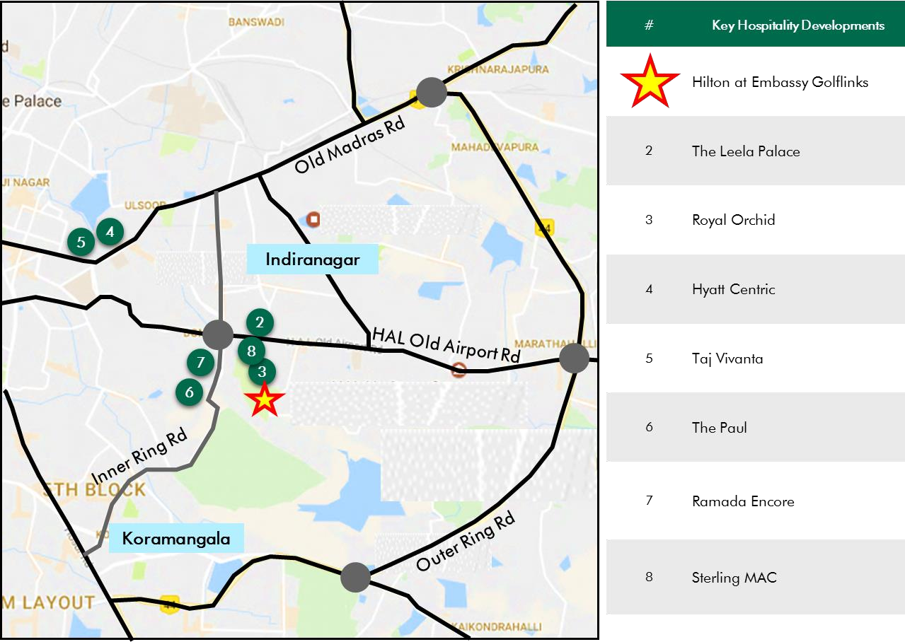

**Location Map for the Subject Property**

*Source: Consultants’ Research*

Shape: Based on site plan provided by the Client and visual inspection during the site visit, it is understood that the subject property is an irregular shaped land parcel.

Topography: Based on the site plan and as corroborated with our site visit, the site appears to be even and on the same level as abutting access roads and adjoining properties.

Frontage: Based on review of site plan, visual inspection and measurements made on Google maps, we understand that the frontage is through the Embassy GolfLinks campus (for which the frontage is approximately 30 meters along the primary access road (viz. Inner Ring Road)).

Accessibility: Based on site maps provided by the Client coupled with visual inspection undertaken, it was observed that the subject property is part of a larger Office Park and is accessible by the Intermediate Ring Road, which acts as the primary access. The subject property can also be accesses through Wind Tunnel Road, which acts as a secondary access for the development.

Please refer Exhibit & Addenda for the site plan of the subject property.

* + 1. Legal Details

As per the title due diligence undertaken by King & Partridge and the occupancy certificate as provided by the Client, we understand that the exact address of the subject property is Challaghatta Village, Varthur Hobli, Bengaluru East Taluk, Bengaluru, Karnataka. Additionally, it is understood that the subject property is freehold in nature.

Further, this appraisal exercise is based on the premise that the subject property has a clear title and is free from any encumbrances, disputes, claims, etc. we have not made any inquiries in this regard with the relevant legal/ statutory authorities.

* + 1. Town Planning

Zoning The subject property is part of an operational Office Park which is a commercial zoned land parcel and is approved for development of a commercial office space (STPI) along with support hospitality. It is located along the mutation corridor of Intermediate Ring road.

The permissible land use adopted by the Consultants for the subject property has been based on information/review of various documents provided by the Client. It must be noted that all factual data viz. permissible development control regulations, land area and achievable FSI have also been based on information/review of various documents (such as title deed, plan sanction letter, site plan, etc.) provided by the Client or assumed

Approved Usage:

based on building regulations, and no physical verification/ measurement has been undertaken for the purpose of this valuation exercise.

For the purpose of this exercise, it has been assumed that all developments adhere to building regulations as prescribed by the relevant authorities. We have not validated the information provided by the Client with the relevant development authorities.

Based on the site inspection undertaken by the Consultants, we understand that the subject property is an operational hospitality development.

Restrictions: As per feedback received from the Client, there are no restrictions on the current use of the property.

Natural or induced hazards:

We are of the opinion that the project/ site has been developed to withstand natural or induced hazards (with the exception of extreme/ out of the ordinary hazards).

* + 1. Statutory Approvals, One Time Sanctions & Periodic Clearances

Please refer section 18.3 on Statutory Approvals, One time Sanctions & Periodic Clearances

* + 1. Area Details, Type and Age of Existing Structures

The table below highlights the area detail of the subject property

**Subject Property**

**Developable area (sf)**

**Completed Area (sf)**

**Committed Area Occupied Area (sf) (sf)**

Hilton at GolfLinks 448,156 448,156 NA NA

*Source: Architect Certificate,*

The table below highlights the details of the subject development:

**Property Name**

**Building Elevation**

**Type**

**Age (Years)**

**No of Keys**

Hilton at GolfLinks 2B+G+3 Hospitality 9 247

Total 247

*Source: Architect Certificate, Occupancy Certificate provided by Client*

* + 1. Site Services and Finishes

Based on the information provided by the Client, we understand that the occupancy certificate was received in 2011 and the hotel has been operational since 2014.

* + 1. Condition & Repair

Based on inputs provided by the Client and visual inspection, we understand that the hotel is well maintained internally with the external maintenance, refurbishments forming part of the larger Embassy GolfLinks asset. The table below highlights the planned repairs and maintenance/ infrastructure upgrade works to be undertaken for the subject property:

**Expense Head**

**Total Cost (INR Mn) Total Cost**

**Spent (INR Mn)**

**Total Pending Cost (INR Mn)**

**Quarter of Completion**

Hilton - Infra Upgrade Capex Works 144.16 0 144.16 Q4, FY 2022

*Source: Information provided by Client*

* + 1. Property Photographs

Please refer to the property photographs highlighted below:

Hilton at GolfLinks

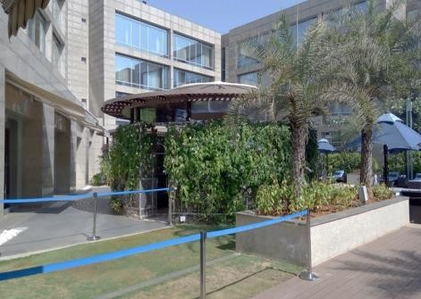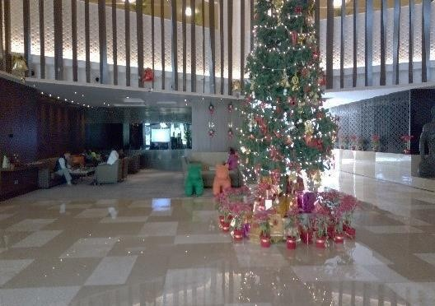

External view of the subject property (SP) Internal view of the SP

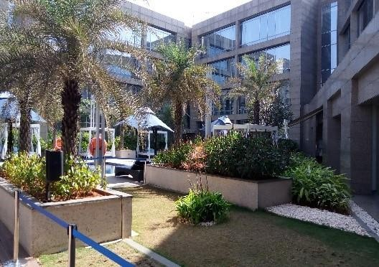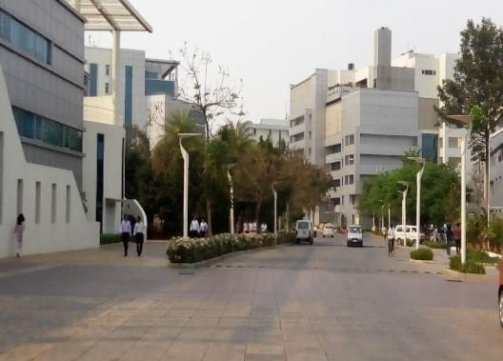

External view of the SP Internal access road

* 1. Assumptions Rationale
     1. Bengaluru Hospitality Segment Overview

The key demand driver for hospitality activity in Bengaluru has been the consistent growth of the corporate sector with development in the Technology sector. The operational premium hotels in the city witness significant demand from business travellers with mid to high level employees of MNCs forming majority of their guest composition. While the concentration of premium hotels is limited within the CBD earlier, a few upscale hotels have commenced operations in prominent commercial/ peripheral regions in the recent past. The table below highlights the room inventory for hotels across different categories:

|  |  |
| --- | --- |
| **Hotel Category** | **Existing Inventory**  **(No of Keys)** |
| Luxury (5 star and 5 Star Deluxe) | 6,500 |
| Upscale (4 star) | 4,500 |
| Midscale (3 star) | 4,100 |
| Total | 15,100 |

*Source: CBRE Research*

Bengaluru hospitality segment (total of approx. 15,100 room keys) is largely concentrated in the premium segment (approx. 43.0%), viz. The Leela palace, The Oberoi, Windsor Manor, Taj West End, ITC Gardenia, JW Marriott, Ritz Carlton, Hilton Conrad, etc. Most of these hotels are located in and around the Central Business District (CBD) of Bengaluru. However, the city has witnessed additional keys in suburban and peripheral areas on account of circular growth of the city and development of other business hubs such as Whitefield, Sarjapur ORR and Hebbal. The city is expected to witness new supply of approx. 1,600 – 1,800 room keys across various segments over the next 2-3 years.

* + 1. Sub Market Analysis for Hospitality Segment

The subject property is located along Intermediate Ring Road, which connects Indiranagar to Koramangala. The erstwhile International Airport and spill over of activities from the CBD initiated the commencement of commercial activities and redevelopment of residential houses in the sub market. On account of good connectivity to CBD, the subject region started witnessing large scale commercial developments such as Embassy GolfLinks, Diamond District etc. in early 2000. Increased commercial activities in the subject sub market have led to the transformation of the residential profile around the subject sub market to a preferred location for the affluent and further led to commensurate increase in capital values. The subject sub market has also emerged as a retail destination and is primarily in the form of high-street formats housing standalone units, typically witnessed along the 100 feet road.

In addition, the subject sub market is well connected by various prominent roads such as the Intermediate Ring Road, Old Airport Road and the Old Madras road which has made the subject sub market easily accessible to the city centre, established residential locations of Koramangala, Old Airport Road etc. and

commercial office destinations such as Whitefield, Old Madras Road etc. The Metro, which passes through Indiranagar and Swami Vivekananda road, has further increased the connectivity of the region.

This location is also home to several educational institutions and hospitals, which emerged, owing to the large residential catchment. Some of the prominent educational institutes include Cauvery High School, Frank Anthony Public School and prominent hospitals include Manipal Hospital, ESI Hospital, Chinmaya Mission Hospital, Sai Baba Hospital, etc. In addition, the sub market has presence of recreational developments such as Domlur club, Indiranagar club, etc. catering to the upper middle class and affluent populace.

The existing upscale hotels that are operational in the vicinity of the subject property have achieved ARRs in the range of INR 7,500 – 9,500 per room per night and occupancies in the range of 70.0-75.0%. Similarly, mid-scale business hotels that are operational in the vicinity of the subject property have achieved ARRs in the range of INR 4,600 – 7,500 per room per night and occupancies in the range of 65.0-85.0%.

* + 1. Historical performance of the subject property

The table below highlights the historical performance of the subject property

|  |  |  |  |  |
| --- | --- | --- | --- | --- |
| **Parameter** | **FY 2016-17** | **FY 2017-18** | **FY 2018-19** | **FY 2019-20** |
| Average ARR (INR) | INR 7,246 | INR 8,163 | INR 9,378 | INR 9,430 |
| Average Occupancy (%) | 68.0% | 72.0% | 69.3% | 63.7%* |

*Source: Client input; low on account of limited occupancy observed during the month of March 2020.*

As can be seen from the table above, the subject property has witnessed substantial increase in both ARRs and Occupancy during the last 3 years. Over the last six months, the ARR for the subject property has averaged in the range of INR 9,500 – INR 11,500 per room per night. Improvement in performance of the hotel can be attributed to its location (within a larger Office Park), demand for room night from corporate travellers within the larger development and from other developments in close vicinity of the subject property, quality of service offering by the operator brand (Hilton), etc.

* 1. Value Assessment
     1. Adopted Methodology

We acknowledge that the approaches to valuation differ considerably and that for a particular purpose, alternative approaches to the valuation can be utilized subject to the Client’s consultations and giving due consideration to the Client’s requirements. Considering the objective of this exercise and the nature of asset involved, the value of the subject property has been assessed through the following approaches:

|  |  |
| --- | --- |
| **Particulars Operational Hotel** | |
| **Valuation Methodology** | Discounted Cash Flow Method |

The sections below highlight detailed valuation workings for the subject property. Please note that the assumptions/ opinions highlighted in the subsequent sections are to be read in conjunction with Section

1.11 and the following:

*“In the current uncertain environment caused by the outbreak of the Novel Coronavirus (COVID-19), we have considered /* relooked *at various performance parameters and have adopted heuristic/ careful interventions (including but not limited to the points mentioned below) to our projected cashflows based on our view as of the date of valuation.*

* *Limited/ no growth in ARR has been considered over the next few quarters*
* *Occupancy has been rationalized in the short term”*
  + 1. Area statement

Based on information provided by the Client, the details for the subject property are highlighted in the table below:

**Components Status No of Keys**

Hilton at GolfLinks Operational 247 keys Total 247 keys

*Source: Architect certificate and information provided by Client*

* + 1. Construction Timelines

Based on the information provided by the Client, occupancy certificate and our visual inspection we understand that the subject property is fully operational as of date of valuation.

* + 1. Revenue Assumptions (Hotel)
       1. *ARR and Occupancy Assumptions*

As per the information provided by the Client, occupancy certificate and our site visit, it is understood that the hotel Hilton at GolfLinks is operational as of date of valuation.

The details of the hotel are mentioned in the table below:

***Components* No of Keys**

Hotel 247

Total 247

*Source: Client’s inputs*

The existing upscale hotels that are operational in the vicinity of the subject property have achieved ARRs in the range of INR 7,500 – 9,500 per room per night and occupancies in the range of 70.0-75.0%. Similarly, mid-scale business hotels that are operational in the vicinity of the subject property have achieved ARRs in the range of INR 4,600 – 7,500 per room per night and occupancies in the range of 65.0-85.0%.

Given the positioning & location of the subject property, performance of the hotel, performance of competing hotels in the subject sub market and development mix (part of a larger commercial development) etc., it is opined that ARRs for hotel component would range from INR 8,800 – INR 9,200 per room night (viz. approx. INR 9,000 per room night). Additionally, the stabilized occupancy for the subject development is opined to be 72.0% and based on the recent performance of the subject property the same is expected to be stabilized 4 quarters from the date of valuation.

* + - 1. *Other Revenues*

The revenue assumptions for the hotel component of the subject development have been enumerated in the table below:

|  |  |  |  |  |  |
| --- | --- | --- | --- | --- | --- |
| **Component** | **Particular** |  |  | **Unit** | **5 Star** |
| **Hotel** | Food & Beverage Revenue | (% | of | Room Revenue) | 50.0% |
| MOD Revenue | (% | of | Room Revenue) | 6.0% |

*Source: Valuer’s Assessment*

* + 1. Expense Assumptions
       1. *Major Repair and improvements*

The following table highlights the assumptions towards the refurbishment expenses/ infrastructure upgrade works in the subject development:

**Expense Head Total Pending Cost (INR Mn) Quarter of Completion**

Hilton - Infra Upgrade Capex Works 144.16 Q4, FY 2022

*Source Client Input; Valuer’s Assessment* the pending cost towards refurbishment is apportioned in equal proportion across remaining quarters from the date of start of the refurbishment works*

* + - 1. *Operating Costs*

The following operating costs have been considered based on benchmarks available in the market for various heads as well as past operational history of the hotel to arrive at the net cash flows for the purpose of this valuation exercise:

|  |  |
| --- | --- |
| ***Expense Heads*** | **5 Star** |
| Room Costs (as a % of room revenue) | 14.0% |
| F&B costs (as a % of F&B revenue) | 35.0% |
| MOD Costs (as a % of MOD revenues) | 2.0% |
| Administrative expenses (as a % of total revenue) | 4.0% |
| Maintenance expenses (as a % of total revenue) | 4.0% |
| Payroll Expenses (as a % of total revenue) | 12.0% |
| Operating Expenses (as a % of total revenue) | 5.0% |
| Marketing costs (as a % of total revenue) | 4.0% |
| Base management Fee (as a % of total revenue) | As per contract |
| Management Incentive Fee (% of GOP) | As per contract |
| Annual Escalation of Operating Costs (viz. admin, maintenance, Op-ex) | 5.0% |
| Property Tax (as a % of total revenue) | 3.4% |

*Source: Valuer’s Assessment & Client input*

* + 1. Capitalization Rates

As highlighted in section 3.3, we have adopted an EV/ EBITDA multiple of 14 for the hotel component.

* + 1. Discount Rate

For discounting the cash flows, the appropriate discounting rate has been calculated on the basis of estimated ‘Weighted Average Cost of Capital’ (WACC). The detailed analysis of WACC rate adopted for the subject property has been detailed in Section 3.4 of this report.

16.4 Value of the Subject Property

Based on the above mentioned analysis, the value of the subject property is estimated as follows:

|  |  |  |  |
| --- | --- | --- | --- |
| Component | Value (INR Mn) |  | % Share |
| Operational Hotel | 4,436 |  | 100.0% |
| **Hilton at GolfLinks** |  | **INR 4,436 Mn** |  |

##### Embassy Energy

* 1. Asset Description

|  |  |
| --- | --- |
| **Brief Description** | |
| **Particulars** | **Details** |
| **Entity Name** | Embassy-Energy Private Limited (EEPL) |
| **Asset Details** | Solar Photovoltaic (PV) electricity generation facility |
| **Property Address** | Villages Ittigi and Mooregeri in Huvin Hadagali Taluka and Nellukudure in Hagri Bommanhalli Taluka, Bellary District, Karnataka |
| **Land Area** | Approximately 465.77 acres |

*Source: Deferred Payment Agreement between EEPL and IL&FS Solar Power Limited, Title Report*

Based on the review of various documents provided by the Client, it is understood that EEPL has entered into a project development agreement with IL&FS Solar Power Limited, as per which IL&FS Solar Power Limited would set up the entire solar plant facility including land acquisition, development, design, engineering, procurement, construction, erection, testing and commissioning of the solar park. For the same, IL&FS Solar Power Limited will receive deferred payments from EEPL in equated monthly instalments for 15 years (180 months) from Commercial Operation Date (COD)6. Additionally, it is also understood that IL&FS Solar Power Limited would undertake the O&M services for the solar park facility for a period of 15 years from COD. For the same, EEPL would pay a lump sum operations and maintenance service fee (during the term of this agreement) to IL&FS Solar Power Limited.

* + 1. Site Details

Situation: Subject property – is a Solar PV electricity generation facility spread across Villages Ittigi and Mooregeri in Huvin Hadagali Taluka and Nellukudure in Hagri Bommanhalli Taluka, Bellary District, Karnataka.

Location: As mentioned above, the subject site is spread across three villages namely Ittigi, Mooregeri and Nellukudure. During the site visit, it was observed that the land parcels in Villages Ittigi and Mooregeri are contiguous, while Nellukudure is located at a distance of approx. 7 km from these two villages. The subject location is situated at a distance of more than 300 km from Bengaluru City and the region is predominantly characterized by the presence of agricultural land parcels (with

*6 Commercial Operation Date (COD) is February 28, 2018*

black cotton soil). A few solar parks are currently operational/ proposed at the subject location by other infrastructure companies such as Adani, ReNew, etc.

The subject property is accessible via State Highway – 45 (SH – 45) and enjoys good connectivity to neighbouring towns and villages.

The distances from key hubs to the subject property are presented in the table below:

**Landmark Distance (km)**

220 KV Sub-station (Ittigi) 3 – 4

Ittigi Village Centre 4 – 5

Davangere 65 – 70

MG Road (Bengaluru) 300 – 310

*Source: Consultants’ Research*

Surrounds: The subject property is surrounded as follows:

Suitability of existing use:

* North: Agricultural land
* South: Primary access road (SH – 45)
* East: Agricultural land
* West: Agricultural land

Considering the profile of subject location, the subject property is opined to be suited for its current use viz. Solar Park.

Shape: Based on site plans provided by the Client and visual inspection during the site visit, it is understood that the subject property comprises of irregular shaped land parcels.

Topography: Based on the site plan and as corroborated with our site visit, the site appears to be even and on the same level as abutting access road and adjoining properties.

Accessibility / Frontage:

Based on visual inspection, the primary access to the subject property is by the State Highway – 45 (SH – 45), which is located towards the south of the subject property. By virtue of the same, the property enjoys excellent accessibility. Further, as highlighted earlier, the subject site is spread over a land area of approximately

465.77 acres across multiple villages. Owing to its large size, the subject property enjoys good frontage along the access road.

Please refer Exhibit & Addenda for the site plan of the subject property.

**Location Map for the Subject Property**

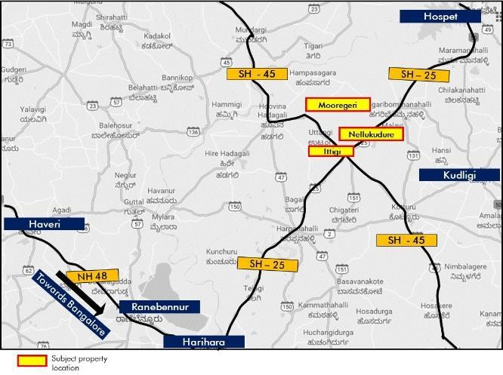

*Source: Consultants’ Research*

* + 1. Legal Details

As per the title due diligence undertaken by *‘Law Shield’* and as provided by the Client, we understand that the exact address of the subject property is Villages Ittigi and Mooregeri in Huvin Hadagali Taluka and Nellukudure in Hagri Bommanhalli Taluka, Bellary District, Karnataka. Additionally, it is understood that the subject property is freehold in nature.

Further, this valuation exercise is based on the premise that the subject property has a clear title and is free from any encumbrances, disputes, claims, etc. The Consultants have not made any inquiries in this regard with the relevant legal/ statutory authorities.

We understand from the Client, title reports, site plans, letter highlighting Commercial Operations Date and site visit, that the park is spread over 465.77 Acres of which the land aggregation is in place by way of sale deed, Agreement to Sell (ATS) or General Power of Attorney (GPA), etc. We understand that currently only about 254.47 Acres is owned by the company by way of Sale Deed whereas the rest is

under various stages of sale and conversion – below is a table which highlights the current status of the Land Aggregation. Further, we understand that physical possession of the land is with EEPL and/or its contractors and sub-contractors and that the solar park has been constructed on most of the land. It is assumed that the sale and conversion would be successful and any adverse impact has not been factored in the valuation.

|  |  |
| --- | --- |
| **Particular** | **Area (acres)** |
| Total extent of identified Land | 465.77 |
| Registered ATS and POA completed | 465.77 |
| Applied for approval u/s 109 | 464.51 |
| Extent of land approved/recommended by DC u/s 109 | 442.54 |
| Final approval received u/s 109 | 442.54 |
| Sale Deed executed favouring EEPL | 254.47 |
| *Source: Client inputs; Section 109 of Karnataka Land Reforms Act, 1961* |  |

* + 1. Town Planning

Zoning: As per the agreement to sell (ATS) and title due diligence report provided by the Client, it is understood that the subject property is zoned for ‘Agriculture’ use. Further, as per the Government Order (dated March 28, 2016) along with an amendment of the same (dated September 8, 2017) provided by the Client, we understand that the company has obtained the necessary permission from the Government of Karnataka for setting up a ‘Solar Power Plant’ at the subject land parcels. The same has been considered for the purpose of this valuation. The Consultants have made no further inquiries with the relevant authorities in this regard.

The permissible land use adopted by the Consultants for the subject property has been based on information/review of various documents provided by the Client.

Approved Usage:

Based on Commissioning Certificates (issued by Gulbarga Electricity Supply Company Limited dated February 7, 2018 and March 8, 2018) provided by the Client, we understand that the subject property is being utilized for operating a ‘Solar Power Plant’. The same has been considered for the purpose of this exercise.

Restrictions: As per feedback received from the Client, there are no restrictions on the current use of the property.

Natural or induced hazards:

We are of the opinion that the project/ site has been developed to withstand natural or induced hazards (with the exception of extreme/ out of the ordinary hazards).

* + 1. Statutory Approvals, One Time Sanctions & Periodic Clearances

Please refer section 18.3 on Statutory Approvals, One time Sanctions & Periodic Clearances

* + 1. Solar Power Plant Details

The table below highlights the key details for the subject power plant:

|  |  |
| --- | --- |
| Particulars **Details** | |
| **Land Area** | Approximately 465.77 acres |
| **Plant Installed Capacity** | 130 MW DC |
| **Plant Output** | 100 MW AC |
| **Electricity Units to be produced** | Approx. 215 Million Units (MU) of electricity by the end of the first 12 months from Commercial Operation Date (COD) and subject to plant stabilization* |
| **COD** | February 28, 2018 |
| **Completion Phases** | 40% commenced operations on January 23, 2018  60% commenced operations on February 28, 2018 |

*Source: Information, Deferred Payment Agreement (DPA), Commissioning Certificates provided by Client*

*\* However, considering the past performance of the subject plant, the maximum generation has been capped at approx. 200 Million Units (MU) for any given year*

* + 1. Condition & Repair

Based on information provided by the Client and the site visit, it is understood that the ‘Solar Power Plant’

at the subject property is in good condition and is being maintained well.

* + 1. Property Photographs

Please refer to the property photographs highlighted below:

Embassy Energy, Bellary District, Karnataka

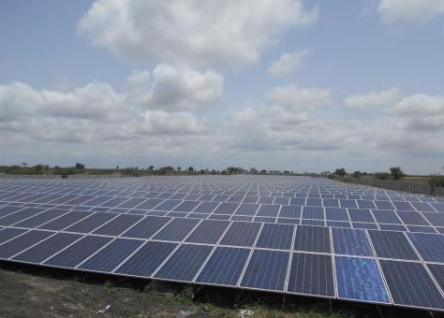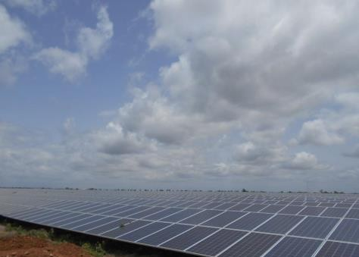

View of the solar power plant View of the solar power plant

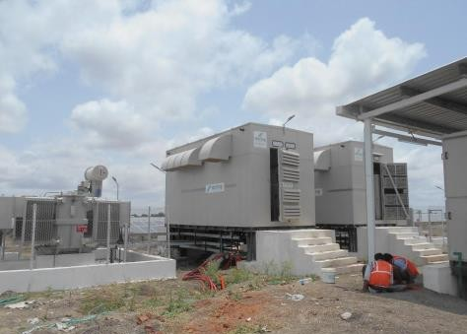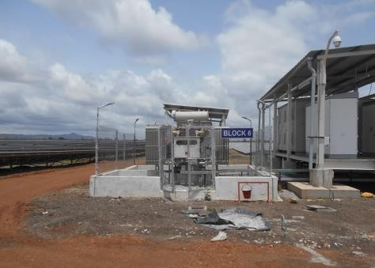

View of the solar power plant View of the solar power plant

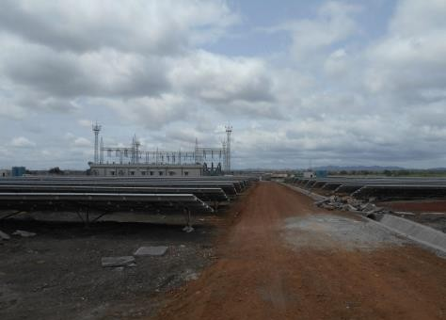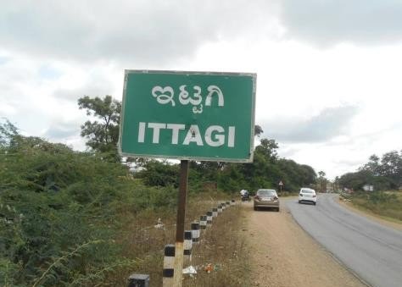

View of the solar power plant View of the access road

* 1. Renewable Energy Policy

India’s renewable energy sector is growing at a significantly fast pace, which has resulted in India becoming the fourth largest producer of wind power in the world. Additionally, India has set a target to achieve 175 GW of renewable generation by 2022. Moreover, renewable energy installations in India amount to approx. 87 GW as of March 2020, accounting for approx. 24% of the total energy source in India. Further, India has an installed solar capacity of approx. 34.63 GW as of March 2020 which contributes approx. 40% of the total installed capacity from renewable energy sources7.

* + 1. Indian Solar Industry Overview

India is endowed with huge solar energy potential with most states having about 300 sunny days per year with an annual solar radiation in the range of 4.5 – 6.5 kWh/m2/day. Further, the favourable state level policies, feed-in-tariff regime, viability gap funding mechanism, capital subsidies, progressive net- metering arrangements and solar specific Renewable Purchase Obligations (RPO) have created a supportive environment for development of solar power in the country.

In the past years, there were several policy measures which were undertaken to encourage renewable energy generation. A few key policy initiatives have been highlighted below:

**Policy Target**

National Action Plan for Climate Change To increase renewable penetration in energy from 5% to 15% by 2020

National Solar Mission Target of 100 GW Solar energy capacity additions by 2022

Renewable Purchase obligations States have already specified; ranging from 2% to 14% of the total energy

demand to be met by renewable energy

Renewable Energy Certificates provide a mechanism for the purchase of

Renewable Energy Certificate

renewable energy that is added to and pulled from the electrical grid. And

further, these REC’s are tradeable in the open market for end use purposes

State level policies Individual State specific solar policy targets 10GW+ capacity addition by 2022

National tariff Policy

*Source:* [*www.ibef.org*](http://www.ibef.org/)

The National Tariff Policy for Electricity was amended by the Union Government on 20 January, 2016. The policy aims to achieve the objectives of Ujwal DISCOM Assurance Yojana (UDAY scheme) with a special focus on renewable energy

The key driver amongst all the policies is National Solar Mission which is also known as Jawaharlal Nehru National Solar Mission (JNNSM). The said mission is a part of the several initiatives that are part of National Action Plan for Climate Change. The program was launched in 2010 with a target of 20GW of contribution to the total energy requirement which was later revised to 100 GW in 2015 Union budget.

7 *Source: Ministry of New and Renewable Energy (MNRE)/ Central Electricity Authority (CEA)*

* + 1. Karnataka Solar Policy: Highlights

Karnataka’s rich solar resources and solar energy has complemented the conventional sources of energy in a large way with an average solar radiation of 5.4 to 6.2 kWh/m2/day. Karnataka was the first southern state to notify its Solar Policy in 2011 and was the first state to commission utility scale solar project in India. Karnataka Electricity Regulatory Commission (KERC) established in the year 1999, has been entrusted the regulatory responsibilities from the Government of Karnataka to coordinate and implement various policies, so as the targets set can be achieved with optimum utilization of resources.

Further, the initial solar policy formulated in 2011 was for period of 2011 – 16. However, in light of technological advantages unfolding in the solar sector, the existing solar policy of Karnataka was revised and a new policy was formulated in 2014 (namely Karnataka Solar Policy 2014 – 21) to promote capacity addition in solar power in order to augment the current sources. The objectives of this policy are highlighted below:

* + - * To add solar generation of minimum 2,000 MW (which was later revised to 6,000 MW) by 20218 in a phased manner by creating a conducive industrial environment
      * To encourage public private participation in the sector
      * To promote solar roof top generation and technologies
      * To encourage decentralized generation and distribution of energy where access to grid is difficult
      * To promote R&D, innovations and skill development in the sector

*8 Source: Karnataka Renewable Energy Development Limited (KREDL)*

* 1. Project Details

Based on the project development agreement between Embassy-Energy Private Limited (EEPL) and IL&FS Solar Power Limited (IL&FS) provided by the Client, it is understood that IL&FS (the developer / main contractor) is entrusted to procure the site and set up the entire solar plant facility. Also, IL&FS will undertake operation and maintenance for the park for a period of 15 years post which the asset would be handed over to EEPL for future operations.

* + 1. Deferred Payment Agreement between EEPL and IL&FS

As highlighted earlier, EEPL and IL&FS have entered into an agreement, as per which IL&FS would set up the entire solar plant facility including land acquisition, development, design, engineering, procurement, construction, erection, testing and commissioning of the solar park. The consideration payable by EEPL to IL&FS for setting up the facility is estimated at INR 6,853.90 Mn under the supply agreement, civil works & construction agreement, engineering, testing & commissioning agreement and land development agreement.

The key features of the contract have been highlighted below:

* + - * EEPL owns a solar photovoltaic electricity generation facility at the project land situated in Karnataka with a minimum capacity of 100 MW AC
      * Consideration payable by the EEPL to the contractors under the definitive agreements is being funded by IL&FS.
      * Further, IL&FS will receive the consideration of INR 6,853.90 Mn as deferred payments in equated monthly instalments for 15 years from COD.
      * Further, as per the agreement, the deferred payments have been arrived at based on the assumption that the consideration shall be funded at a normative debt to equity ratio of 75:25.

Security for IL&FS:

* + - * IL&FS shall have exclusive first charge by way of deposit of title deeds on the project land in accordance with the Mortgage Documentation
      * Further, IL&FS shall have a charge over all the moveable properties (present and future) of the owner (EEPL), in relation to the project (including without limitation all tangible and intangible assets), whether affixed to the earth or not, and in particular including, without limitation, PV Solar panels, erections, and construction of every description which are standing, erected or attached to the project land or lying loose at the site.
      * Further, IL&FS shall have charge over the PPA receivables till such time that such PPA receivables remain in the Escrow account in accordance with the terms of the Escrow Agreement, wherein once the monies required to service the immediately next EMI have been collected in the Escrow Account, the remaining monies in the Escrow Account shall be transferred to any other account as may be specified by the Owner.
    1. Operation & Maintenance Agreement between EEPL and IL&FS

Based on the review of the Operation and Maintenance Agreement (O&M Agreement) provided by the Client, it is understood that IL&FS shall undertake the O&M services for the solar park facility from the COD and continue until the expiry of 15 years unless terminated otherwise.

The key features of the contract have been highlighted below:

* + - * As per the agreement, IL&FS shall undertake the operation, maintenance, and repair of the facility during the term of the agreement (i.e. for a period of 15 years from COD).
      * Further, the contract also states that IL&FS shall be responsible for the supervision of and coordinating with KPTCL which provides and maintains in good order and / or repair, the required metering device for the measurement of electricity supplied to the owner at the interconnection and metering point in compliance with the applicable grid code and in co-ordination with the relevant government instrumentality.
      * IL&FS shall monitor the plant continuously during the term of this agreement.
      * IL&FS shall be responsible to provide dedicated staff to monitor the facility for outage and performance 24 hours per day, 7 days a week. The contractor shall also operate and maintain all equipment related to any monitoring solution, software or platform, as part of the services.
      * IL&FS shall ensure that the facility generates minimum guaranteed units as set out in the corresponding year
      * IL&FS shall be responsible, at its own cost, for procuring, obtaining, maintaining and complying with all the applicable permits and clearances necessary to perform the services under the agreement in accordance with the applicable laws.
      * For the O&M services offered, EEPL shall pay a lump sum operations and maintenance service fee of INR 86.00 Mn per annum to IL&FS as consideration for the services rendered pursuant to this agreement.
    1. Executed Power Purchase Agreements (PPAs)

Based on information provided by the Client (viz. PPAs), it is understood that the solar plant supplies electricity to the existing office parks / hotels of Embassy in Bengaluru (viz. Embassy Manyata, Embassy GolfLinks, Hilton at GolfLinks and Embassy TechVillage). In lieu of the same, it is understood that EEPL has signed power purchase agreements (PPAs) with various entities for commercial and industrial category.

Based on the review of power purchase agreements shared by the Client, it is understood that a typical PPA being entered into has following terms and conditions:

* + - * The obligation of the seller to supply contracted quantity to the purchaser shall commence on the commercial operation date and shall continue until the 25th anniversary of the commercial operation date.
      * Each party may issue a notice request for an extension of term at least 6 months prior to the completion of the initial term.
      * The purchaser of PPAs has agreed to purchase at least 85% of the contracted quantity (‘minimum guaranteed offtake’) each tariff year, commencing from the commercial operation date until the end of the term. Additionally, we understand that the seller also confirms that it shall supply at least 85% of the contracted quantity (‘minimum guaranteed supply’) each tariff year
      * Except due to the failure of the seller to supply the minimum guaranteed offtake at the delivery points, if the purchaser does not draw the minimum guaranteed offtake in any tariff year, the purchaser shall continue to have an irrevocable obligation to pay the seller for the difference between minimum guaranteed offtake and the delivered energy, in such tariff year.
      * If the seller fails to provide the minimum guaranteed supply in any tariff year except the first tariff year, the seller shall pay the aggregate of:
        + The difference between the tariff and the prevailing BESCOM tariff for the units corresponding to the difference between the minimum guaranteed supply and the delivered energy for such tariff year and
        + Any costs and expenses incurred by the purchaser in procuring the remainder of the minimum guaranteed supply from alternate sources
      * The tariff for the billable energy in each preceding billing month shall be calculated, as the aggregate of:
        + The BESCOM tariff applicable to such preceding billing month
        + The applicable policy charges which has been levied by BESCOM, if any, applicable in respect of the billable energy
        + Penalties, if any, levied in accordance or an unpaid sum of previous invoice
        + Any adjustment pursuant to reconciliation of an invoice
        + Open access charges, if applicable
      * The open access charges, if any levied on and from the 11th tariff year shall be borne by both the parties equally. If, upon the levy of 50% of the open access charges, the tariff exceeds the BESCOM tariff and the purchaser does not agree with the revised tariff, the parties shall endeavour to arrive at a mutually acceptable revised tariff mechanism. If a mutually acceptable revised tariff mechanism is not agreed between the parties within 30 days from the occurrence of a tariff elevation event, the purchaser may at its option, terminate the agreement
  1. Assumptions Rationale

The valuation has been undertaken to ascertain the equity/ enterprise value of EEPL given the prevalent industry conditions. In consideration of the same, a detailed research of the industry, guidelines, regulations, reports, centre & state policies, government orders and documentations from Ministry of New and Renewable Energy (MNRE), Indian Renewable Energy Development Agency Ltd. (IREDA), Karnataka Electricity Regulatory Commission (KERC) and Bengaluru Electricity Supply Company Ltd. (BESCOM) has been undertaken to understand the industry, and the future trends of the power and utilities sector.

The details of various factors considered while undertaking this valuation have been highlighted in the subsequent sections.

* + 1. Capacity Utilization Factor (CUF)

The energy generation of a plant primarily depends on two key parameters; solar radiation and the number of clear sunny days experienced by the plant’s location. The performance of a PV power plant is often denominated by a metric called the capacity utilisation factor (CUF), also known as Plant Load Factor (PLF). It is the ratio of the actual output from a solar plant over the year to the maximum possible output from it for a year under ideal conditions. Capacity utilisation factor is usually expressed as a percentage of the total installed capacity.

On the basis of the research undertaken and with reference to the various reports from Ministry of New and Renewable Energy (MNRE), we understand that the average capacity utilisation of Solar PV Plants in India is in the range of 18% - 20% in solar friendly states.

The CUF of Solar PV Plants in several solar friendly states in India has been tabulated below:

|  |  |
| --- | --- |
| **State** | **CUF (%)** |
| Gujarat | 18 |
| Karnataka | 19 |
| Madhya Pradesh | 19 |
| Maharashtra | 19 |
| Punjab | 19 |
| Rajasthan | 20 |
| Seemandhra/Telangana | 20 |
| Tamil Nadu | 19 |
| Uttarakhand | 19 |

*Source:* [*www.mnre.gov.in*](http://www.mnre.gov.in/)

*Note: The calculation is based on average plant performance across each state*

Hence, the Capacity Utilization Factor of 18.9% assumed for the subject plant is in line with industry benchmarks.

* + 1. Commercial/Industrial tariff

Based on review of Power Purchase Agreements (PPAs) signed between EEPL and various entities, we understand that solar plant supplies electricity to the existing office parks / hotels of Embassy in Bengaluru and the tariff shall be calculated in accordance with the prevailing BESCOM tariff. Hence, in order to ascertain the revenues from the solar plant, we have looked at the prevailing and historical BESCOM tariffs applicable to areas under Bruhat Bengaluru Mahangara Palike (BBMP) and Municipal Corporations for commercial and industrial category consumers.

The details of the same have been mentioned in the table below:

|  |  |  |  |  |  |  |  |  |  |  |
| --- | --- | --- | --- | --- | --- | --- | --- | --- | --- | --- |
| Category | FY 2011 | FY 2012 | FY 2013 | FY 2014 | FY 2015 | FY 2016 | FY 2017 | FY 2018 | FY 2019 | FY 2020 |
| Commercial HT 2b (i) | 6.30 | 6.80 | 7.00 | 7.25 | 7.65 | 7.85 | 8.35 | 8.55 | 8.80 | 9.00 |
| (Highest Slab) |
| Industrial HT 2a (i) | 5.00 | 5.30 | 5.50 | 5.75 | 6.15 | 6.30 | 6.75 | 6.95 | 7.20 | 7.40 |
| (Highest Slab) |

*Source:* [*http://bescom.org*](http://bescom.org/)

*\* The tariffs are mentioned in INR per kWH*

As highlighted in the table above, it is understood that that the prevailing BESCOM tariff for commercial category is INR 9.00 per kWH, whereas the tariff is INR 7.40 per kWH for industrial category.

Further, as highlighted earlier, the PPAs that have been signed are distributed between commercial and industrial segments. Keeping the same in perspective, we have considered a blended tariff (in proportion of the distribution between commercial and industrial category consumers) of INR 8.76 per kWH for the subject plant.

* + 1. Escalation in tariff

Based on the review of various Power Purchase Agreements (PPA’s) signed, we understand that the tariff for the billable energy shall be calculated in accordance with the prevailing BESCOM tariffs. Hence, in order to ascertain the future growth in tariff, we have analysed the historical BESCOM unit rates to understand how the tariffs have grown over the last 9 years.

The escalation trend of BESCOM tariffs from FY 2011 to FY 2020 has been represented in the graphs below:

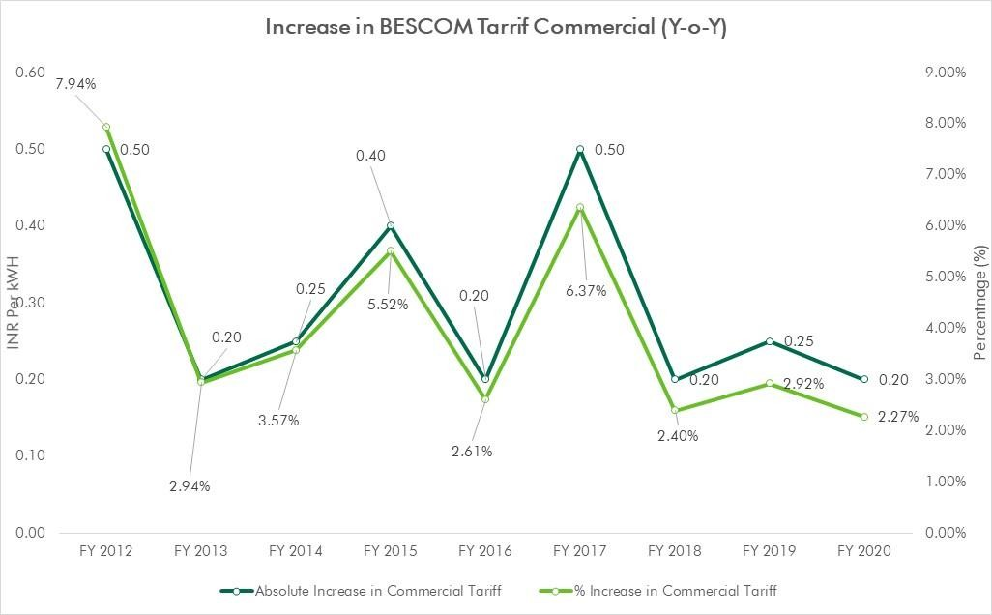

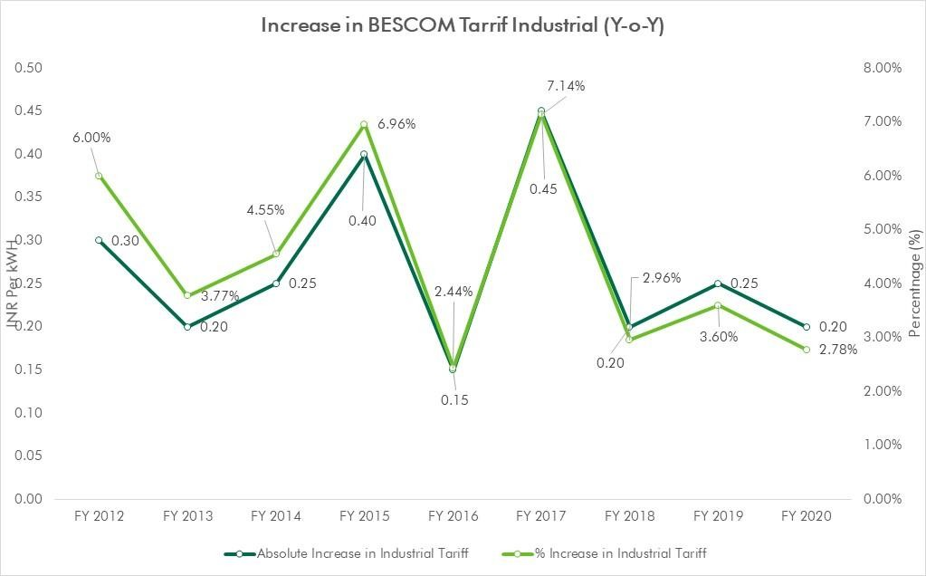

*Source:* [*http://bescom.org*](http://bescom.org/)

Based on our analysis, it is understood that the CAGR for BESCOM tariff is 4.0% for commercial category, while the industrial tariffs have witnessed a CAGR of 4.5% over a period of last 9 years. In absolute terms, the commercial tariffs have annually grown by approx. INR 0.30 per kWH in the last 9 years, whereas the industrial tariffs have witnessed an average annual increase of INR 0.27 per kWH during the same period. However, owing to technological advancements in the solar industry, it is understood

that the capital cost of solar PV power projects has decreased by approx. 65% - 70% in the span of last 8 – 9 years. Hence, keeping the same in perspective coupled with increasing share of solar energy (owing to favourable policy environment), the tariffs are expected to rationalize going forward. Hence, on a conservative basis, we have assumed an annual escalation of 2.5% in the tariff.

* + 1. Operation & Maintenance (O&M) Expenditure

The O&M expenditure includes cost towards repair, operation, maintenance and general upkeep of the plant so as to optimize the efficiency of the plant. Additionally, other expenses such as employee expenses, administrative & general expenses, etc. are also included in the operating expenditure. The maintenance activities can be further categorised as follows:

|  |  |  |  |  |
| --- | --- | --- | --- | --- |
| Nature of maintenance |  | Major | Activities | |
| Preventive Maintenance  Corrective Maintenance  Condition based Maintenance (CBM) | Panel Cleaning |  | | Upkeep of data acquisition and monitoring systems (e.g. electronics, sensors) |
| Wildlife prevention |  | | Upkeep of power generation system (e.g. inverter servicing, Tracker maintenance) |
| Vegetation Management |  | | Water Drainage |
| On – site monitoring |  | | Critical reactive repair – addresses production losses issues |
| Rectification of defects |  | | Non – Critical reactive repair – addresses production degradation issues |
| Active Monitoring – Remote and on site | | | Equipment Replacement (Planned and Unplanned) |
| Warranty Enforcement (Planned and Unplanned) | | |

*Source: Electric Power Research Institute (EPRI)*

Based on secondary research, we understand that the annual operating expenditure generally ranges from INR 0.60 – 0.70 Mn per MW. Hence, in light of the same, we have assumed annual O&M (operation & maintenance) expenses of INR 0.66 Mn per MW for the subject solar park. Further, these expenses have been escalated at 4% p.a.

* + 1. Useful Life

According to research reports and feedback from industry players, we understand that the rated power of solar panels typically degrades at about 0.5% to 0.8% per year. Considering the same, we have assumed an annual derating of approx. 0.7%.

On further interactions, we understand that majority of the solar PV manufacturers claim life of 25 years for standard solar panel warranty, which means that power output should not be less than 80% of the rated power till 25 years. Also, as per the CERC (Central Electricity Regulatory Commission) guidelines, a useful life of 25 years has to be assumed for a Solar PV generation facility for determination of levellized tariff. However, the said technology of photovoltaics is relatively new (less than 10 years old) and hence, we do not have enough evidence to conclude the actual life of a Solar PV cell. Hence, based on the aforementioned warranties and CERC guidelines, we have assumed a useful life of 25 years for the subject plant.

* + 1. Working Capital

Working capital for the purpose of valuation of the subject plant includes O&M expenses, maintenance spares and revenue receivables. Further, the said parameters have been benchmarked on the basis of working capital requirements for similar kind of projects. The assumptions for working capital have been tabulated below:

|  |  |  |
| --- | --- | --- |
| Working capital component Units Details | | |
| Operation and Maintenance Cost | No. of Months' O&M Cost | 1 month |
| Receivables | No. of Months' Revenue | 3 months |
| Maintenance Spares | % of O&M Cost | 3.0% |
| Margin Money Requirement | % | 25.0% |
| Working Capital Loan | % | 75.0% |
| Interest on Working Capital | % | 11.0% |
| *Source: Valuer Assumption/ Client Input* |  |  |

As per information provided by the Client, we understand that the working capital will be funded by a mix of equity and working capital loan (which will be accrued at a market interest rate of approx. 11.0%) in proportion of 25.0% and 75.0%, respectively.

* 1. Value Assessment
     1. Adopted Methodology

Considering the objective of this exercise and the nature of asset involved, the equity/ enterprise value of the subject plant has been assessed through the following approach:

|  |  |
| --- | --- |
| **Particular Embassy Energy** | |
| **Valuation Methodology** | Discounted Cash Flow Method |

The sections below highlight detailed valuation workings for the subject property. Please note that the assumptions/ opinions highlighted in the subsequent sections are to be read in conjunction with Section

1.11 and the following:

*“In the current uncertain environment caused by the outbreak of the Novel Coronavirus (COVID-19), we have considered /* relooked *at various performance parameters and have adopted heuristic/ careful interventions (including but not limited to the point mentioned below) to our projected cashflows based on our view as of the date of valuation.*

* *Lower unit consumption has been assumed for the solar power plant during the period of limited operations”*
  + 1. Plant Details

Based on site visit, we understand that the solar panels being used in the project are fixed axis solar panels. A fixed tilt system positions the modules at fixed tilt and orientation. The key details of the plant have been tabulated below:

**Particular Detail**

Land Area Approximately 465.77 acres

Capacity (MW) (A) 130 MW DC (100 MW AC)

Plant Load Factor (%) (B) 18.9%

Number of hours in a day (C) 24

Days in a year (D) 365

Total units generated (kWH) (A * B * C * D) * 1000 215 Million Units (MU)* in kWH in Year 1

*Source: Client Inputs; *Subject to plant stabilization, however, considering the past performance of the subject plant, the maximum generation has been capped at approx. 200 Million Units (MU) for any given year*

* + 1. Development Timelines

Based on commissioning certificates provided by the Client, it is understood that the subject plant is operational as on date of valuation.

* + 1. Electricity Consumption

As highlighted earlier, the solar plant supplies electricity to the existing office parks / hotels of Embassy in Bengaluru. In lieu of the same, it is understood that EEPL has signed power purchase agreements (PPAs) for 25 years with various entities for commercial and industrial category. Additionally, as per the agreement, the purchasers of PPAs have agreed to purchase at least 85% of the contracted quantity (‘minimum guaranteed offtake’) each tariff year, commencing from the commercial operation date until the end of the term.

* + 1. Revenue Assumptions

As highlighted earlier, the tariff for the subject plant has been benchmarked against the prevailing BESCOM tariffs for commercial and industrial category consumers. Considering the same and the proportion of commercial and industrial category, we have adopted the following tariff to arrive at the revenue for the subject power plant:

|  |  |  |
| --- | --- | --- |
| **Particular** | **Basis** | **Details** |
| **Blended Tariff**  **Annual Escalation** | INR per kWH | 8.76 |
| % p.a. | 2.5% |

*Source: Valuer Assumption*

* + 1. Expense Assumptions

*17.5.6.1 Development Cost*

As per inputs of the Client, the following capital expenditure has been considered for the subject solar plant:

|  |  |  |
| --- | --- | --- |
|  | **Cost Head** | **Total Cost (INR Mn)** |
|  | Evacuation Infra | 353.10 |
|  | Material Supply | 5,307.20 |
|  | ETC Works | 392.10 |
|  | Civil Works | 504.90 |
|  | Land | 296.60 |
|  | Total | 6,853.90 |
| *Source: Client’s input*  *17.5.6.2 O&M expenses* |  |  |

In addition to capital expenditure, a solar PV plant has few recurring O&M expenses (as highlighted in the section earlier) required for the general up-keep and running of the park. Based on information

provided by the Client and market benchmarks, following O&M expense assumptions have been adopted for the purpose of this valuation exercise:

|  |  |  |
| --- | --- | --- |
| Nature of Expense | Details | Basis |
| Operation & Maintenance Expenditure | 0.50 | INR Mn per MW per annum |
| Employee Expenses | 0.11 | INR Mn per MW per annum |
| Administrative & General expenses | 0.05 | INR Mn per MW per annum |
| Total | 0.66 | INR Mn per MW per annum |

*Source: Valuer Assumption*

Additionally, the aforementioned operating expenses have been escalated at 4% p.a. going forward.

* + 1. Open Access Charges

Open Access charges are payable towards the non-discriminatory provision for the use of transmission lines or distribution system or associated facilities with such lines or system by any licensee or consumer or a person engaged in generation in accordance with the regulations specified by the appropriate Commission. On review of the power regulations / tariff orders of KERC (Karnataka Electricity Regulatory Commission), we understand that an electricity generation facility is bound to the open access charges as listed below:

Cross Subsidy Surcharge (CSS)

Cross-subsidies in electricity tariff can be defined as a mechanism whereby some consumer groups are charged a higher tariff as compared to the cost of supplying power to them. The additional revenue generated from them is used to tide over the revenue shortfall from other consumer groups, who are charged lesser tariff as compared to the cost of supplying power to them. Cross subsidies are targeted at consumer groups who either do not have enough paying capacity or need to be supported for undertaking economic activities (e.g., agriculture, power looms, etc.), which in some way benefit the larger section of society. As per the KERC Tariff Order 2019, it is understood the CSS for commercial category HT-2b (i) is INR 2.13 per kWH and for industrial category HT 2a (i) is INR 1.87 per kWH for FY 2020.

Transmission Charges

Transmission charges refer to the cost of transmitting energy over the transmission grid between the generating facility and the local utility’s distribution facilities. As per the KERC order, transmission charges of INR 111,558 per MW per month is applicable for all long term open access consumers (i.e. consumers intending to avail the open access for a period equal to or more than five years).

State Load Dispatch Centre (SLDC) Charges

SLDC under Karnataka Power Transmission Corporation Limited (KPTCL) is an apex body to ensure integrated operation of the power system in Karnataka. SLDC is responsible for the real time load

dispatch functions, operation and maintenance of the SCADA (Supervisory Control and Data Acquisition) System and energy accounting. Further, for the discharge of its functions, the annual expenses incurred by the SLDC are recovered from the consumers/ beneficiaries using the Intra-State transmission system. As per the KERC order, SLDC charges of INR 34.36 per MW per day are applicable.

Wheeling Charges

Wheeling charge means the operation whereby the distribution system and associated facilities of a transmission licensee or distribution licensee, as the case may be, are used by another person for the conveyance of electricity on payment of charges. Wheeling is a transmission service that enables the delivery of electricity between a buyer and seller, often under a long term PPA. As per the KERC orders, we understand that the wheeling charges are 5.0% of the injected units.

Banking Charges

Banking is a financial and accounting mechanism under which a service provider earns credit for excess electricity supplied to the grid. As per the KERC orders, we understand that the banking charges are 2.0% of the injected units.

Additionally, based on review of various regulatory guidelines, it is understood that in order to promote solar power generation in Karnataka, KERC has exempted all solar power generators achieving COD between April 1, 2013 and March 31, 2018 and selling power to consumers within the State on open access and wheeling, from payment of the aforementioned charges for a period of ten years from the date of commissioning. Hence, the aforementioned charges have been factored in after 10 years from COD since the subject plant has achieved COD on February 28, 2018.

The details of these charges adopted for the purpose of this exercise have been tabulated below:

|  |  |  |
| --- | --- | --- |
| **Expense Head** | **Basis (Units)** | **Details** |
| Cross Subsidy Surcharge | % of revenue | 23.9% (INR 2.09 per kWH)* |
| Transmission Charges | % of revenue | 9.2% (INR 0.81 per kWH) |
| SLDC Charges | % of revenue | 0.1% (INR 0.01 per kWH) |
| Wheeling Charges | % of injected energy | 5.0% |
| Banking Charges | % of injected energy | 2.0% |

*Source: Valuer Research*

*\* Blended rate in proportion of the distribution between commercial and industrial category consumers*

Additionally, as per KERC Tariff Order 2019, an additional surcharge of 15 paise per unit has been imposed for wheeling and the same is being absorbed by EEPL. This additional surcharge translates to approx. 1.7% of revenue and the same has been considered for the purpose of our valuation workings.

* + 1. Other Charges

Insurance Premium

We have considered an annual outflow towards insurance premium at 0.5% of the net assets / block after book depreciation (excluding land cost).

Replacement Cost of Inverter

Based on market feedback and various research reports, it is understood that a solar inverter generally has a lifespan of approx. 10 – 12 years. Hence, we have considered an additional outflow towards replacement of inverter in 13th year from COD.

Additionally, it is understood that the prevailing market price for inverters manufactured in India is approx. INR 2 Mn per MW, while the price is close to INR 3 Mn per MW for those made in Germany. Further, as per inputs of the Client, it is understood that EEPL is using a mix of both in equal proportion. It is also understood that the entire inverter may not need replacement and only the Insulated Gate Bipolar Transistors (IGBT) / electronics will be replaced. Hence, considering the reducing capital cost in the industry, the cost adopted for replacing the inverter has been considered as INR 1.3 Mn per MW in the year of replacement.

* + 1. Working Capital Assumptions

As highlighted in earlier section, the working capital assumptions adopted for this exercise have been tabulated below:

|  |  |  |
| --- | --- | --- |
| Working capital component Units Details | | |
| Operation and Maintenance Cost | No. of Months' O&M Cost | 1 month |
| Receivables | No. of Months' Revenue | 3 months |
| Maintenance Spares | % of O&M Cost | 3.0% |
| Margin Money Requirement | % | 25.0% |
| Working Capital Loan | % | 75.0% |
| Interest on Working Capital | % | 11.0% |

*Source: Valuer Assumption*

* + 1. Cash Flows for EEPL under the Deferred Payment Agreement and O&M Agreement with IL&FS

As highlighted in earlier sections, EEPL has entered into a deferred payment agreement (dated March 3, 2017) with IL&FS, as per which IL&FS would set up the entire solar plant facility including land acquisition, development, design, engineering, procurement, construction, erection, testing and commissioning of the solar park. Hence, the entire cost of development highlighted above would be borne by IL&FS. For the same, IL&FS will receive deferred payments from EEPL in equated monthly instalments for 15 years from COD.

Also, an O&M Agreement (dated January 9, 2017) is signed between EEPL and IL&FS, as per which IL&FS shall undertake the O&M services for the solar park facility from the COD and continue until the expiry of 15 years unless terminated otherwise. Hence, the recurring expenses such as O&M cost, insurance premium, etc. would be borne by IL&FS during the term of this agreement (i.e. 15 years from COD post which the facility shall be handed over to EEPL). For the same, EEPL would pay a lump sum operations and maintenance service fee of INR 86.00 Mn per annum (during the term of this agreement) to IL&FS.

As highlighted earlier, the scope of this exercise is to ascertain the equity/ enterprise value of EEPL. Hence, the arrangements mentioned above have been factored in for deriving the cash flows for EEPL.

* + 1. Depreciation Assumptions

Depreciation is a method of allocating some cost of a tangible long-term asset over its useful life and thus, refers to the decrease in value of the asset during its lifetime. All fixed assets except the value of land depreciate with passage of time. Hence, in order compute the net operating income for calculating the tax liability, following depreciation rates have been used for the subject asset (solar power project):

Applicable act

Nature of

Depreciation

Method of

Depreciation

Depreciable Rate of Depreciation

block (annual)

Rate of

Depreciation (quarterly)

The Companies Act, 2013

The Income Tax Act, 1961

Book depreciation Written Down Value

(WDV)

Tax depreciation Straight Line

Method (SLM)

95% 12.73%* 3.35%*

100% 7.69%** 1.92%**

*Source: The Companies Act, 2013 & The Income Tax Act, 1961*

*\*Assumed a life of 22 years (same as the life of a Wind Power Generation Plant, which is the nearest comparable natural renewable energy source)*

*\*\* Depreciation rate for any other asset not covered in the list of power generating units*

* + 1. Taxation Assumptions

The tax payable as per the prevailing tax rates in India is computed on the earnings after interest and depreciation to arrive at the equity level cash flows for EEPL.

Particulars Tax Rate (%)

Corporate tax rate 25.17%

Minimum Alternate Tax (MAT) rate NA

*Source: Valuer Research*

* + 1. Useful Life

Based on the assumptions highlighted above and duly factoring in the existing arrangements between EEPL and IL&FS, the quarterly cash flows for EEPL have been projected over the useful life of the facility,

i.e. for a period of 25 years.

* + 1. Discount Rate

For discounting the cash flows, the appropriate discounting rate has been calculated on the basis of estimated cost of equity.

The cost of equity has been adopted based on an analysis of the returns of listed power index/ key energy stocks in India and adjusting the same for asset and market specific attributes such as status of development (execution risk), approval risk, marketing risk, etc. The cost of equity has been further ratified from various research papers and industry reports, which highlight the market expectations for required rate of return on equity from Renewable Energy (RE) power projects in India. Based on our analysis, it was observed that the cost of equity for solar power projects would range between 14% - 16%. However, in our opinion, the cost of equity for EEPL would be lower, considering the following factors:

* + - * Low development and execution risk considering the current arrangement between EEPL and IL&FS (as highlighted earlier), wherein IL&FS has undertaken the entire development process and is also responsible for operation, maintenance and repair of the facility for a period of 15 years from COD
      * Low marketing risk since the solar plant supplies electricity to the existing office parks / hotels of Embassy in Bengaluru, and PPAs (with minimum guaranteed offtake set at 85% of the contracted quantity) have already been executed for a period of 25 years

Keeping the above in consideration, the cost of equity for discounting the cash flows for EEPL has been assessed as 13.5%.

The cash flows are assumed to realize evenly during the course of every quarter, hence a mid-quarter discounting convention has been adopted for the purpose of this valuation.

* + 1. Equity Value of EEPL

Based on the above mentioned analysis, the equity value of EEPL is estimated as follows:

|  |  |  |
| --- | --- | --- |
| Component | Useful Life | Value (INR Mn) |
| Equity Value – EEPL | 25 years | 3,799 |

* + 1. Enterprise Value of EEPL

Based on the above mentioned analysis, the enterprise value of EEPL as on March 31, 2020 is estimated as follows:

Component INR Mn

Equity Value – EEPL 3,799

Add: Outstanding Debt as on March 31, 2020 6,489

**Enterprise Value – EEPL INR 10,289 Mn**

##### Exhibits and Addendums

* 1. Other Mandatory Disclosures
     1. Details of Material Litigations

Based on information provided by the Client, please find below the details of material litigations:

1. Embassy Manyata
   1. MPPL has filed a writ petition against the BBMP and others seeking to *inter-alia*, quash (i) a circular from 2014 re-fixing the improvement charges under the Karnataka Municipal Corporations Act, 1976, and the Karnataka Municipal Corporations (Recovery of Improvement Expenses) Rules, 2009, and (ii) a notice from 2015 demanding payment of betterment charges of ₹127.9 million. In 2016, the High Court of Karnataka has granted an interim stay on the impugned circular and notice.
   2. A third party suit was filed against MPPL and other defendants (who are co-owners in joint possession with the plaintiff) in 2020 before the High Court of Karnataka seeking (i) 1/8th share of property by way of partition; (ii)a declaration that the *panchayth parikath* alias partition deed dated February 20, 1997, sale deeds executed in favour of MPPL are void ab-initio and (iii) award of mesne profit to the plaintiff. The matter was heard on January 28, 2020 and was ordered for issuance of summons and interlocutory application to the defendants.
2. Hilton at Embassy Golflinks

A third party has filed a suit against GLSP, UPPL and Mac Charles (India) Limited and others in 2003 before the City Civil Court, Bengaluru, seeking specific performance of an agreement for sale for 94,000 square feet of land forming part of the larger parcel of land admeasuring 5 acres and 23 guntas situated at Challaghatta village. The court dismissed the suit in 2008. The plaintiff has challenged such dismissal in 2009 before the High Court of Karnataka in an appeal. GLSP and UPPL have been arraigned as respondents in the appeal. The High Court of Karnataka has recorded the submission made by GLSP & UPPL indicating that no encumbrance will be created on the suit property of 94,000 square feet.

1. Express Towers
   1. IENMPL has filed a writ petition against the Government of Maharashtra and the Collector, Mumbai in 2003 before the Bombay High Court, challenging the demand against IENMPL for payment of increased transfer charges in relation to a sub-lease. While transfer charges amounting to ₹0.12 million annually for 61 years as per GoI’s letter were levied in 2001, the transfer charges were revised to ₹2.34 million in the same year by the Collector, Bombay. In 2004, the Bombay High Court passed an order staying the operation of demand for increased transfer charges, subject to IENMPL continuing to pay the original transfer charges. IENMPL has also undertaken that in the event of dismissal of petition they shall pay the demanded increased transfer charges.
   2. IENMPL had initiated legal proceedings against a tenant before the Court of Small Causes, Mumbai in 2007 for eviction and recovery of possession of 2,150 square feet in Express Towers and for mesne profits. On November 15, 2011, the court directed the tenant to pay ₹0.26 million per month towards mesne profits for the period between March 1, 2007 and February 2010, and ₹0.29 million per month March 1, 2010 onward. An appeal by the tenant against this order before the Court of Small Causes was dismissed on May 6, 2015. Aggrieved, the tenant filed a petition before the Bombay High Court. On August 28, 2017, the High Court passed an order directing the tenant to pay ₹225

per square feet per month from May 1, 2015 to continue the possession of the premises. The tenant continues to occupy the premises and pay rentals.

* 1. A criminal public interest litigation has been instituted by a third party against the state of Maharashtra and others in 2017 which has alleged irregularities in the manner in which Express Towers was being used, and the manner in which the shareholders of IENMPL have acquired the asset. IENMPL impleaded itself as party to this public interest litigation. The Bombay High Court had directed the third party to file an amended petition to, inter alia, include IENMPL as a party, which has been filed by the third party on February 27, 2019. The last date of hearing in the said matter was on August 5, 2019 wherein the matter was adjourned.

1. Embassy Golflinks
   1. Certain third parties have filed a suit for partition in 2005 against their family members and GLSP before the City Civil Court, Bengaluru, in respect of a property admeasuring 4 acres and 1 guntas, where GLSP is entitled to two acres and 21 guntas, forming part of Embassy Golflinks wherein the court passed a preliminary decree for partition. GLSP has filed an appeal in 2013 before the High Court of Karnataka challenging the decree. The High Court has passed interim orders in 2015 and stayed the decree. The matter came up for hearing on September 23, 2019 wherein it was adjourned.
   2. A third party individual has filed a suit before Court of the City Civil Judge, Bengaluru in 2005, against GLSP and others for declaring a sale deed allegedly executed in 2004 by him in favour of GLSP and another pertaining to a portion of land situated at Embassy Golflinks, as null and void on account of fraud and misrepresentation. The plaintiff died at the evidence stage and his alleged heir was not permitted to come on record by as the court rejected his application by passing an order in 2015. Aggrieved by the order, the alleged heir filed a civil revision petition before the High Court of Karnataka in 2015 which was subsequently converted into a writ petition. The matter is currently pending.
   3. Certain third parties have filed a suit in 2008 before the City Civil Court, Bengaluru in respect of a property admeasuring 1 acre and 21 guntas, forming part of Embassy Golflinks. The suit was dismissed in 2013 due to no representation on behalf of the plaintiffs. The plaintiffs filed a petition before the City Civil Judge, Bengaluru in 2013 to set aside the dismissal order and restore the suit, along with an application for condonation of delay. GLSP has filed objections to the petition.
   4. Certain third parties have filed an application in 2007, before the Court of City Civil Judge, Bengaluru against GLSP and another third party seeking an injunction restraining them from alienating or creating any third party interest in a property admeasuring 2 acres and 14 guntas, forming part of Embassy Golflinks. The court passed an interim order in 2007 which has been subsequently vacated by the court and the matter is currently pending. The third party claimants have also filed a claim in 2009 against GLSP and others, before the High Court of Karnataka seeking appointment of an arbitrator and an arbitrator was appointed by an order in 2015. The claimants sought (i) performance of joint development agreements executed in 2004 and 2005, against GLSP and another individual, pertaining to the property before the arbitrator, and (ii) an injunction to restrain the respondents from alienating or creating any third-party interests in the building constructed on the property, before the arbitrator. The case has been called for arguments on March 30, 2020.
   5. A third party has filed a suit before the City Civil Court, Senior Division, Rural District against GLSP and others alleging that the defendants and GLSP have colluded with each other to sell certain parcels of land belonging to the petitioner, admeasuring 12 guntas, 1 acre 9 guntas and 15 guntas respectively and forming part of Embassy Golflinks to GLSP. The petitioner has alleged that the sale deed executed in 2003 is not binding on the petitioner. The suit was dismissed in 2016 for default by

the petitioner. The petitioner has thereafter filed an application seeking to restore the case and the summons are yet to be served on some of the respondents.

* 1. GLSP received a notice from a third party individual alleging that certain third parties were the absolute owners of land in possession of GLSP admeasuring 2 acres and 8 guntas in Bengaluru. The IX Additional City Civil and Sessions Judge, pursuant to a preliminary decree in 2017, granted the petitioner half a share in the land. GLSP was not made a party to the above suit filed by the third party. GLSP has filed an appeal in the High Court of Karnataka to set aside the decree of the IX Additional City Civil and Sessions Judge and to remand the suit to the trial court by impleading GLSP as a defendant. Currently, the matter is in the admission stage and the High Court of Karnataka has requested that the lower court records to be produced before it.

I. Material litigation and regulatory action pending against the Embassy REIT (Asset SPVs and the Investment Entity)

*With respect to the Asset SPVs and the Investment Entity, details of all pending regulatory actions and criminal matters against the Asset SPVs and the Investment Entity have been disclosed.*

*For the purpose of pending civil/ commercial matters against the Embassy REIT (Asset SPVs and Investment Entity) and Associates of the Embassy REIT, matters exceeding [₹●million] (being [●%] of the consolidated income of the Embassy REIT as of March 31, 2020) have been considered material and proceedings where the amount is not determinable but the proceeding is considered material by the Manager from the perspective of the Embassy REIT has been disclosed.*

*Other than as disclosed below, there are no pending criminal litigation, regulatory actions or material civil/ commercial matters against any of the Asset SPVs or the Investment Entity or the Associates of the Embassy REIT as of March 31, 2020. Further, there is no litigation against the Embassy REIT as of March 31, 2020.*

1. MPPL Regulatory Proceedings
2. The Director, SEZ Section, GoI issued guidelines in 2009 which laid down that captive power plants in IT/ ITES SEZs were to be classified as separate units and were entitled to avail fiscal benefits under the SEZ Act including the benefit of exemption from the levy of excise duty under the Central Excise Act, 1994, on the goods supplied to them. However, in 2015, a new circular was issued which withdrew all such benefits and incentives extended to the captive power plants set up in a SEZ with effect from April 1, 2015. In 2016, new guidelines were issued which restored the benefits and exemptions given under the 2009 circular. However, the exemptions and benefits were prospective in nature and did not apply to SEZ developers, such as MPPL, for the period between the 2015 circular and the 2016 guidelines. By way of their letters in 2016, two diesel providers who were providing high speed diesel to MPPL, informed MPPL that amount payable due to excise duty on supply of diesel to MPPL was ₹31.60 million and ₹8.49 million, respectively, due to the changed guidelines. MPPL filed an application before the Development Commissioner, Manyata Embassy Business Park SEZ in 2016 seeking approval of its DG set unit as a SEZ unit with retrospective effect, which was not granted.

Subsequently, MPPL filed an appeal before the Development Commissioner, Manyata Embassy Business Park SEZ seeking modification of the letter of approval granted by the Board of Approval,

SEZ Section to classify MPPL’s captive power plant as a SEZ unit, as it was not granted with retrospective effect, which was rejected.

1. MPPL has also received a demand order dated 9 Oct 2017 to pay a sum of Rs. 760.07 million (including penalty) towards the differential property tax based on the total survey report for certain blocks for the period 2008-09 to 2017-18. An appeal has been filed before the Joint Commissioner, BBMP, Bytarayanapura, Bangalore objecting the total survey report and property tax assessment notice arising therefrom. However, the appeals preferred by SPV was disposed on 3 Jan 2018 as per the orders passed by the Appellate Authority and pursuant to the orders of the Appellate Authority a new demand notice dated 17 Jan 2019 was issued to pay a sum of Rs. 860.39 million towards the differential property tax for the period 2008-09 to 2017-18. MPPL is in the process of challenging the order dated Jan 3, 2018 passed by the Appellate Authority before the District Judge i.e., Principal City Civil Judge, Bangalore.

(a) Other Material Litigation

Certain third parties have filed a petition against MPPL and others before an arbitral tribunal in 2018, where such third parties have prayed for an award directing MPPL and others, in accordance with a memorandum of agreement entered into between the third parties and MPPL to pay, (i) ₹90 million along with interest at 18% per annum from September 3, 2008 to date of realisation (ii) ₹7.52 million as interest on delayed payment of ₹70 million calculated for specified periods mentioned therein, and

* 1. *₹*19.39 million as interest on delayed payment of ₹40 million calculated for specified periods mentioned therein. An order was passed on September 07, 2018 allowing part of the claim. Additionally, an execution petition was filed before the City Civil Court in 2019 by the award holder. However, this execution petition has been stayed pursuant to an appeal filed against the order in 2019 before the City Civil Court, Bengaluru.] The matter came up for arguments on February 28, 2020 and the counsels for the petitioner and respondent have requested time for arguments.

EEPL

*Regulatory Proceedings*

* + 1. The Karnataka Electricity Regulatory Commission has issued orders in 2005, 2008 and 2014 granting exemption to all solar power generators in Karnataka that achieved commercial operation date between April 1, 2013 and March 31, 2018 from paying certain charges such as, *inter alia*, payment of wheeling and banking charges, cross subsidy surcharges, transmission losses and wheeling losses for a period of ten years from the date of commissioning. The Commission issued an order in 2018 directing cancellation of the aforementioned exemption available to Karnataka’s power generators, including EEPL. Subsequently, EEPL and others have filed writ petitions in 2018 in the High Court of Karnataka against the State of Karnataka, the Karnataka Electricity Regulatory Commission, Bangalore Electricity Supply Company Limited, Gulbarga Electricity Supply Company Limited and Karnataka Power Transmission Corporation Limited. The High Court of Karnataka by way of an order dated May 24, 2018 has directed interim stay on the Commission’s order. In the event of cancellation of the aforesaid exemption, EEPL would incur an estimated loss of approximately ₹1053.50 million over a ten year period. The Bangalore Electricity Supply Company Limited filed an interlocutory application on June 18, 2018, seeking recalling of order dated May 24, 2018 of the High Court of Karnataka, and Karnataka Electricity Regulatory Commission has filed common preliminary objections on September 27, 2018 and requested the High Court of Karnataka to dismiss the writ petition filed by EEPL and others. The High Court of Karnataka, by way of an order dated March 13, 2019, allowed the writ petitions filed by EEPL and others, and quashed the order dated May 14, 2018 issued by the

Karnataka Electricity Regulatory Commission. EEPL has filed the Caveat Petition for receiving notifications in case any suit / appeal is filed by any of the parties to the said petition. Karnataka Electricity Regulatory Commission has filed a common writ appeal against the said order. However, EEPL has not been made a party to the said appeal. In the event an adverse order is passed in the said appeal, EEPL may also be affected.

* + 1. The Karnataka Electricity Regulatory Commission has issued an order in 2018 pursuant to which banking facilities available to non-renewable energy certificate based renewable energy generators were reduced from a period of one year to six months, and restrictions were imposed on the extent of banked energy which could be withdrawn during the peak time of day. EEPL filed a writ petition against the Karnataka Electricity Regulatory Commission and others before the High Court of Karnataka. The High Court of Karnataka pursuant to an order dated August 9, 2018 granted an interim stay on the commission’s order. Pursuant to an order dated July 24, 2019, the High Court of Karnataka has allowed the writ petition and quashed the order dated January 09, 2018 issued by the Karnataka Electricity Regulatory Commission with a direction to Karnataka Electricity Regulatory Commission to reconsider the matter. Karnataka Electricity Regulatory Commission has filed a common appeal against EEPL and all other companies before the Division Bench of the High Court of Karnataka.

*Other Material Litigation*

1. EEPL has received a demand notice under the Insolvency and Bankruptcy Code, 2016 on February 28, 2019 from a third party subcontractor, engaged by IL&FS Development Company (IEDCL), the parent company of ISPL, which was itself engaged by ISPL as a contractor for Embassy Energy. The demand notice alleges that unpaid amounts (categorized as operational debts) aggregating up to Rs. 1,008.1 million are due to the sub-contractor directly from EEPL for the various works claimed to have been undertaken at the site of Embassy Energy, on the basis of certain correspondence with EEPL. The demand notice requires payment within 10 days of the letter, failing which the subcontractor may initiate a corporate insolvency resolution process against EEPL. EEPL has by its letter dated March 1, 2019, refuted all such claims *inter alia* on the basis that the payments are due from ISPL (and/ or its parent entity) to the sub-contractor and not from EEPL, and therefore the sub-contractor has no claim against EEPL. By its letters dated March 18, 2019, the subcontractor has responded to the letter from EEPL, denying all statements made by EEPL and reiterating that the unpaid amounts are due from EEPL, without prejudice to any action, including criminal, that may be taken under law including the Insolvency and Bankruptcy Code, 2016 against EEPL, IEDCL, ISPL and certain representatives of these entities, including Jitendra Virwani. EEPL has also written to ISPL in relation to deficiencies in services required to be contractually provided by ISPL. ISPL has responded to EEPL denying the allegations in such letters. The lenders of ISPL have also written to EEPL in relation to certain payments made by EEPL to ISPL under the deferred payment agreement dated March 3, 2017. EEPL has responded to the lenders stating that they are not party to the arrangements between EEPL and ISPL and should approach ISPL directly.
2. The third party sub-contractor has filed an application as an operational creditor for initiation of proceedings under the Insolvency and Bankruptcy Code, 2016 (“Code”) before the NCLT, Bengaluru against EEPL. The matter is in the preliminary hearing stage before the NCLT, Bengaluru and has not been admitted.
3. In relation to Embassy Energy, ISPL has identified 465.77 acres of land for Embassy Energy. The approval obtained by EEPL from the Government of Karnataka for the establishment of Embassy Energy requires that the land is purchased and the solar project is established only after obtaining conversion of the use of the land for non-agricultural purposes. EEPL is required to obtain approval from the local authorities to purchase the land for the solar project under Section 109
4. GLSP

of the Karnataka Land Reforms Act, 1961 which is deemed conversion of agricultural land and no further approvals are necessary. EEPL directly or through land aggregators has executed agreements for sale and powers of attorney with various land owners for 465.77 acres of land. Applications for approval under Section 109 have been made for 464.51 acres of land and such approvals have been received for 442.20 acres. EEPL has executed sale deeds in respect of

254.47 acres of land. Of the 254.47 acres of land for which sale deeds have been executed, payment of conversion fine is pending.

*Regulatory Proceedings*

GLSP and its occupier have received a notice in 2017 from the Karnataka State Pollution Control Board stating that the sewage treatment plant at Embassy Golflinks was inspected by the relevant officials and was found to not be operating in accordance with the standards stipulated pursuant to an order passed by the National Green Tribunal and a public notice issued by the Karnataka State Pollution Control Board detailing revised standards required to be adopted for such plants in 2017. GLSP was called upon to show cause as to why action should not be initiated against it under the Water Act, 1974 and related legislations within 30 days from the date of the notice. Golflinks Embassy Business Park Management Services LLP has responded to the notice stating that it is in the process of complying with the observations and requesting for a period of five to seven months for compliance and to grant consent.

1. IENMPL

Since the 1970s, many correspondences have been exchanged by IENMPL, MCGM, and the Government of Maharashtra, in relation to unauthorized construction and approval for change of use of three floors of Express Towers since the execution of the lease deed (including notices relating to alleged unauthorized construction and unauthorized use) IENMPL last applied to the MCGM in 1990 for such permission which was rejected. IENMPL thereafter wrote to the Government of Maharashtra requesting that they direct the MCGM to regularise the office use and occupation of plaza floors (as per the previous approval of the Government of Maharashtra). The Government of Maharashtra has observed that the local regulations do not contain a provision dealing with plaza floors and has since written to the local authorities in 2004 to formulate guiding principles for treatment of plaza floors, such amendments are yet to be notified.

* + 1. Details of options or rights of pre-emption and other encumbrances, revenue pendencies and any matters which may affect the property or its value

Please refer the final offer document, details of material litigations highlighted in section above, Embassy Office Parks REIT (Embassy REIT) Annual Report FY 2019 – 20 and title reports for more details of the same.

* 1. Site Plans
     1. Embassy Manyata

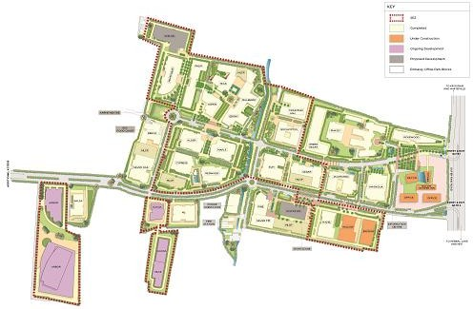

*Source: Client*

* + 1. Express Towers

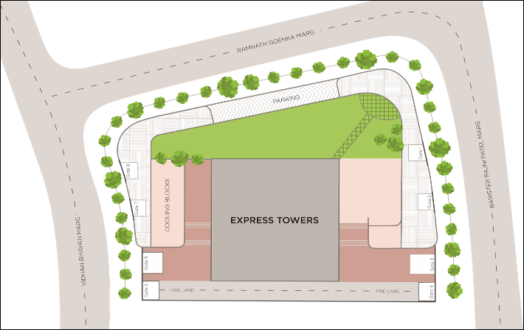

*Source: Client*

* + 1. Embassy 247

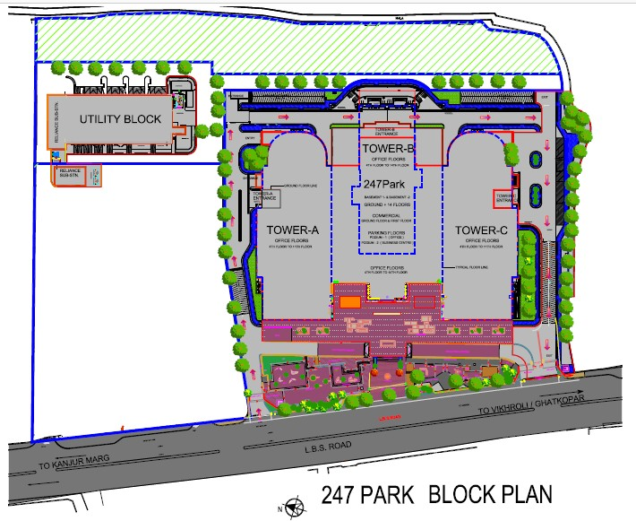

*Source: Client*

* + 1. First International Finance Center (FIFC)

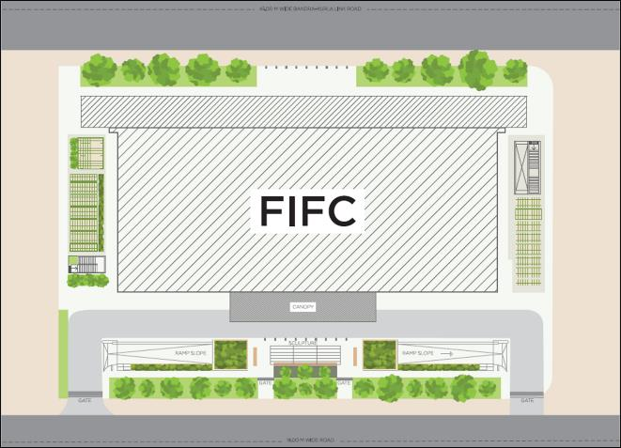

*Source: Client*

* + 1. Embassy TechZone

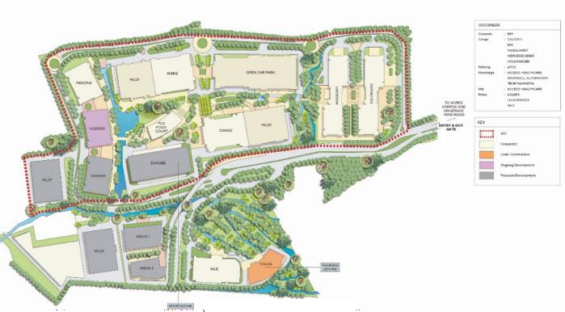

*Source: Client*

* + 1. Embassy Quadron

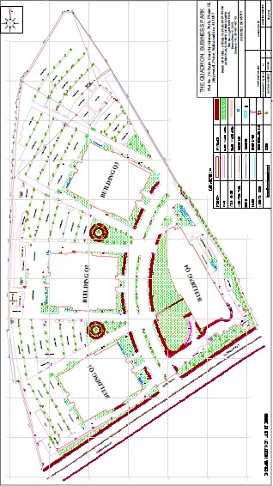

*Source: Client*

* + 1. Embassy Qubix

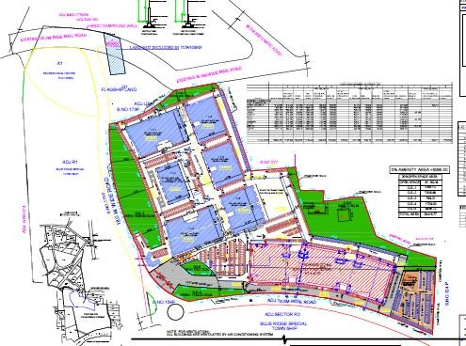

*Source: Client*

* + 1. Embassy Oxygen

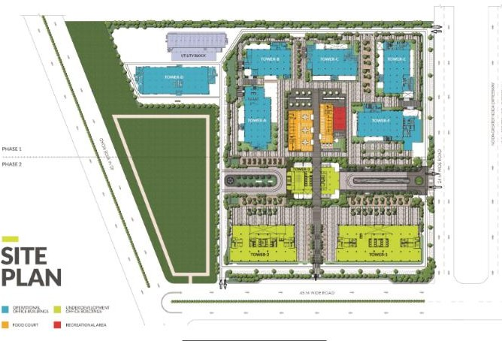

*Source: Client*

* + 1. Embassy Galaxy

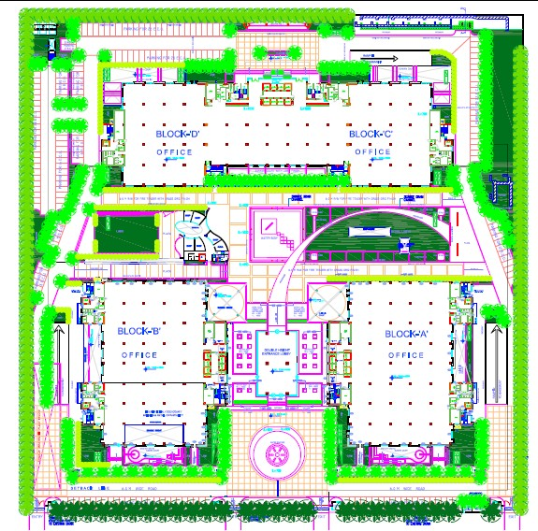

*Source: Client*

* + 1. Embassy GolfLinks

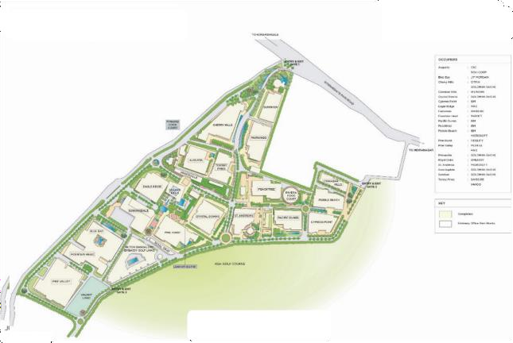

*Source: Client*

* + 1. Embassy One

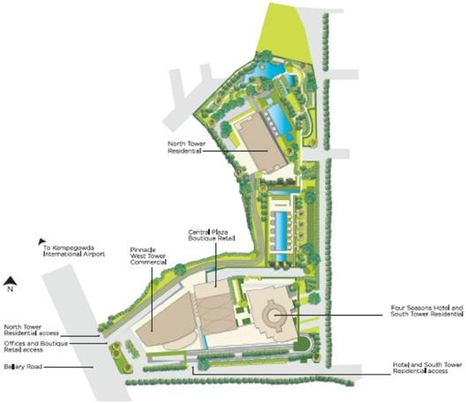

*Source: Client*

* + 1. Hilton at GolfLinks

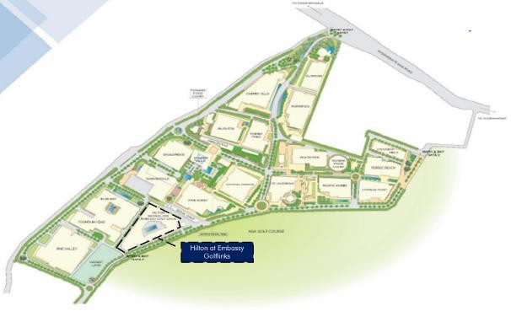

*Source: Client*

* + 1. Embassy Energy

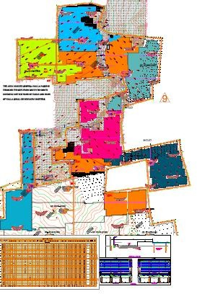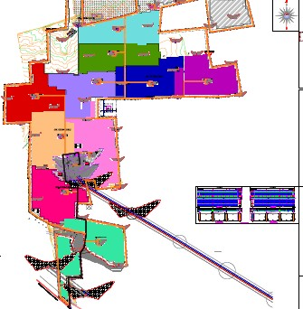

*Source: Client*

* 1. Statutory Approvals, One time Sanctions & Periodic Clearances

Based on information provided by the Client, please find below the details of Statutory Approvals, One time Sanctions & Periodic Clearances.

Embassy Manyata

As per approval documents shared by the Client, it is understood that all requisite approvals and occupancy certificates for the operational blocks have been received. The Client also has the sanction plan for the entire development, hence for all the under-construction & proposed blocks, individual approvals will be obtained as and when the development is initiated.

The details of the Occupancy Certificate for the respective completed blocks are shared by the Client and the same has been reviewed by Consultants and considered for the purpose of the valuation exercise:

|  |  |  |
| --- | --- | --- |
| **Block Name** | **Authority** | **Date of Issue (DD-MM-YY)** |
| Jacaranda (C1) | Karnataka Industrial Areas Development Board (KIADB) | 17-04-09 |
| Cedar (C2) | Karnataka Industrial Areas Development Board (KIADB) | 17-04-09 |
| ELM (C4) | Karnataka Industrial Areas Development Board (KIADB) | 17-04-09 |
| Alder (D1) | Karnataka Industrial Areas Development Board (KIADB) | 26-10-06 |
| Maple (D2) | Karnataka Industrial Areas Development Board (KIADB) | 26-10-06 |
| Redwood (D3) | Karnataka Industrial Areas Development Board (KIADB) | 13-07-07 |
| Cypress (D4) | Karnataka Industrial Areas Development Board (KIADB) | 03-08-07 |
| Beech (E1&FC) | Karnataka Industrial Areas Development Board (KIADB) | 12-02-08 |
| Ebony (G2) | Karnataka Industrial Areas Development Board (KIADB) | 02-05-12 |
| Aspen (G4) | Karnataka Industrial Areas Development Board (KIADB) | 10-09-12 |
| Rosewood (K) | Karnataka Industrial Areas Development Board (KIADB) | 26-10-06 |
| Magnolia (B) | Karnataka Industrial Areas Development Board (KIADB) | 13-07-06 |
| Silver Fir (L6) | Karnataka Industrial Areas Development Board (KIADB) | 23-12-11 |
| Mahogany (F2) | Karnataka Industrial Areas Development Board (KIADB) | 27-02-09 |
| Silver Oak (E2) | Karnataka Industrial Areas Development Board (KIADB) | 12-02-08 |
| Pine (L5) | Karnataka Industrial Areas Development Board (KIADB) | 24-04-09 |
| Eucalyptus (H1) | Karnataka Industrial Areas Development Board (KIADB) | 16-07-08 |
| Mulberry (G1) | Karnataka Industrial Areas Development Board (KIADB) | 30-04-10 |
| Palm (F3) | Karnataka Industrial Areas Development Board (KIADB) | 05-12-13 |
| G1-G2 Bridge (G1G2) | Karnataka Industrial Areas Development Board (KIADB) | 02-05-12 |
| Mountain Ash (H2) | Karnataka Industrial Areas Development Board (KIADB) | 05-12-13 |
| Hazel (L3) | Karnataka Industrial Areas Development Board (KIADB) | 09-06-15 |
| MFAR (MFAR Green) | Karnataka Industrial Areas Development Board (KIADB) | 12-06-15 |
| Teak (G3) | Karnataka Industrial Areas Development Board (KIADB) | 19-11-15 |
| Philips (Philips) | Karnataka Industrial Areas Development Board (KIADB) | 26-10-06 |
| L1 –L2 (Banyan & Willow) | Karnataka Industrial Areas Development Board (KIADB) | 10-08-17 |
| NXT (Front Land parcel) | Karnataka Industrial Areas Development Board (KIADB) | 03-01-2020 |

*Source: Approval documents provided by the Client*

The table below highlights the status of approvals for the under-construction blocks

Block Front Land Parcel (Retail, Hotel and Convention Center)

**Approval/NOC**

**Status (Applied/Received)**

**Authority**

**Date of Issue (DD- MM-YY)**

Revised Development plan approval Received KIADB 29-08-19

Commencement Certificate Received KIADB 04-07-18

Fire NOC Received Office of the Director General of Police 06-12-17

Height Clearance Received AAI 24-10-16

Clearance for Water Supply Received BWSSB 03-05-17

Clearance from Electricity Authority Received BESCOM 07-02-19

Environment clearance Received MOEF 23-01-20

Clearance from Pollution Control Board To be applied KSPCB NA

Final Fire NOC To be applied Office of the Director General of Police NA

Occupancy Certificate To be applied KIADB NA

*Source: Approval documents provided by the Client*

Block M3

**Approval/NOC**

**Status (Applied/Received)**

**Authority**

**Date of Issue (DD- MM-YY)**

Development Permission/

|  |  |  |  |
| --- | --- | --- | --- |
| Development plan approval |  | | |
| Commencement Certificate | To be applied | KIADB | NA |
| Fire NOC | Received* | Office of the Director General of Police | 10-06-2016 |
| Height Clearance | Received* | AAI | 04-05-2016 |
| Clearance for Water Supply | Received** | BWSSB | 01-03-2016 |
| Clearance from Electricity Authority | Received* | BESCOM | 25-07-2018 |
| Clearance from Pollution Control Board | To be applied | KSPCB | NA |
| Environment clearance | To be applied | MOEF | NA |
| Final Fire NOC | To be applied | Office of the Director General of Police | NA |
| Occupancy Certificate | To be applied | Bruhat Bengaluru Mahanagara Palike (BBMP) | NA |

Received* BDA 22-02-2018

*\*Note: The following approvals have been received for the existing plan for Block M3 (i.e. 997,057 sft). The Client will have to re-apply and secure approvals with the additional proposed area.*

*\*\* No amendment required in these NOCs due to change in area Source: Approval documents provided by the Client*

Express Towers

As per the review of the documents provided by the Client, we understand that all requisite approvals along with Occupancy Certificate for all the operational floors have been received.

The details of the Occupancy Certificates for the respective blocks shared by the Client and the same has been considered for the purpose of the valuation exercise:

|  |  |  |
| --- | --- | --- |
| **Floor Numbers** | **Authority** | **Date of Issue (DD-**  **MM-YY)** |
| B+2 floors | Presidency Division Building & Construction Department, Bombay | June 1971 |
| 3 to 12 floors | Presidency Division Building & Construction Department, Bombay | May 1971 |
| 13 to 15 floors | Presidency Division Building & Construction Department, Bombay | September 1970 |
| 16 to 24 floors | Presidency Division Building & Construction Department, Bombay | July 1970 |

*Source: Occupancy certificate*

Embassy 247

As per the review of the documents provided by the Client, we understand that all requisite approvals along with the Occupancy / Completion Certificate have been received for the subject property.

The details of the Occupancy Certificates for the respective blocks shared by the Client and the same has been considered for the purpose of the valuation exercise:

**Block Name Floors Authority Date of Issue\***

Wing A, B & C 2B+G+10 (A & C Wing) 2B+G+12 (B Wing)

Wing A, B & C 11th & 12th Floor (A & C Wing)

13th & 14th Floor (B Wing)

*Source: Occupancy certificate (Information provided by Client)*

First International Financial Centre (FIFC)

Municipal Corporation of Greater Mumbai 30-06-2009

Municipal Corporation of Greater Mumbai 14-08-2014

As per the review of documents provided by the Client, we understand that all requisite approvals along with the occupancy / completion certificate have been received for the subject property.

The details of the Occupancy Certificate for the subject property is shared by the Client and the same has been considered for the purpose of the valuation exercise:

|  |  |  |
| --- | --- | --- |
| **Subject Property** | **Authority** | **Date of Issue (DD-MM-YY) \*** |
| FIFC | MMRDA | 21-06-12 |
| *Source: Information provided by Client;* |  |  |

Embassy TechZone

As per the review of documents provided by the Client, we understand that all requisite approvals along with the occupancy / completion certificate for the operational blocks have been received. The Client also has the sanction plan for the entire development, hence for all the under-construction & proposed blocks, individual approvals will be obtained as and when the development is initiated.

The details of the Occupancy Certificates for the respective blocks shared by the Client are mentioned in the table below. The same has been considered for the purpose of the valuation exercise:

|  |  |  |  |
| --- | --- | --- | --- |
| **Block Name** | **Authority** | **Date of Issue (DD-MM-YY)** | **Remarks** |
| Building No. 1 | MIDC | 3/3/2008 | Still to 5th |
| Building No. 2 | MIDC | 3/3/2008 | Still to 4th |
| Building No. 1 & 2 | MIDC | 23/05/2008 | Complete Block |
| Building No. 3 | MIDC | 23/07/2015 | 5/6/8 & 9 |
| Building No. 3 (A Wing) | MIDC | 24/6/2011 | 4/5/6/7 (A Wing) |
| Building No. 3 (A Wing) | MIDC | 7/1/2012 | 8th & 10th (A wing) |
| Building No. 3 (B Wing) | MIDC | 21/7/2016 | 4/7/10 (B Wing) |
| Building No. 3 (A Wing) | MIDC | 10/04/2019 | 9th Floor |
| Building No. 3 | MIDC | 29/10/10 | G/1/2/3 |
| Building No. 5 | MIDC | 25/4/2011 | G to 3 |
| Building No. 5 (A Wing) | MIDC | 15/6/2012 | 4th & 5th |
| Building No. 5 (A Wing) | MIDC | 22/07/2016 | 2/3/6/7th Floor |
| Building No. 5 (B Wing) | MIDC | 22/07/2016 | 4/5/6/7/ & 8th |
| Building No. 5 (A Wing) | MIDC | 25/8/15 | LG, G, 1st & 8th (A Wing) |
| Building No. 5 | MIDC | 28/06/2019 | Terrace |
| Building No. 6 | MIDC | 7/1/2012 | 1st to 9th |
| Building No. 6 | MIDC | 29/03/2019 | Ground |
| Building No. 11 | MIDC | 16/04/2009 | 3rd and 4th |
| Building No. 11 | MIDC | 7/1/2009 | G, 1st and 2nd |
| Building No. 11 | MIDC | 4/3/2011 | 6th Floor |
| Food Court | MIDC | 28/06/2019 | - |

*Source: Information provided by Client*

*MIDC ~ Maharashtra Industrial Development Corporation*

Further, there are few floors for which occupancy certificate is yet to be received. For the purpose of this valuation, we have assumed appropriate lease up time for such spaces taking into consideration the minimum time required for attaining occupancy certificate.

Embassy Quadron

#### As per the review of documents provided by the Client, we understand that all requisite approvals along with the occupancy / completion certificate for the operational blocks have been received.

The details of the Occupancy Certificates for the respective blocks which has been considered for the purpose of the valuation exercise:

|  |  |  |
| --- | --- | --- |
| **Block Name** | **Authority** | **Date of Issue (DD-MM-YY)** |
| Building No. 1 | MIDC | 9/5/2008 |
| Building No. 2 | MIDC | 13/3/2008 |
| Building No. 3 | MIDC | 30/9/2009 |
| Building No. 4 | MIDC | 29/11/2011 |

*Source: Occupancy Certificate/ Information provided by Client; MIDC ~ Maharashtra Industrial Development Corporation*

Embassy Qubix

As per the information provided by the Client, all requisite approvals for the operational blocks have been received.

We understand that the Subject development has received Occupancy Certificates in parts. The details of the Occupancy Certificates for the respective blocks shared by the Client are mentioned in the table below. The same has been considered for the purpose of the valuation exercise:

|  |  |  |
| --- | --- | --- |
| **Block Name** | **Authority** | **Date of Issue (DD- MM-YY)** |
| IT 01 | MIDC | 29-11-11 |
| IT 02 | MIDC | 29-11-11 |
| IT 03 | MIDC | 29-11-11 |
| IT 04 | MIDC | 04-01-13 |
| IT 05 | MIDC | 12-02-14 |
| IT 06 | MIDC | 29-11-11 |

*Source: Occupancy certificate/ Information provided by Client*

Embassy Oxygen

As per the review of documents provided by the Client, we understand that all requisite approvals along with the occupancy/ completion certificates have been received for the completed blocks. The Client also has the sanction plan for the entire development, hence for the proposed block, individual approvals will be obtained as and when the development is initiated.

The details of the Occupancy/ Completion Certificates for the respective blocks shared by the Client have been tabulated below:

|  |  |  |
| --- | --- | --- |
| **Block Name** | **Authority** | **Date of Issue (DD-MM-YY)** |
| Tower A | New Okhla Industrial Development Authority (NOIDA) | 21-01-11 |
| Tower B | New Okhla Industrial Development Authority (NOIDA) | 21-01-11 |
| Tower C | New Okhla Industrial Development Authority (NOIDA) | 03-07-12 |
| Tower D | New Okhla Industrial Development Authority (NOIDA) | 21-01-11 |

Tower E New Okhla Industrial Development Authority (NOIDA) Excluding 9th floor: 07-01-13

Including 9th floor: 25-05-17

Tower F New Okhla Industrial Development Authority (NOIDA) 30-09-13

|  |  |  |
| --- | --- | --- |
| **Block Name** | **Authority** | **Date of Issue (DD-MM-YY)** |
| Tower 3 and Food Court | New Okhla Industrial Development Authority (NOIDA) | 29-11-18 |
| Tower 2 | New Okhla Industrial Development Authority (NOIDA) | 06-03-20 |

*Source: Information/ approval documents provided by Client;*

Further, the details of approvals received for proposed tower are highlighted in the table below:

**Approval**

**Authority**

**Date of Issue (DD-MM-YY)**

Sanctioned Area Statement/ Building Plan Approval

New Okhla Industrial Development Authority (NOIDA) 12-09-16

Environmental Clearance State Level Environment Impact Assessment Authority,

|  |  |  |
| --- | --- | --- |
|  | Uttar Pradesh |  |
| Provisional Fire NOC | Chief Fire Officer, Uttar Pradesh Fire Services | 01-09-16 |
| Height Clearance | Airports Authority of India | 04-10-17 |
| Pollution NOC | Uttar Pradesh Pollution Control Board | 17-05-18 |
| Structural Certificate | TPC Technical Projects Consultants Pvt. Ltd. | 22-03-16 |

16-08-16

Soil Test Report Nagadi Consultants Pvt. Ltd. 03-02-16

16-02-16

LEED Gold Pre-Certification U.S. Green Building Council (USGBC) Tower 1: 22-03-2017

*Source: Information/ approval documents provided by Client;*

Embassy Galaxy

As per the review of documents provided by the Client, we understand that all requisite approvals along with the occupancy/ completion certificates have been received for the subject development.

The details of the Occupancy/ Completion Certificates for the subject development shared by the Client have been tabulated below:

|  |  |  |
| --- | --- | --- |
| **Block Name** | **Authority** | **Date of Issue (DD-MM-YY)** |
| Towers A – E | New Okhla Industrial Development Authority (NOIDA) | 08-10-07 to 16-12-11 |

*Source: Information/ approval documents provided by Client*

Embassy GolfLinks

As per approval documents provided by the Client, all requisite approvals and occupancy certificate for the operational blocks have been received. The Occupancy Certificates for the respective blocks have been shared by the Client and the same has been considered for the purpose of the valuation exercise:

|  |  |  |
| --- | --- | --- |
| **Block Name** | **Authority** | **Date of Issue (DD- MM-YY)** |
| Augusta | Bengaluru Development Authority | 05-05-07 |
| Blue Bay | Office of City Municipal Council, Mahadevapura | 01-02-06 |
| Crystal Downs | Bengaluru Development Authority | 17-01-05 |
| Eagle Ridge | Office of City Municipal Council, Mahadevapura | 29-12-06 |
| Fairwinds | Bengaluru Development Authority | 01-08-06 |
| Fountain Head | Office of City Municipal Council, Mahadevapura | 23-01-06 |

|  |  |  |
| --- | --- | --- |
| **Block Name** | **Authority** | **Date of Issue (DD- MM-YY)** |
| Augusta | Bengaluru Development Authority | 05-05-07 |
| Blue Bay | Office of City Municipal Council, Mahadevapura | 01-02-06 |
| Pacific Dunes | Bengaluru Development Authority | 02-04-04 |
| Peach Tree | Bengaluru Development Authority | 02-07-05 |
| Pine Valley | Bengaluru Development Authority | 22-10-07 |
| Prince Ville | Bengaluru Development Authority | 05-05-07 |
| Rivera FC | Bengaluru Development Authority | 02-07-05 |
| St. Andrews | Bengaluru Development Authority | 10-03-06 |
| Sunningdale | Office of City Municipal Council, Mahadevapura | 29-12-06 |
| Torrey Pines | Bengaluru Development Authority | 05-05-07 |

*Source: Approval documents provided by the Client*

Embassy One

As per approval document provided by the Client, all requisite approvals and occupancy certificate for the office, retail and hotel area have been received as of date of valuation.

The details of the Occupancy Certificate for the subject property is shared by the Client and the same has been considered for the purpose of the valuation exercise:

|  |  |  |
| --- | --- | --- |
| **Block Name** | **Authority** | **Date of Issue (DD-MM-YY)** |
| Office and Retail | Bruhat Bengaluru Mahanagara Palike (BBMP) | 23-06-17 |
| Hotel | Bruhat Bengaluru Mahanagara Palike (BBMP) | 12-10-18 |

*Source: Approval documents provided by the Client*

Hilton at GolfLinks

As per approval documents provided by the Client, all requisite approvals and occupancy certificate for the operational hotel has been received. The occupancy certificate for the development has been shared by the Client and the same has been considered for the purpose of the valuation exercise:

**Property Name**

**Authority**

**Date of Issue (DD- MM-YY)**

Hilton at GolfLinks Bengaluru Development Authority 30-11-11

*Source: Approval documents provided by the Client*

Embassy Energy

Based on the review of documents provided by the Client, we understand that all the requisite approvals along with the Commissioning Certificates (issued by Gulbarga Electricity Supply Company Limited) have been received for operating a ‘Solar Power Plant’ at the subject property.

The details of the Commissioning Certificates shared by the Client have been tabulated below:

40 MW Gulbarga Electricity Supply Company Limited 07-02-18 23-01-18

**Capacity Commissioned**

**Authority**

**Date of Letter (DD-MM-YY)**

**Date of Commissioning (DD-MM-YY)**

60 MW Gulbarga Electricity Supply Company Limited 08-03-18 28-02-18

*Source: Information/ Commissioning Certificates provided by Client*

Please note that the above list of approvals is reflective of major approvals for each asset. Additionally, as per details provided by the Client, it is understood that all the other requisite approvals/ clearances have been obtained/ will be obtained in due course of time as and when applicable.

* 1. Historical Value Summary

30th September 2019

|  |  |
| --- | --- |
| Property | Market Value (INR Mn) |
| Completed Under Construction Total  (UC)/ Proposed |

|  |  |  |  |
| --- | --- | --- | --- |
| Embassy Manyata, Bengaluru | 113,662 | 25,385 | 139,047 |
| Express Towers, Mumbai | 18,590 | - | 18,590 |
| Embassy 247, Mumbai | 17,256 | - | 17,256 |
| First International Financial Centre, Mumbai | 14,912 | - | 14,912 |
| Embassy TechZone, Pune | 15,395 | 5,930 | 21,325 |
| Embassy Quadron, Pune | 14,609 | - | 14,609 |
| Embassy Qubix, Pune | 9,962 | - | 9,962 |
| Embassy Oxygen, Noida | 15,107 | 5,550 | 20,657 |
| Embassy Galaxy, Noida | 8,914 | - | 8,914 |
| Embassy One, Bengaluru | 13,852 | - | 13,852 |
| Hilton at Embassy GolfLinks, Bengaluru | 5,045 | - | 5,045 |
| Embassy Energy, Bellary District, Karnataka | 10,519 | - | 10,519 |
| Total – 100% owned assets | 257,823 | 36,865 | 294,688 |
| Embassy GolfLinks, Bengaluru | 26,432 | - | 26,432* |
| Total | 284,255 | 36,865 | 321,120 |

*\* Note: Indicative of Embassy REIT’s economic interest in the asset, viz. 50%*

31st March 2019

|  |  |
| --- | --- |
| Property | Market Value (INR Mn) |
| Completed Under Construction Total  (UC)/ Proposed |

|  |  |  |  |
| --- | --- | --- | --- |
| Embassy Manyata, Bengaluru | 110,946 | 24,449 | 135,395 |
| Express Towers, Mumbai | 18,849 | - | 18,849 |
| Embassy 247, Mumbai | 17,323 | - | 17,323 |
| First International Financial Centre, Mumbai | 14,957 | - | 14,957 |
| Embassy TechZone, Pune | 14,371 | 6,215 | 20,586 |
| Embassy Quadron, Pune | 14,610 | - | 14,610 |
| Embassy Qubix, Pune | 10,253 | - | 10,253 |
| Embassy Oxygen, Noida | 15,065 | 4,874 | 19,939 |
| Embassy Galaxy, Noida | 8,478 | - | 8,478 |
| Embassy One, Bengaluru | 13,955 | - | 13,955 |
| Hilton at Embassy GolfLinks, Bengaluru | 4,824 | - | 4,824 |
| Embassy Energy, Bellary District, Karnataka | 10,782 | - | 10,782 |
| Total – 100% owned assets | 254,412 | 35,538 | 289,950 |
| Embassy GolfLinks, Bengaluru | 26,174 | - | 26,174* |
| Total | 280,586 | 35,538 | 316,124 |

*\* Note: Indicative of Embassy REIT’s economic interest in the asset, viz. 50%*